RetrofitNY: ICAST

Net Zero Energy Retrofit Schematic Design

Final Report

Prepared for: RetrofitNY

New York State Energy Research and Development Authority

Albany, NY

Christopher Mahase

Senior Project Manager

Prepared by: Robert Foley

The International Center for Appropriate and Sustainable Technology

Lakewood, CO

Robert Foley

Project Manager

NYSERDA Report XXX NYSERDA Contract YYYYYY March 2019

Notice

This report was prepared by the International Center for Appropriate and Sustainable Technology in the course of performing work contracted for and sponsored by the New York State Energy Research and Development Authority (hereafter “NYSERDA”). The opinions expressed in this report do not necessarily reflect those of NYSERDA or the State of New York, and reference to any specific product, service, process, or method does not constitute an implied or expressed recommendation or endorsement of it. Further, NYSERDA, the State of New York, and the contractor make no warranties or representations, expressed or implied, as to the fitness for particular purpose or merchantability of any product, apparatus, or service, or the usefulness, completeness, or accuracy of any processes, methods, or other information contained, described, disclosed, or referred to in this report. NYSERDA, the State of New York, and the contractor make no representation that the use of any product, apparatus, process, method, or other information will not infringe privately owned rights and will assume no liability for any loss, injury, or damage resulting from, or occurring in connection with, the use of information contained, described, disclosed, or referred to in this report.

NYSERDA makes every effort to provide accurate information about copyright owners and related matters in the reports we publish. Contractors are responsible for determining and satisfying copyright or other use restrictions regarding the content of reports that they write, in compliance with NYSERDA’s policies and federal law. If you are the copyright owner and believe a NYSERDA report has not properly attributed your work to you or has used it without permission, please email [print@nyserda.ny.gov](mailto:print@nyserda.ny.gov)

Information contained in this document, such as web page addresses, are current at the time of publication.

Preferred Citation

New York State Energy Research and Development Authority (NYSERDA). 2018. “NYSERDA RetrofitNY Overall Rehab Proposal Martin Luther King – Building #10,” NYSERDA Report Number xx-yy (added by NYSERDA). Prepared by Robert Foley, the International Center for Appropriate & Sustainable Technology, Lakewood, CO. nyserda.ny.gov/publications

Table of Contents

Notice 2

Preferred Citation 2

List of Figures (Heading 1 No Number style) 6

List of Tables 6

Acronyms and Abbreviations 7

Glossary (Heading 1 No Number style) 7

Executive Summary (Heading 1 No Number style) 8

0.1.1.1 11

1 Project Narrative 12

2 Schematic Design Documents 35

3 Scalability Strategy 37

4 Budget and Financing Plan 39

5 Projected Construction Schedule 40

6 Building Performance Summary 41

6.1 Distributed Energy Resources Summary 41

6.2 Supplemental Renewables Plan 41

7 Resident Management Plan 42

8 Performance Guarantee Pathway 45

Maintenance and Warranties 45

9 Regulatory Barrier Summary 51

10 Resiliency Summary 52

11 Resident Health Impact Summary 54

12 Overall Rehab Proposal 56

References 57

Appendix A. Schematic Design Documents 57

Appendix B. Scalability Strategy 59

Appendix C. Budget and Financing Plan 60

Appendix D. Projected Construction Schedule 61

Appendix E. Building Performance Summary 62

Appendix F. Resident Management Plan 63

Appendix G. Performance Guarantee Pathway 64

Appendix H. Regulatory Barrier Summary 65

Appendix I. Resiliency Summary 66

Appendix J. Resident Health Impact Summary 67

Appendix K. Overall Rehab Proposal 68

Appendix L. RetrofitNY Energy Simulation Report 69

[Page number should be small Roman numerals]

List of Figures (Heading 1 No Number style)

(This is Table of Authorities style and this list can be automatically generated).

Figure 1. Figure and Table Title 4

List of Tables

Table 1. Figure and Table Title 4

[Page numbering should be small Roman numerals]

Acronyms and Abbreviations

BAU business as usual

DHW domestic hot water

ECM energy conservation measure

EUI energy use intensity

ERV estimated recovery value

ft feet

kBTU/ft2/year Kilo-British Thermal Unit per square foot per year

kWh kilowatt hours

m/s meters per second

MW megawatts

NYS New York State

NYSERDA New York State Energy Research and Development Authority

NZE Net Zero Energy

PPA power purchase agreement

PV photovoltaic

SHGC solar heat gain coefficient

THA Troy Housing Authority

Glossary (Heading 1 No Number style)

(This list uses A&A style)

***Energy Use Intensity*:** The total amount of site energy consumed by the building on an annual basis divided by the gross floor area in kBtu/ft2/yr.

***Multifamily building*:** residential building with five or more residential units.

***Net Zero Energy Performance*:** Total site energy consumed by the Building being less than or equal to the amount of renewable energy created by solar photovoltaics or other distributed energy resources located on the Building or elsewhere on the site, calculated on an annual basis.

[Page numbering should be small Roman numerals]

Executive Summary (Heading 1 No Number style)

As part of NYSERDA’s RetrofitNY program, ICAST and its team were awarded a design project to assist the Troy Housing Authority (THA) and its developer partner, Beacon Communities Inc., in designing a Net Zero Energy (NZE) retrofit to one of the buildings at the Martin Luther King apartment complex in Troy, New York. This report outlines the results of that design project and the recommendations on the project’s rehabilitation.

The ICAST RetrofitNY team took the base renovation plans and proposed high performance design components in lieu of business as usual (BAU) construction methods to achieve a near net zero property. The project gross floor area is approximately 7,150 ft2 with 6 units: two units have two bedrooms, three units have three bedrooms, and one unit has four bedrooms.

The final project design modeled Energy Use Index (EUI) was calculated to be: **21.1 kBtu/sf/yr.**

Thebase renovation plans and proposed high performance design components are listed in the table below:

|  |  |  |  |
| --- | --- | --- | --- |
| **ECM** | **Existing Rehab Plan** |  | **Retrofit NY Plan** |
| **Shell** | | | |
| Wall Insulation | Blown (SFS) In R-24.5 |  | No Insulation in cavity (Cost is removal of existing) |
| Windows | U Value .28/SHGC .27 |  | Passive House /U Value .18 SHGC .5 |
| Doors | Standard Steel Insulated doors with kerf weatherstrip |  | Standard Doors |
| Ceiling insulation | Blown In R-55 |  | Blown In R-70 |
| EPDM roof removed- Weather resistive barrier installed | |  | EPDM roof removed- Weather resistive barrier installed |
| Slab Insulation | None |  | 12” Slab Insulation, excavate + R10 |
| Power Wash and seal Concrete foundation | N/A |  |  |
| Air Sealing | 5 ACH @ 50 Pa |  | 1.5-2.5 ACH @ 50 Pa |
| Siding |  |  | R-24 Wall Assembly + Siding |
| **Mechanical** | | | |
| Heating | 95% Combi Boiler |  | Carrier Cold Climate HP |
| Cooling | 14 SEER A/C |  | Carrier Cold Climate HP |
| Ventilation | ASHRAE Bath Fan |  | Panasonic ERV in Each Unit |
| DHW | Same Combi boiler |  | Rheem HPWH in each unit |
| Heat Recovery | None |  | Waste Water Heat Recovery |
| Solar DHW | None |  | 1 Collector System |
|  |  |  | Less NYSERDA Solar DHW Rebate |
| **Appliances** | | | |
| Common Dryer | Electric Dryer |  | Heat Pump Dryer (with-coin op retrofit) |
| Range | Conventional Range |  | Smart Burner Retrofit |
| **Renewable Electric** | | | |
| **Energy Management** | | | |
| Energy monitoring (M&V) | None |  | Energy monitoring (M&V) |
| Control Devices (HEMS) | None |  | Control Devices (HEMS) |
| Capital Cost of New Electric Meters | Capital Cost of New Electric Meters |  | Capital Cost of New Electric Meters |
| Capital Cost of New Gas Meters | Capital Cost of New Gas Meters |  | No gas meters |

Table 1. ECM’s

**Synergy of Components**

Our design is a whole building approach in which each element of the building was evaluated to minimize the energy use of the building without compromising indoor air quality, tenant safety or comfort.

Our design team was constrained by the fact that this project is one building in a multi-building complex rehab. That meant that our finished building appearance had to closely match the appearance of the other buildings. Because of our desire to add R-value to the building shell (as well as improve the infiltration rate), we were able to get the developer to agree to allow covering the existing brick on the first floor with foamboard insulation, and then use the same siding on the first floor as is being used on the second floors throughout the rehab. This will make our building look somewhat different from the other buildings, but not so much as to look out of place.

Staengl Engineering ran dozens of permutations of the possible elements of the scope of work and based on the relative value of different approached (cost vs. impact on EUI) we settled on the final design as presented. While we did not meet the target EUI of 20 kBtu/sf/year we got very close while keeping the budget under the maximum allowed.

The greatest challenge was coming up with a strategy for effective air sealing, which maintains a continuous air barrier. Utilizing the Hunter panels and the Huber Zip sheathing along with utilizing the Aerobarrier aerosol air sealing should allow us to achieve a minimum airtightness of at least 1.5 ACH50. This is a close approximation of the Energiesprong approach to building shell, while utilizing current US building practices. It was a goal of NYSERDA to find or create a market for panel manufacturers similar to those present in Europe, but our extensive efforts failed to identify a single US manufacturer who actually makes retrofit panels. We identified two manufacturers who claimed a willingness to start making panels (Wythe Windows and Funform), however neither option was deemed viable due to cost.

Critical to the building performance was being confident that the wall assembly would not be prone to surface condensation inside the wall assembly in cold temperatures. In order to devise a safe wall design we ran several Therm model itineration studies to see where condensation might occur using different wall assemblies. Those studies indicated that with installing foamboard exterior sheathing, the existing cavities needed to have no insulation so that the critical temperature level was maintained inside the wall assembly to prevent condensation.

The fenestration installations have been designed to align with the air barrier, so that we are to the extent possible maintaining a continuous air barrier. We are also planning a training with the installers to maximize the air sealing performance of the installation.

In addition, we are planning to use Aeroseal aerosol air sealing to maximize the infiltration measure.

The foundation insulation makes minor improvements to the EUI but will certainly make a definite improvement to the comfort of the units on the first floor.

Using heat pump water heaters create a unique challenge since they dissipate waste cold into the living space. We will work with the selected mechanical contractor to assess whether it is practical to duct that waste cold outside the envelope or increase the size of the heat pump from 1.0 ton to 1.5 tons to have sufficient capacity to properly heat each apartment. Increasing the heat pump to 1.5 tons will increase the EUI for heating from 8.27-9.85 kbtu/h to 10.152-13.974 kbtu/h. This decision will be made in conjunction with the mechanical contractor selected by the general contractor.

The Solar thermal system was originally conceived for the entire building, but due to budget constraints was downsized to only serve the common laundry. We are confirming with Rheem (HPWH manufacturer) that their unit will operate properly with the solar thermal system.

With regard to ERV and wintertime indoor air vapor management, the challenge of wintertime relative humidity is that the incoming air is very dry—especially as it is warmed up to room temperature. The ERV is desirable to retain indoor air humidity, hence the enthalpy performance of the Enthalpy Recovery Ventilator—it is designed to capture that moisture. Heat Recovery Ventilators (HRV) do not recoup the interior humidity during the wintertime, and can create an overly dry interior climate, which is why we selected the ERV.

The HVAC systems (heat pump and ERV) will be connected to the HEMS system (i.e., Smapee), to continuously monitor system operation and performance. This will also be the gateway for measurement and verification (M&V) interaction with the property.

The smart burner retrofit makes for some small energy savings but contributes greatly to the safety of the residents.

#### 

# Project Narrative

**Building Envelope**

|  |  |
| --- | --- |
| **Key design criteria to consider** | **How does your design address the criteria?** |
| Thermal performance | We have added R-Value to each major component of the shell to reduce heat loss/gain and heating/cooling load.  Wall Assembly: *No insulation in wall cavity, min. R-24.8 continuous insulation at exterior walls.*  *Foundation: R-10 at foundation walls.*  Roof: *Existing EPDM roof removed, and the underlying EPS- so we will be applying a new air tightness layer onto the existing roof deck and insulate with loose fill cellulose to match the optimized depth per Staengl’s evaluation.* |
| Sealing performance | We have established a very aggressive air sealing target of 1.5 to 2.5 ACH @50 Pa. Integral to that air sealing strategy is adding a Class A fire rated air sealing membrane over the existing flat roof (which will be over framed with a pitched roof as part of the rehab).   * Installing a new sheathing layer, which will define the air barrier and be the installation point for fenestrations. * Specified Passive House compliant windows and specified a stringent installation process for fenestration installation. * Defined an air sealing process for the foundation installation and defined an air sealing process for the wall-roof connection where the sheathing meets the roof air barrier.   We also have flexibility in our air sealing goals, since in retrofits you can never be certain of hitting your target. Since our Model EUI is 21.1 kBtu/sf/yr, even if we only achieved an infiltration rate of 5 ACH50, our EUI would only increase to approximately 23 kBtu/sf/yr, well below our target of 25 kBtu/sf.  Air sealing will be with a continuous Zip board wall sheathing attached to second floor studs and installed over the existing brick and taped to the foundation. The existing EPDM membrane and underlying EPS insulation will be removed per the design architect’s direction, and Zip board with taped joints or a Class A air barrier with taped joints will be installed over the existing plywood deck. The vertical Zip board will be taped to the new roof deck air barrier for continuous air tightness from foundation to roof. The new pitched roof truss assembly will be installed over this, with raised heels to permit required insulation depth. |
| Moisture performance | Exterior: The Buildings will have a much more robust ability to resist exterior moisture sources due to the new envelope construction. Ceilings will be protected by a new over framed roof structure, weather resistive barrier and zip roof panels acting as the new floor of the attic. Walls will have a comprehensive air sealing/moisture plane, and foundations will have a 2” Geoform EPS (treated to protect structure from termite infestation) with cap flashing and stucco finish to 6” below grade and grading corrected so that bulk moisture is not sitting against the foundation.  Interior: A key component of the retrofit is installing continuously operating Enthalpy Recovery Ventilators (ERV) in each unit, so that they each meet the ASHRAE 62.2 residential ventilation requirements. These should mitigate much excessive moisture accumulating in the apartments, thus stunting mold/mildew growth and promoting indoor air quality. |
| Structural performance and long-term integrity of materials | The proposed modifications call for the addition of continuous sheathing from foundation to roof, increasing the shear strength and wind uplift resistance of the structures. Planned corrective work at existing overhang conditions will strengthen bearing walls. Together, these improvements will greatly increase the structural integrity of the wall assemblies. The proposed over framed truss roofs will bear on these exterior walls, consistent with preceding phases of work completed by architect of record.  Exterior insulation panels, Zip sheathing, and weather resistive barrier will add approximately 4 pound per sf to the wall system.  While this adds some weight to the structure it is not excessive and as long as the assemblies are installed according to manufacturer’s instructions, they should have no impact on durability.  Additional attic insulation and house wrap adds negligible weight to the structure. Foundation insulation contributes to protecting the foundation from bulk water intrusion. Included in the rehab is adding plywood to interior walls to add sheer strength to the exterior walls inherently protecting the integrity of the RetrofitNY proposed upgrades. |
| How will the new design affect resident life? Are there custom/atypical design features that require careful consideration? | The main ways would be improved indoor air quality due to managed ventilation, much better thermal comfort due to installation of foundation insulation, and right sized HVAC which will have longer run times at slower fan speeds promoting destratification of air and more even temperatures with less noise. New windows and doors will be draft free and should add considerable thermal comfort to the residents’ experience.  Replacing the electric resistance stoves with either induction cooktops or temperature-controlled replacement coils will reduce the risk of fire and injury from hot cooktops. Improved kitchen ventilation will reduce the amount of indoor air contaminants, improving the air quality for residents. |
| Maintenance of solution | The systems will require typically less maintenance than the system they are replacing with the exception of the solar thermal for the laundry. Existing DHW for example are tankless type demand appliances which require annual maintenance to prevent mineral deposits. Heat pump hot water (HPWH) heaters heat water much slower and do not tend to precipitate out minerals nearly as much and as such require less maintenance. Existing space heaters are pancake style air handlers which derive their heat from the same demand appliance that provides DHW, and like most hydronic systems require regular maintenance/service. These will be replaced by conventional dx type cold climate air source heat pumps. These will require a similar (if not less) maintenance cycle. |
| Sustainability of solution | Since we are reducing our carbon footprint by 75%, we are implementing a very sustainable path in terms of resource usage.  The life cycles of the shell measures should be at least 25 years if not longer.  The life cycles of the solar thermal should be 25-30 years.  The life cycle of the HVAC (including the ERV) should be 15-20 years.  The all electric solution that our team has proposed allows the use of on-site distributed or stored energy resources. |
| Replication potential at scale | The additional sheathing and insulation is a very familiar US-specific building method and so will be easily adopted by construction crews. Very replicable.  The windows and doors use similar installation to most fenestrations, with the additional air sealing techniques being a necessary training element as part of any rollout. Very replicable  The air sealing process we propose is very familiar to construction crews today, involving the installation of Zip sheathing with their proprietary tapes is common practice today. The added care required to seal penetrations and terminations to the foundation walls and roof are newer concepts but are basic and easily taught. Very replicable  The HVAC systems specified are very conventional, readily available, very familiar to mechanical contractors. Very replicable.  The heat pump water heaters are a newer technology in the US, but the installation is very similar to conventional heat pumps and water heaters. Any mechanical contractor can install easily, and service is very similar to other refrigeration systems. Units are well suited to individual residences. Very replicable.  ERV installation is increasingly common in conventional construction but will still be unfamiliar to many crews. The installation process for ERVs however is very simple, and the kit of parts that most manufacturers supply is typically “click together” with little need for extra taping or other means of air sealing. Very replicable  The solar thermal is not common and so is unfamiliar to most mechanical contractors, however it is simple in its operation and so easily serviceable. It is a poor solution for a single residence system, however when a central plant is serving multiple homes it is very advantageous. Sometimes replicable. |

|  |  |
| --- | --- |
| **Other Questions** | **Team Response** |
| What challenges have you encountered in designing an envelope solution that meets the RFP requirements? How are you addressing them? | The major challenge we have found is in sourcing any exterior panel manufacturers. Our attempts to mimic the Energiesprong approach will be greatly limited until such time as American manufacturers embrace this modular approach and make cost effective panels. |
| Are there any unresolved major issues? What would it take to resolve them? | Since we met most of the design criteria in a cost effective way, we think being able to add the panelized system will just be a bonus in the future. |
| Other comments (optional) |  |

**Ventilation and Indoor Air Quality**

|  |  |
| --- | --- |
| **Key design criteria to consider** | **How does your design address the criteria?** |
| RFP requirement of greater of 20 cfm / bathroom + 25 cfm / kitchen and 18 cfm / person | The installation of the energy recovery ventilator (ERV) system in each apartment achieves this design goal in a very energy efficient manner.  This solution includes, for each apartment and the laundry room, an ERV running continuously to provide the required ventilation air while recovering sensible and latent heat (82% sensible effectiveness, 60% latent effectiveness) from the exhaust air. This tempered ventilation air is then mixed with the supply air from an air handler that distributes air that is heated and cooled by a mini-split heat pump. |
| Prevention of mold, mildew, pests and other environmental triggers of respiratory or other ailments | The regular air changes provided by the dedicated ventilation system and its integral filters should greatly improve indoor air quality and mitigate indoor pollutants. The design will incorporate filtration systems, integrated with the air handling systems, which provide a minimum efficiency of MERV 8 for the ventilation systems and MERV 8 for the space conditioning systems (established using ASHRAE Standard 52-1994). Filter return grilles shall be used instead of the filter bank in the ducted indoor unit for ease of filter changing. Heat pumps will be equipped with dry mode for additional humidity control. |
| Active ventilation to reduce volatile organic compounds and other potential internal air contaminants | The regular air changes provided by the dedicated ventilation system and its integral filters should greatly improve indoor air quality and mitigate indoor pollutants. |
| Maintenance of solution | Since there are disposable filters integral to this solution, regular filter changes will be required. |
| Sustainability of solution | As long as there is fresh air outside, the very small energy penalty associated with these systems seems like a reasonable tradeoff for better indoor air quality. |
| Replication potential at scale | Easily replicable at scale. |

|  |  |
| --- | --- |
| **Question** | **Team Response** |
| What challenges have you encountered in designing an IAQ solution that meets the RFP requirements? How are you addressing them? | Very straightforward solution. |
| Are there any unresolved major issues? What would it take to resolve them? | None |
| Other comments (optional) |  |

**Space Heating/Cooling**

|  |  |
| --- | --- |
| **Key design criteria to consider** | **How does your design address the criteria?** |
| Space heating/cooling EUI of not more than 11 kBtu/ft2/year | We crush this metric. EUI for heating and cooling, including fan energy, is 5.0 kbtu/sf/year.  Heating: 1.9  Cooling: 2.4  Fans: 0.7  The ICAST team analyzed a number of heating and cooling systems, including central systems and individual systems. The other buildings in the rehab plan (non-RetrofitNY) included gas fired combi-boiler type systems. Due to the goals of this project all gas systems were eliminated from consideration. We evaluated electric resistance, air source heat pump, air to water heat pump and hybrid systems utilizing multiple technologies. We determined that cold climate air source heat pumps were the best mix of cost effectiveness, serviceability, efficiency and simplicity. There are more efficient types of equipment available like the Chilltrix air to water heat pump for example; these are not currently a widely used type of equipment and lack a track record for local installation and service. |
| Maintaining heating and cooling comfort (including humidity) | Since these are variable speed units, they will run at lower speeds providing mostly continuous air circulation, de-stratifying the air on a regular basis, leading to more even space temperatures. The ERVs will help maintain humidity during dry winter months, and the heat pumps can provide dehumidification during humid summer months. |
| Innovative ways to improve system efficiency |  |
| Required sensors and controls | Will use a smart thermostat |
| Maintenance of solution | Regular filter changes |
| Sustainability of solution | Super-efficient equipment lowers carbon footprint |
| Replication potential at scale | Very standard equipment makes this approach very replicable. |

|  |  |
| --- | --- |
| **Other Questions** | **Team Response** |
| What challenges have you encountered in designing a space heating/cooling solution that meets the RFP requirements? How are you addressing them? | Finding equipment with sufficient cold temperature performance such that we do not require back-up resistance electric would have been impossible 10 years ago. Now they are readily available. |
| Are there any unresolved major issues? What would it take to resolve them? | None |
| Other comments |  |

**Domestic Hot Water**

|  |  |
| --- | --- |
| **Key design criteria to consider** | **How does your design address the criteria?** |
| DHW system design and sizing | While we feel the demand criteria are high; however, the system was designed to meet the 21 gallon/person/day requirement. The system consists of seven Rheem heat pump water heaters. |
| Innovative ways to improve system efficiency (i.e. heat recovery) | We were proposing drain waste heat recovery units be installed in each apartment until budget constraints eliminated that option. Since there is only one shower in each apartment that helps lower cost. These were modeled to account for approximately 29% of the DHW energy usage and would have been a nice feature to incorporate. |
| Required sensors and controls | The systems are each self-contained and independent of each other. The solar thermal will act as an energy battery and simply provide heated water (when its sunny) to the input of the Rheem water heater in the laundry. |
| Maintenance of solution | The Rheem water heaters will have similar maintenance requirements as the heat pumps. The tanks should not have most of the problems associated with high delta/t water heaters that tend to precipitate out minerals as sediment, so should require less maintenance than most water heaters. Solar thermal systems require regular maintenance (especially of circulation pumps), which should be added to regular maintenance schedules. |
| Sustainability of solution | No natural gas, lower GHG emissions, 35% electric, 35% Solar, and 30% Recovered energy, about as sustainable as it gets (well ok a cold shower is in fact MORE sustainable, but other than that solution). |
| Replication potential at scale | As replicable as any DHW system. |

|  |  |
| --- | --- |
| **Other Questions** | **Team Response** |
| What challenges have you encountered in designing a DHW solution that meets the RFP requirements? How are you addressing them? | The DHW was the most challenging element of the EUI to reduce. It required all three elements to get us below a EUI of 20 kBtu/sf. Where cost constraints limit your choices to just the DHW plant (no solar, no recovery), reducing the impact of DHW to the overall EUI will be quite challenging. The 21 gal/person/day design standard proved to be a challenge. |
| Are there any unresolved major issues? What would it take to resolve them? | None |
| Other comments |  |

**Miscellaneous Electric Loads (MELs)**

|  |  |
| --- | --- |
| **Key design criteria to consider** | **How does your design address the criteria?** |
| Strategies to minimize consumption of MELs (controls, motivate habit shift in occupants, replace devices with more efficient models, etc.) | The main way we are reducing electric loads is with the smart burner retrofit of the electric ranges. These thermostatically controlled burners do not allow the burner temperature to exceed 650°F (below the flash point of most oils). So, they are both a health and safety measure as well as an energy saver. |
| Variation in consumption between occupants |  |
| Maintenance of solution | None |
| Sustainability of solution | Very |
| Replication potential at scale | Very |

|  |  |
| --- | --- |
| **Other Questions** | **Team Response** |
| What challenges have you encountered in designing a MELs solution that meets the RFP requirements? How are you addressing them? | MEL’s is such a black box, that it will always be a challenge. How do you control misc. usage without really annoying your tenants? |
| Are there any unresolved major issues? What would it take to resolve them? | Yet to find really good MEL’s solutions other than the smart burner |
| Other comments (optional) |  |

**Distributed Energy Resources (DER)**

|  |  |
| --- | --- |
| **Key design criteria to consider** | **How does your design address the criteria?** |
| DER relevant to/included in the retrofit design | Our design did not include any of the work associated with the on-site solar PV plant. The implementation of the on-site solar PV plant is being conducted by the developer and Troy Housing Authority. |
| Onsite DER capacity vs. offsite | N/A |
| How to integrate DER into HVAC and other major end uses | N/A |
| Structural performance | N/A |
| Efficiency degradation | N/A |
| Required sensors and controls | N/A |
| Maintenance of solution | N/A |
| Sustainability of solution | N/A |
| Replication potential at scale | N/A |

|  |  |
| --- | --- |
| **Other Questions** | **Team Response** |
| What challenges have you encountered in designing a DER solution? How are you addressing them? | N/A |
| Are there any unresolved major issues? What would it take to resolve them? | N/A |
| Other comments (optional) | N/A |

**Building Performance + Modeling & Life Cycle Cost Analysis**

|  |  |
| --- | --- |
| **Key design criteria to consider** | **How does your design address the criteria?** |
| Overall site EUI of not more than  25 kBtu/ft2/year | Staengl Engineering conducted energy analysis of potential retrofit solutions for Martin Luther King Apartments, Building #10. The goal of the retrofit design is to achieve a site energy use intensity (EUI) of 20 kBtu/sf/year or less, excluding energy offset by the planned photovoltaic system.  We used the energy modeling software IES-VE 2018 to estimate the energy consumption throughout three rounds of analysis:   1. 24 different design solutions, plus a baseline case based on the Phase II retrofit being implemented for the other buildings in the apartment complex (this first round of simulations is described in the attached Energy Simulation Report dated August 1, 2018) 2. Various configurations of slab insulation, wall insulation, heat pump and solar thermal DHW, and air-to-water heat pumps for DHW and space conditioning. 3. A narrowed-down list of specific envelope enhancements (including high-performance windows and doors, exterior wall insulation) drain-water heat recovery, and solar thermal DHW.   Through these iterative energy studies, the team has arrived at the conceptual design for the project, which as an estimated EUI of 16.3 kBtu/sf/year.  The PHASE II retrofit baseline has an estimated EUI of 54.5 kBtu/sf/year. Utility bills show that the pre-retrofit baseline has an estimated EUI of 61.9 kBtu/sf/year.  The final project Schematic design modeled Energy Use Index (EUI) was calculated to be: **21.4 kBtu/ft2/yr.**  Figure 1 shows the EUI for the existing, pre-retrofit building (based on utility bills), the Phase II retrofit baseline, and the schematic design.  Heating EUI: 3.0 kBtu/ft2/yr  Cooling EUI: 1.8 kBtu/ft2/yr  Fans EUI: 1.1 kBtu/ft2/yr  Infiltration rate assumed: 1.6 ACH50  In the **Schematic** Design the modeled Energy Use Index (EUI) was calculated to be **21.4 kBtu/ft2/yr.** |
| Determination of operational assumptions  (schedules, people densities, etc.) | The project RFP lists the following required “levels of comfort and service”:    Items one through four from this list have been included in the model. Item number five has been accounted for by entering inputs for lighting, appliances, and plug loads based on reasonable assumptions and schedules, as described in the next sub-section.  Occupancy-Based Parameters  ***Table 1: Occupancy, ventilation, and DHW***   |  |  |  |  |  |  |  |  |  |  | | --- | --- | --- | --- | --- | --- | --- | --- | --- | --- | | **Unit** | **Bath** | **Bedroom** | **Kitchen** | **OA cfm bathroom + kitchen** | **OA cfm people** | **OA req'd** | **# people** | **DHW peak gal/hr** |  | | **A** | 1 | 3 | 1 | 45 | 72 | **72** | 4 | 6.72 |  | | **B** | 1 | 3 | 1 | 45 | 72 | **72** | 4 | 6.72 |  | | **C** | 1 | 2 | 1 | 45 | 54 | **54** | 3 | 5.04 |  | | **D** | 1 | 2 | 1 | 45 | 54 | **54** | 3 | 5.04 |  | | **E** | 2 | 4 | 1 | 65 | 90 | **90** | 5 | 8.4 |  | | **F** | 1 | 3 | 1 | 45 | 72 | **72** | 4 | 6.72 |  | | **TOTAL** | **6** | **17** | **6** | **270** | **414** | **414** | **23** | **21** | **gal/person/day** | |  |  |  |  |  |  |  |  | 1.68 | peak gal/hr/person | |  |  |  |  |  |  |  |  | 483 | gal/day HW |   Peak Consumption and Heat Gains  The peak electricity consumption and heat gains (sensible and latent) for appliances, miscellaneous plug loads, and lights are described in the following tables.  ***Table 2: Peak consumption and heat gains for appliances, plug loads, and lighting***   |  |  |  |  | | --- | --- | --- | --- | |  | **Peak elecricity consumption (Btu/h)** | **Peak sensible heat gain (Btu/h)** | **Peak latent heat gain (Btu/h)** | | Dishwasher | 135 | 81 | 20 | | Washer* | 207 | 166 | 0 | | Dryer* | 1653 | 744 | 248 | | Oven/Range | 399 | 160 | 120 | | Refrigerator | 365 | 365 | 0 | | Miscellaneous | 517 | 481 | 0 | | Lights | 997 | 997 | 0 | | *This appliance is per site. All others are per apartment unit. | | | |   These peaks are then multiplied by the hourly fractions shown in the Schedules sub-section on the next page. The lighting power is estimated to be 0.6 W/ft2 for the laundry room and 0.4 W/ft2 for the apartment units. The appliance consumption and hourly schedules are based on the *2014 Building America House Simulation Protocols* published by NREL. The dryer is based on an average of 3 loads/day using a 7.4 cu. ft. Energy Star rated Whirlpool heat pump dryer (model WED9290).  Peak Consumption and Heat Gains  The peak electricity consumption and heat gains (sensible and latent) for appliances, miscellaneous plug loads, and lights are described in the following tables.  ***Table 2: Peak consumption and heat gains for appliances, plug loads, and lighting***   |  |  |  |  | | --- | --- | --- | --- | |  | **Peak electricity consumption (Btu/h)** | **Peak sensible heat gain (Btu/h)** | **Peak latent heat gain (Btu/h)** | | Dishwasher | 135 | 81 | 20 | | Washer* | 207 | 166 | 0 | | Dryer* | 1653 | 744 | 248 | | Oven/Range | 399 | 160 | 120 | | Refrigerator | 365 | 365 | 0 | | Miscellaneous | 517 | 481 | 0 | | Lights | 997 | 997 | 0 | | *This appliance is per site. All others are per apartment unit. | | | |   Schedules    ***Table 3: Hourly schedules***   |  |  |  |  |  |  |  |  |  |  | | --- | --- | --- | --- | --- | --- | --- | --- | --- | --- | | **Time of Day** | **Dish-washer** | **Washer** | **Dryer** | **Occup-ancy** | **Oven/ Range** | **Refrig-erator** | **Miscel-laneous** | **Lights** | **DHW** | | 0:00 | 0.28 | 0.28 | 0.33 | 1.00 | 0.07 | 0.82 | 0.73 | 0.16 | 0.29 | | 1:00 | 0.15 | 0.05 | 0.28 | 1.00 | 0.04 | 0.80 | 0.60 | 0.06 | 0.09 | | 2:00 | 0.06 | 0.05 | 0.05 | 1.00 | 0.04 | 0.78 | 0.56 | 0.06 | 0.04 | | 3:00 | 0.05 | 0.03 | 0.05 | 1.00 | 0.03 | 0.75 | 0.55 | 0.06 | 0.01 | | 4:00 | 0.03 | 0.05 | 0.03 | 1.00 | 0.03 | 0.73 | 0.55 | 0.06 | 0.01 | | 5:00 | 0.03 | 0.06 | 0.05 | 1.00 | 0.06 | 0.71 | 0.52 | 0.19 | 0.04 | | 6:00 | 0.09 | 0.13 | 0.06 | 1.00 | 0.07 | 0.71 | 0.58 | 0.39 | 0.25 | | 7:00 | 0.16 | 0.25 | 0.13 | 1.00 | 0.16 | 0.73 | 0.68 | 0.44 | 0.94 | | 8:00 | 0.28 | 0.45 | 0.25 | 0.85 | 0.28 | 0.80 | 0.71 | 0.39 | 1.00 | | 9:00 | 0.54 | 0.60 | 0.45 | 0.39 | 0.31 | 0.81 | 0.60 | 0.17 | 0.98 | | 10:00 | 0.56 | 0.66 | 0.60 | 0.23 | 0.33 | 0.84 | 0.52 | 0.12 | 0.84 | | 11:00 | 0.51 | 0.66 | 0.66 | 0.23 | 0.28 | 0.80 | 0.53 | 0.12 | 0.76 | | 12:00 | 0.45 | 0.75 | 0.66 | 0.23 | 0.33 | 0.80 | 0.53 | 0.12 | 0.61 | | 13:00 | 0.36 | 0.73 | 0.75 | 0.23 | 0.39 | 0.84 | 0.52 | 0.12 | 0.53 | | 14:00 | 0.38 | 0.74 | 0.73 | 0.23 | 0.29 | 0.84 | 0.53 | 0.12 | 0.48 | | 15:00 | 0.34 | 0.71 | 0.74 | 0.23 | 0.28 | 0.81 | 0.60 | 0.20 | 0.41 | | 16:00 | 0.34 | 0.68 | 0.71 | 0.23 | 0.39 | 0.84 | 0.56 | 0.12 | 0.48 | | 17:00 | 0.34 | 0.75 | 0.68 | 0.30 | 0.64 | 0.90 | 0.71 | 0.44 | 0.54 | | 18:00 | 0.45 | 0.90 | 0.75 | 0.56 | 1.00 | 0.95 | 0.85 | 0.61 | 0.74 | | 19:00 | 0.75 | 0.88 | 0.90 | 0.90 | 0.79 | 1.00 | 0.94 | 0.82 | 0.86 | | 20:00 | 1.00 | 0.84 | 0.88 | 0.90 | 0.40 | 0.95 | 0.97 | 0.98 | 0.81 | | 21:00 | 0.82 | 0.60 | 0.84 | 0.90 | 0.25 | 0.93 | 1.00 | 1.00 | 0.74 | | 22:00 | 0.57 | 0.54 | 0.60 | 1.00 | 0.17 | 0.91 | 0.97 | 0.69 | 0.61 | | 23:00 | 0.38 | 0.33 | 0.54 | 1.00 | 0.11 | 0.90 | 0.84 | 0.38 | 0.53 |   Note: See *2014 Building America House Simulation Protocols* published by NREL, Section 4.5: Appliances and Miscellaneous Electric Loads.  The model, with these peak values and hourly fractional multipliers, results in monthly consumption for cooling, appliances, plug loads, and lighting that is in reasonable agreement with measured pre-retrofit electricity consumption after accounting for upgrading the lighting to LED from a pre-retrofit mix of incandescent and fluorescent.    ***Figure 2: Measured electricity consumption vs. adjusted model***  Figure 3, shows the hourly profile for all appliances, miscellaneous plug loads, and lights for one apartment. The peak demand (kW) for each end use has been calibrated to force the annual consumption to match the Building America consumption.    Design Solution Parameters  The previous round of energy modeling (documented in the attached Energy Simulation Report dated August 1, 2018) identified the following influential design pieces which may be mixed in several ways to form a solution meeting the energy target:   * Envelope enhancements (windows, doors, walls, roof, slab edge) * Solar thermal domestic hot water system * Drain-water heat recovery * Air-sealing for infiltration reduction * Air-to-air or air-to-water heat pumps for space conditioning and/or DHW   Note that many of the items relate to domestic hot water, which is the single largest energy end-use for this project.  The following design solution parameters were held constant for all solutions:   * Lighting: all LED * Shared dryer: Heat pump type * Exhaust air energy recovery: passive ERV   The second round of energy modeling, presented in this report, analyzed the impact of slab insulation, wall insulation, heat pump and solar thermal DHW, and air-to-water heat pumps for DHW and space conditioning.  The third round of energy modeling assumed ERVs plus mini-split heat pumps for space conditioning and explored the impact of specific envelope enhancements (including high-performance windows and doors, exterior wall insulation) drain-water heat recovery, and solar thermal DHW.  The Schematic design for the project is based on implanting all the analyzed energy-efficiency measures:   * Walls: No Cavity batt insulation + R-24 sheathing exterior insulation * Slab insulation: R-10, 1' deep vertical foam board from the slab edge down along the foundation wall * Roof: R-70 loose fill insulation above the existing roof * Windows: U-factor 0.18, SHGC 0.5 * Doors: R-2.5 * Infiltration: 1.5 to 2.5 ACH at 50 Pa (0.05 ACH at atmospheric pressure) * 19 SEER ducted mini-split heat pump per apartment * ERV per apartment (82% sensible effectiveness, 60% latent effectiveness) * Solar DHW system comprising 1 30-tube collector (evacuated tube type) * 7 Rheem heat pump water heaters to meet the DHW load   In addition to the design solutions, we have simulated the Phase II retrofit baseline to allow comparison of the design solutions to the “business as usual” case.  The EUI associated with the baseline case is 54.4 kBtu/ft2/year. |
| Operation and maintenance costs |  |
| Anticipated costs savings for 30 years relative to “business as usual” normal retrofit intervention |  |
| Retrofit business model + sustainability and scalability of solution | A number of challenges are evident from our utility cost analysis. For example, even though our design reduces the EUI for the building by approx. 70% from 56 to 16 kbtu/sf/yr, the annual cost of energy (ignoring the presence of solar PV), is only reduced by 30%, due to the dramatic difference in the cost of natural gas vs. electric. That will continue to be a major economic hindrance to the adoption of all electric solutions. |

|  |  |
| --- | --- |
| **Other Questions** | **Team Response** |
| What challenges have you encountered in designing a solution that meets the RFP’s EUI requirement? How are you addressing them? | The major challenge was reducing the energy requirements of the DHW load. That was addressed by adding solar thermal and heat recovery systems. |
| What challenges have you encountered in modeling the solution’s performance? How are you addressing them? | The biggest challenge has been the basic strategy of leaving in place the existing brick veneer and being confident that we are not creating an assembly that will have the potential to allow condensation inside the wall cavity at low temperatures.  We have modeled dew point analysis using several scenarios to have confidence in our design. |
| What challenges have you encountered in completing an LCCA? How are you addressing them? | Getting accurate costs for some measures has been challenging |
| Are there any unresolved major issues? What would it take to resolve them? | None |
| Other comments (optional) |  |

**Construction Budget**

|  |  |
| --- | --- |
| **Key criteria to consider** | **How does your budget address the criteria?** |
| Cost compression due to anticipated innovation | Very little cost compression expected. Typical site-based construction is very hard to squeeze dollars out of. |
| Cost compression at scale | Very little cost compression expected. Typical site-based construction is very hard to squeeze dollars out of. |
| Current availability of required products | All materials specified are readily available on standard construction delivery schedules. |
| Anticipated future availability of required products | All materials specified are readily available on standard construction delivery schedule. |
| Transportation of products/systems to project site | Transportation will be as standard as most construction materials. |
| On-site vs. off-site labor | We don’t expect there to be any off-site labor |

|  |  |
| --- | --- |
| **Other Questions** | **Team Response** |
| What challenges have you encountered in producing a construction budget? How are you addressing them? | Local construction costs are quite high due to tight labor market and very busy subcontractors |
| Are there any unresolved major issues? What would it take to resolve them? | Project is currently cost-prohibitive without major subsidies on the order of $60k per unit or more. |
| Other comments (optional) |  |

**Construction Schedule**

|  |  |
| --- | --- |
| **Key criteria to consider** | **How does your schedule address the criteria?** |
| Schedule compression due to anticipated innovation | Scheduling issues really aren’t applicable on this project since it is a subset of a greater rehab project.  Only element of project that might affect construction schedule is the more involved sheathing installation/ air sealing, which will require additional training of installer staff. |
| Schedule compression at scale | As these methods become more standard construction schedules should be able to be compressed slightly. |
| Current availability and lead time of required products | All materials specified are readily available on standard construction delivery schedules. |
| Anticipated future availability and lead time of required products | All materials specified are readily available on standard construction delivery schedules. |
| Transportation of products/systems to project site |  |
| On-site vs. off-site labor | If any US manufacturers start making cost effective panel systems the offsite labor savings should kick in. |

|  |  |
| --- | --- |
| **Other Questions** | **Team Response** |
| What challenges have you encountered in producing a construction schedule? How are you addressing them? | We have no say in schedule. |
| Are there any unresolved major issues? What would it take to resolve them? | Not our purview. |
| Other comments (optional) |  |

# Schematic Design Documents

* Combined specifications
* Design specification
* Schematic design documents
* Revitalization phase plans
* 00_RetrofitNY_CONCEPT SKETCHES - 2018-09-15
* 00_RetrofitNY_EXISTING - 2018-09-15
* 01_RetrofitNY_CRITICAL CUSTOM DETAILS - Perimeter Insulation Change_2018-10-04
* 2018-09-17_THERM MODEL SLIDES_REVISED
* 2018-10-04_THERM DIAGRAMS_Full Wall Section_PERIMETER INSULATION CHANGE
* 223300 - electric water heaters
* 223450 - solar hot water heating system
* 237200 - air-to-air energy recovery equipment
* 238130 - air-to-air heat pumps
* 38MAR Sizes 09-12
* 40MBDQ Sizes 09-48
* 40MPHA Sizes 09-12
* 40VM900006-C-1SD
* Architectural Specs
* Eurotek-Flyer-Updated-01192018
* Hot Water Schematic 12_14_18 each apartment
* HP Dryer installation-instructions-W10679043-RevA
* HP Dryer warranty-W10678945-W
* Hunter-Xci-CG-Submittal
* Hunter-XCI-NB
* Hunter-Xci-Ply-Submittal
* MLK Building 10 Elevation
* Panasonic ERV FV-10VEC1_Sell Sheet
* Panasonic ERV FV-10VEC1_Submittal
* Performance Data eurotek windows
* Pioneer SmartBurner Spec Sheet
* RetrofitNY Combined Specifications
* Rheem HPWH THD-PPEH4_Rev6_THD_Gen_4_Hybrid+15_amp
* Smappee Pro Installation and Product Manual_EN - US Version

# Scalability Strategy

We started our design by thinking in terms of how buildings are currently built and rehabbed. Recognizing that since this project is a subset of an ongoing rehab of the existing property, we needed any approach to be easily delivered by the same contractors that were doing the conventional rehab. While that was limiting, it was also useful in the sense that we wanted our approach to be readily repeatable by your typical residential construction crew.

Everything we proposed as an energy saving element is very familiar and repeatable by typical construction firms.

The major barrier to scalability is payback on these improvements. Barring a dramatic rise in utility costs or the imposition of a carbon tax, the industry will need to develop retrofit solutions that are far more cost-effective to achieve viable payback periods.

With regard to the Energiesprong notion of a panelized system, manufacturing companies should take the lead in developing an inexpensive system so that significant adoption can take place.

|  |  |  |
| --- | --- | --- |
| **Building System** | **Describe strategy for successfully measuring, producing and installing the solution at scale on similar buildings. Include detail on building system sub-components (i.e. piping, windows, etc.)** | **If design solutions with a better potential for scalability were considered, describe the solutions and explain why they did not make it to the final design (i.e., cost, product availability, aesthetics, etc.)** |
| Ventilation and IAQ | Since ERV’s are being installed commonly in building today, solution is readily scalable as add on to HVAC System | CERV is a terrific unit <https://www.buildequinox.com/>  But cost was prohibitive |
| Space Heating/Cooling | Cold Climate Heat pumps are quickly being adopted throughout the country. Rigorous M&V will prove actual energy savings which will help adoption. | Ground Source heat pumps are always an interesting choice, especially where bodies of water are available |
| Domestic Hot Water | HPWH is a simple modification of refrigeration systems that have been in use for 100 years. While only around for a few years in this form, technology is very proven | Europe and Asia have a HP HVAC unit that also does the DHW job. Introducing that technology into the US will reduce costs further and drive scalability. |
| Miscellaneous Electric Loads | Plug load monitoring for MEL | Home automation systems, as they get cheaper and more prevalent will drive scale in this segment |
| Façade | Since there is still no actual manufacturer of panels currently selling in the USA, adding foam insulation to existing façade or adding SIPS or sheathing solutions over the insulation is readily scalable and easily adopted by US Builders. | Perhaps blown-in insulation with residents in place, a solution in place for decades, is a cost-effective and scalable option. |
| Roof | More ceiling insulation is readily scalable and adopted |  |
| Distributed Energy Resources | Solar PV is an established solution |  |

Project unit cost for reproducing the retrofit solution at scale.

|  |  |  |  |  |  |
| --- | --- | --- | --- | --- | --- |
| Location | Pilot Project (1 unit) | 10 units | 100 units | 1,000 units | 10,000 units |
| Ventilation and IAQ | 2500 | 2400 | 2000 | 2000 | 2000 |
| Space Heating/Cooling | 7000 | 6750 | 6000 | 5000 | 5000 |
| Domestic Hot Water | 2000 | 2000 | 1750 | 1500 | 1400 |
| Miscellaneous Electric Loads | 1000 | 1000 | 1000 | 750 | 500 |
| Façade | n/a | n/a | n/a | n/a | n/a |
| Roof | n/a | n/a | n/a | n/a | n/a |
| Distributed Energy Resources | n/a | n/a | n/a | n/a | n/a |

# Budget and Financing Plan

Our approach was to evaluate each potential improvement using the cost per kWh saved as a yardstick of which improvements made the most sense. We then had an easily understood rubric for evaluating each measure as compared to every other measure. As a result, it became abundantly clear the high cost of insulated wall panels or other envelop treatments made pursuing heat pumps or heat pump water heaters instead a more cost-effective route toward achieving the same performance levels.

We worked with National Grid to try to maximize utility incentives, which we chose not to pursue, because they amounted to less than $10,000. The cost effectiveness of this project is difficult. Utility costs will need to greatly increase and retrofit costs will need to greatly decrease before projects like this will be cost effective in terms of payback.

The retrofit scope should slightly improve building’s durability due to better moisture management.

# Projected Construction Schedule

Our team had no input on Construction Schedules.

Project is being run by Developer and General contractor who, at the time of this report’s completion, were still determining construction schedule for Phase II of the overall campus renovation.

Project will not be a tenant in place rehab, so we cannot comment on that element.

# Building Performance Summary

We selected mechanical equipment from major manufacturers with a long history of high-quality manufacturing and product support.

Our design was able to reduce energy consumption by approximately 70%, which is quite impressive. At this point any more efficiency would result in an exponential increase in costs. Because the project has a community wide solar array, we were always going to NZE, and we feel that a mix of 70% efficiency and 30% renewables seems like the sweet spot for a NZE rehab project.

We evaluated at least 10 different approaches to increasing the wall insulation and air sealing. We discussed the difficulties of installation, cost of approach with architect, engineer and our potential general contractor. Based on those conversations we eliminated all but two, based on practical considerations such as cost and availability of materials. Those two remaining were a simple adding of foam to the existing shell in conventional manner, and the theoretical wall panel system which we continued to evaluate based on NYSERDA’s interest in that option. Ultimately, we were unable to identify an affordable panelized approach.

## Distributed Energy Resources Summary

The solar array onsite is completely outside the scope of our project. It is just there and will provide electricity to the site at approx. .10 per kWh.

## Supplemental Renewables Plan

This was not applicable due to the project developer introducing a community solar array to serve the campus.

# Resident Management Plan

The Troy Housing Authority will spearhead these efforts, since their staff is present onsite. They have expertise and enthusiasm for helping tenants reduce energy usage.

**Resident Management Plan**

**Goals**

To educate tenants on opportunities for saving energy, and making facility more sustainable.

**Length of construction phase**

06/2019 to 12/2019

**Length of resident management plan**

TBD

**Plan for resident notifications and communication**

Residents in the homes to be renovated are already relocated. These are major renovation projects.

**Resident liaison or resident groups**

No one named in particular. There is a program to establish a community ‘club house’ where these types of relationships are to be addressed and engaged in.

**In-unit construction plan**

As scheduled- Building will not be occupied

**Exterior construction plan**

As scheduled

**Parking impacts**

Limited, as building will be unoccupied

**Plan for special needs**

Not applicable

**Expected areas of pushback**

None

**Residents’ Meeting Plan**

**Plan for initial resident outreach**

Will be scheduled 2 months prior to commencement of construction or perhaps occupancy.

**Kickoff event**

This is an ongoing project with multiple renovations already completed. No kick-off event is likely.

**Resident update meetings**

None Planned

**Trainings**

To be determined

**Other Resident Activities**

Community Club-house; Interaction with other communities in North Troy in terms of developing critical mass for various activities and community development; Community Gardens are in the exploration stages.

ICAST has a resident engagement app, available on the android and iphone platforms, called “ICAST”, which it will offer to THA and others involved in the program, at no cost. The App, allows for resident education of EE and other sustainable behaviors and offers ‘challenges’ as a means for resident engagement that can be offered to the NZE building occupants in ‘competition’ with occupants from BAU buildings.

**Method to gauge resident participation and track achievements**

Not determined.

**Residents’ Guidelines**

Include guidelines directed specifically toward residents beneath each heading or submit the guidelines as separate attachments.

**Operations and maintenance guidelines**

To be determined in the future

**Health and safety guidelines**

To be determined in the future

**Residents’ guide to understanding the utility bill**

To be determined in the future

**Schedule of routine in-unit maintenance**

To be determined in the future

# Performance Guarantee Pathway

As far as we know there is no precedence in the US for guaranteeing performance of residential buildings with regards to energy usage. This may be because of the many variables that can adversely affect energy usage, especially in instances when tenants are not paying utilities.

To our knowledge contractors, developers and landlords alike have expressed little interest in a performance guarantee, though this might interest the insurance industry should a market develop and the economics prove out. Designing a building for high performance is often an excellent marketing opportunity, though often this is only verified as part of the construction process or simply assumed given the additional construction processes and costs. M&V might assist in demonstrating performance but the widespread adoption of a performance guarantee would represent a significant change to the current state of the industry, especially when new and unproven technologies are involved.

Given the disparity our analysis revealed between energy savings and retrofit cost, we do not see an easy pathway to financing a project by guaranteeing those savings. Compounding the challenge is that the infrastructure needed for such a guarantee (third party verification, established energy savings standards, predictable energy costs, financial vehicles to support or insure performance) is not yet present in this country, while the risk of legal liability may also prove a deterrent.

Providing legislative safeguards to the Guarantor might facilitate adoption, but given these obstacles ICAST as an organization could not foresee providing a comprehensive performance guarantee at this time.

## Maintenance and Warranties

**Which of your solution’s energy performance parameters can be guaranteed (e.g. heat pump COP, on-site kWh production, Btu/person/HDD for heating, BTU/person/CDD for cooling, etc.)? Include a list that maps each parameter to its corresponding building system(s)**

None of the systems offer an energy savings performance guarantee. Most have one year labor warranty. The equip. warranties are provided below. The solar PV solution is on a PPA basis and as such is a pay-for-performance contract.

**What are the warranty term lengths for the various building systems included in your solution?**

Typical contractor warranties are 1 year for parts and labor, and that would be part of the contracting process for this project. In terms of the actual equipment specified the warranties are as follows.

|  |  |  |  |
| --- | --- | --- | --- |
| Component | Manufacturer | Parts Warranty | Labor Warranty |
| Cold Climate Heat Pump | Carrier | 10 Years | n/a |
| Cold climate ERV | Panasonic | 3 years | 6 years motor |
| Heat Pump Water Heater | RHEEM | 10 years | n/a |
| Windows | Eurotek | 10 Years | n/a |
| Doors | Jeld-Wen | 10 Years | n/a |
| Heat Pump Dryer | Whirlpool | 1 year | 1 year |
|  |  |  |  |

**List the schedule of high-level maintenance needs through your project’s lifetime for each building system including major interventions (i.e. heat pump compressor replacements). Include building systems that are expected to require little to no maintenance and specify as such**

|  |  |  |
| --- | --- | --- |
| System | Component | Expected intervention needed |
| Wall Insulation | Wall Insulation | None |
| Windows |  | None |
| Doors |  | Occasional weather-strip maintenance |
| Ceiling Insulation |  | None |
| Weather resistive barrier |  | None |
| Slab Insulation |  | None |
| Air Sealing |  | None |
| Siding |  | Regular Painting |
| HVAC | Compressor | Replace 10% before life cycle ends |
| HVAC | Fan (Condenser side) | Replace 10% before life cycle ends |
| HVAC | Fan (Evaporator side) | Replace 10% before life cycle ends |
| HVAC | Filter | Change regularly |
| Ventilation | Motor | Replace 10% before life cycle ends |
| Ventilation | Filter | Change regularly |
| DHW | System | Tri-annual servicing |
| Solar DHW | Major Components | Bi-annual servicing of key components |
| HP Dryer |  | Annual service maintenance |
| Range |  | None |
|  |  |  |

**How should your solution’s maintenance schedules and warranties be aligned/coordinated in order to provide a comprehensive extended warranty to last the duration of the project lifetime, ultimately becoming a performance guarantee? Break out by building system**

Most extended warranties are not cost-effective. A service contract could be negotiated with the mechanical contractor to provide extended warranty service for the mechanical systems, but if you talk with most multifamily owners, they NEVER purchase extended warranties.

|  |  |  |
| --- | --- | --- |
| System | Is an extended warranty available? | Would such warranty be beneficial |
| Wall Insulation | No | n/a |
| Windows | No | n/a |
| Doors | No | n/a |
| Ceiling Insulation | No | n/a |
| Weather resistive barrier | No | n/a |
| Slab Insulation | No | n/a |
| Air Sealing | No | n/a |
| Siding | No | n/a |
| HVAC- Heat Pump | Yes | Second most likely to have failures, might benefit from service contract |
| Ventilation- ERV | Maybe | Very unlikely to fail |
| DHW | Maybe | Very unlikely to fail |
| Solar DHW | Maybe | Most likely system to fail- Most benefit from service contract |
| HP Dryer | Yes- Might not qualify in commercial application | Would benefit from extended warranty |
| Range | no | No |
|  |  |  |

**Who will provide the maintenance work and performance guarantee for each building system?**

|  |  |  |
| --- | --- | --- |
| System | Is an extended warranty available? | Who would do work |
| Wall Insulation | No | n/a |
| Windows | No | n/a |
| Doors | No | n/a |
| Ceiling Insulation | No | n/a |
| Weather resistive barrier | No | n/a |
| Slab Insulation | No | n/a |
| Air Sealing | No | n/a |
| Siding | No | n/a |
| HVAC- Heat Pump | Yes | Installing mechanical contractor |
| Ventilation- ERV | Maybe | Installing mechanical contractor |
| DHW | Maybe | Installing mechanical contractor |
| Solar DHW | Maybe | Installing Solar Contractor |
| HP Dryer | Yes- Might not qualify in commercial application | Appliance Service Company of owners choice |
| Range | no | Appliance Service Company of owners choice |
|  |  |  |

**What is the cost of guaranteeing the energy performance of each building system in the solution beyond the warranty term (provide schedule of annual costs through project lifetime)?**

There isn’t a contractor, manufacturer or engineer in the country who will guarantee the energy performance of their components. There are way too many variables, especially in a MF building, which can affect energy performance.

Perhaps if a single entity is controlling every aspect of the retrofit, they may provide a performance guarantee.

|  |  |  |
| --- | --- | --- |
| System | Is there a performance guarantee available | What is the cost |
| Wall Insulation | No | n/a |
| Windows | No | n/a |
| Doors | No | n/a |
| Ceiling Insulation | No | n/a |
| Weather resistive barrier | No | n/a |
| Slab Insulation | No | n/a |
| Air Sealing | No | n/a |
| Siding | No | n/a |
| HVAC- Heat Pump | No | n/a |
| Ventilation- ERV | No | n/a |
| DHW | No | n/a |
| Solar DHW | No | n/a |
| HP Dryer | No | n/a |
| Range | no | n/a |
|  |  | n/a |

**How would the cost be impacted if the maintenance and guarantee provider is under contract for one hundred performance guarantees? For one thousand?**

Do not know and have no way of figuring it out.

**M&V**

**Who will be responsible for monitoring each of the building systems listed above? (i.e. solution provider, maintenance and guarantee provider, owner, tenant, etc.)?**

M&V subcontractor

**List the components of each building system and of the overall solution that will be monitored**

|  |  |  |
| --- | --- | --- |
| System | Is there value to monitoring | How will system be monitored |
| Wall Insulation | No | n/a |
| Windows | No | n/a |
| Doors | No | n/a |
| Ceiling Insulation | No | n/a |
| Weather resistive barrier | No | n/a |
| Slab Insulation | No | n/a |
| Air Sealing | No | n/a |
| Siding | No | n/a |
| HVAC- Heat Pump | Yes | HEMS |
| Ventilation- ERV | Yes | HEMS |
| DHW | Yes | HEMS |
| Solar DHW | Yes | HEMS |
| HP Dryer | Yes | HEMS |
| Range | Yes | HEMS |
|  |  |  |

**List the technologies/products/protocols that will be used to monitor/measure each of the components listed above**

SMAPEE home energy monitoring service will provide dashboard feedback on component specific energy usage for both tenant and management and provide reporting basis for M&V..

**What is the cost of instrumenting the building systems with these monitoring technologies?**

Approximately $1000 per unit (apt of laundry) in materials and $500 in labor (Electrician).

**What is the cost of analyzing the data generated by these monitoring technologies?**

M&V subcontractor will charge $7,000 per year for compiling and reporting usage data per building.

**List the key performance indicators (KPIs) that will be measured corresponding to each of the components listed above**

|  |  |  |  |
| --- | --- | --- | --- |
| System | kWh usage | kW demand | Coincident peak demand |
| Wall Insulation | No | No | n/a |
| Windows | No | No | n/a |
| Doors | No | No | n/a |
| Ceiling Insulation | No | No | n/a |
| Weather resistive barrier | No | No | n/a |
| Slab Insulation | No | No | n/a |
| Air Sealing | No | No | n/a |
| Siding | No | No | n/a |
| HVAC- Heat Pump | Yes | Yes | Yes |
| Ventilation- ERV | Yes | Yes | Yes |
| DHW | Yes | Yes | Yes |
| Solar DHW | Yes | Yes | Yes |
| HP Dryer | Yes | Yes | Yes |
| Range | Yes | Yes | Yes |
|  |  |  |  |

**List the sampling rate for each KPI**

Every 60 seconds

**How is the M&V program expected to improve the operational efficiency of the building systems and mitigate both the frequency and potential emergency nature of major maintenance interventions? Please quantify to the fullest extent possible.**

This team did not go into these details – the M&V contractor, hired for the job may have insights. ICAST believes access to performance data will assist the property in not only ensuring energy consumption is within design parameters but can also help improve operational efficiencies by ‘tagging’ when energy consumption goes off expected values so that someone can conduct some analysis and perhaps a site visit to evaluate the reason for the change and in that process, perhaps ‘catch’ a malfunctioning equipment sooner, rather than later.

**What is the expected impact of the above-mentioned operational efficiency improvements and mitigated major maintenance interventions on the cost of providing the performance guarantee? Please quantify to the fullest extent possible.**

ICAST has no idea at this juncture – this is what we think, the pilot project will help determine, at the end of Phase II. Also since there are no ‘takers’ to offer a performance guarantee, the question will remain unanswered until someone steps up to offer such a guarantee and does the necessary analysis.

# 9 Regulatory Barrier Summary

Regulatory barriers were a minor concern in our design. We had a couple of potential code issues that did not rise to the level of consulting any code official because the Architect of record devised solutions that made this unnecessary. Issues were not typical or likely to be common.

|  |  |  |  |  |  |  |  |
| --- | --- | --- | --- | --- | --- | --- | --- |
| **Regulation** | | | **Impediment** | **Action** | **Resolution** | | |
| **Code** | **Section** | **Description** | **Explain how this regulation impedes your ability to achieve the RetrofitNY criteria.** | **What action has the team taken to date to resolve this barrier?** | **Resolved** | **Resolution in Progress** | **Seeking Assistance with Resolution** |
|  |  | Fire Code regarding existing EPDM Roofing | Removing existing membrane roof increased cost of project, but was a minor cost increase | Discussed with Architect of record and he required removal of existing roof. Never got to the level of Building official | Yes |  |  |

# 10 Resiliency Summary

Building resiliency was not a primary area of attention given our focus on energy savings, deferring instead to the overall rehab team on this matter.

Though resiliency was not central to our scope, some elements of our design will enhance resiliency by their implementation.

HVAC and DHW will require less wattage and thus a smaller back up system if one is present.

ERV will more effectively manage inside shell moisture.

New exterior shell will better manage moisture migration through walls.

|  |  |
| --- | --- |
| **Indicator** | **Design Solution** |
| **Protection**: Identify strategies to reduce a building’s vulnerability to extreme weather: | |
| Floodproofing or Flood Control | None |
| Sewer Backflow Prevention | None |
| Mechanical Equipment Protection and Location | None |
| Electrical Equipment Protect and Location | None |
| Backup Power Location and Protection | None |
| Communications | None |
| Envelope Protection | Buildings will be wrapped with moisture resistive barrier () |
| Fire Protection | None |
| **Adaptation**: Identify strategies that improve a facility’s ability to adapt to changing climate conditions: | |
| Envelope Design | Tight efficient building has much slower response to changing conditions, is able to maintain even temperature even as conditions quickly change |
| Mechanical Equipment | Properly size equipment provides adequate Heating and Cooling, so as climate conditions change system will still be able to provide comfort temperatures |
| Passive Cooling or Ventilation Strategies | Operable Windows |
| In-unit | Energy awareness, CO2 control on ERV |
| Site | Outside of our scope |
| **Backup**: Identify strategies that provide critical needs for when a facility loses power or other services: | |
| Critical Systems with Backup | Mechanical systems will be all electric, and facility will have PV Solar, so systems will have ability to operate when solar resource is available. If Battery systems are added later then then systems could operate during power outages |
| Backup Power Type | Solar PV array for site. No Battery reserve |
| Access to Potable Water and Sanitary Services | None |
| Safety Precautions for Mechanical Equipment Operations | No Systems in the design are subject to severe damage by sudden power loss. |
| **Community**: Identify strategies that encourage behavior which enhances resilience: | |
| Emergency Management Awareness for Residents | Outside of our scope |
| Access to Manuals, Emergency Event Guidelines | Maintenance staff will be trained on Emergency Event guidance |

# 11 Resident Health Impact Summary

Having an active 24/7 ventilation system in place will support the promotion of indoor air quality.

That will include reducing the chance for mold growth etc.

Active ventilation will also allow VOC to be exhausted from the building.

|  |  |  |  |
| --- | --- | --- | --- |
| **Indicator** | **Location** | **Intervention** | |
| **Design Solution** | **Maintenance Plan** |
| Mold | Units – Kitchens | Continuous Ventilation using ERV | Change filters regularly |
| Units – Bathrooms | Continuous Ventilation using ERV | Change filters regularly |
| Units - Windows and Exterior Doors | Continuous Ventilation using ERV | Change filters regularly |
| Units - Mechanical Rooms | Continuous Ventilation using ERV | Change filters regularly |
| Common Areas - Windows and Exterior Doors | Laundry is only common area. | Staff regularly cleans |
| Common Areas - Mechanical Rooms |  |  |
| Below Grade | N/A |  |
| Pests | Units | Effective air sealing will limit infiltration opportunities |  |
| Common Areas |  |  |
| Below Grade | N/A |  |
| Exterior |  |  |
| VOCs  (enter level of VOCs in products: conventional, low- or no- VOC) | Units - Paints | Low-Voc |  |
| Units - Coatings | Low-Voc |  |
| Units - Primers | Low-Voc |  |
| Units - Adhesives and Sealants | Low-Voc |  |
| Units - Flooring Materials | Low-Voc |  |
| Common Areas - Paints | Low-Voc |  |
| Common Areas – Coatings | Low-Voc |  |
| Common Areas – Primers | Low-Voc |  |
| Common Areas - Adhesives and Sealants | Low-Voc |  |
| Common Areas - Flooring Materials | Low-Voc |  |
| Other Contaminants | Units |  |  |
| Common Areas |  |  |

# 12 Overall Rehab Proposal

Our proposal only relates to the energy component of the project, which was then to be incorporated into the overall renovation scope of the entire campus. While the project Developer, Architect, Engineer and contractor collaborated closely with our team, we ultimately had little input on the conventional aspects of the remaining rehab and so cannot comment meaningfully on the integration of our proposal into that larger scope.

Our role in the rehab was to define the scope of work to deliver an NZE building (including renewables) as part of a larger rehab project and, once completed, this was handed over to the Developer.

Given current project funding and the added cost for us to supervise the rehab work, we do not foresee playing a role in the implementation of our design.

When trying to develop new construction processes, the first few projects are likely to not be economically viable and, without grant funding, many organizations may not be willing to absorb these initial losses while developing new processes.

# References

Appendix A. Schematic Design Documents

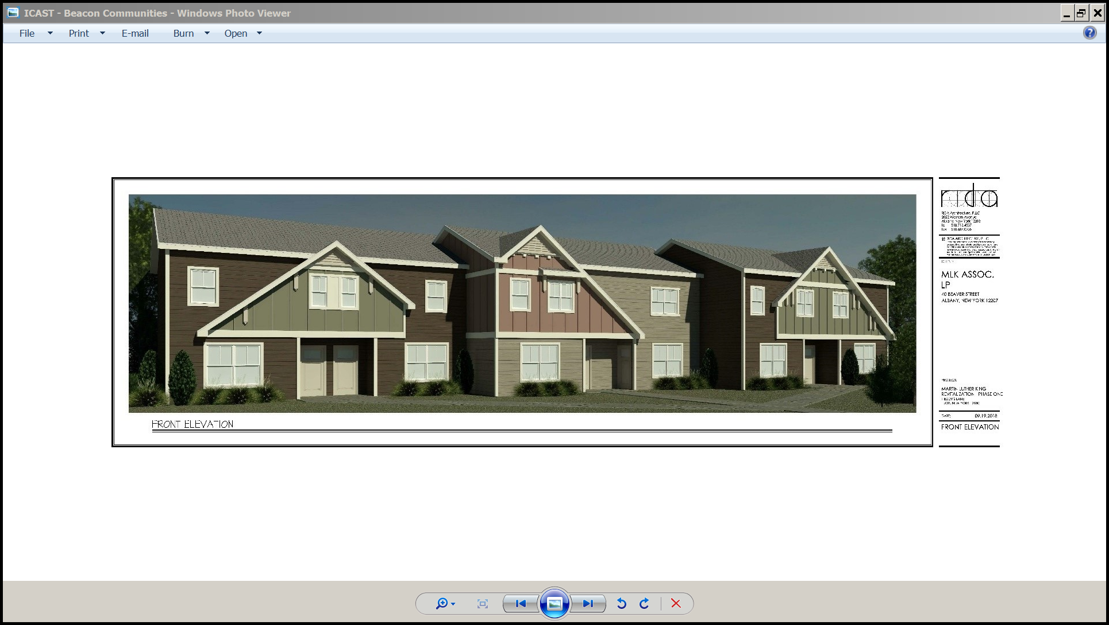

(Click on image to access the Rendering)

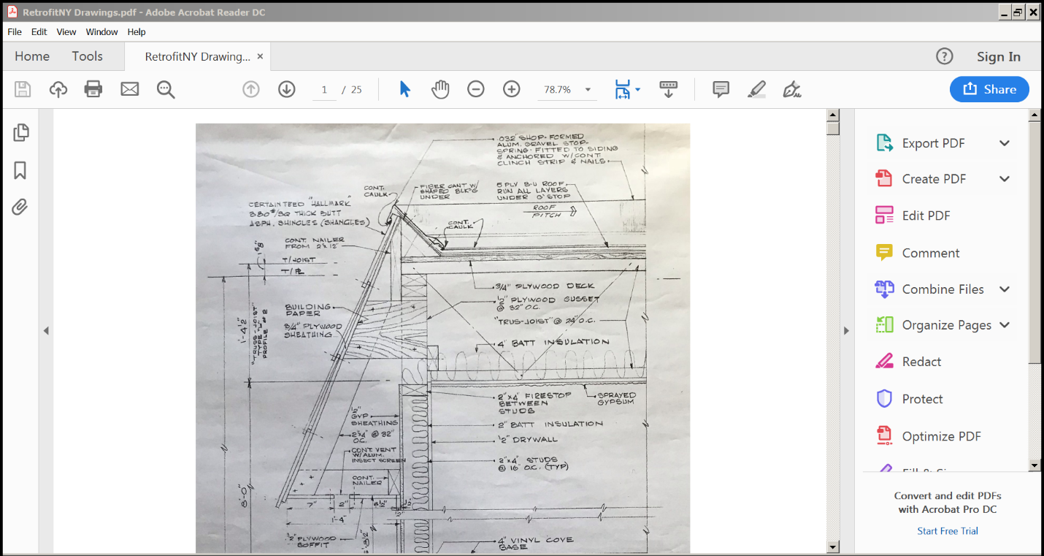

(Click on image to access the Design Documents)

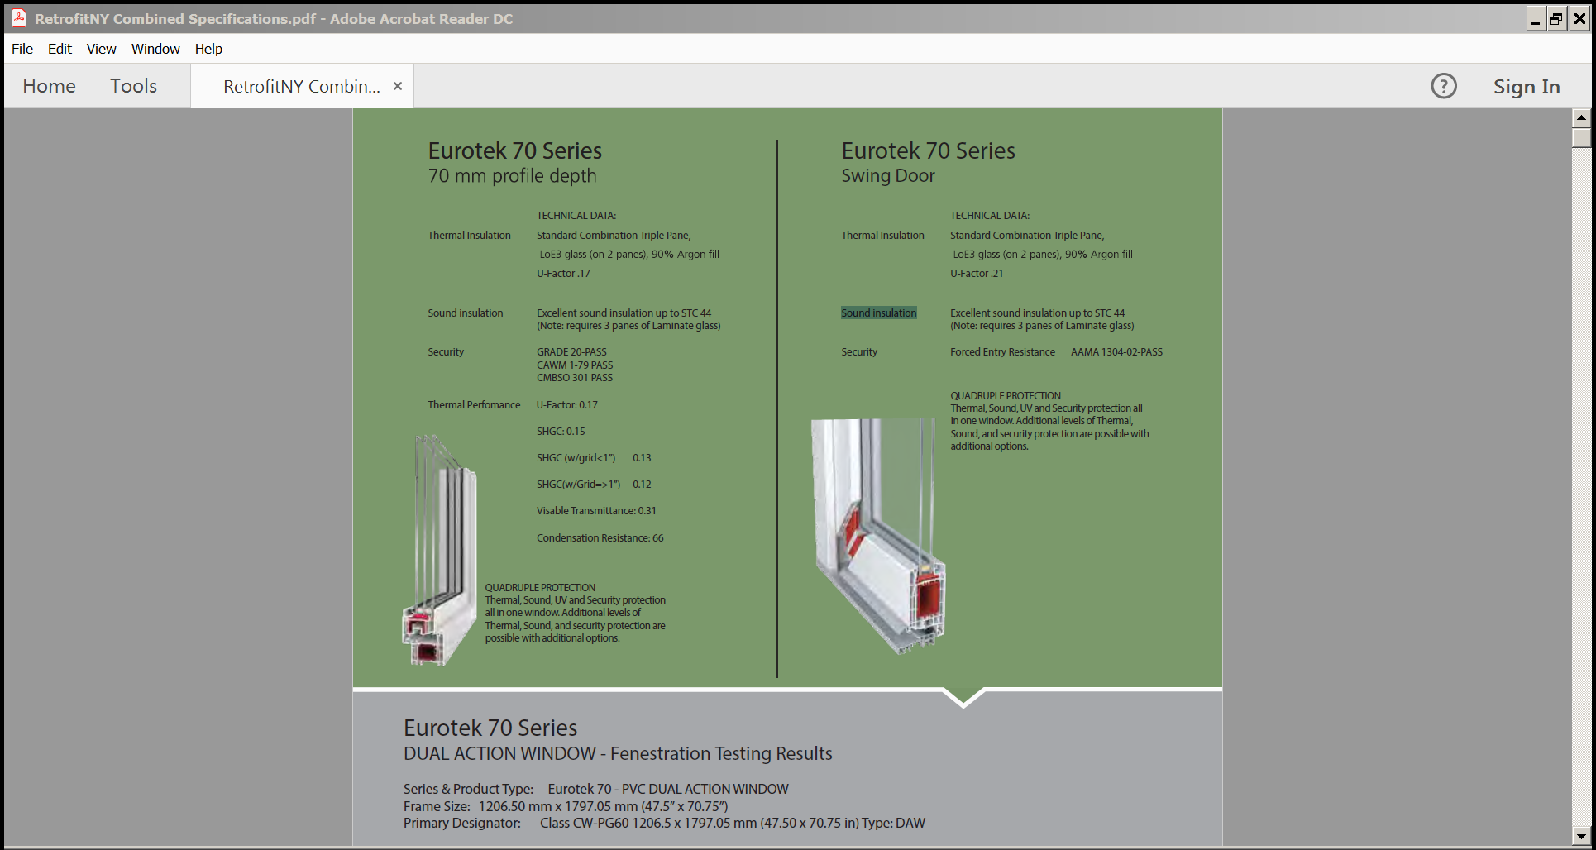

(Click on image to access the Preliminary Specifications)

Appendix B. Scalability Strategy

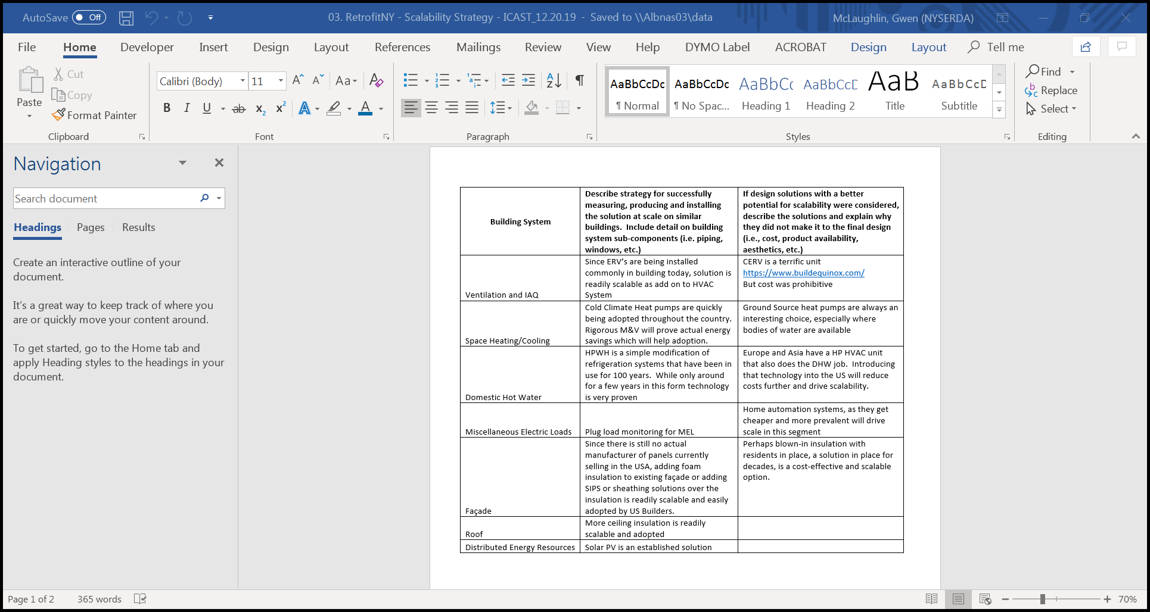

(Click on image to access the Scalability Strategy)

Appendix C. Budget and Financing Plan

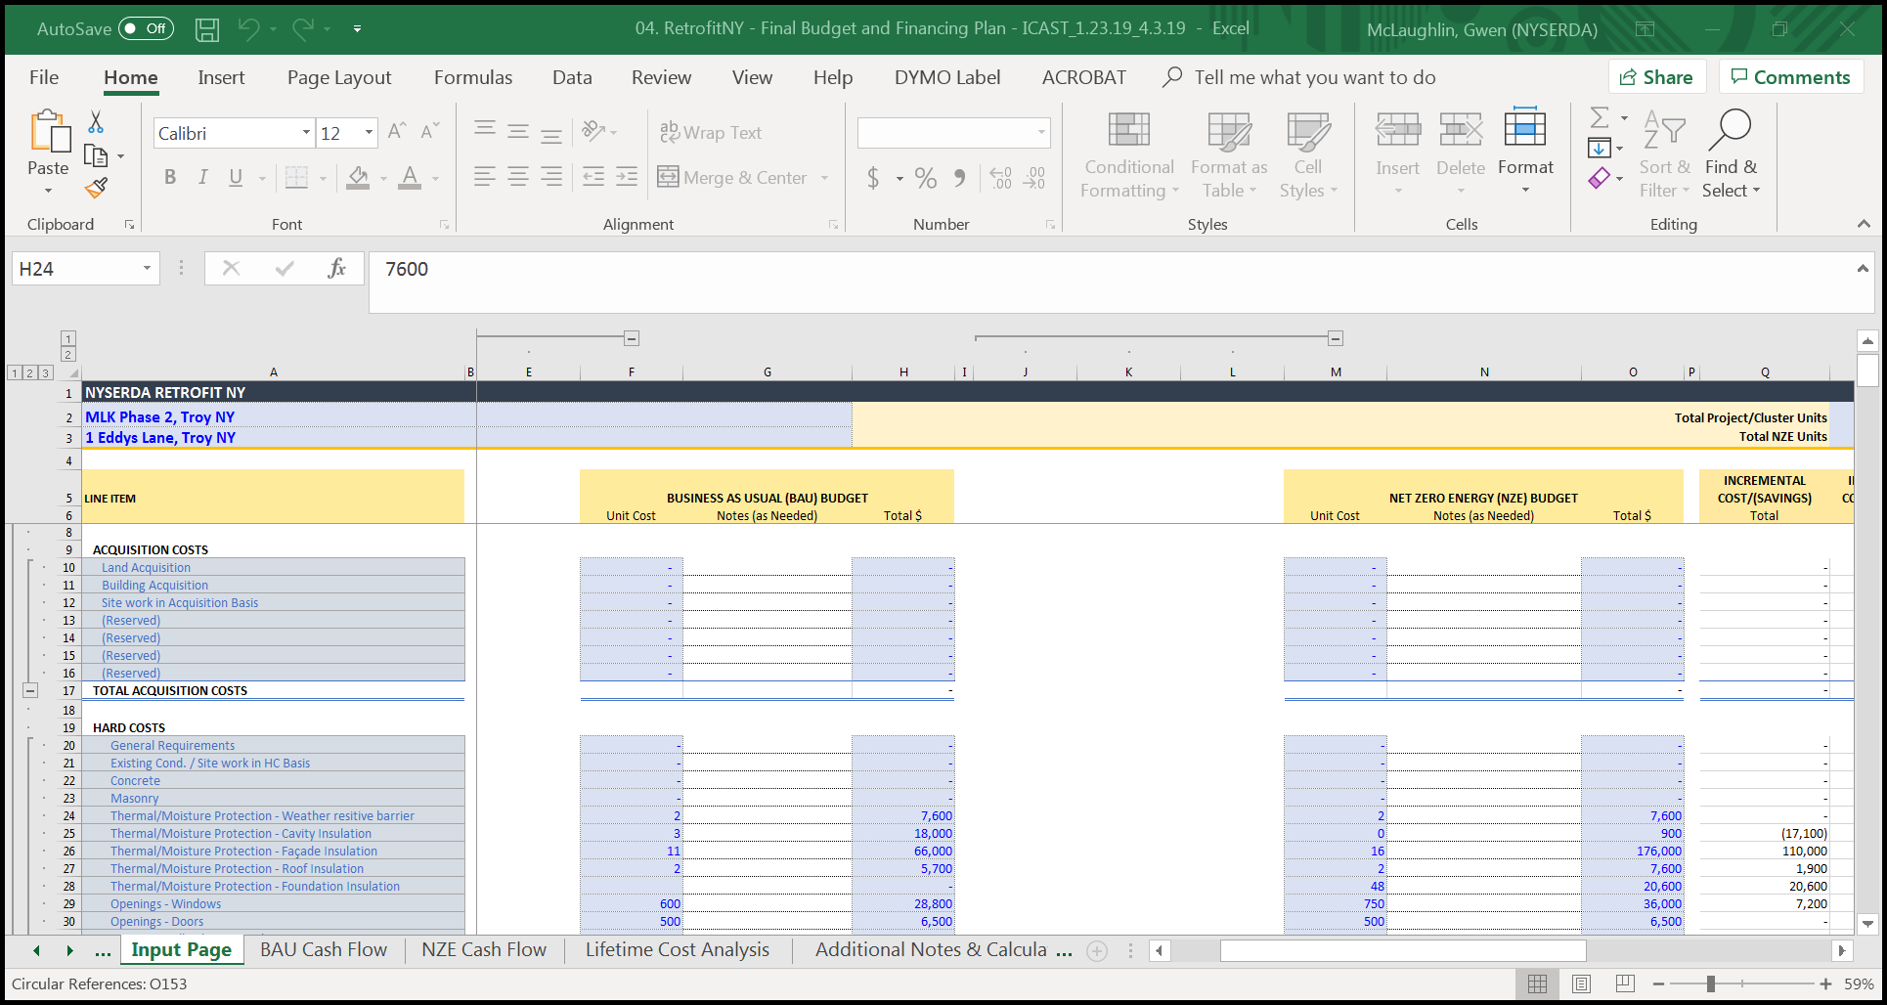

(Click on image to access the Budget and Financing Plan)

Appendix D. Projected Construction Schedule

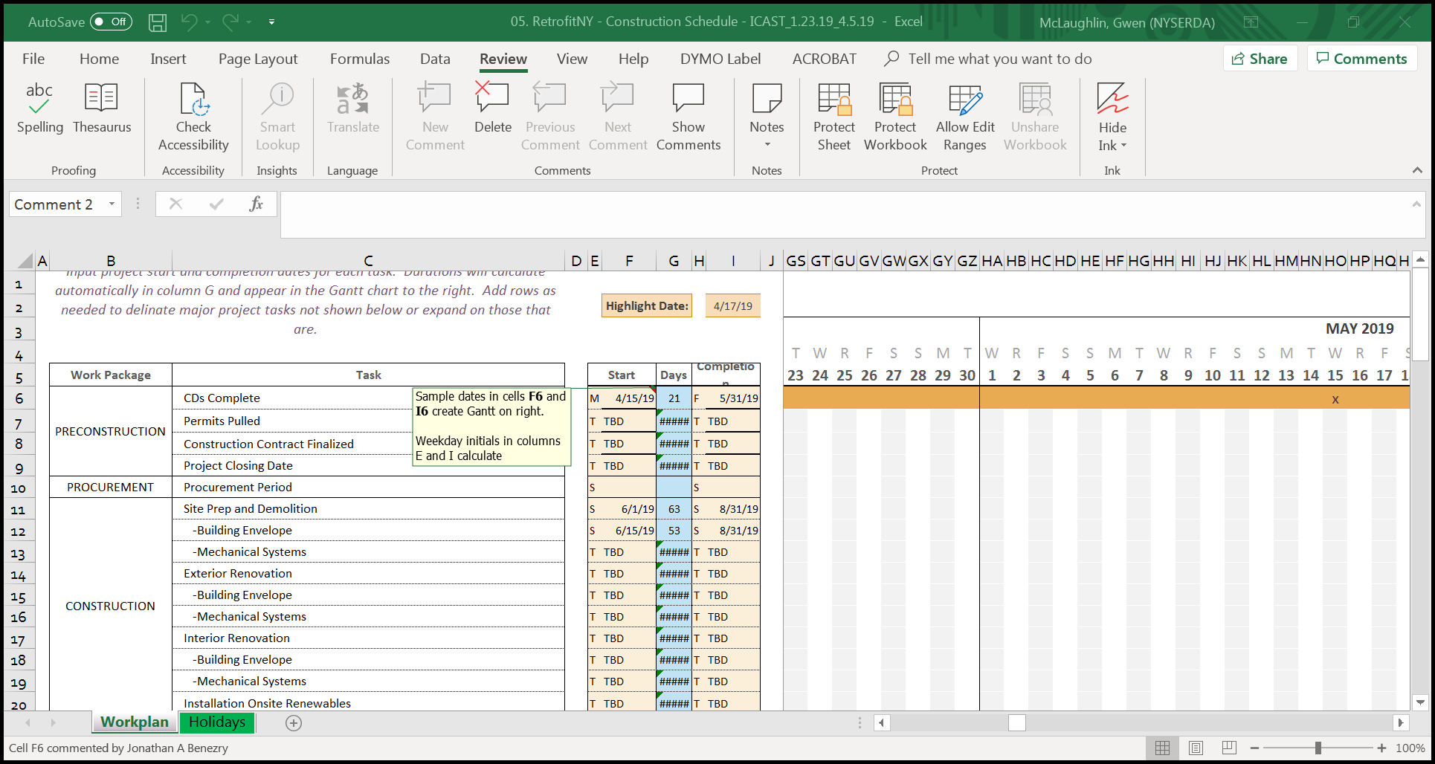

(Click on image to access the Projected Construction Schedule)

Appendix E. Building Performance Summary

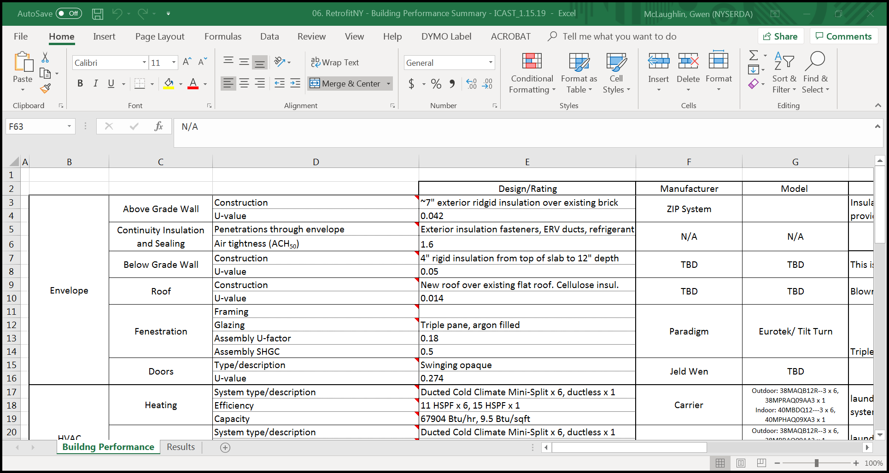

(Click on images to access the Building Performance Summary and Modeling Report)

Appendix F. Resident Management Plan

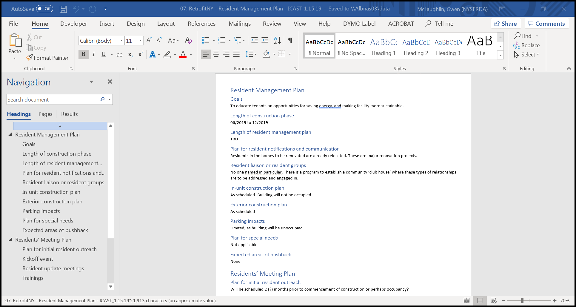

(Click on image to access the Resident Management Plan)

Appendix G. Performance Guarantee Pathway

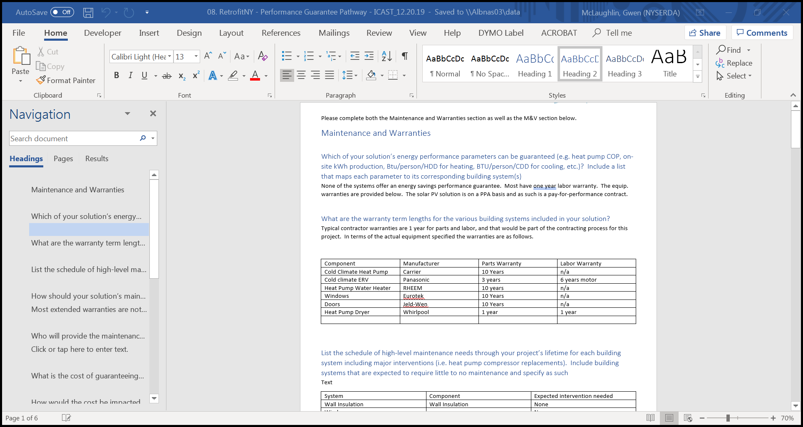

(Click on image to access the Performance Guarantee Pathway)

Appendix H. Regulatory Barrier Summary

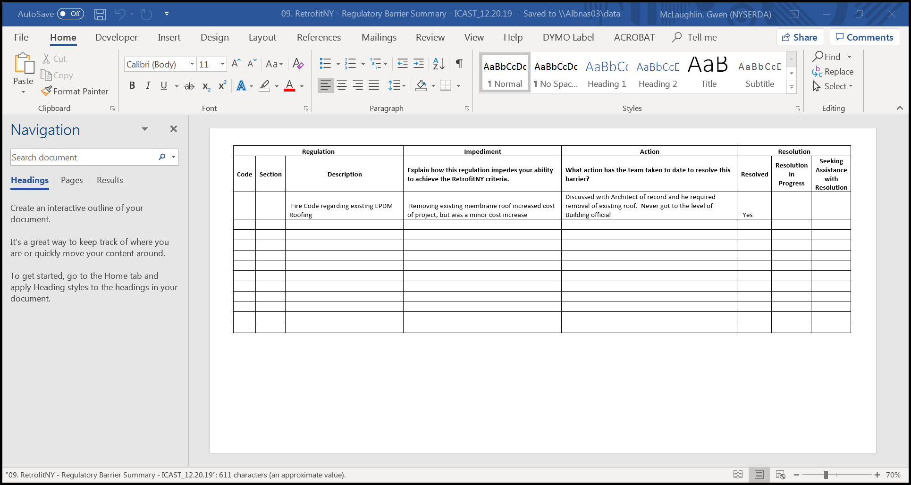

(Click on image to access the Regulatory Barrier Summary)

Appendix I. Resiliency Summary

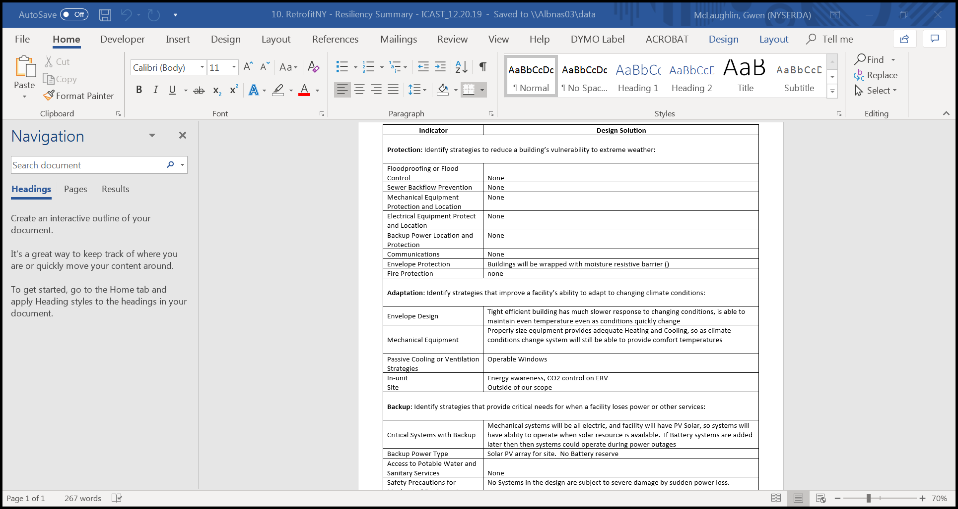

(Click on image to access the Resiliency Summary)

Appendix J. Resident Health Impact Summary

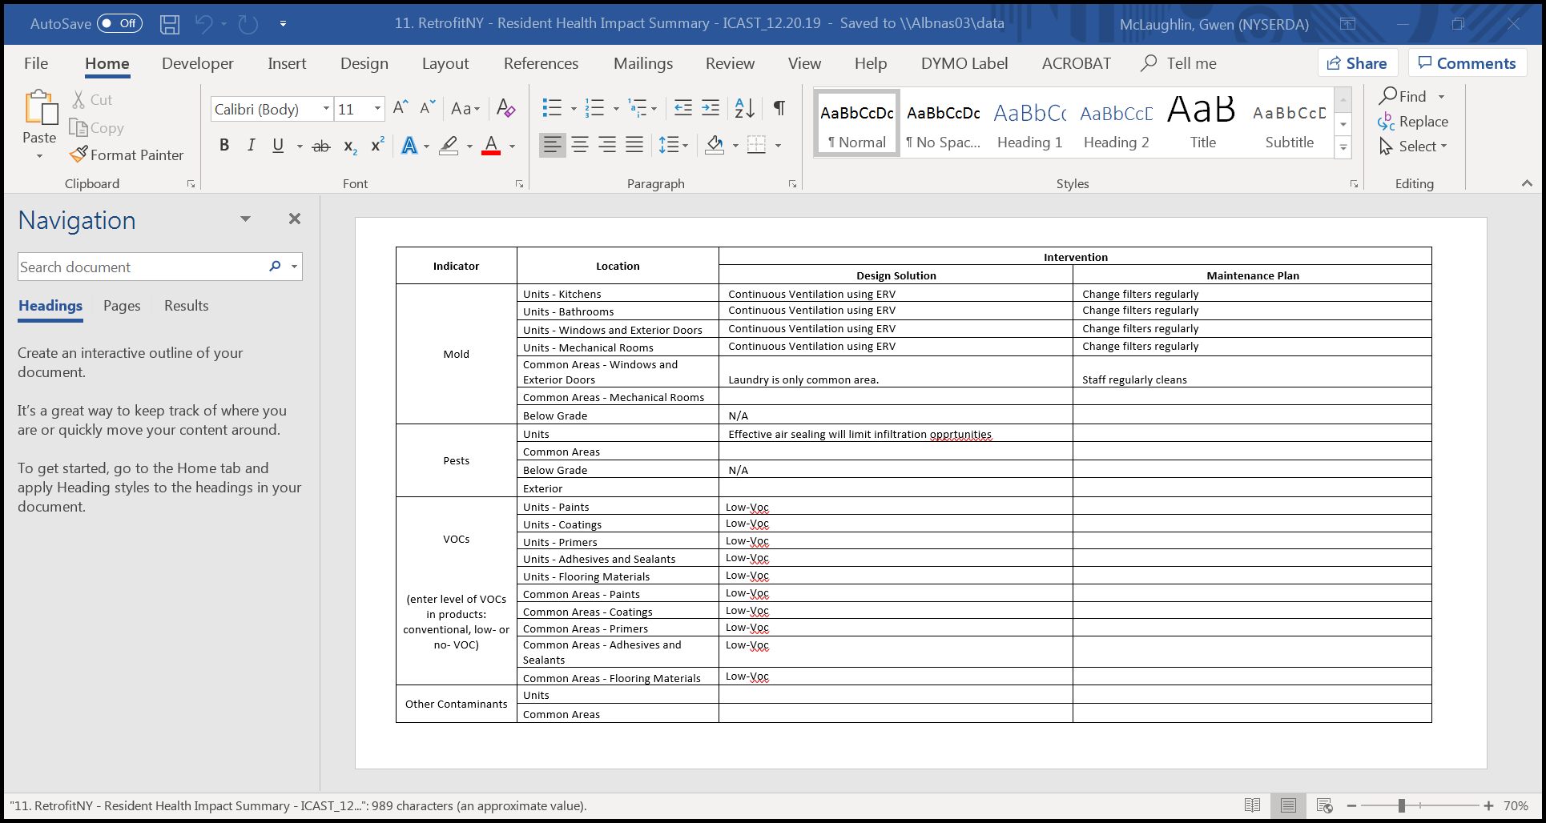

(Click on image to access the Resident Health Impact Summary)

Appendix K. Overall Rehab Proposal

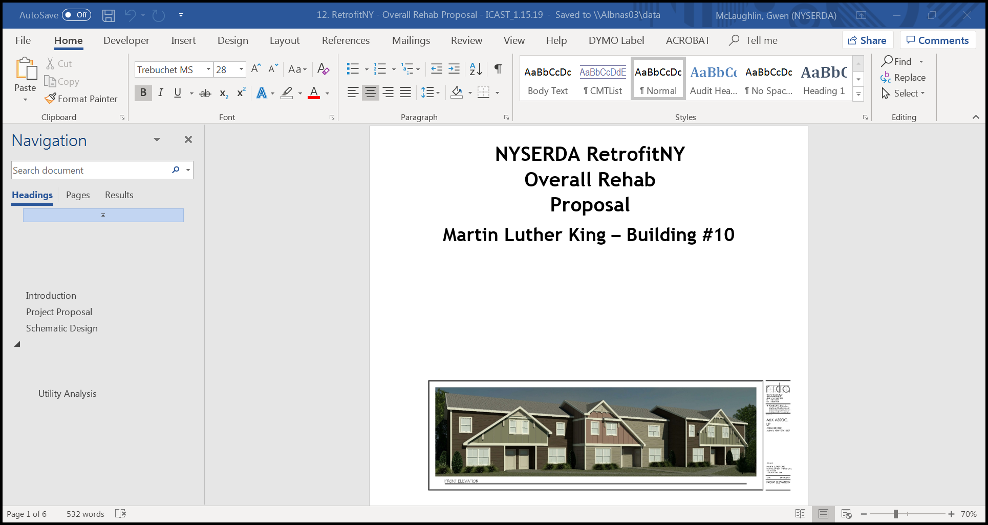

(Click on image to access the Overall Rehab Proposal)

Appendix L. RetrofitNY Energy Simulation Report

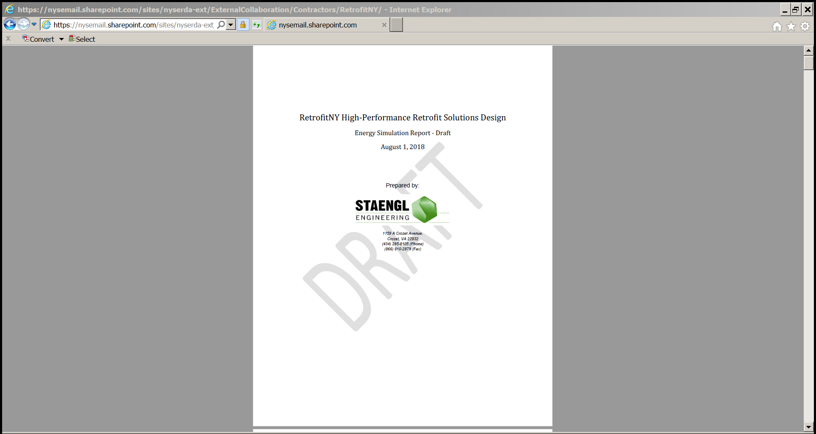

(Click on image to access the RetrofitNY Energy Simulation Report)