Photo Release
I hereby grant to NYSERDA, its employees, clients, legal representatives, and assigns, those for whom NYSERDA is acting, and those acting with its authority and permission, the absolute right and permission to copyright, in NYSERDA’s own name or otherwise, and use and re-use still/video pictures of me or in which I may be included, in whole or in part, without restriction, in conjunction with my own or a fictitious name, or reproductions thereof in color or otherwise, made through any medium, and used in any and all media now or hereafter known for illustration, promotion, art, advertising, trade, or any other purpose whatsoever, in perpetuity and on a worldwide basis.
I hereby waive any right that I may have to inspect or approve the finished product or products and the advertising copy or other material that may be used in connection therewith or the use to which it may be applied.
I release, discharge and agree to hold harmless NYSERDA, its employees, clients, legal representatives, and assigns, and all persons acting under its permission or authority or those for whom it is acting, from any liability by virtue of any blurring, distortion, alteration, optical illusion, or use in composite form, whether intentional or otherwise that may occur or be produced in the use of my likeness as provided above, including without limitation any claims for libel or invasion of privacy.
I hereby warrant that I am of full age and have the right to contract in my own name and grant these rights without violating the rights of any third party. I have read the above agreement, prior to its execution, and I am fully familiar with the contents thereof. This agreement shall be binding upon me and my heirs, legal representatives, and assigns.
Signature: ____________________________________ Address: _____________________________________
Print Name: ____________________________________ _____________________________________
Date: ____________________ _____________________________________
If the signatory is a minor, the following section must be completed by a parent/guardian:
I, the parent/guardian of the minor who has signed above, consent to the terms of this Photo Release with respect to that minor.
Signature: ____________________________________ Address: _____________________________________
Print Name: ____________________________________ _____________________________________
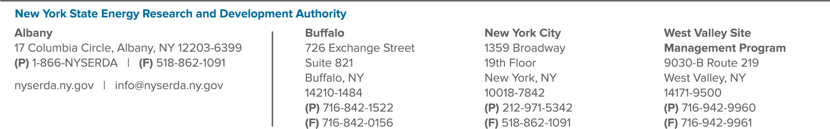
Date: ____________________ _____________________________________

