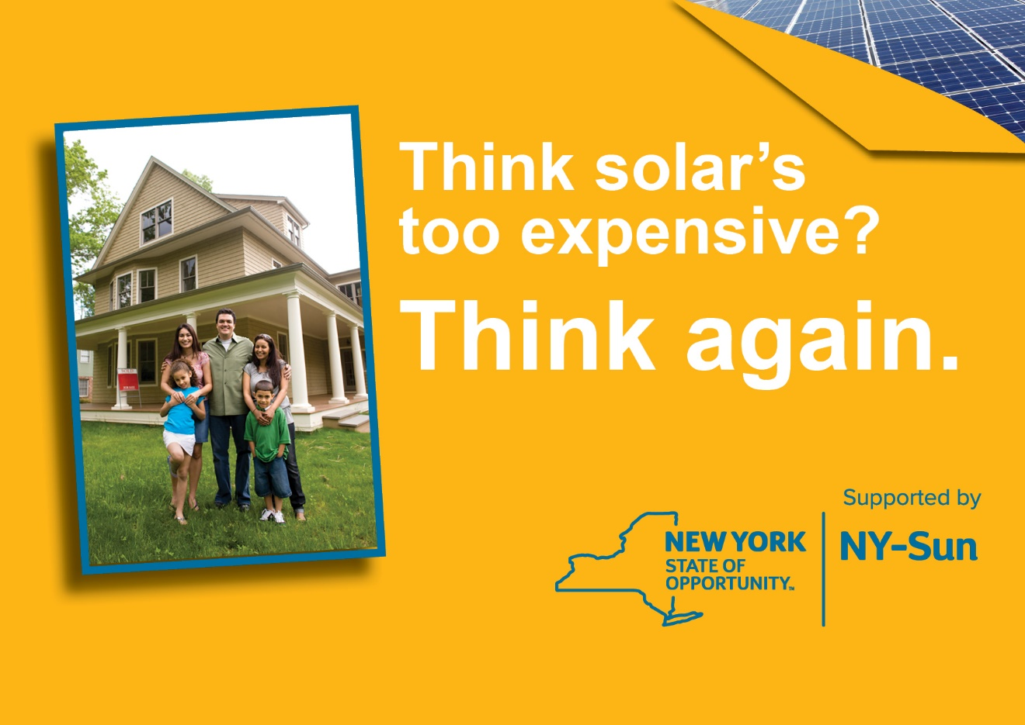

**www.websitegoeshere.com**

Solarize

[insert municipality]

• Save thousands of dollars on   
 your installation

• No-Money Down options

• Pre-selected, competitively-  
 chosen installer

• [Town/City/Village] &   
 NYSERDA approved

For a **FREE** no-obligation site   
visit, contact:

[insert solar contractor name,

phone number, and email]

*You must sign a contract by [insert end date] to qualify.

**[www.website.com]**