- Contractor Registration
Prior to submitting applications for incentive funding, applicants must be a participating contractor in the Program. To become a Participating Contractor in the NY-Sun Performance-Based (>200kW) Program an Applicant must complete an Application form on which you agree to abide by the terms and conditions in the Participation Agreement included with the Application package and fulfill one of the following credentialing paths:
- Provide three reference letters for commercial-scale projects completed in the past two years that, in aggregate, sum to at least 500kW. These must be verifiable references for specific projects and be accompanied by a brief description of the systems installed and the applicant’s role in the project, or
- Indicate that your organization has successfully completed a PV project under any of the prior Customer Sited Tier Competitive PONs that has been reporting data to the NYSERDA DG Integrated Data System website for at least three months. See: http://chp.nyserda.ny.gov/facilities/index.cfm?Filter=Solar
Note that a webinar is planned for February 2015 to walk through the process, share documents and provide guidance on the registration process.
- Incentive Application Process
Once you become a participating contractor your organization will be provided access to the NY-Sun Performance-Based (>200kW) Program Powerclerk online applications database. With this access, registered participants can submit applications for project incentives in either of the two tracks described below. All project applications include an application for incentive funding (generated from information input into Powerclerk) and project specific documentation (uploaded to Powerclerk). This project specific documentation will be similar to what has been required in previous Competitive PV PONs. Applications also must include additional documentation related to the application track they choose as described below. NYSERDA, at its discretion, will audit documents submitted in project applications.
- Track One – Project Maturity
In addition to the documentation required for all applications, projects applying under the Project Maturity Track must also provide:
  - An attestation confirming that there is a fully executed binding financial agreement to develop the PV project between the developer and the electric customer, and
  - Interconnection application with completion of Investor Owned Utility (IOU) preliminary review including determination of interconnection viability. If a CESIR is required then the CESIR cost estimate must also be provided, and
  - An attestation that applications have been submitted for all required jurisdictional permits (unless a CESIR is required).
However, if IOU response from Item 2 above indicates a CESIR is required, then the incentive application must also include confirmation from the IOU of receipt of payment to conduct the CESIR. Additionally, no later than 180 days from date of the NYSERDA approved application for funding, contractors must provide a) an executed New York Standardized Contract for interconnection and b) confirmation from the IOU of receipt of advance payment for the estimated interconnection costs per NY State Standardized Interconnection Requirements and Application Process as well as c) an attestation that applications have been submitted for all required jurisdictional permits. If these three items are not provided, then the contract with NYSERDA will be deemed in default and the awarded incentive rescinded.
- Track Two – Application Security
In addition to the documentation required for all applications, projects applying under the Application Security Track must also provide:
  - Interconnection application with completion of IOU preliminary review including determination of interconnection viability. If a CESIR is required then the CESIR cost estimate must also be provided, and
  - An attestation that the developer and electric customer have, at a minimum, signed a Letter of Intent to develop the PV project that includes all items listed in Appendix A of this document, and
  - Application Security equal to 15% of total incentive in Zones A-H and 10% of total incentive in I&J, or $25/kW of system size, whichever is greater.
- All Application Security amounts must be provided in the form of (a) certified funds, or (b) an irrevocable stand-by letter of credit, payable to NYSERDA, and drawn on an institution acceptable to NYSERDA. See Appendix B for a sample letter of credit.
- Amounts provided by the Contractor as Application Security will be returned or refunded to the Contractor by NYSERDA in their entirety when the Contractor provides NYSERDA with proof of project completion as outlined in Section III.A (Project Completion) below.
- Applications under Track Two must provide all of the following within 9 months of the date of the NYSERDA approved application for funding otherwise the incentive will be rescinded and the amounts provided as Application Security will be retained in their entirety by NYSERDA:
      - Signed and notarized attestation that confirms a binding financial agreement between the developer and electric customer that follows the form provided in Appendix C of this document
      - An executed New York Standardized Contract for interconnection and, if required, confirmation of receipt from the IOU of advance payment for the estimated interconnection costs per NY State Standardized Interconnection Requirements and Application Process.
      - Proof of Application for all jurisdictional permits

- Project Completion

- Applications under either Track One or Track Two must be installed, interconnected, and operational no later than 18 months from the date of the NYSERDA approved application for funding otherwise the incentive will be rescinded and any amounts provided as Application Security will be retained in their entirety by NYSERDA. Proof of completion must include:
  - Inspection report verifying system size, operational status, and conformation with NEC Code that has been conducted by either a NYSERDA contractor or by a licensed professional engineer (PE) including the PE stamp; and
  - A copy of either an official letter on the IOU letterhead or an email directly from an IOU representative providing approval for the photovoltaic system at the site address for operation and interconnection to the grid.
- A one-time project completion deadline extension of 6 months will be granted once all required timelines and deliverables identified in Section II (Incentive Application Process) above are met and the Contractor provides:
  - Proof of major equipment procurement in the form of copies of the bills of lading for all panels, inverters, and racking equipment necessary to complete the construction of the entire system accompanied by onsite photographs of this equipment. The bills of lading and photographs must demonstrate that this equipment was delivered to the project site; and
  - Extension security equal to $50/kW of system size.
- All Extension Security amounts must be provided in the form of (a) certified funds, or (b) an irrevocable stand-by letter of credit, payable to NYSERDA, and drawn on an institution acceptable to NYSERDA. See Appendix B for a sample letter of credit.
- Amounts provided by the Contractor as Extension Security and Application Security (if applicable) will be returned to the Contractor by NYSERDA in their entirety when the Contractor provides NYSERDA with proof of project completion as outlined in Section III.A (Project Completion) above within 24 months from the date of the NYSERDA approved application for funding.
Projects with an approved extension of the completion deadline must provide NYSERDA with proof of project completion as outlined in Section III.A (Project Completion) within 24 months from date of the NYSERDA approved application for funding otherwise the incentive will be rescinded and the amounts provided as Extension Security and Application Security (if applicable) will be retained in their entirety by NYSERDA.

- Additional Guidelines
- Project applications are limited to one host meter per application. A host meter is the location where the PV system will be interconnected to the utility meter. If multiple host meters are present then multiple systems may be eligible for incentives under separate applications.
- An individual project site cannot exceed 10% of the total MWs in an individual block in ROS and 30% of an individual block in ConEd.
- Total award is based on 3 years of PV System Estimated Annual Energy Production at a 13.4% capacity factor for grid interconnected projects that displace utility (investor-owned or public) provided electricity at the incentive level associated with the Block in which the project application is approved by NYSERDA. Total award is divided into four payments with the first payment of 25% of total award at installation and the remaining 75% of total award disbursed across three years as performance payments based on measured annual production. Refer to the Incentive Estimator on the NY-Sun website. (http://ny-sun.ny.gov/-/media/NYSun/files/Meetings/2014-12-19/MW-Block-Incentive-Estimator.xlsx)
- Incentives are provided for systems (or the portion of a system) that offset no greater than 110% of the customer’s historical annual grid supplied electric usage. Starting with Block 3, incentives will be limited to 90% of annual historical usage except for:
  - projects that demonstrate planned load growth as shown by PE or IOU documentation, or
  - load served by PV project is a net-zero building(s) as shown by PE or NYSERDA documentation
- Projects sited in IOU-identified strategic locations receive the incentive level of the current block plus 20%
- Site and/or customer substitutions no longer allowed
- Assigning an executed contract to a different contractor under the NY-Sun Program involves cancelling the active contract and creating a new contract at the incentive level of the current block.
- PV projects receiving or selected to receive awards under any other NYSERDA PON, RFP or Program are not eligible to receive incentives under NY-Sun Incentive Program for those projects. Contractors are not permitted to nullify an active NYSERDA contract in order to apply to the NY-Sun Performance-based (>200kW) Program for the same project. Project sites and offtaker meters awarded under PON 2956 are not eligible to participate in the first block of the NY-Sun Performance-based (>200 kW) Program.
- NYSERDA will monitor Program activity and share this information on the NY-Sun website in order for stakeholders to monitor current Program status.
- NYSERDA will conduct regularly scheduled NY-Sun Stakeholder meetings throughout the duration of the program in order to gain stakeholder feedback on program activity and market conditions. This input will be taken into consideration when making adjustments to the MW block design, if warranted. Stakeholders will be notified at least one full block in advance of any planned changes. The first of these meeting will be in June 2015 with subsequent meetings approximately every six months thereafter.

Appendix A
Required Items for Track Two Application Letter of Intent

In order for the Letter of Intent to be acceptable to NYSERDA it must be dated no later than 6 months prior to application, contain all of the items listed in this Attachment, and be signed by the Contractor, the electric customer, and the site owner (if applicable). Please note that all information provided in the Letter of Intent must be consistent with all the information provided in the project application in order for the application to be accepted by NYSERDA.
- Date
- Applicant
- Customer
- Site Address
- System Size (kW)
- System type (ground mount, roof, mount, canopy, dual axis, etc)
- Identify, at a minimum, the following members of the project team: Solar Developer, Equity Investment Partners, and EPC Contractors.
- Statement that the system will be grid-connected, displace utility provided electricity, and that the IOU has completed a preliminary interconnection review.
- If project is sited in a Strategic Location include a statement that the Strategic Location has been confirmed by the IOU.
- Statement confirming customer acknowledgement that this Letter of Intent is for the purposes of applying for funding through NY-Sun and that the Applicant is granted a period of exclusivity (of at least 12 months) to develop this project (size, type, and location).
- Statement confirming that the customer and developer will provide proof of a binding agreement to develop and install this project within 9 months of the application for incentive being accepted by NYSERDA.
- Statement acknowledging that both parties are aware that in compliance with Orders issued by the New York State Public Service Commission, NYSERDA and the NYS Department of Public Service hold all rights, for the life of the project, to the environmental attributes associated with all of the energy produced from a project receiving incentive funding through NY-Sun.
- If one of the parties to this letter is not the owner of the project site, then the entity that owns the project site must also sign this letter of intent indicating that they are aware of the intention to construct a PV system at the project site.
- A statement indicating that the conditions at the project site have been assessed and are such that site preparations customary in the solar industry will be sufficient to prepare the site for the PV system.
- If the project is a roof mounted system, then this letter must include a statement indicating that a roof inspection has been conducted and that condition of the roof is acceptable to support the size and weight of the PV system. If the roof inspection reveals that repairs to the roof are necessary in order to support the size and weight of the system, then a statement must be included indicating that the developer and customer have received a cost estimate for the necessary roof repairs and that the installation of the PV project (including any roof repairs) can be completed within 18 months of the application being accepted by NYSERDA.

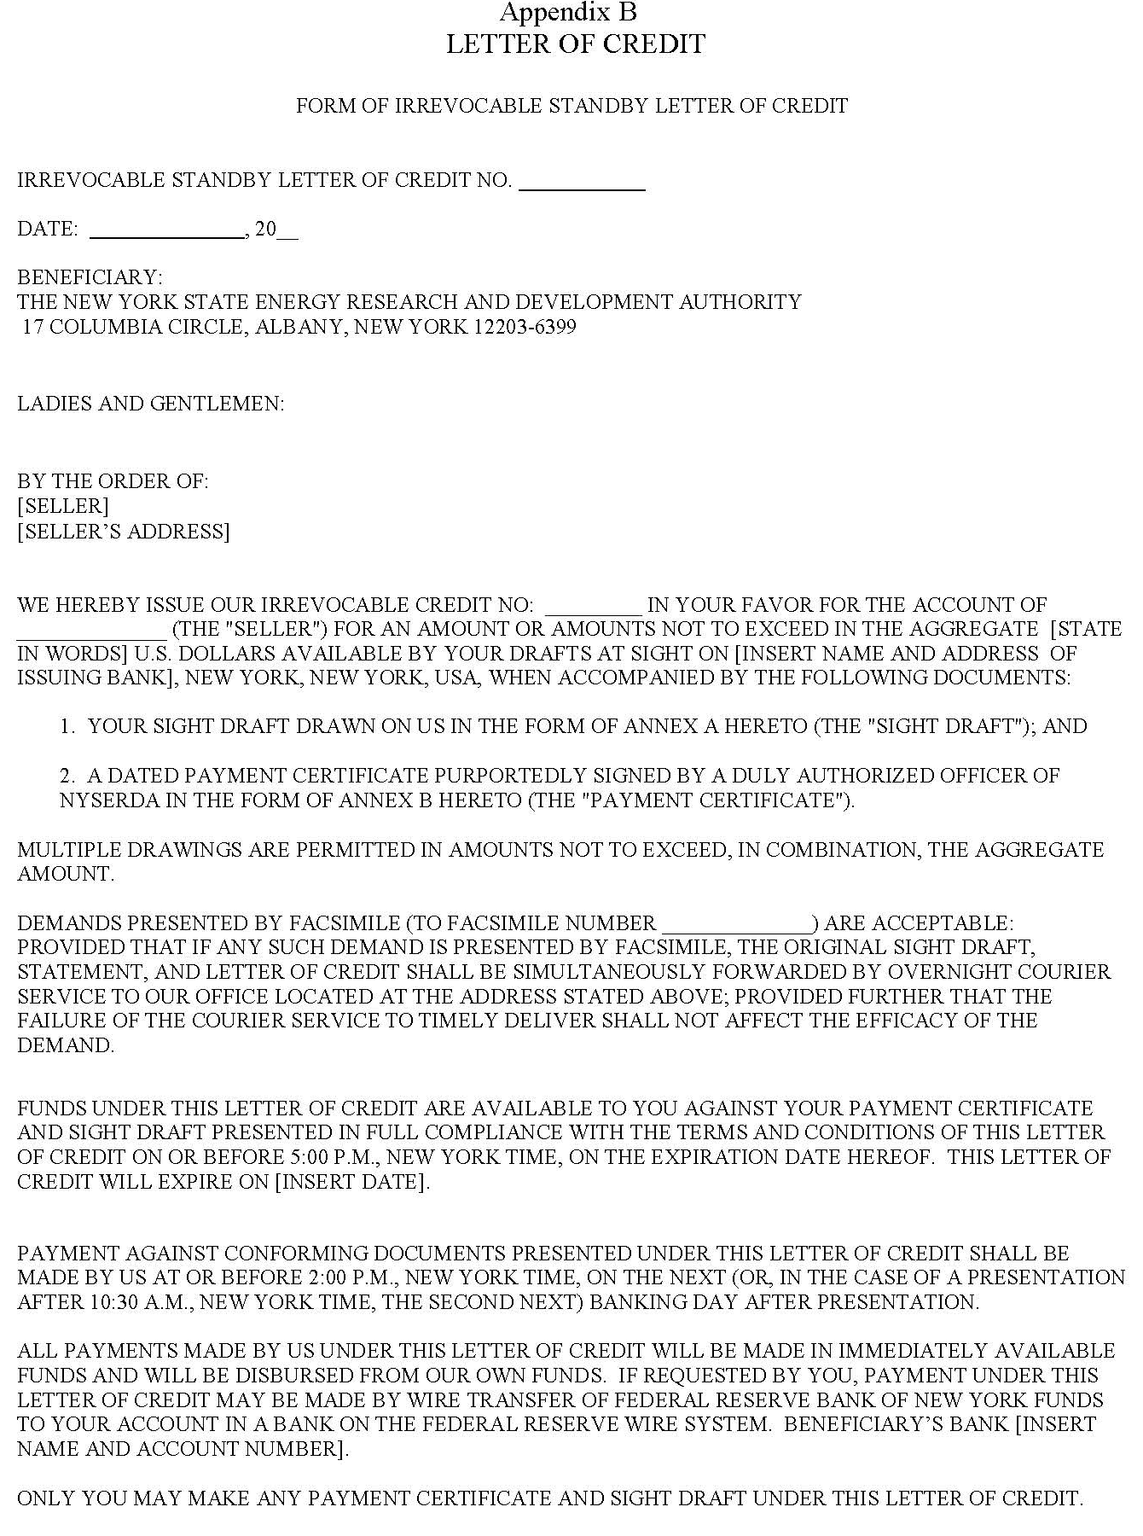

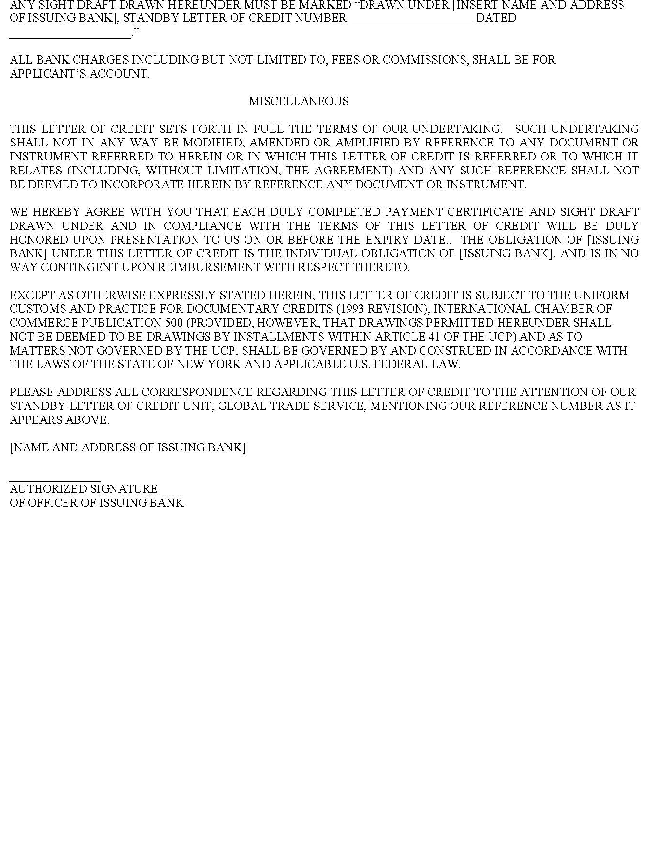

Appendix C
Attestation of Solar Services Agreement and/or Power Purchase Agreement between <<Developer>> and <<Electric Customer>>
Date
<<Developer name>> (“Developer”) has agreed to develop and install a <<size>> kW <<roof-mount, ground-mount, canopy, combination>> system. Electricity output from the System will be used to offset the electric usage of <<Electric Customer name>> (“Electric Customer”). The System will be located at <<street address, city, state, zip code>> and will be interconnected with <<IOU>>. The terms and conditions of ownership of the System and/or sale the electricity output from the System have been agreed upon by the Developer and Electric Customer in a formal written and signed legally binding agreement dated <<date agreement was signed>>. Both parties acknowledge that the purpose of this attestation is to satisfy one of the application requirements of the NY-Sun Performance-based (>200kW) Program and that the amount of incentive funding available is dependent upon the date when a complete and accurate application for funding is received by NYSERDA.
In compliance with Orders issued by the New York State Public Service Commission, NYSERDA and the NYS Department of Public Service hold all rights, for the life of the project, to the environmental attributes associated with all of the energy produced from a project receiving incentive funding through NY-Sun.
We hereby attest that we have entered into a current, valid, and binding financial agreement for Solar Services and/or Power Purchase for the purposes of constructing, financing, and/or purchasing the electricity output of a <<size>> kW grid-connected solar PV system (“System”) to be located at <<street address, city, state, zip code>>.
By signing, all parties acknowledge that they have read and understand the above information and requirements and agree to abide by them.
IN WITNESS WHEREOF, the Parties hereto declare that the above statements are true and accurate to the best of their knowledge.

DEVELOPER ELECTRIC CUSTOMER
By By
Date Date
Name Name
Title Title

