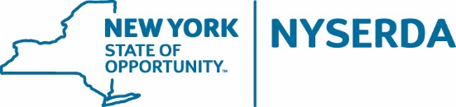

Build-Ready Market Advisory Group Meeting
Thursday, February 16, 2023, 11:00 AM – 1:00 PM
Discussion Summary

The Build-Ready Program held a virtual Market Advisory Group (MAG) meeting on Thursday, February 16, 2023 from 11:00 AM – 1:00 PM. The purpose of the meeting was to provide an update on the Build-Ready Program’s first project Request for Proposal (RFP) for the BR Benson Mines Solar PV Project (BR Project 1 LLC), to review the responses to a survey that was circulated to MAG participants prior to the meeting, and to discuss questions related to the upcoming auction. The participants included representatives from solar development companies that responded to the Build-Ready Program Request for Information 5034 and requested to participate in the Program’s voluntary MAG. The following document summarizes the participant questions and NYSERDA answers provided during the MAG meeting.
Will an EPC contractor be identified by NYSERDA? No, the bidders will need to identify an EPC contractor (or potential contractors) as part of the Step One qualification round and confirm the EPC contractor in the Step Two Bid Proposal.
How will the Fixed REC Price / Index REC Strike Price be set, to allow developers to determine the development fee? NYSERDA clarified that Build-Ready will provide a fixed development fee value in the RFP. Bidders will incorporate the development fee into their pro forma for developing the project and submit a Fixed REC Price or Index REC Strike Price in their Step Two bid proposal. NYSERDA has made well informed estimates and assumptions regarding project cost, but it’s up to the developer to determine and set their REC Price.
Is NYSERDA developing other projects in addition to Benson? How many? Yes, NYSERDA is developing other projects in addition to Benson. There are about a dozen projects advancing that Build-Ready will auction through subsequent solicitations. For this first auction, NYSERDA is only auctioning one project, Benson Mines. In subsequent auctions, NYSERDA seeks to auction more than one project at a time.
What is NYSERDA looking for in terms of a team bidding approach? How specified does the team need to be in the Bid Proposal, just potential partners or executed teaming / JV agreements? NYSERDA has not fully resolved this question and is interested in the MAG’s perspective on what is reasonable to require / encourage when. Typically, NYSERDA is used to seeing a teaming agreement executed at the stage of the process when the RFP is tendered, but given the length of that process NYSERDA may not require it.

