Clean Energy Tax Credit Implications from the One Big Beautiful Bill Act (OBBBA)
The One Big Beautiful Bill Act (OBBBA) was signed into law on July 4th, 2025, rescinding or revising some programs established in the Inflation Reduction Act of 2022. This document outlines the key changes to the clean electricity investment tax credit (CEITC) and the clean electricity production tax credit (CEPTC). General changes to CEITC and CEPTC credits are described in the following pages.
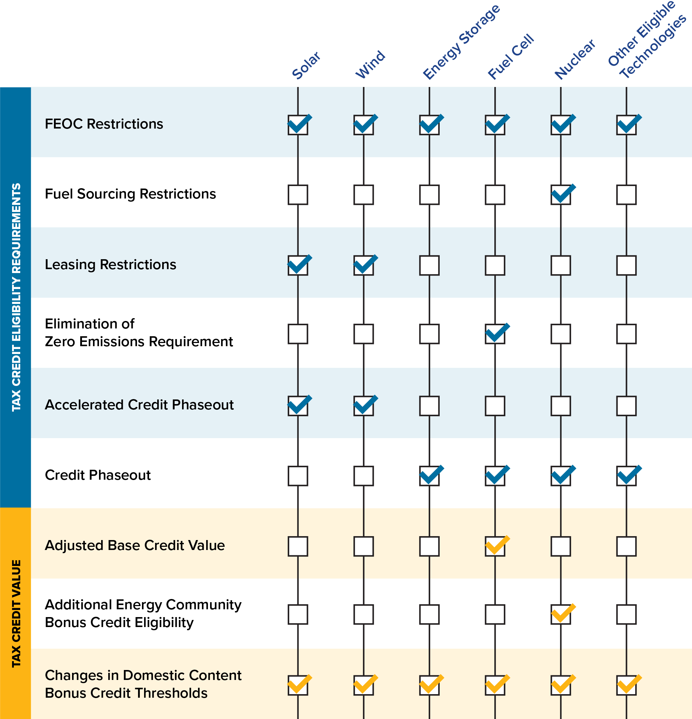

Technology-Agnostic Changes

Foreign Entities of Concern (FEOC) Restrictions
Projects that begin construction after December 31, 2025, will be deemed ineligible for CEITC/CEPTC tax credits if they do not meet the new foreign entity of concern (FEOC) restrictions:
Procurement: Projects meet the Material Assistance Cost Ratio (MACR) threshold:
  - $MACR=\frac{Total Cost of Goods - Cost of PFE\text{-}Sourced Goods}{Total Cost of Goods }$
  - Projects must exceed the MACR thresholds defined for each technology and start date of construction.
Ownership: The project taxpayer cannot be a Prohibited Foreign Entity (PFE). PFEs are entities (e.g. individuals, organizations, or businesses) that are tied to adversarial nations to the United States, and is comprised of:
  - Specified Foreign Entities (SFE) refers to entities that are identified as national security risk, including but not limited to: entities designated as foreign terrorist organizations; entities with ties to covered nations (North Korea, China, Russia and Iran); and entities involved in activities resulting to national security convections.
  - Foreign Influenced Entities (FIE) are entities that have a certain legal and financial control by an SFE, including but not limited to: entities with significant ownership by SFEs (at least 25% from a single SFE and/or at least 40% from multiple SFEs); entities under effective control by an SFE; entities with over 15% of its debt owned by SFEs; and entities where SFEs have the authority to appoint covered officers. Effective control occurs when SFEs provide payments to the entity that grant them authority over component selection, energy production, and energy storage.

Domestic Content Bonus Credit Thresholds
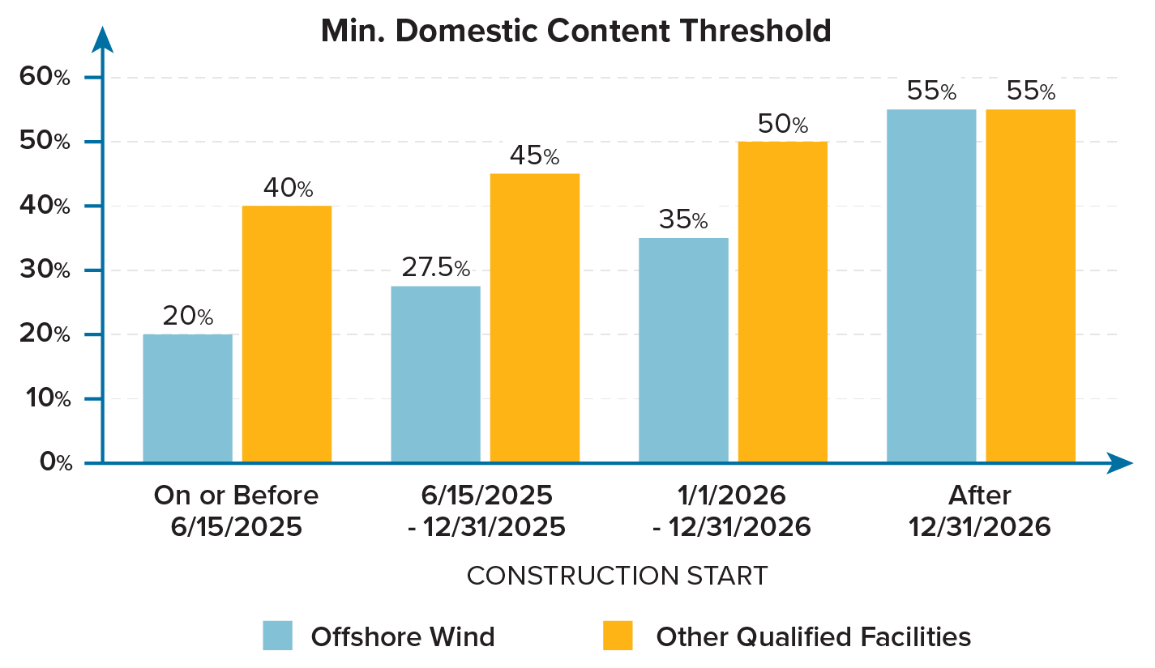
The graphic below shows the minimum domestic content threshold percentages for manufactured products needed to receive CEITC and CEPTC bonus credits based on the start of construction.

Technology-Specific Changes
The OBBBA contains provisions that are specific to the credit value available, financing conditions, emission standards, and phaseout for different clean energy technologies. A summary of key technology-specific changes is contained in the following table.
Solar and wind projects experience the greatest changes from the OBBBA. Projects that do not begin construction prior to July 4, 2026 must be placed in service by December 31, 2027 in order to qualify for the CEITC or CEPTC. Solar and wind projects exceeding 1.5 megawatts (MW), measured in alternating current, beginning construction after September 1, 2025 must rely on the Physical Work Test to determine the start of construction. Both on-site and off-site work will be considered when the IRS evaluates whether the Physical Work Test requirements have been met. Off-site work includes the manufacturing of required components and will be recognized if the work is being done in accordance with a binding written contract and components are not stored in a manufacturer’s inventory. Preliminary activities such as design, planning, geotechnical work, removing existing equipment at the site, and site clearing will not be considered eligible on-site work. Once construction begins, projects must demonstrate continuous progress on construction or be placed in service within four calendar years to remain eligible for clean energy credits.
 | Examples of Physical Work of a Significant Nature for Solar Facilities |  | Examples of Physical Work of a Significant Nature for Wind Facilities
On-Site Activities
Installation of Racks  to Affix Photovoltaic Panels to a Site |  |  | Excavation for the Foundation
Installation of Structures  to Affix Collectors and/ or Solar Cells to a Site |  |  | Setting of Anchor Bolts into the Ground
Construction of Access Roads or Drainage Ditches |  |  | Pouring of Concrete Pads for the Foundation
Off-Site Activities
Manufacturing of Components
Manufacturing of Mounting Equipment
Manufacturing of Support Structures
Manufacturing of Other Power Conditioning Equipment

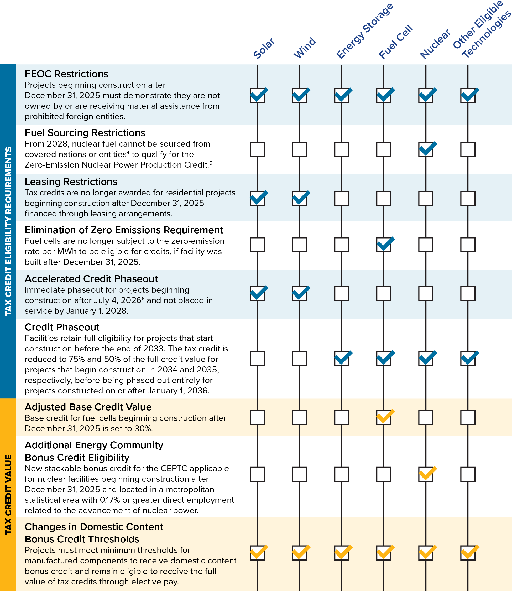

Key Dates From the OBBBA
The graphic below presents a timeline of the changes to the clean energy credits in the OBBBA. Most of the changes are enacted in the 2026 tax year. Generally, technologies have a complete phase out of credits by the end of 2035 (with the exception of solar and wind).
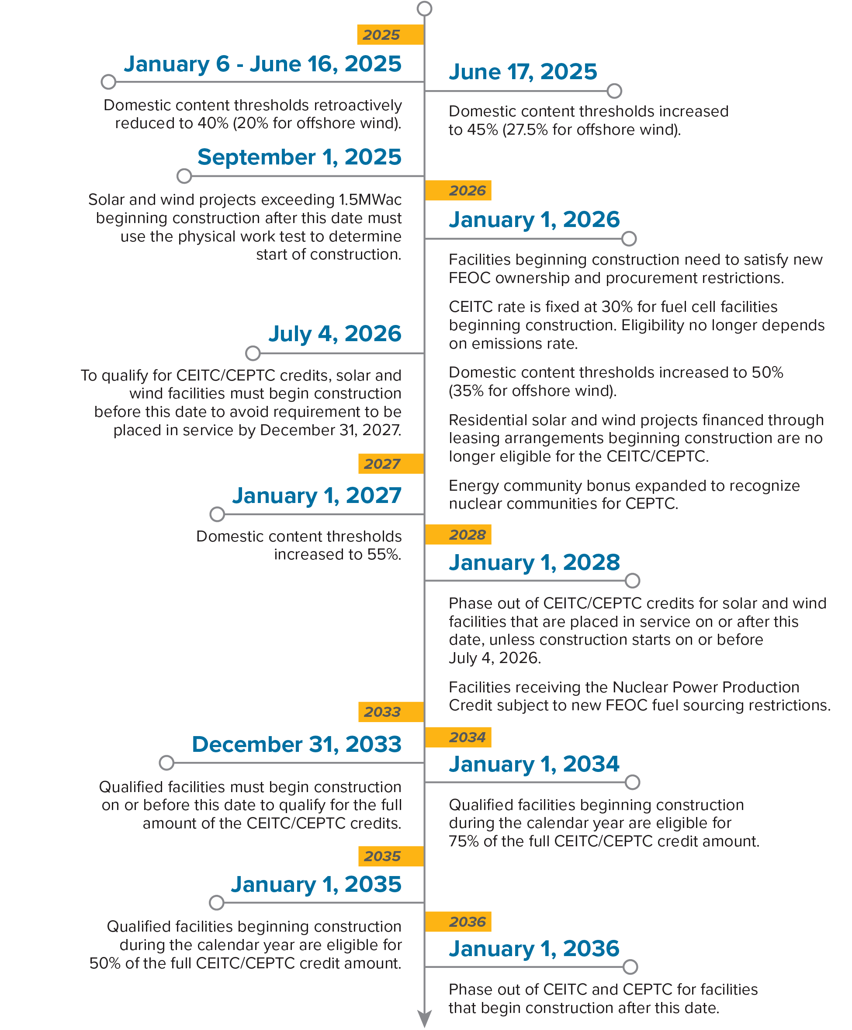

“One Big Beautiful Bill Act” signed into law: Clean energy credits and new FEOC/ Prohibited Foreign entity rules
The Physical Work Test requires physical work of a signature nature related to the manufacturing, construction or production of the applicable facility to begin. There is no minimum amount of work or monetary percentage to meet this test. Further details found here: Sections 45Y and 48E Beginning of Construction Notice
Allowable disruptions to construction include severe weather, labor stoppages, inability to obtain specialized equipment, supply shortages or delays in permitting, interconnection requests, manufacturing of custom components, or financing.
Unless acquired under a binding contract in force prior to January 1, 2023. Covered entities include North Korea, China, Russia, and Iran.
The Zero-Emission Nuclear Power Production Credit is separate from the CEPTC as it only applies to existing facilities operational before August 16, 2022, and aims to preserve electricity generation of existing facilities: congress.gov/crs_external_products/IN/HTML/IN12557.web.html
Beginning of construction is recognized as either the Five Percent Safe Harbor rule (for projects less than 1.5MWac or projects that begin construction prior to September 2, 2025) or the Physical Work Test (for projects greater than 1.5MWac that begin construction after September 1, 2025).

