Multifamily Simulation Guidelines

For NYSERDA Multifamily Programs

April 2026
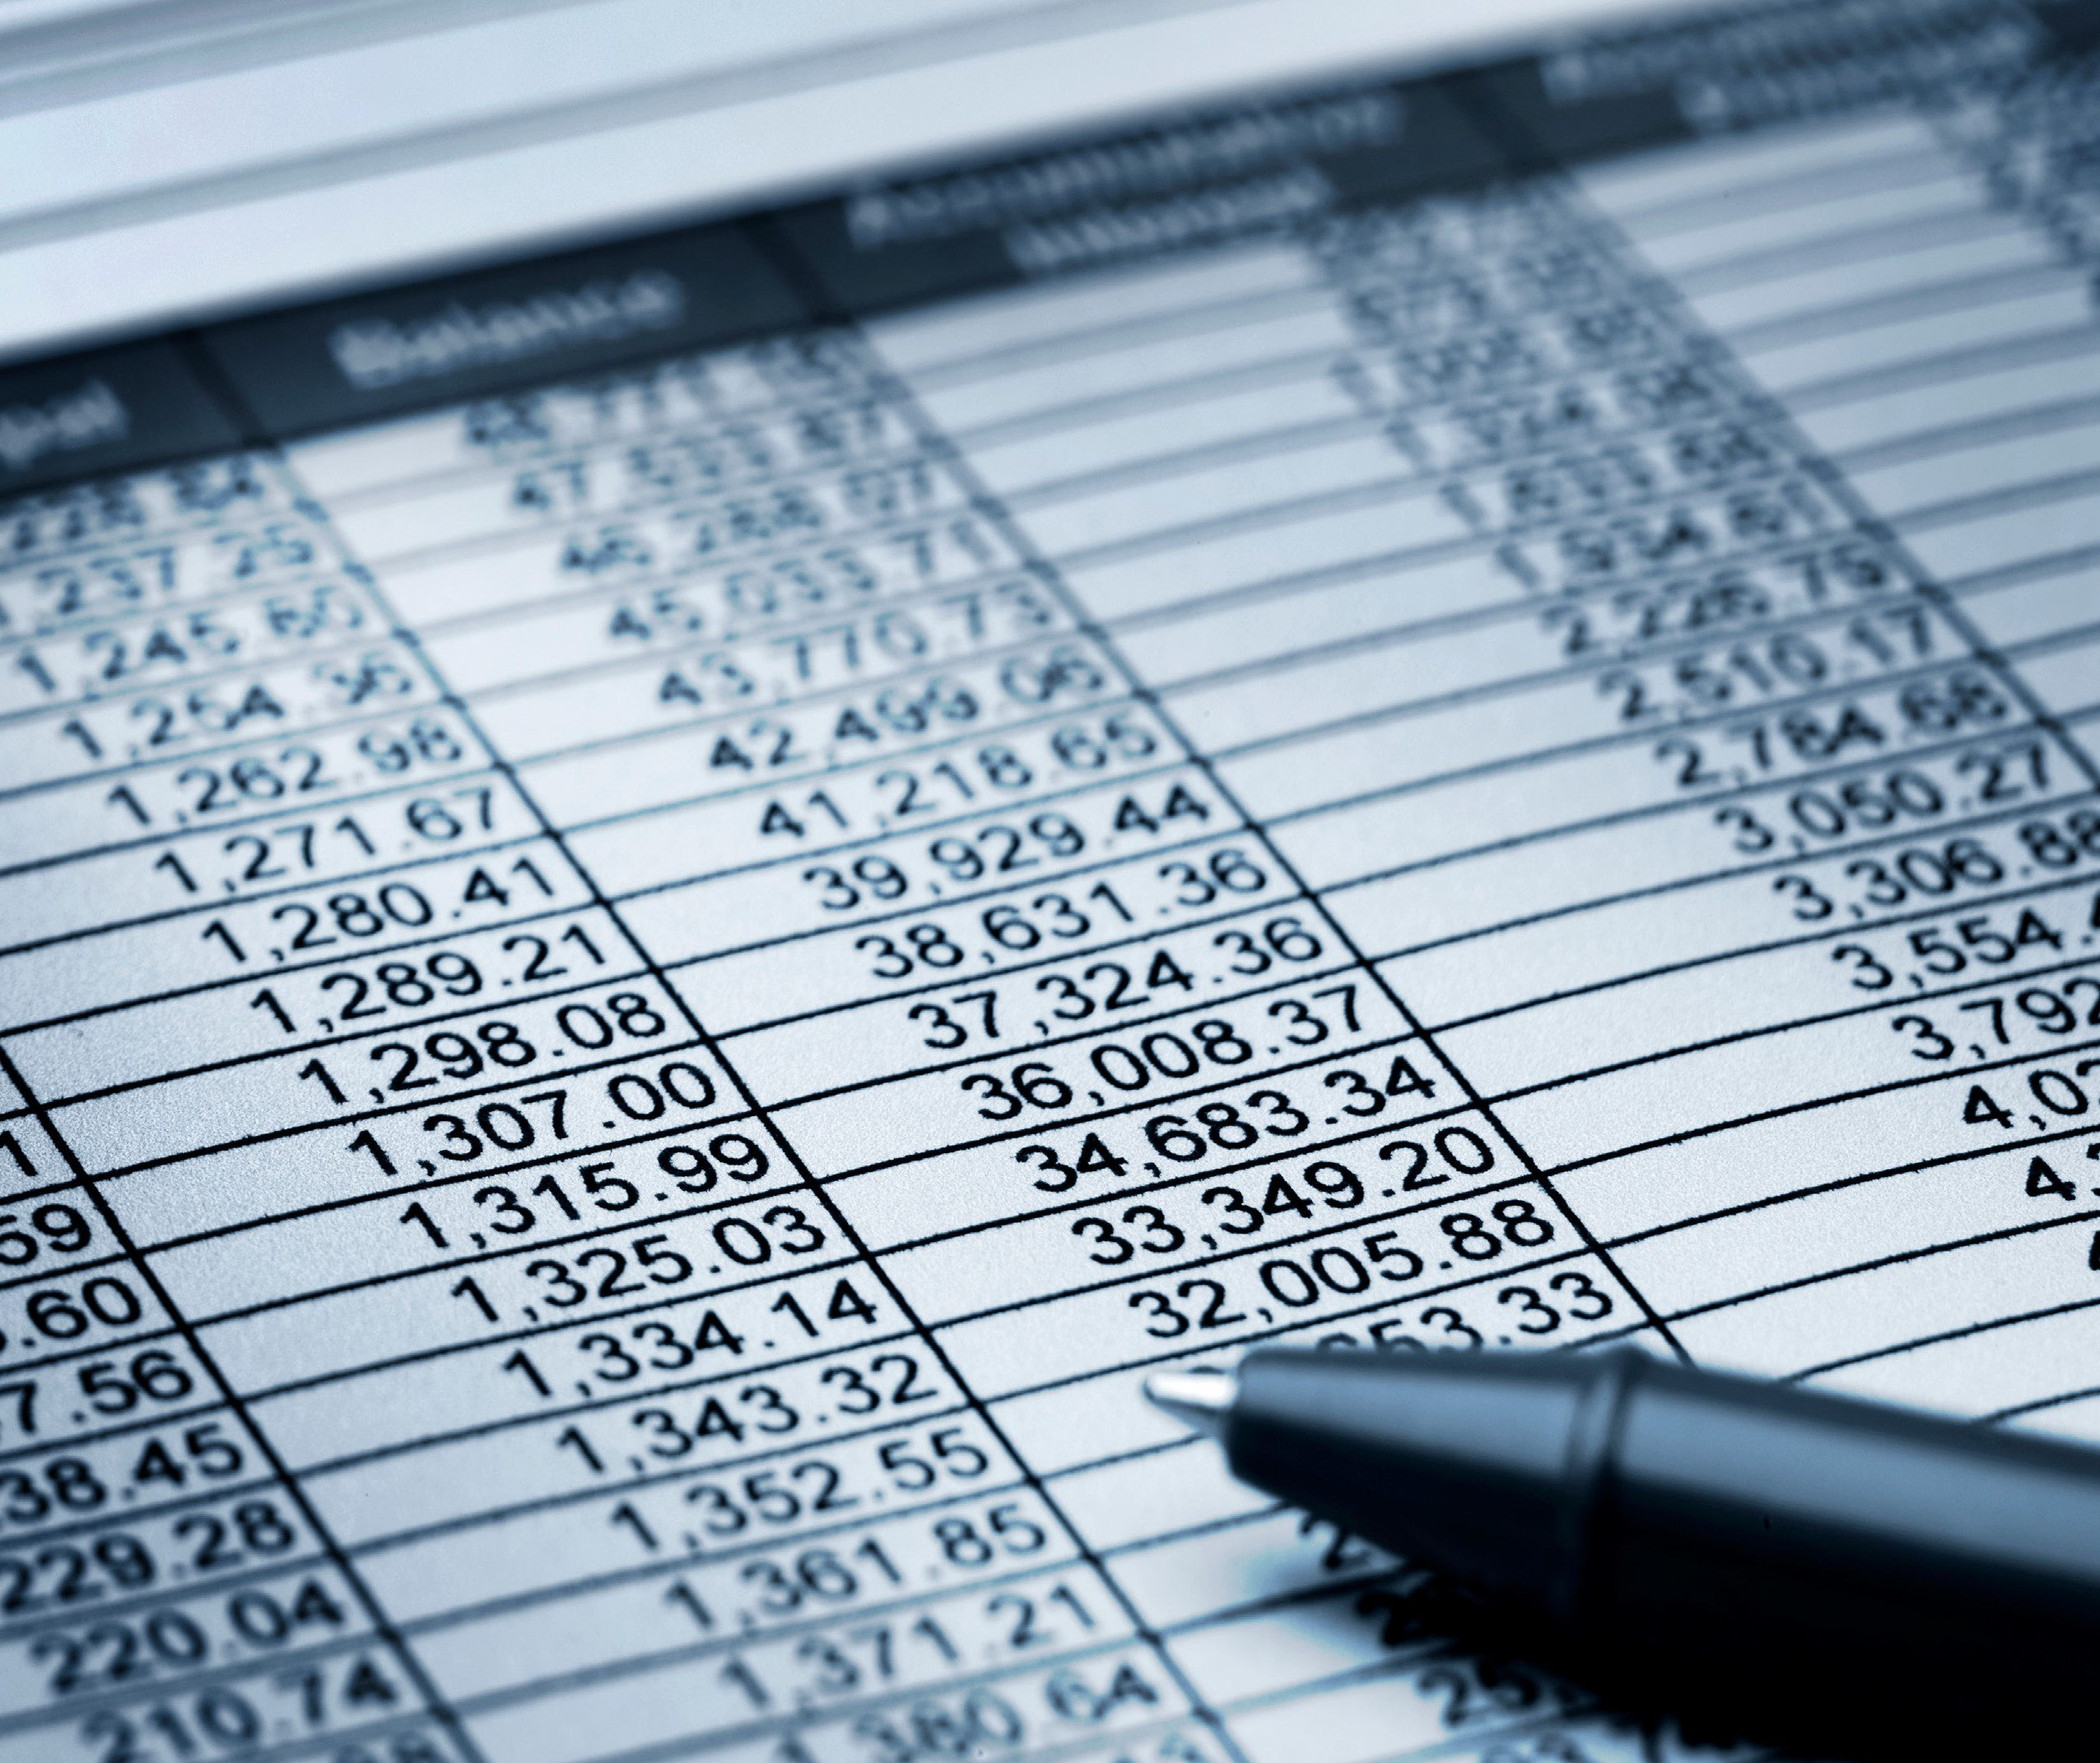

Multifamily Performance Program Simulation Guidelines For Multifamily Building Service Providers
Publish Date: April/2026

  - Copyright Notice
Copyright © YYYY by New York State Energy Research and Development Authority. All rights reserved. No part of this document may be reproduced in any form without the permission of the copyright owner.
Information contained in this document, such as web page addresses, are current at the time of publication.
All inquiries should be addressed to:
New York State Energy Research and Development Authority
17 Columbia Circle
Albany, NY 12203-6399

  - Keywords

  - Record of Revision
Revision Date | Description of Changes | Revision on Page(s)
Month YYYY | Provide a brief description of what changed in the manual for the new revision. | Example:  5  25-40
January 2026 | Initial Publication | N/A

Table of Contents
Multifamily Performance Program Simulation Guidelines For Multifamily Building Service Providers 2
Copyright Notice 2
Keywords 2
Record of Revision 2
1. Scope and Objectives 6
2. General Approach 7
3. Simulation Software 9
4. Model Calibration 11
4.1 General Approach 11
4.2 Calibration Requirements 14
5. Thermal Zones 15
6. Heating and Cooling Systems 17
6.1 Heating Equipment 17
6.1.1 General 17
6.1.2 Existing Conditions 21
6.1.3 Improvements 23
6.2 Cooling Equipment 24
6.3 Distribution System 24
6.3.1 Variable Frequency Drives (VFD) 24
6.3.2 Steam Distribution Improvements 25
7. Heating/Cooling Temperature Schedule 28
7.1 Existing Conditions 28
7.2 Improvements 29
8. Air Infiltration and Mechanical Ventilation 31
8.1 Mechanical Ventilation 31
8.2 Pre-retrofit Infiltration 32
8.3 Interaction between Infiltration and Mechanical Ventilation 33
8.4 Infiltration Reduction Improvements 34
8.5 Modeling Approach 35
9. Lighting 36
9.1 General 36
9.2 Existing Conditions 36
Table 9-1. In-Unit Lighting 37
Table 9-2. Common Area Lighting 37
9.3 Improvements 37
10. Envelope Components 40
10.1 Surfaces 40
10.2 Fenestration 41
10.2.1 Existing Condition 41
10.2.2 Proposed windows 41
11. Domestic Hot Water 42
11.1 Domestic Hot Water Heating Systems 42
11.1.1 Water Heating Equipment Categories 42
11.1.2 Water Heating Equipment Performance Characteristics 42
11.1.3 Evaluating Performance of the Existing Water Heaters 43
11.2 Existing DHW Demand 44
11.2.1 Clothes Washers 46
11.2.2 Dishwashers 47
11.3 DHW Improvements 47
11.3.1 Low-flow devices 47
11.3.2 EnergyStar® clothes washers. 48
11.3.3 EnergyStar® dishwashers. 48
12. Elevators 49
12.1 Existing Conditions 49
12.2 Improvements 50
13. Plug Loads 51
13.1 Existing Conditions 51
13.2 Improvements 52
14. References 53
15. Appendix A: Lighting Power Tables 43
16. Appendix B: Effective Leakage Area Tables 93
17. Appendix C: Technical Topic—Boiler Efficiency Definitions 99
18. Appendix D: Technical Topic—Energy Management Systems 103
19. Appendix E: Technical Topic—LED Screw-In Replacements 111
20. Appendix F: Technical Topic—Elevator Energy Use and Other Essentials 110
21. Appendix G: Technical Topic—Indoor Temperature 121
22. Appendix H: Technical Topic—Calculating the U-Values of a Surface 122
23. Appendix I: Technical Topic—Cut Sheet Requirements 123-124

Scope and Objectives

This document contains methodologies for engineering analysis, energy simulation and model calibration for buildings participating in NYSERDA’s Multifamily Programs. All contractors working on NYSERDA Multifamily programs must use this guidance to evaluate energy reduction measures and to calculate the projected savings and cost effectiveness of recommendations included in the Program’s tools and calculators required for submission (Program Submission Documents). This document may be shared with the developer or property owner if requested.
This document is a resource for Providers, the Program Implementer, and NYSERDA to ensure that:
- Savings projections are realistic
- The number of model revisions is minimized because more guidance is provided from the beginning
- Productivity is improved because Providers do not need to individually research the assumptions for various modeled parameters or develop external calculations
- Consistent simulation methodology is used from provider to provider and building to building based on peer-reviewed protocols
- The best energy simulation and model calibration practices are followed
- Modeling assumptions are within reasonable ranges
This document will be periodically updated to cover additional topics. The sources for new material will include information from Multifamily Technical Topics (Tech Tips).

General Approach

Savings from energy reduction measures shall be estimated using the Whole Building Calibrated Simulation Approach, as described in ASHRAE Guideline 14.¹ This approach involves modeling the existing building (creating a pre-retrofit simulation) with an approved whole building simulation software tool. The parameters for the pre- retrofit simulation are adjusted so that the projected annual energy consumption of each fuel is within the allowable margin from the annual utility bills, as described in the Model Calibration section of this document.
Energy reduction measures are evaluated by making changes to the appropriate parameters of calibrated pre- retrofit simulation. If a simulation tool is used to evaluate the energy reduction measures, these parameter changes should be modeled using the software’s energy reduction measure tools (for example, in TREAT the “Improvements” and “Packages” tabs should be utilized, while in eQUEST the “Parametric Runs Tool” should be used). The model and savings calculations should be developed using a “stacked” parametric approach, whereby energy savings begin with the existing components, and are gradually transformed into the proposed design by adding the energy reduction measures one-by-one.
Pre-retrofit simulation inputs shall be based on results of field inspections, measurements, and as-built drawings. Where assumptions are made regarding building operating conditions, such as lighting runtime hours, interior temperature, hot water demand, etc., the assumed values shall be within the ranges provided in this document. If the provider believes that there are special conditions that dictate the use of different assumptions or approaches for a particular project, these special conditions and appropriate references shall be documented in the Program Submission Documents and are subject to program review.
Inputs of pre- and post-retrofit simulations must be the same unless the related component is specifically addressed by proposed measures. All differences between the pre- and post-retrofit model inputs must be documented in the Program Submission Documents, including key assumptions built into the simulation tool. For example, if U-values of the proposed windows or post-construction ACH are automatically set by the software, such as in EA QUIP, these defaults must be explicitly listed in the Program Submission Documents.
The same operating condition assumptions shall be used in the energy reduction measure as in the existing building unless a change in operating conditions is specifically included as part of the measure or unless directed otherwise in this document. For example, the lighting hours of operation must be the same in pre- and post- retrofit models unless one of the proposed measures includes installation of devices that affect fixture runtime, such as occupancy sensors, timers, or photocells.
Measures that are expected to increase energy consumption must be included in the post-retrofit model (i.e., higher proposed ventilation rates). The increase in energy usage must be offset by other measures to demonstrate achievement of the program energy target.
For vacant units, use the average existing building conditions to address unknown conditions, unless otherwise stated in the sections below.
- From ASHRAE Guideline 14: The whole building calibrated simulation approach involves the use of a computer simulation tool to create a model of energy use and demand of the facility. This model, which is typically of pre-retrofit conditions, is calibrated or checked against actual measured energy use and demand data and possibly other operating data. The calibrated model is then used to predict energy use and demand of the post-retrofit conditions. Savings are derived by comparison of the modeled results under the two sets of conditions or by comparison of modeled and actual metered results.

Simulation Software
Providers are only required to use approved simulation software to model energy savings if it is a Program requirement. However, any project using simulation software must follow simulation requirements in Section 2 and 3, regardless of projected energy savings, and use approved simulation programs dictated by the Program. New analytical tools may apply to the program by submitting an application describing tool capabilities and demonstrating compliance with the listed program requirements. Based on program review, the tool may be accepted for use on one or several pre-approved pilot projects. Deliverables for projects that are not identified as pilot projects prior to preparing the comprehensive energy assessment and that utilize software not approved for use in the program will not be accepted. Only analytical tools that satisfy the requirements outlined below may be considered.
- Compliance with ASHRAE 90.1 Appendix G simulation and documentation requirements; OR
- Approval for EPAct Federal Tax Deductions; OR
- DOE approval for use in Weatherization Assistance Program for multifamily buildings.
- Support of systems and configurations that are typical for multifamily buildings in the northeastern United States.
- Support of Program business process and reporting requirements.
- Availability of technical support, training, and/or user manual and documentation.
- NYSERDA Program staff will not provide assistance with software-related questions or model troubleshooting.
- Built-in troubleshooting tools and errors/warnings reports.
- Integrated support for evaluation of design alternatives (improvements).
The energy consumption of systems, equipment, and controls that are not directly supported by the software used for the project should be calculated outside of the simulation tool. External calculations may not be used to replace functions that are supported by the software tool. The results of external calculations may be used to inform modeling inputs or to adjust modeling results. The external calculation methodology must be documented and is subject to program review. Original spreadsheets must be included in the submittals where applicable.

Example 1: The proposed scope of work includes replacement of incandescent fixtures with fluorescent fixtures. Since any approved simulation tool will calculate savings from reduced lighting wattage, including interaction with space heating/cooling, the energy savings from this measure must be modeled in the simulation tool.
Example 2: The proposed scope of work includes installation of daylighting controls. If the simulation tool used for the project does not support daylighting modeling, then the provider may use external custom calculations or software tools to estimate the related energy savings or reduction in fixture runtime.

Model Calibration

General Approach
Projects may include several buildings that are individually metered for some or all fuels or have a common set of utility bills. Each building may have a single whole-building set of bills for each fuel or may include multiple sets of bills (i.e., electricity consumption in apartments is metered separately from the common space). This section provides guidelines for aggregating model results and utility bills for the purpose of model calibration.
- When a single building has multiple sets of bills for a given fuel — for example, if electricity consumption in apartments is directly metered, or if there is a separate set of electric bills for the common space — all individual sets must be combined so that there is one set of bills representing the total whole building consumption of each fuel. Comparing the individual sets of bills to the modeled consumption of corresponding spaces — for example, comparing electricity usage of common spaces predicted by the model to the billing data for common spaces — may provide valuable additional insight into building operation, but it is not required.
- When a project includes multiple buildings, the model calibration approach depends on the metering configurations and whether the buildings have similar envelope and mechanical systems.
Buildings are considered to have similar envelopes if all the following conditions are met:
- Building geometries are similar:
  - Total conditioned building area differs by no more than 20%
  - Percentage of area taken by common spaces differs by no more than 20 percentage points
  - Spaces in buildings are of a similar occupancy type
  - Areas of surfaces of each type (exterior and below grade walls, windows, roof, slab) differ by no more than 20%
- Thermal properties of envelope components are similar
- Infiltration rates are similar
Example: There are two 60,000 SF, 6-story buildings in the project. One building has 12,000 SF of corridors and common spaces (20% of total building area). The other building has the same corridor area, plus a community room, rental office and laundry on the first floor, with the total area of common spaces equal to 20,000 SF (33% of total building area). The percentage of common spaces in each of these buildings differ by 13 percentage points (33%-20%), and the buildings have spaces of different occupancy types; because of the different occupancy types, they may not be considered as having similar geometry
Buildings are considered to have similar mechanical systems if all the following conditions are met:
- HVAC or domestic hot water equipment in buildings is of similar type
- Overall plant efficiency varies by no more than 5 percentage points
- Mechanical ventilation rates are similar (within 10% based on air changes per hour (ACH)
Buildings are considered to have similar usage if the annual fuel usage per square foot of conditioned floor area differs by no more than 10%.
Calibration approaches for several typical configurations are described in Table 4-1. Other approaches may be allowed and are subject to program review.
Table 4-1. Calibration Approaches for Several Typical Configurations
 | Similarity of Buildings and  Systems | Type and Similarity of Heating Bills | Modeling Approach
Case A | Non-similar envelope or mechanical | Billing for heating fuel is either per apartment or per building. | Buildings must be explicitly modeled and individually calibrated to the corresponding set of utility bills.
Case B | Similar envelope and mechanical | Billing for heating fuel is either per apartment or per building; usage is similar between buildings. | Create single model representing one building; calibrate to area- weighted average annual usage.
Case C | Similar envelope and mechanical | The meter or billing data for heating fuel applies to multiple buildings. | Create single model representing all buildings that are served by a single heating-fuel meter; calibrate to the total annual usage shown for all fuels used at those buildings.
Case D | Non-similar mechanical systems | The meter or billing data for heating fuel applies to multiple buildings. | If simulation tool supports explicit modeling of non-identical HVAC systems in a single model file, the same approach as for Case C may be used. For tools that do not have this capability (such as TREAT), separate models must be created representing each building, and the total heating usage of these models must be calibrated to utility bills.

Calibration Requirements
If applicable, project should use the program required weather normalization procedure for the utility data. The difference between the annual modeled use and the weather-normalized utility consumption for heating, cooling, and base load must differ by no more than -10% to 0%. Please note, if using TREAT, the cooling consumption is exempt from this -10% to 0% range. The model should not show more energy consumption than the weather-normalized utility data. Where variation exceeds -10% to 0%, review the billing data and model inputs for anomalies, data entry errors, misinterpretation of performance features, etc.

Thermal Zones
The thermal zones defined in the model impact the simulation accuracy. The following rules must be followed:
Each space or group of spaces that is served by non-identical HVAC systems, or that will be served by non- identical HVAC systems due to a proposed retrofit, must be modeled as a separate thermal zone served by an HVAC system of appropriate type and efficiency. For simulation tools such as TREAT that do not allow modeling multiple HVAC systems in one project, efficiency of the modeled HVAC system that represents the various actual systems found in the building must be based on the efficiencies of actual systems weighted by the heating load of thermal zones that they serve.
Example 1: Site condition: Each apartment has a dedicated gas-fired furnace and a split system air conditioner. All in-unit systems are the same.
Modeling approach: Since all in-unit systems are identical, apartments may be combined into one thermal zone, provided that other conditions outlined in this section are met.
Example 2: Site condition: Apartments in a building have hydronic baseboards and are served by a central boiler. Stairwells and utility areas have electric unit heaters.
Modeling approach: Stairwells and utility areas may be combined into one thermal zone because they are served by the same type of heating system (electric heaters). Apartments should be modeled as a separate zone served by central boiler. For TREAT projects, usage of electric unit heaters may be estimated using the heating load of the zone that includes stairwells and utility areas and modeled as a secondary heating system using fixed percentage of monthly energy or similar approach.
Example 3: Site condition: All utility spaces in the building are served by electric heaters. The Program Submission Documents includes a recommendation to replace electric heaters in some of these spaces with gas unit heaters.
Modeling approach: Utility spaces for which the new heating system is proposed may only be combined with other utility spaces that would undergo the same improvement to correctly estimate the post-retrofit reduction in heating electric load and the increase in gas heating load.
Example 4: Site condition: All apartments in the building are served by a central heating system. Some of the apartments also have room air conditioners.
Modeling approach: To correctly account for cooling energy usage, apartments may be modeled as two thermal zones — one combining all rooms that are cooled and another combining all rooms with no cooling.
If a space or group of spaces is determined to be overheated, and the overheating is being addressed in the Program Submission Documents, overheated spaces may be modeled as a separate zone. Space temperature measurements or other means that were used to determine temperature and size of overheated zones must be included in the Program Submission Documents. If overheated zones are not modeled explicitly, then the procedure used to calculate modeled pre- and post- retrofit temperature of aggregated zones must be documented in the Program Submission Documents. An example calculation is included in Section 8.1.
Each space or group of spaces that have unique internal or solar heat gains or envelope loads may be modeled as separate thermal zones to improve the accuracy of the simulation. Combining apartments with different exposures or apartments adjacent to different surface types (roof, slab-on-grade, etc.) into one thermal zone may underestimate the cooling and heating loads.
Example 5: Site condition: On a sunny day in April, south-facing apartments may get overheated due to solar gains, while north-facing apartments may need heat to maintain the thermostat setpoint.
Modeling approach: If all apartments are modeled as a single thermal zone, then solar gains through south- facing windows will offset heating load of north-facing apartments, which is not an accurate representation of site conditions. This will decrease the modeled heating usage and impact model-to-billing calibration. Modeling south-facing and north-facing apartments as two separate zones will improve the accuracy of simulation.

Heating and Cooling Systems

Heating Equipment

General
Several efficiency descriptors may be available for the existing heating equipment and the equipment considered as the retrofit.
Combustion Efficiency (Ec) accounts for stack losses and may be measured in the field by performing a combustion efficiency test.
Thermal Efficiency (Et) accounts for the heat loss through the boiler jacket during boiler firing in addition to the stack losses; therefore, Et is lower than Ec for the given equipment. It may be calculated as the ratio of the nameplate boiler output to the nameplate boiler input.
Annual Fuel Utilization Efficiency (AFUE) accounts for stack and jacket loss, as well as for equipment performance during the part load conditions in a “typical” installation. AFUE also accounts for the energy that is wasted when the boiler is “idling” to maintain internal temperature while the building is not calling for heat.
AFUE cannot be measured in the field or calculated based on the parameters shown on the nameplate. It is determined through testing performed by the manufacturer. AFUE is also called “seasonal efficiency” and is typically only provided for equipment under 300,000 Btu/h. The AFUE represents the part-load efficiency at the average outdoor temperature and load for a typical boiler installed in the United States. Although this value is useful for comparing different boiler models, it is not meant to represent actual efficiency of a specific installation ⁴⁹. With the exception of condensing boilers, part-load efficiency metrics are usually not provided for larger boilers.
A more complete explanation of each efficiency descriptor is available in the MPP’s April 17, 2008, Tech Tip – Boiler Efficiency (see Appendix C).
Energy consumption of fans and pumps associated with the heating system must be captured in both the pre- and post-retrofit models.
Example 1: Site Conditions: Electric baseboards in apartments are replaced by a central hot water boiler.
Modeling Approach: Electricity consumption of pumps serving the new system must be included in the post- retrofit model to fully capture the tradeoffs between electric and hydronic heating. Ignoring the heating-related electricity consumption of the post-retrofit system will lead to overestimated electricity savings.
Performance of heating equipment may vary significantly depending on the overall HVAC system design and field conditions. The model inputs must be based on the performance of the existing and proposed heating systems for the conditions that exist at the given site. The relevant system design parameters must be described in the Program Submission Documents for both existing and proposed conditions.
Example 2: Site Conditions: The scope of work includes replacement of the existing boiler with a new condensing boiler. Marketing literature for the condensing boiler reports that the boiler has a thermal efficiency up to 98%.
Modeling Approach: The performance of condensing boilers depends strongly on the return water temperature and the variations in load, as shown in Figure 1, which is based on manufacture’s literature for an example boiler. The operating conditions that are required to achieve the modeled efficiency must be documented in the Program Submission Documents. The existing piping arrangement and a sample of radiators must be evaluated to ensure that the conditions required to achieve the modeled efficiency are feasible.
Figure 1. Example Condensing Boiler Thermal Efficiency
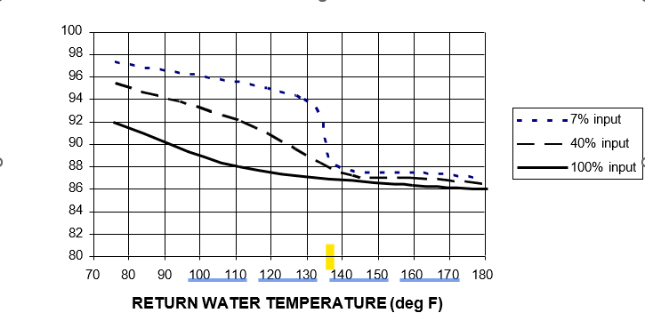
Example 3: Site Conditions: The work scope includes replacement of the existing boiler with a boiler that is equipped with a burner that can fire at reduced inputs while modulating both fuel and air.
Modeling Approach: Projected savings should capture increased efficiency of modulating boiler at part load conditions. The performance curves entered in eQUEST or efficiency adjustment calculations for TREAT should be based on boiler part-load performance from manufacture, or typical performance of modulating boilers from ASHRAE Systems and Equipment Handbook.

Figure 2. Boiler Efficiency as Function of Fuel and Air Input
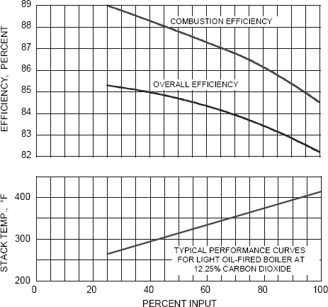

Example 4: Site Conditions: Energy modeling indicates that the existing boiler is significantly oversized. The scope of work proposes to replace the existing boiler with a new higher efficiency unit of the appropriate size.
Modeling approach: In space heating applications, low part-loading for a boiler occurs over much of the heating season because of equipment oversizing and the fact that space heating boilers must be sized to meet the maximum load even though this load only occurs rarely. For example, one study found that multifamily boilers with on/off burners are typically only 21% loaded on a heating season average basis” ⁵⁰.
Run fraction at a given load condition may be estimated in the field by observing the burner operation. For example, if a boiler fires for 5 minutes, then remains off for 20 minutes before restarting, the run fraction is equal to 5 minutes / (5 minutes + 20 minutes) = 0.2 or 20% ⁵².
In eQUEST, the boiler part-load performance penalty may be captured by specifying the size of the equipment in the Boiler Properties window of the Basic Specifications tab. In addition, specify the appropriate performance curves in f (part load ratio) input box of Performance Curves tab. The eQUEST library has default curves for atmospheric, forced draft, and condensing boilers. Alternatively, custom curves may be created using manufacture-specified or measured efficiency at part load conditions. eQUEST will combine part load equipment characteristics with hourly heating loads and use the appropriate efficiency for each hour of the year in the simulation. In TREAT, part-load efficiency is handled as described in the User Manual: “The part-load adjustment is calculated for each month depending on equipment type and part-load ratio during the month and varies between 0.75 and 1. If part-load ratio for boilers is less than 0.1, then monthly usage is adjusted by 0.75 + 2.5 * PartLoadRatio. For forced air heating and cooling systems, the monthly usage is adjusted by 0.75 + 0.25 * PartLoadRatio.”

Existing Conditions
For equipment with a heating capacity of 300,000 Btu/h or less, if the listed AFUE is available from the equipment manufacturer for the existing equipment, AFUE actual shall be used in the pre-retrofit model. For equipment with a heating capacity of 300,000 Btu/h or less with unknown listed AFUE, and for equipment with heating capacity greater than 300,000 Btu/h, Et,actual shall be used. AFUE actual and Et,actual shall be calculated as described.
Exception: If a heating retrofit is considered and AFUE is available for the existing equipment but is not available for the proposed equipment, Et, actual shall be used for the existing equipment.
AFUE actual and Et,actual for the existing equipment shall be calculated assuming that deterioration in annual or thermal efficiency is proportional to the deterioration in combustion efficiency as follows:
AFUEactual=AFUElisted*Ec,actual/Ec,listed Et,actual=Et,listed*Ec,actual/Ec,listed Where
AFUEactual = actual AFUE of existing equipment
AFUElisted = AFUE of existing equipment listed on the nameplate or in the manufacturer’s literature. Ec,actual = actual combustion efficiency of existing equipment measured during the audit.
Ec,listed = combustion efficiency of existing equipment listed on the nameplate or in manufacturer’s literature. Et,actual = actual thermal efficiency of existing equipment.
Et,listed = thermal efficiency of existing heating equipment listed on equipment nameplate or in manufacturer’s literature.
If either Ec,listed or Et,listed is not available for the existing equipment, then Table 6-1 shall be used to estimate Et,actual based on the measured combustion efficiency Ec,actual. To compute Et,actual, subtract the numbers in the table from the measured (actual) combustion efficiency percentage.
Table 6-1. Average Percentage Point Differences Between Et & Ec ¹⁷
Fluid | Heat  Exchanger | 300,000-2,500,000 Btu/h |  | 2,500,000 - 10,000,000 Btu/h
Fluid | Heat  Exchanger | Natural Gas | Oil #2 | Natural Gas | Oil #2
Steam | Cast Iron | 2.1 | 2.4 | 1.5 | 1.6
Water | Cast Iron | 1.6 | 2.4 | 1.4 | 1.6
Water | Steel | 2.2 | 3.4 | NA | NA
For equipment below 300,000 Btu/h, if AFUEactual cannot be calculated as described in the section above, and for air-source heat pumps, then Table 6-2 must be used to estimate efficiency based on the equipment age.
Table 6-2. Minimum Age-Based Efficiency
Mechanical Systems | Units | pre-1991 | 1992 to present
Gas Furnace | AFUE | 0.76 | 0.78
Gas Boiler | AFUE | 0.77 | 0.8
Oil Furnace or Boiler | AFUE | 0.8 | 0.8
Air-Source Heat Pump | HSPF | 6.8 | 6.8
Ground-Water Geothermal Heat Pump | COP | 3.2 | 3.5
Ground-Coupled Geothermal Heat Pump | COP | 2.7 | 3
The simulation model may account for lower summer efficiencies for the space heating boiler, in the case where this boiler heats domestic hot water. The assumptions and references must be documented in the Program Submission Documents.

Improvements

System Replacement
AFUE shall be used to model the performance of equipment proposed as retrofit when the listed AFUE is available from the equipment manufacturer for both existing and proposed equipment. In all other cases, thermal efficiency (Et) shall be used to model both pre- and post-retrofit equipment. Alternative methods may be used with appropriate references and documentation.
The maximum AFUE and/or thermal efficiency for new condensing boilers must be modeled at 92% or less. Higher boiler efficiencies may be achievable with an aggressive outdoor reset schedule. However, distribution systems designed for higher temperature return water may not be able to provide sufficient heat with the low return water temperatures required for condensing. In addition, near boiler piping may not be designed to allow for low-return water temperatures. If a higher efficiency is modeled, the following documentation must be provided: 1) the outdoor reset schedule; 2) a detailed description of the near-boiler piping and distribution system showing that sufficient heat can be provided to the building at low return water temperatures OR the proposed plan for updating the near-boiler piping and distribution system to accommodate lower return water temperatures.
Rated efficiency of proposed HVAC equipment must be included in the Program Submission Documents and must be based on the test procedure appropriate for the specified equipment type, as listed in the Energy Conservation Construction Code of New York State. Equipment that does not have the standard rating, such as ARI rating, may be allowed as a measure, but is subject to program review.

Boiler Tune-up
The estimated useful life of boiler tune ups shall not exceed one year. The efficiency increase due to boiler tune- up depends on the boiler condition prior to the tune-up and the scope of work being performed. The longevity of such savings is difficult to determine, as factors such as water quality, fuel, and proper maintenance are all influential. For example, commercial boilers that use gas and light oil may only need to be cleaned once a year in comparison to boilers using heavy oil, which require several cleanings each year ⁴³.

Cooling Equipment

Efficiency of Existing Equipment
If the efficiency of existing system cannot be determined based on the equipment nameplate, the following values must be used in the pre-retrofit model:
- central air conditioners: SEER 10 / EER 9.2 ⁵³
- heat pumps: SEER 10 / HSPF 6.8 ⁵³
- room air conditioners ⁵³
  - <20,000 Btu/h: SEER 9.7
  - >=20,000 Btu/h: SEER 8.5

Refrigerant charge correction
Refrigerant charge correction may be modeled as 10% improvement in pre-retrofit EER ⁵³.

Distribution System

Variable Frequency Drives (VFD)
Savings from the installation of variable speed drives shall be determined based on the fan/pump affinity laws using an exponent of 2.2 (to account for system effect) and no more than a 30% reduction in average flow.
Savings can be attributed to water or air distribution.
Example 1: Site condition: A central chiller plant in a high-rise multifamily building, using a primary/secondary pumping scheme feeds 300 gallons per minute (GPM) of water throughout the building to fan coil units. The pump is driven with a 10 hp motor with an operating bhp of 8.5. A VFD will be installed with an estimated average flow reduction of 20%. Existing motor revolutions per minute (RPM) is 1,800 (RPM is to be taken from design documents where available or from field gathered data).
Flow is directly proportional to rotational speed: Q1/Q2 = N1/N2, 300/240 = 1800/N2, N2 =1,440
Where:
Q = chilled water flow before and after VFD installation. N = motor RPM before and after VFD installation.
Once the new RPM is found the reduction in kW can be determined as follows. kW1/kW2 =(N1/N2)^{2.2} , kW2 =kW1/(N1/N2)^{2.2}
Where:
kW1 = 8.5(bhp) * 0.746/0.88 (motor efficiency) = 6.34 kW kW2 = 7.2/(1800/1440)^{2.2}
kW2 =7.2 / 1.75 = 4.11
Pre- and post-kW should then be multiplied to the typical run hours for the unit based on location where applicable and the difference in kWh determined. The improvement can now be modeled as an appliance using the difference in kWh as the yearly consumption and removed as part of the improvement.

Steam Distribution Improvements
Improving a steam distribution system can improve tenant comfort and save energy. Various distribution improvements, including installing orifice plates and thermostatic radiator valves, repairing all basement steam traps, and installing an energy management system that controls the boiler based on actual average building temperature appear to have a synergistic effect when installed together.
The highest amount of savings will be achieved when all the following improvements are implemented:
- Install a correctly sized orifice plate on every radiator.
- Install TRVs or other in-unit controls so tenants can reduce the amount of heat supplied by each radiator.
- Install an EMS to control the boiler based on average actual indoor temperature or recommission an existing EMS to reflect the new conditions in the building.
- Install air vents on all the risers to ensure that air can vent from the distribution system quickly.
- Repair all steam traps in the basement.
- Repair the pressure controls on the boiler to supply steam at the correct pressure for the steam traps or orifice plates.
- Tune up the burner to maximize the efficiency across the range of firing levels.
Modeling distribution improvements using modeling software is difficult and is not recommended at this time. Instead, the table below shows estimated savings for various combinations of steam distribution improvements. The higher amount of savings is the maximum estimated savings allowed for each combination of measures.
Table 6-3. Steam Distribution Improvement Savings
Installed Measure(s) | Savings as a Percent of Heating Energy Usage²
Orifice plates or apartment steam traps ONLY | 0%
Orifice plates or apartment steam traps AND  Basement steam trap repair/replacement | 2-5%
Orifice plates or apartment steam traps AND Basement steam trap repair/replacement AND  EMS | 10-20%
Orifice plates or apartment steam traps AND  Basement steam trap repair/replacement AND | 15-30%
EMS AND
TRVs
- Estimated based on “Implementation of Supply-Side Orifice Plates in Two-Pipe Steam Systems” Prepared by Steven Winter Associates, New York, NY.

Note: If any portion of the measures above were previously installed and will be recommissioned as part of the proposed scope of work or have been recently tested and are in good condition, please describe this in the Measure Description, and savings may still be claimed.
When estimating savings, it is important to understand the reason for each of the measures in Table 6-3. Installing orifice plates on every radiator prevents steam from entering the return piping via the radiators. However, if the steam traps in the basement are not also repaired or replaced, steam will continue to pressurize the return piping, leading to underheated apartments.
If orifice plates are installed on every radiator and the basement steam traps are repaired or replaced, steam will not be able to pressurize the return piping, and heating imbalances in the building will be reduced. The tenants will be much more comfortable but reducing heating imbalances does not produce substantial energy savings by itself; the apartments will be uniformly overheated instead of some being overheated and some being underheated.
To achieve savings, the overheating must be reduced. A straightforward way to do this is to install an EMS that turns the boiler off when a sample of apartments reaches the setpoint temperature. If the building already has an EMS, it must be recommissioned after the orifice plates have been installed and the basement steam traps are repaired. The settings must be adjusted to the new conditions in the building to achieve savings.
Adding TRVs in addition to an EMS gives additional control over how much steam is needed to heat the building. Tenants that prefer cooler temperatures can set their TRVs lower, which reduces the amount of steam needed to heat the building if the distribution system is well balanced.
When calculating interactivity between measures using modeling software, model the fuel savings as an appliance that is removed.

Heating/Cooling Temperature Schedule

Existing Conditions
Actual indoor temperatures during heating and cooling seasons must be modeled as thermostat setpoints. Heating and cooling setpoints used in the model must be documented in the Program Submission Documents.
If the total area-weighted building temperature of all modeled zones combined is outside a range of 69°F – 76°F for at least some of the time during the heating season, then the inputs must be supported by a record of indoor temperatures measured in multiple locations. See the Technical Topic, Indoor Temperature, for more information. ^{24, 25, 28}.
Example 1: Site Conditions: It is determined that 20% of apartments are overheated and that the average temperature for these apartments is 82°F. The average space temperature in the remaining apartments is 72°F.
Modeling Approach: Overheated spaces may be modeled as a separate zone or aggregated with other apartments. If modeled as a separate zone, then the space temperature of the zone representing overheated apartments will be modeled as 82 °F, and the space temperature of the zone representing the rest of the apartments will be modeled as 72°F. If overheated areas are aggregated with other apartments into single zone, then the modeled temperature of this zone is calculated as 82°F * 20% + 72°F * 80% = 74°F.
With either approach, the weighted average temperature in the model is 74°F, which falls within the range allowed by this Section 8.1(b).

Improvements
Table 7-1. Temperature Reduction at Apartment Level
Existing | Proposed | Modeling Protocol
Non-programmable thermostats; corresponding heating or cooling bills NOT paid by residents | Programmable thermostats in apartments or TRVs with no upper limit set | Not allowed in scope of work as an energy efficiency measure ²⁵ – unlikely to generate energy savings
Non-programmable thermostats; corresponding heating or cooling bills paid by residents | Night setback via programmable thermostats in apartments | Heating: maximum 3°F setback for 8 hours per day ⁵³  Cooling: maximum 2°F increase for 6 hours per day ¹⁸
Any resident-controlled thermostat, TRV, or other temperature control | Range-limited thermostats, TRVs, or other controls with a specific upper limit on indoor temperature | Must use interior space temperature no less than specified upper limit ^{24, 25}. Maximum 2°F temperature reduction.
Note that if modeled energy savings are based on the reduction of space temperature in apartments where occupants have unlimited apartment-level control over the heating setpoint, the post retrofit temperature during occupied periods should not be less than 74°F in buildings with owner-paid corresponding utilities, or 72°F in buildings with resident-paid corresponding utilities ²⁵.
Table 7-2. Temperature Control at Building Level – Steam Systems
Existing | Proposed | Modeling Protocol - Steam
On/off control only; no outdoor reset  Note that outdoor reset for steam systems is defined as a control that adjusts the length of the steam cycle as the outdoor temperature changes. | Outdoor reset | Model as a temperature reduction. Do not model as “outdoor reset” as this option only applies to hot water system or vacuum steam systems. Must provide details of existing controls and evidence that outdoor reset is not currently being utilized.  1°F maximum temperature reduction
Outdoor reset;  heating imbalances observed | EMS with indoor temperature sensors | Distribution imbalances not addressed: 2°F maximum temperature reduction  Distribution imbalances addressed: 3°F maximum temperature reduction
Outdoor reset;  no heating imbalances | EMS with indoor temperature sensors | 3°F maximum temperature reduction
The temperature reductions in the table above are weighted average reductions, inclusive of night setback.

Table 7-3. Temperature Control at Building Level – Hot Water Systems
Existing | Proposed | Modeling Protocol – Hot Water
On/off control only, no outdoor reset | Outdoor reset | Model as outdoor reset control on hot water loop. Must provide details of existing controls and evidence that outdoor reset is not currently being utilized. System must be able to operate with outdoor reset (condensing boilers and/or boilers separated from heating loop).
On/off control only, no outdoor reset | Outdoor reset and EMS with indoor temperature sensors | Model as above for outdoor reset portion of savings.  Additionally, model a temperature reduction of 1°F maximum if the outdoor reset curve (i.e. the hot water loop set point) will be adjusted based on feedback from apartment sensors.
Outdoor reset | EMS with indoor temperature sensors | Model as a temperature reduction if outdoor reset curve (hot water loop set point) will be adjusted based on feedback from apartment sensors.  1°F maximum temperature reduction
Steam boilers that supply a hot water loop are to be considered a hot water system. The temperature reductions in the table above are weighted average reductions, inclusive of night setback. For more information, see Appendix D.

Air Infiltration and Mechanical Ventilation

Mechanical Ventilation
Mechanical ventilation shall be modeled according to data collected by the provider during the site visit, including the fan runtime hours and flow rates. Fan flow rates may be measured, obtained from as-built drawings and specifications, estimated based on manufacturer’s data for the installed model and ductwork characteristics, or estimated based on the rated fan motor horsepower listed on the nameplate.
The electricity consumption of fan motors shall be included in the model based on the rated power consumption and the annual fan run time, as determined in the field. The following equations may be used to estimate fan motor energy:
${kW}_{fan}=CFM\left(\frac{FanStatic Pressure}{8520*FanEfficiency}\right)$ ²⁰
${kW}_{fan}=bhp\left(\frac{0.746}{FanEfficiency}\right)$ ¹⁵

where:
CFM = design flow rate
FanStaticPressure = pressure drop in ductwork, inch H2O FanEfficiency = fan motor efficiency fraction
8520 = conversion factor, $\left(\frac{ft3*inches}{minutes*kW}\right)$
bhp = break horsepower of fan motor
If the proposed improvements include a change in mechanical ventilation rates, then the projected savings should reflect the impact of the change on heating and cooling loads and fan motor energy consumption.

Pre-retrofit Infiltration
Average air changes per hour (ACH) in the conditioned space caused by natural infiltration of outdoor air during the heating season must be below 1.0 ACH, or below 0.21 CFM per square foot³ of gross vertical exterior wall area ^{2,4,6,7,8,9}.⁴ However, infiltration rates may be much lower than these maximum values in most multifamily buildings, and 0.6 ACH should be considered typical. Average heating season air changes that are higher than 1.0 ACH might occur when there are many intentional openings, such as a high occurrence of open windows. If present, these conditions must be documented in the Program Submission Documents.
Blower door measurements may be converted to estimated annual infiltration rates using the equations below ²¹:
ACH=ACH50/K
ACH50=CFM50*L/Building Volume [CF]
Coefficients K and L may vary depending on the building and test conditions. In the absence of project-specific references, K=20 and L=60 should be used.
Non-apartment spaces with low area of exterior surfaces, such as corridors or basements, have much lower infiltration rates. For example, 0.2 ACH is considered typical for a basement. A notable exception to this rule are mechanical rooms, which often have much higher infiltration rates due to intentional combustion air openings.
- This value of CFM/sq. ft. represents infiltration through all components of the building envelope, including the roof, normalized to CFM per square foot of gross vertical wall area above ground.
- These are approximations based on a review of reports by Gulay, et al., (1993); Palmiter, et al., (1995); Shaw et al., (1980, 1990, and 1991); and Sherman et al., (2004). Information on measured infiltration rates in multifamily buildings is extremely limited. Most of the available information cannot be directly correlated to New York State’s building stock and climate conditions

Interaction between Infiltration and Mechanical Ventilation
Outdoor air flow rates in pre- and post-retrofit models shall reflect the combined effect of natural and mechanical ventilation. If the simulation tool does not automatically account for the interaction between infiltration and ventilation, which is the case for most tools, including TREAT and eQUEST, then the combined flow rate must be calculated using equation ⁵¹ in Chapter 16 of the 2017 ASHRAE Handbook–Fundamentals, as quoted below:
$$Q_{comb}=Q_{bal}+\sqrt{Q_{unbal}^{2}+Q_{infiltration}^{2}}$$
(Equation 8.1)
Qcomb [CFM] = combined rate of natural and mechanical ventilation.
Qbal [CFM] = balanced mechanical ventilation in a space or group of connected spaces that have both exhaust and supply fans. This represents the portion of mechanical ventilation where the exhaust flow is equal to the supply flow. Qbal = minimum (Qexhaust, Qsupply)
Qunbal [CFM] = unbalanced mechanical ventilation flow in a space of group of connected spaces. This is the portion of mechanical ventilation where either the exhaust or supply flow is greater than the other.
Qunbal = maximum (Qexhaust, Qsupply)- Qbal. If the space has only supply or exhaust, all the flow is unbalanced.
Qinfiltration [CFM] = natural (non-mechanical) infiltration rate.
Equivalent combined rate Qcomb may be modeled as either all-mechanical or all-natural ventilation, or as a combination of the two as appropriate for the simulation tool being used. See Modeling Approach section for calculation procedure.

Infiltration Reduction Improvements
Air sealing and infiltration reduction improvements should be conservatively estimated as not to overstate energy savings. When calculating the proposed infiltration reduction, it is recommended that you use known leakage rates of specific building components, for both pre- and post-retrofit conditions. Included in Appendix B is a table from the 2001 ASHRAE Fundamentals Handbook listing the Effective Leakage Area through common building components.
Once the combined reduction in Effective Leakage Area has been calculated, the following formula can be used to calculate the natural ACH reduction achieved:
$$A_{n}=6.944\left(\frac{A_{L}}{A_{f}}\right){\left(\frac{H}{H_{0}}\right)}^{0.3}$$
An = Normalized leakage area, equivalent to natural ACH reduction achieved ⁵⁶ Al = Effective Leakage Area (in2)
Af = Gross floor area (ft2)
H = Building height (ft)
H0 = reference height of one-story building, 8 ft
Field research has shown that extensive air sealing measures can reduce a building’s total infiltration rate by 18% to 38% ^{2, 9}. Consistent with that, the maximum percentage reduction in infiltration from all improvements combined should be capped at 38%. This does not include the portion of infiltration that is attributable to occupant behavior, such as opened windows due to poor heating control.
If an infiltration reduction measure is included in the scope of work, it is important to update the interaction between the infiltration and mechanical ventilation for post-retrofit conditions using Equation 8.1 above. More details are included in the Modeling Approach section below.

Modeling Approach
As mentioned in the section above, it is important to consider the interactions between infiltration and mechanical ventilation when calculating savings associated with either of these types of measures. The combined natural and mechanical ventilation should be calculated using Equation 8.1 above for both pre- and post-retrofit conditions and entered correctly into the energy modeling software.
When entering mechanical ventilation, adjust rates to reflect runtimes. Whole building natural infiltration higher than 0.6 ACH usually indicates above average air leakage, which should be evident from the site visit, with the locations of leakage documented in the Program Submission Documents.
When modeling or calculating the infiltration savings due to reducing the number of open windows by tenants, a penetration rate of no more than 90% should be used in assuming the retrofit ACH value.

Lighting

General
The modeled wattage of fixtures that have ballasts or transformers must include the consumption of all components and not just the nominal lamp wattage. Every effort should be made to look up the specifications for the particular ballast model number. Appendix A lists total wattages for the typical lamp/ballast combinations that may be used in the model if the fixture-specific information is not available.
If the hourly lighting load distribution must be entered into the modeling tool, then the software default schedules, or the schedules developed by NREL and made available at the Building America website at http://www1.eere.energy.gov/buildings/building_america/perf_analysis.html (End-Use Profiles), may be used, provided that the load distribution does not exceed the total hours of operation required in this document.
Exterior lighting that is on the site utility meters (e.g., pole fixtures for walkways and parking, exterior lighting attached to the building, etc.) must be included in the energy simulation and considered for retrofit.
Improvements to exterior lighting may involve replacement of existing fixtures with new fixtures having better efficacy, reducing the number of fixtures to eliminate over lighting, and installing lighting controls such as timers, occupancy sensors and photosensors.
The same hours of operation must be used for pre- and post-retrofit fixtures unless the measure includes the installation of device(s) that affect the fixture runtime.

Existing Conditions
The modeled wattage of existing incandescent fixtures must be equal to the wattage of the installed bulbs, but no greater than the maximum rated fixture wattage (see Appendix A).
Lighting inside apartment units for which no retrofit is proposed should be modeled as having an installed wattage of 2.0 W/SF ¹⁰ and operating 2.34 hr/day ²³, or 2.0 * 2.34 = 4.68 [Wh/SF-day]. As part of the process to calibrate the model to utility bills, this energy consumption may be modified ± 30% by adjusting either the installed wattage or hours of operation.
Apartment lighting that is being retrofitted must be modeled with the operating hours in Table 9-1 below based on the room type ¹⁰. Alternatively, 3.2 hours/day runtime may be assumed for the existing incandescent lamps retrofitted with screw-in LEDs and 2.5 hours per day may be assumed for all other existing fixtures that are replaced ⁵⁵. Alternative assumptions may be used but must be accompanied by the proper references and are subject to program review.
Existing or proposed lighting controls, including occupancy sensors and timers, may be modeled as a reduction in the hours of operation or as an equivalent adjustment to the installed lighting power from Table 9-2 ^{14, 15}. Alternative reductions in hours may be used but must be accompanied by the proper references and are subject to program review.

Table 9-1. In-Unit Lighting

Room Type | Average Lighting Usage  (hrs/day)
Kitchen/Dining | 3.5
Living Room | 3.5
Hall | 2.5
In-unit laundry/utility room | 2.5
Bedroom | 2.0
Bathroom | 2.0

Table 9-2. Common Area Lighting
Space Type | Power Adjustment Percentage  Reduction in Operating Hours
Hallways/Corridors | 25%
All other spaces intended for 24-hour use | 10%

Improvements
Without evidence of significant over-lighting, reductions in light output should not be included as part of energy savings projections from LED retrofits. For more details see Technical Topic: LED Lighting Recommendations in Appendix E.
If an improvement includes installation of fixtures that will use screw-in CFLs, then the modeled wattage of proposed fixtures must be equal to the maximum rated fixture wattage, regardless of the wattage of the proposed bulbs. For example, if a new fixture can use either incandescent bulbs or CFL, the wattage of the fixture’s maximum allowable incandescent bulb must be used in the model.
Depending on existing lighting and proposed lighting, the program limits allowable claimed wattage reduction based on the table below. Note, these wattage reductions are often different than what is recommended by manufacturers’ packaging. In addition, care must be taken with special populations (such as seniors) to provide appropriate lighting levels. For more details see Technical Topic: LED Lighting Recommendations in Appendix E.

Table 9-3. Wattage Reduction Limit
Existing Fixture Type | Proposed Fixture Type | Wattage reduction limit | Example
Incandescent | Fluorescent or CFL | 3.4:1 reduction in wattage | CFL replacing a 60W incandescent bulb should be modeled at no less than 18W (60W/3.4)
Incandescent | LED | 4.5:1 reduction in wattage | LED replacing a 60W incandescent bulb should be modeled at no less than  13.3W (60W/4.5)
Fluorescent & High Intensity Discharge (HID) | LED | If the efficacy of the existing fixtures is unknown, then a wattage reduction of no more than 1/3 should be assumed | LED replacing a 150W HID should be modeled at no less than 100W
If a project includes a wattage reduction greater than what is allowed as described in the above table, one of the following documentation alternatives must be submitted for each non-compliant fixture:

Table 9-4. Documentation Alternatives
 | For the Existing Fixture | For the Proposed Fixture
Option 1* | Existing light output and how measured, existing wattage and how measured, make and model of existing fixture, lamp, and ballast. | Cut sheet including the model number, wattage, and mean lumen output.
Option 2 | Photos of light meter readings confirming space foot-candles. | Foot-candle calculations for the space, confirming the proposed design provides lumens per square foot that are greater than or equal to the existing measured light levels.
Option 3 | N/A | Foot-candle calculations to confirm foot-candles meet or exceed recommendations in the current edition of the Illumination Engineering Society (IESNA) Lighting Handbook based on space type.
* See the Technical Topic: LED Lighting Recommendations in Appendix E.
For estimating proposed energy usage from lighting controls, see section 9.2 and Table 9-2.

Envelope Components

Surfaces
If different cross-sections through non-steel-framed surfaces have different R-values, then the overall effective R-value for those surfaces must be calculated by first calculating the U-values of each cross-section and then pro-rating the U-value by the corresponding fraction of surface area as described in the calculation example in the Technical Topic on Calculating the U-values of a Surface released for New Construction projects.
Construction libraries of approved simulation tools may be used but must represent the combined thermal properties of the frame and cavity sections.
Effective R-values of metal frame constructions must be based on the tables in ASHRAE Standard 90.1 (Appendix A within ASHRAE Standard 90.1). The applicable version of ASHRAE 90.1 should align with the state’s commercial energy code in effect on the buildings permit date. The ‘permit date’ is the date on which the permit authorizing construction of the building was issued. If the pre-retrofit or post-retrofit conditions include insulation that has an intermediate R-value between those provided in the tables, then it is legitimate to interpolate between the framing/cavity R-values shown in the table. For example, if cavity insulation was determined to be R-20, but ASHRAE 90.1 only provides effective R-value for R-19 and R-21 cavity insulation for the given construction, then the average of these values may be used to model a surface with R-20 cavity insulation.
If gaps or other defects in the existing insulation are discovered, then its U-value must be de-rated. The de-rating procedure must be explained in the Program Submission Documents.
For portions of envelope where construction cannot be determined, the following assumptions may be used ⁵³:
- Old, poorly insulated / un-insulated wall – R-7
- Existing wall with average insulation – R-11
- Old, poorly insulated roof – R-11
- Existing roof with average insulation – R-19
Libraries available in the simulation tools include many common constructions. If the exact match for the existing or proposed construction cannot be found (for example, if there is no matching entry in the TREAT library), then the effective R-value for the surface, including de-rating for insulation defects, should be calculated outside of the simulation tool. If software (such as TREAT) does not allow entering custom constructions, then the surface with the closest effective R-value must be selected from the library. An attempt should be made to select a surface assembly which also has a similar thermal mass. For example, if the actual wall has block construction, it is preferable that the surface assembly selected from the library to represent this wall includes a block layer.

Fenestration

Existing Condition
The following properties must be used to model existing windows unless building-specific information is available ⁵³:
- Single pane windows: solar heat gain coefficient of 0.87 and U-value of 1.2 Btu/h-SF-deg F
- Double pane windows: solar heat gain coefficient of 0.77 and U-value of 0.87 Btu/h-SF-deg F
Please note, the modeler is allowed to use more conservative values if the existing window solar heat gain coefficient and U-value are unknown, in order to more realistically project savings based on the existing buildings characteristics. Please note these assumptions in the Program Submission Documents and reasoning for not using the prescribed values above.

Proposed windows
The actual properties of the specified window must be used in the modeling. If those U-values and SHGC’s are not available, model windows that meet the Program's Minimum Performance Standards.

Domestic Hot Water

Domestic Hot Water Heating Systems

Water Heating Equipment Categories
Residential Storage Water Heaters. This category includes electric heaters with input ≤ 12kW, gas heaters with input ≤ 75,000 BTU/h, and Oil heaters with input ≤ 105,000BTU/h, and storage capacity below 120 gallons.
Residential Instantaneous Water Heaters. This category includes gas heaters with input ≤ 75,000 BTU/h and oil heaters with input ≤ 210,000BTU/h.
Larger storage and instantaneous heaters are categorized as Non-residential.

Water Heating Equipment Performance Characteristics
Efficiency of water heating equipment is described through one or more of the following parameters:
Recovery Efficiency – heat absorbed by the water divided by the heat input to the heating unit during the period that water temperature is raised from inlet temperature to final temperature.
Recovery Rate – the amount of hot water that a residential water heater can continually produce, usually reported as flow rate in gallons per hour, which can be maintained for a specified temperature rise through the water heater.
Energy Factor – a measure of water heater overall efficiency determined by comparing the energy supplied in heated water to the total daily energy consumption of the water heater determined following DOE test procedure (10 CFR Part 430). The energy factor represents the fraction of all heat that was used to heat the water and maintain the temperature of that water in the face of standby losses that is still present in the water when it flows into the distribution system. It can never be higher than the thermal efficiency (see below).
Standby loss, as applied to a tank type water heater under test conditions with no water flow, is the average hourly energy consumption divided by the average hourly heat energy contained in the stored water expressed as percent per hour. This may be converted to the average Btu/h energy consumption required to maintain any water-air temperature difference by multiplying the percent by the temperature difference, 8.25 Btu/gal*F (a nominal specific heat for water), the tank capacity, and then dividing by 100.
Thermal Efficiency is the heat in the water flowing from the heater outlet divided by the heat input over a specific period of steady-state conditions. Et accounts for the flue losses and the loss through the heater (boiler) jacket when boiler is firing.
Residential water heaters (storage and instantaneous) have performance specified by the energy factor, EF. Non-residential water heaters with storage volume <10 gal usually have thermal efficiency Et available. Water heaters with larger storage capacity have standby loss ratings in addition to thermal efficiency. For unfired storage tanks, R-value of tank insulation is usually specified.

Evaluating Performance of the Existing Water Heaters
If performance of the existing water heater is unknown, combustion efficiency Ec should be measured. This value should be reduced by 3 percentage points to estimate thermal efficiency Et ³⁹.
Et=Ec-0.03
For all instantaneous water heaters, assume negligible standby losses SL=0 and EF=Et. For residential water heaters, the following relationship may be used to estimate EF ³⁸: EF=0.62-0.0019*Rated Storage Tank Volume
For commercial storage water heaters, use the following relationship to estimate SL ³⁸:

$$SL=\frac{Q}{800}+\frac{110}{\sqrt{V}}$$

Q[Btu/h] - rated input power V[gallons] - rated storage tank volume
eQUEST requires that user enters Heat Input Ratio (HIR), tank volume in gallons, and tank UA ³⁸. These shall be determined as follows:
HIR = 100/Et
UA=SL*Et/70
Part load performance degradation must be based on default DOE2 performance curves. If simulation tool allows specifying water heater efficiency using different parameters, such as in TREAT, the same efficiency descriptors must be used for both baseline and proposed equipment where possible.

Existing DHW Demand
Overall Hot Water Consumption
The typical usage reported in the ASHRAE Applications Handbook is 14-54 gal/day/person. This is based on studies by Goldner and Price ⁴⁶, which also demonstrate that a middle range is 30 gal/day/person. This middle range is a good starting point for modeling. Demographic characteristics affecting hot water consumption are shown in Table 11-1.
Consumption above 54 gal/day/person is possible and was observed in some field studies ⁴⁶; however, if the model is using a high-water consumption to calibrate the model, then other possible factors affecting DHW usage must also be considered, and justification must be included in the Program Submission Documents. Examples of factors affecting DHW demand and/or DHW energy consumption could be the DHW temperature, equipment efficiency, standby and distribution losses, and water leaks.

Table 11-1. Demographic Characteristics Correlating to DHW Consumption
Demographic Characteristics | Average daily DHW usage  (gallons/day per person)
No occupants work High % of Children Low income  Public assistance | 54
Families Singles  Single-parent households | 30
Couples Middle income Seniors  All adult occupants work. | 14
Note: These gallons are for DHW set at a temperature that will achieve 120°F at the tap.
Example: Site Conditions: A building has 15 apartments and is occupied mostly by low-income families with children, with an average of three people per apartment.
Modeling Approach: Model hot water usage as being up to 54 gal/day-person*3 person/apt=162 gal/day/apartment. If proper calibration is still not achieved, then other factors affecting hot water heating energy consumption must be considered, including the DHW temperature, equipment efficiency, standby and distribution losses, water leaks, etc., before a further increase in hot water demand is modeled.
Allocation of demand to the correct end uses.
If the Program Submission Documents includes any measure that claims energy savings from reducing DHW consumption, then the base- building DHW consumption must be determined by calibrating the modeled DHW-related energy usage and by modeling all clothes washers and dishwashers on site. Modeling of existing clothes washers and dishwashers is required for modeling the installation of faucet aerators or showerheads. This will assist in validating the portion of total hot water consumption that is allocated to the non-appliance usage in the base-building model.

Clothes Washers
The assumed hot water consumption of existing clothes washers shall be determined as follows:
Determination of annual loads per washer. Use actual measured annual loads per washer when available, such as from coin income receipts. Otherwise, use the typical loads per washer as defined below.
Common area washers. The number of annual wash cycles per each washer located in a common area shall be determined per the formula below, or as 2,738 cycles/year per washer, whichever is less:

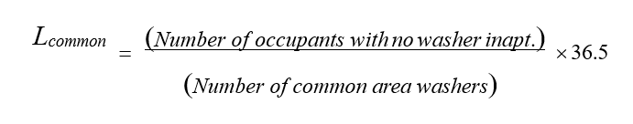
Lcommon = Annual number of loads per each washer located in a shared common area laundry room ⁴⁷. Number of occupants with no washer in apartment is equal to the total number of residents at the site multiplied by the percentage of apartments that do not have in-unit clothes washers.
Number of common area washers is equal to the total number of washers located in common areas, not just the washers intended for replacement.
The number of loads per washer shall be equally distributed among all common area washers.
In-apartment washers. The number of wash cycles for an in-apartment washing machine shall be modeled as being between 110 to 146 loads per occupant per year, multiplied by the number of occupants in that apartment ⁴⁷ (the average number of occupants per apartment may be used). If the apartment has more than one washing machine, then the result should be divided by the number of washers to determine annual loads per washer.
Determination of hot water consumption per load. Hot water consumption per load shall be determined by multiplying the rated total gallons per load (hot and cold water combined) by the following percentages ⁴⁸:
- For non-EnergyStar® models, multiply the total rated water consumption per load by 29%.
- For EnergyStar® models, multiply the total rated water consumption per load by 21%.
Rated total gallons per load (hot and cold water combined) is equal to the rated water factor multiplied by the washer volume (cubic feet). If only the EPA rating for gallons per year is known, such as for residential models, then divide gallons per year by 392 to determine gallons per load (both hot and cold water).

Dishwashers
See discussion of dishwashers in Plug Loads section of this document.

DHW Improvements

Low-flow devices
If the installation of low-flow faucet aerators or showerheads is included in the Program Submission Documents, then:
The flow rate of existing fixtures must be documented and based on measurements in a sample of apartments.
- All existing dishwashers and clothes washers must also be modeled in the base-building model per these guidelines.
- Post-retrofit flow rates must be modeled at a minimum of 1.5 GPM.

- Post-retrofit flow rates less than 1.5 GPM may be modeled if a cut sheet confirming the make, model, and GPM is provided, and this information is able to be verified on the fixture itself during building inspections.
- A penetration rate of no more than 90% should be used in assuming the retrofit of low-flow devices (kitchen sinks, bathroom sinks, showerheads). A 100% penetration rate may be used for toilets.
If the simulation tool allows for explicit modeling of water heating energy savings associated with low-flow device installation (such as TREAT), then the tool functionality must be used to calculate the savings. If the reduction in annual hot water consumption due to low flow fixture installation must be calculated externally (for example, when using eQUEST) the DHW Reduction must be calculated as described below, and applied to the existing modeled flow rate:
DHW Reduction = % reduction in annual DHW usage
LFS [GPM] = average weighted flow rate of low-flow showerheads PS [GPM] = average weighted flow rate of pre-retrofit showerhead LFF [GPM] = average weighted flow rate of low-flow faucet
PF [GPM] = average weighted flow rate of pre-retrofit faucet
The flow rates of existing fixtures that are being replaced must be measured and included in the Program Submission Documents.

EnergyStar® clothes washers.
Annual loads per washer shall be modeled as described in Section 12.2. Hot water consumption per load for new EnergyStar® models shall be determined by multiplying the rated total gallons per load (hot and cold water combined) by 21% ⁴⁸.

EnergyStar® dishwashers.
Simulation guidelines for dishwasher DHW consumption and savings are shown in the Plug Loads section of this document.

Elevators

Existing Conditions
Elevator energy consumption for a specific building is difficult to estimate. Even when the type and size of the motor can be determined, the actual consumption depends on many variables, including building type, population type, hoist mechanism, weights of the load and counterbalance, speed of travel, etc. Best practice for determining the electricity consumption of a specific elevator is to monitor its electricity consumption for several weeks using data logging equipment that can record actual energy consumption.
If actual electricity consumption cannot be determined through data monitoring, pre-retrofit elevator energy use should be modeled as 2%‒7% of whole building electricity use (excluding electric heating and/or electric hot water), unless additional documentation is provided.
Table 12-1. The Relative Efficiency Between Different Types of Elevators
Elevator Type
DC Motor with Motor Generator Set | Least Efficient
DC Motor with Rectifier
AC Geared Motor
AC Geared Motor with VVVF
AC Gearless Motor with VVVF
AC Gearless Motor with VVVF and Regenerative Braking | Most Efficient

The Technical Topic, Elevator Energy Use and Other Essentials (see Appendix F), provides a more detail review of the different types of elevators and their associated energy use.

Improvements
Total projected electrical savings from elevator replacement, motor and/or controls, should not exceed more than 60% of the total elevator electricity consumption pre-retrofit. This maximum reduction assumes that the least efficient type of elevator (DC Motor with Motor Generator Set) is being replaced with the most efficient type of elevator (AC Gearless Motor with VVVF and Regenerative Braking). See Table 12-1 above for the relative efficiencies between different types of elevators. If savings are greater than 60%, they must be clearly documented and supported.

Plug Loads

Existing Conditions
With the exception of refrigerators and dishwashers, kitchen appliances that are not targeted for replacement in the Program Submission Documents may be modeled using the appropriate software defaults or as specified for pre-retrofit conditions in the Improvements section below. Usage of such appliances may be adjusted ±30% as part of model calibration.
The provider must sample a reasonable number of existing refrigerators, and must use data from the manufacturer, the appliance Energy Guide label, the Association of Home Appliance Manufacturers (AHAM) directory, or from the online databases such as https://www.energy.gov/scep/wap/articles/refrigerator-and-freezer-energy-rating-online-search-tool based on the actual models found in the building. If data on energy consumption based on the model numbers is not available in the sources listed above, the provider must monitor a reasonable sample of refrigerators.
Loads from miscellaneous small kitchen appliances, home entertainment equipment, computers, etc., may be combined into one category and modeled as 1.37 kWh/yr. per square foot of finished floor area of living space ²⁶. This usage may be adjusted ±30% as part of the process of calibrating the model to utility bills.
Alternatively, the actual equipment may be modeled as recorded during the audit and documented usage assumptions.
Miscellaneous electric loads in non-apartment spaces may either be based on Table 13-1 ²⁷ or loads from actual equipment found during the audit and documented usage assumptions.
Table 13-1. Miscellaneous Electric Loads in Non-Apartment Spaces
Space Type | Annual Electricity Usage
Corridors, restrooms, stairs and support areas | 0.7 kWh/SF
Offices | 4.9 kWh/SF
All Other | 1.0 kWh/SF

Improvements
If the Program Submission Documents includes installation of ENERGY STAR® refrigerators, the post-retrofit usage must be based on data from https://www.energystar.gov/products/refrigerators.
If the Program Submission Documents includes the installation of ENERGY STAR dishwashers, then pre- and post-retrofit usage must be based on data for the existing and proposed models from the manufacturer, taken from the appliance Energy Guide label, or as published by Association of Home Appliance Manufacturers (AHAM). If the data for the pre- or post-retrofit dishwasher is unknown, then values from Table 13.2 may be used. The usage is based on 215 cycles per year.
Table 13-2. Pre- and Post-Retrofit Energy Usage for Dishwashers
Annual Fuel Usage per Unit | Energy Star® Dishwasher | Existing Dishwasher
Electricity consumption | 187 kWh | 264 kWh
Water Heating Gas / Electric | 6 therm /144 kWh | 19 therm / 203 kWh
If the Program Submission Documents includes the installation of ENERGY STAR® clothes washer, then information about the existing and proposed washer models must be provided, including manufacturer, model number, the rated total motor electricity consumption as listed by the manufacturer or current ENERGY STAR publications, and documentation of the typical kWh consumed per cycle for each model. The associated water heating savings shall be modeled as described in Section 11.

References

¹ Emmerich, S. J. and Persily, A. K., (1998), “Energy Impacts of Infiltration & Ventilation in U.S. Office Buildings Using Multizone Airflow Simulation,” Proceedings of IAQ and Energy 98 Conf., New Orleans, LA 22-27 Oct. 1998. IAQ and Energy 98, pages 191-203.
² Gulay, G.W., C.D. Stewart, G.J. Foley, (1993), “Field investigation survey of airtightness, air movement and indoor air quality in high-rise apartment buildings: summary report,” Canada Mortgage and Housing Corporation Technical Report, prepared by Wardrop Engineering Inc.
³ Hill, Duncan, (August 1997), “Field Investigations of Indoor Environment and Energy Usage of Mid-Rise Residential Buildings.” Prepared by Scanada Consultants Limited, for Research Division, Canada Mortgage and Housing Corporation.
⁴ Palmiter, L., J. Heller, M. Sherman, (1995), “Measured Airflows in a Multifamily Building,” American Society for Testing and Materials, Special Technical Publication; ISSUE: 1255; Airflow Performance of Building Envelopes, Components and Systems, Ed. Modera, M. P., and Persily, A.K.
⁵ Persily, A.K., (1998), “Airtightness of Commercial and Institutional Buildings: Blowing Holes in the Myth of Tight Buildings.” Thermal Envelopes VII Conference. December 6-10, 1998.
⁶ Shaw C.Y., (1980), “Methods for Conducting Small-Scale Pressurization Tests and Air Leakage Data of Multi- Storey Apartment Buildings,” ASHRAE Transactions, Vol. 86 (1), 1980, pp. 241-250.
⁷ Shaw C.Y., Gasparetto S. and Reardon J.T., “Methods for Measuring Air Leakage in High-Rise Apartments,” Air Change Rate and Airtightness in Buildings, ASTM STP 1067, Sherman M.H., Ed., American Society for Testing and Materials, Philadelphia, 1990, pp. 222-230.
⁸ Shaw C.Y., Magee R.J., Rousseau J., “Overall and Component Airtightness Values of a Five-Story Apartment Building,” ASHRAE Transactions, Vol. 97 (2), 1991, pp. 347-353.
⁹ Sherman, M.H. and Chan, R., (2004) “Building Airtightness: Research and Practice,” Lawrence Berkeley Laboratory report LBNL-53356.
¹⁰ Navigant Consulting: U.S. Lighting Market Characterization: Volume 1: National Lighting Inventory and Energy Consumption Estimate.
¹¹ EIA 1993 Residential Energy Consumption Survey, Lighting Supplement.
¹² Nexant: 2007 M&V Evaluation of the EmPower New York Program conducted by Nexant in 2007
¹³ KEMA: Evaluation of the 2004-2005 Partnership for Energy Affordability in Multi-Family Housing Program.
¹⁴ 2005 Building Energy Efficiency Standards of California Energy Code, Section 146.
¹⁵ ASHRAE Standard 90.1 2013.
¹⁶ Roland J. Hwang, Francis X. Johnson, Richard E. Brown, James W. Hanford, and Jonathan G. Koomey: Residential Appliance Data, Assumptions and Methodology for End-Use Forecasting with EPRI-REEPS 2.1.

¹⁷ Michelle J. Ware, Lawrence Berkeley National Laboratory: Establishing an Energy Efficiency Recommendation for Commercial Boilers.
¹⁸ 2006 Mortgage Industry National Home Energy Rating System Accreditation Standards by RESENT and the National Association of the State Energy Officials.
¹⁹ Morril, J and Wilson, A (1996) Consumer Guide to Home Energy Savings. Wash. DC & Berkeley, CA: American Council for an Energy Efficient Economy.
²⁰ eQUEST ® Training for Energy Professionals – Reference Materials.
²¹ Minneapolis Blower Door TM Operation Manual for Model 3 and Model 4 Systems.
²² ASHRAE Guideline 14-2002 Measurement of Energy and Demand Savings.
²³ Architectural Energy Corporation: Incorporating Lighting and Appliance Energy Consumption into the Home Energy Rating Score – A Pilot Study.
²⁴ New York State Energy Research and Development Authority 1995: Thermostatic Radiator Valve (TRV) Demonstration Project. Report 95-14. Prepared by EME Group.
²⁵ Post-construction AMP / MPP audits by Taitem Engineering. Temperature-related data available upon request.
²⁶ Energy consumption data is per the End-Use Profiles developed by NREL for the Building America Research Benchmark, DOE Energy Efficiency and Renewable Energy, as made available at http://www.eere.energy.gov/buildings/building_america/pa_resources.html. Non-apartment plug loads.
²⁷ Table N2-7 of California non-residential ACM.
²⁸ The New York Power Authority’s Energy-Efficient Refrigerator Program for the New York City Housing Authority – Savings Evaluation, R.G Pratt, J.D.Miller.
²⁹ Residential Appliance DCata, Assumptions and Methodology for End-Use Forecasting with EPRI-REEPS 2.1 by Roland J. Hwang, Francis X. Johnson, Richard E. Brown, James W. Hanford, and Jonathan G. Koomey, Energy and Environment Division Lawrence Berkeley Laboratory University of California.
³⁰ 2001 ASHRAE Handbook- Fundamentals. Atlanta: American Society of heating, Refrigerating and Air- Conditioning Engineers, Inc.
³¹ TenWolde, Anton, Charles Carll, Vyto Malinauskas. 1998. Air Pressures in Wood Frame Walls. Thermal Performance of the Exterior Envelopes of Buildings VII. Clearwater beach, FL.
³² Canada Mortgage and Housing Corporation. Research and Highlight Developments- Wet sprayed cellulose insulation in Wood frame construction. Technical Series 90-240.
³³ National Fenestration Rating Council, Inc. 2002. NFRC 400: Procedure for Determining Fenestration Product Air Leakage. Silver Spring, MD.
³⁴ Sherman, M.H. and Dickerhoff, D. 1998. “Airtightness of US Dwellings”. Lawrence Berkeley Laboratory report LBNL-35700.
³⁵ No longer referenced.
³⁶ Canadian Building Energy End Use Data and Analysis Centre. Domestic Water Heating and Water Heater Energy Consumption in Canada. April 2005. http://www.ualberta.ca/~cbeedac/publications/documents/domwater_000.pdf.
³⁷ Pacific Northwest National Laboratory. Technical Support Document: The Development of the Advanced Energy Design Guide for Small Retail Buildings. September 2006.
³⁸ Pacific Northwest National Laboratory. Technical Support Document: The Development of the Advanced Energy Design Guide for Small Office Buildings. September 2006.
³⁹ US Department of Energy. Technical Support Document: Energy Efficiency Standards for Consumer Products: Residential Water Heaters. December 2000.
⁴⁰ Official Nebraska Government Website, Energy Statistics Glossary.
⁴¹ ASHRAE Handbook HVAC Applications.
⁴² Lundstrom, Carl E. "Top Recommissioning Measures to Maintain Efficiency". 2006. Presentation given at the Federal Energy Management Program's "Energy 2006" exposition.
⁴³ Jayamaha, Lal. Energy-efficient building systems. McGraw-Hill Professional. 2006. pg 100.
⁴⁴ US Department of Energy. Residential Furnaces and Boilers Technical Support Document Analytical Tools, Engineering Spreadsheet. October 2005; Appendix D. Determination of Furnace and Boiler Energy Use in the Engineering Analysis. http://www1.eere.energy.gov/buildings/appliance_standards/residential/fb_fr_analysis.html
⁴⁵ Energy Star Consumer Products Lighting Project, Market Progress Evaluation Report prepared by Kema, July 2008.
⁴⁶ DHW Modeling: System Sizing and Selection Criteria by Fredrick S. Goldner and David C. Price.
⁴⁷ Water Conservation: Overview of Retrofit Strategies. A Guide for Apartment Owners and Managers. Prepared by Water Resources Engineering, Inc., San Francisco, CA. Prepared for the U.S. Department of Housing and Urban Development, Office of Policy Development and Research, Washington, D.C. May 2002.
⁴⁸ Cal-UCONS Commercial Laundry Program Measurement and Evaluation: Southern California Gas Company and San Diego Gas and Electric Company. Final Report. By G. P. Sullivan, G. B. Parker, R. Pugh. Prepared for UCONS, LLC. Battelle Project Number 52641. January 2008.
⁴⁹ 2000 ASHRAE Systems and Equipment Handbook.
⁵⁰ Measuring seasonal efficiency of space heating boilers, Russell L. Landry, Douglas E. Maddox, Mary S. Lobenstein, David L. Bohac; ASHRAE Journal September 1993.
⁵¹ Seasonal Efficiency and Off-cycle Flue Loss Measurements of Two Boilers prepared by Center for Energy and Environment, Minneapolis, MN Principal Investigators Russell L.Landry, Douglas E. Maddox, David L. Bohac.
⁵² Model Hydronic Heating for Residential and Light Commercial Buildings, John Siegenthaler, Thomson Delmar Learning, 2nd Edition.
⁵³ New York Standard Approach for Estimating Energy Savings from Energy Efficiency Programs – Residential, Multi-Family, and Commercial/Industrial Measures, Version 2, December 10, 2014, by New York State Department of Public Service.

⁵⁴ LED Screw-in Replacements, NYSERDA Multifamily Performance Program Technical Topic, May 15, 2014.
⁵⁵ New York Standard Approach for Estimating Energy Savings from Energy Efficiency Measures Version 5, July 7, 2017, by New York State Joint Utilities.
⁵⁶ The Use of Blower Door Data, Max Sherman; Lawrence Berkley Laboratory, March 13, 1998.
⁵⁷ Implementation of Supply-Side Orifice Plates in Two-Pipe Steam Systems; Steven Winter Associates, Inc., 2021.

Appendix A: Lighting Power Tables
The following tables are from the New York Standard Approach for Estimating Energy Savings from Energy Efficiency Measures Version 12, October 22, 2024 ⁵⁵ and show typical lighting power for various fixtures and their ballast/lamp combinations.
Fixture Code | Lamp Code | Description | Ballast | Lamp/Fixture | Watt/Lamp | Watt/Fixture
CF10/2D | CFD10W | Compact Fluorescent, 2D, (1) 10W lamp | Mag-STD | 1 | 10 | 16
CF10/2D-L | CFD10W | Compact Fluorescent, 2D, (1) 10W lamp | Electronic | 1 | 10 | 12
CF11/1 | CF11W | Compact Fluorescent, (1) 11W lamp | Mag-STD | 1 | 11 | 13
CF11/2 | CF11W | Compact Fluorescent, (2) 11W lamp | Mag-STD | 2 | 11 | 26
CF16/2D | CFD16W | Compact Fluorescent, 2D, (1) 16W lamp | Mag-STD | 1 | 16 | 26
CF16/2D-L | CFD16W | Compact Fluorescent, 2D, (1) 16W lamp | Electronic | 1 | 16 | 18
CF18/3-L | CF18W | Compact Fluorescent, (3) 18W lamp | Electronic | 3 | 18 | 60
CF21/2D | CFD21W | Compact Fluorescent, 2D, (1) 21W lamp | Mag-STD | 1 | 21 | 26
CF21/2D-L | CFD21W | Compact Fluorescent, 2D, (1) 21W lamp | Electronic | 1 | 21 | 22
CF23/1 | CF23W | Compact Fluorescent, (1) 23W lamp | Mag-STD | 1 | 23 | 29
CF23/1-L | CF23W | Compact Fluorescent, (1) 23W lamp | Electronic | 1 | 23 | 25
CF26/3-L | CF26W | Compact Fluorescent, (3) 26W lamp | Electronic | 3 | 26 | 82
CF26/4-L | CF26W | Compact Fluorescent, (4) 26W lamp | Electronic | 4 | 26 | 108
CF26/6-L | CF26W | Compact Fluorescent, (6) 26W lamp | Electronic | 6 | 26 | 162
CF26/8-L | CF26W | Compact Fluorescent, (8) 26W lamp | Electronic | 8 | 26 | 216
CF28/2D | CFD28W | Compact Fluorescent, 2D, (1) 28W lamp | Mag-STD | 1 | 28 | 35
CF28/2D-L | CFD28W | Compact Fluorescent, 2D, (1) 28W lamp | Electronic | 1 | 28 | 28

Fixture Code | Lamp Code | Description | Ballast | Lamp/Fixture | Watt/Lamp | Watt/Fixture
CF32/3-L | CF32W | Compact Fluorescent, (3) 32W lamp | Electronic | 3 | 32 | 114
CF32/4-L | CF32W | Compact Fluorescent, (4) 32W lamp | Electronic | 4 | 32 | 152
CF32/6-L | CF32W | Compact Fluorescent, (6) 32W lamp | Electronic | 6 | 32 | 228
CF32/8-L | CF32W | Compact Fluorescent, (8) 32W lamp | Electronic | 8 | 32 | 304
CF38/2D | CFD38W | Compact Fluorescent, 2D, (1) 38W lamp | Mag-STD | 1 | 38 | 46
CF38/2D-L | CFD38W | Compact Fluorescent, 2D, (1) 38W lamp | Electronic | 1 | 38 | 36
CF42/1-L | CF42W | Compact Fluorescent, (1) 42W lamp | Electronic | 1 | 42 | 48
CF42/2-L | CF42W | Compact Fluorescent, (2) 42W lamp | Electronic | 2 | 42 | 100
CF42/3-L | CF42W | Compact Fluorescent, (3) 42W lamp | Electronic | 3 | 42 | 141
CF42/4-L | CF42W | Compact Fluorescent, (4) 42W lamp | Electronic | 4 | 42 | 188
CF42/6-L | CF42W | Compact Fluorescent, (6) 42W lamp | Electronic | 6 | 42 | 282
CF42/8-L | CF42W | Compact Fluorescent, (8) 42W lamp | Electronic | 8 | 42 | 376
CFQ10/1 | CFQ10W | Compact Fluorescent, quad, (1) 10W lamp | Mag-STD | 1 | 10 | 15
CFQ13/1 | CFQ13W | Compact Fluorescent, quad, (1) 13W lamp | Mag-STD | 1 | 13 | 17
CFQ13/1-L | CFQ13W | Compact Fluorescent, quad, (1) 13W lamp, BF=1.05 | Electronic | 1 | 13 | 15
CFQ13/2 | CFQ13W | Compact Fluorescent, quad, (2) 13W lamp | Mag-STD | 2 | 13 | 31
CFQ13/2-L | CFQ13W | Compact Fluorescent, quad, (2) 13W lamp, BF=1.0 | Electronic | 2 | 13 | 28
CFQ13/3 | CFQ13W | Compact Fluorescent, quad, (3) 13W lamp | Mag-STD | 3 | 13 | 48
CFQ15/1 | CFQ15W | Compact Fluorescent, quad, (1) 15W lamp | Mag-STD | 1 | 15 | 20
CFQ17/1 | CFQ17W | Compact Fluorescent, quad, (1) 17W lamp | Mag-STD | 1 | 17 | 24
CFQ17/2 | CFQ17W | Compact Fluorescent, quad, (2) 17W lamp | Mag-STD | 2 | 17 | 48

Fixture Code | Lamp Code | Description | Ballast | Lamp/Fixture | Watt/Lamp | Watt/Fixture
CFQ18/1 | CFQ18W | Compact Fluorescent, quad, (1) 18W lamp | Mag-STD | 1 | 18 | 26
CFQ18/1-L | CFQ18W | Compact Fluorescent, quad, (1) 18W lamp, BF=1.0 | Electronic | 1 | 18 | 20
CFQ18/2 | CFQ18W | Compact Fluorescent, quad, (2) 18W lamp | Mag-STD | 2 | 18 | 45
CFQ18/2-L | CFQ18W | Compact Fluorescent, quad, (2) 18W lamp, BF=1.0 | Electronic | 2 | 18 | 38
CFQ18/4 | CFQ18W | Compact Fluorescent, quad, (4) 18W lamp | Mag-STD | 2 | 18 | 90
CFQ20/1 | CFQ20W | Compact Fluorescent, quad, (1) 20W lamp | Mag-STD | 1 | 20 | 23
CFQ20/2 | CFQ20W | Compact Fluorescent, quad, (2) 20W lamp | Mag-STD | 2 | 20 | 46
CFQ22/1 | CFQ22W | Compact Fluorescent, quad, (1) 22W lamp | Mag-STD | 1 | 22 | 24
CFQ22/2 | CFQ22W | Compact Fluorescent, quad, (2) 22W lamp | Mag-STD | 2 | 22 | 48
CFQ22/3 | CFQ22W | Compact Fluorescent, quad, (3) 22W lamp | Mag-STD | 3 | 22 | 72
CFQ25/1 | CFQ25W | Compact Fluorescent, quad, (1) 25W lamp | Mag-STD | 1 | 25 | 33
CFQ25/2 | CFQ25W | Compact Fluorescent, quad, (2) 25W lamp | Mag-STD | 2 | 25 | 66
CFQ26/1 | CFQ26W | Compact Fluorescent, quad, (1) 26W lamp | Mag-STD | 1 | 26 | 33
CFQ26/1-L | CFQ26W | Compact Fluorescent, quad, (1) 26W lamp, BF=0.95 | Electronic | 1 | 26 | 27
CFQ26/2 | CFQ26W | Compact Fluorescent, quad, (2) 26W lamp | Mag-STD | 2 | 26 | 66
CFQ26/2-L | CFQ26W | Compact Fluorescent, quad, (2) 26W lamp, BF=0.95 | Electronic | 2 | 26 | 50
CFQ26/3 | CFQ26W | Compact Fluorescent, quad, (3) 26W lamp | Mag-STD | 3 | 26 | 99
CFQ26/6-L | CFQ26W | Compact Fluorescent, quad, (6) 26W lamp, BF=0.95 | Electronic | 6 | 26 | 150
CFQ28/1 | CFQ28W | Compact Fluorescent, quad, (1) 28W lamp | Mag-STD | 1 | 28 | 33
CFQ9/1 | CFQ9W | Compact Fluorescent, quad, (1) 9W lamp | Mag-STD | 1 | 9 | 14
CFQ9/2 | CFQ9W | Compact Fluorescent, quad, (2) 9W lamp | Mag-STD | 2 | 9 | 23

Fixture Code | Lamp Code | Description | Ballast | Lamp/Fixture | Watt/Lamp | Watt/Fixture
CFS7/1 | CFS7W | Compact Fluorescent, spiral, (1) 7W lamp | Electronic | 1 | 7 | 7
CFS9/1 | CFS9W | Compact Fluorescent, spiral, (1) 9W lamp | Electronic | 1 | 9 | 9
CFS11/1 | CFS11W | Compact Fluorescent, spiral, (1) 11W lamp | Electronic | 1 | 11 | 11
CFS15/1 | CFS15W | Compact Fluorescent, spiral, (1) 15W lamp | Electronic | 1 | 15 | 15
CFS20/1 | CFS20W | Compact Fluorescent, spiral, (1) 20W lamp | Electronic | 1 | 20 | 20
CFS23/1 | CFS23W | Compact Fluorescent, spiral, (1) 23W lamp | Electronic | 1 | 23 | 23
CFS27/1 | CFS27W | Compact Fluorescent, spiral, (1) 27W lamp | Electronic | 1 | 27 | 27
CFT13/1 | CFT13W | Compact Fluorescent, twin, (1) 13W lamp | Mag-STD | 1 | 13 | 17
CFT13/2 | CFT13W | Compact Fluorescent, twin, (2) 13W lamp | Mag-STD | 2 | 13 | 31
CFT13/3 | CFT13W | Compact Fluorescent, twin, (3) 13 W lamp | Mag-STD | 3 | 13 | 48
CFT18/1 | CFT18W | Compact Fluorescent, long twin., (1) 18W lamp | Mag-STD | 1 | 18 | 24
CFT22/1 | CFT22W | Compact Fluorescent, twin, (1) 22W lamp | Mag-STD | 1 | 22 | 27
CFT22/2 | CFT22W | Compact Fluorescent, twin, (2) 22W lamp | Mag-STD | 2 | 22 | 54
CFT22/4 | CFT22W | Compact Fluorescent, twin, (4) 22W lamp | Mag-STD | 4 | 22 | 108
CFT24/1 | CFT24W | Compact Fluorescent, long twin, (1) 24W lamp | Mag-STD | 1 | 24 | 32
CFT28/1 | CFT28W | Compact Fluorescent, twin, (1) 28W lamp | Mag-STD | 1 | 28 | 33
CFT28/2 | CFT28W | Compact Fluorescent, twin, (2) 28W lamp | Mag-STD | 2 | 28 | 66
CFT32/1-L | CFM32W | Compact Fluorescent, twin or multi, (1) 32W lamp | Electronic | 1 | 32 | 34
CFT32/2-L | CFM32W | Compact Fluorescent, twin or multi, (2) 32W lamp | Electronic | 2 | 32 | 62
CFT32/6-L | CFM32W | Compact Fluorescent, twin or multi, (2) 32W lamp | Electronic | 6 | 32 | 186
CFT36/1 | CFT36W | Compact Fluorescent, long twin, (1) 36W lamp | Mag-STD | 1 | 36 | 51

Fixture Code | Lamp Code | Description | Ballast | Lamp/Fixture | Watt/Lamp | Watt/Fixture
CFT36/4-BX | CFT36W | Compact Fluorescent, Biax, (4) 36W lamp | Electronic | 4 | 36 | 148
CFT36/6-BX | CFT36W | Compact Fluorescent, Biax, (6) 36W lamp | Electronic | 6 | 36 | 212
CFT36/6-L | CFT36W | Compact Fluorescent, long Twin, (6) 36W lamp | Electronic | 6 | 36 | 198
CFT36/6-L | CFT36W | Compact Fluorescent, long Twin, (6) 36W lamp/ High Ballast Factor | Electronic | 6 | 36 | 210
CFT36/8-BX | CFT36W | Compact Fluorescent, Biax, (8) 36W lamp | Electronic | 8 | 36 | 296
CFT36/8-L | CFT36W | Compact Fluorescent, long Twin, (8) 36W lamp | Electronic | 8 | 36 | 270
CFT36/8-L | CFT36W | Compact Fluorescent, long Twin, (8) 36W lamp/ High Ballast Factor | Electronic | 8 | 36 | 286
CFT36/9-BX | CFT36W | Compact Fluorescent, Biax, (9) 36W lamp | Electronic | 9 | 36 | 318
CFT40/1 | CFT40W | Compact Fluorescent, twin, (1) 40W lamp | Mag-STD | 1 | 40 | 46
CFT40/12-BX | CFT40W | Compact Fluorescent, Biax, (12) 40W lamp | Electronic | 12 | 40 | 408
CFT40/1-BX | CFT40W | Compact Fluorescent, Biax, (1) 40W lamp | Electronic | 1 | 40 | 46
CFT40/1-L | CFT40W | Compact Fluorescent, long twin, (1) 40W lamp | Electronic | 1 | 40 | 43
CFT40/2 | CFT40W | Compact Fluorescent, twin, (2) 40W lamp | Mag-STD | 2 | 40 | 85
CFT40/2-BX | CFT40W | Compact Fluorescent, Biax, (2) 40W lamp | Electronic | 2 | 40 | 72
CFT40/2-L | CFT40W | Compact Fluorescent, long twin, (2) 40W lamp | Electronic | 2 | 40 | 72
CFT40/3 | CFT40W | Compact Fluorescent, twin, (3) 40 W lamp | Mag-STD | 3 | 40 | 133
CFT40/3-BX | CFT40W | Compact Fluorescent, Biax, (3) 40W lamp | Electronic | 3 | 40 | 102
CFT40/3-L | CFT40W | Compact Fluorescent, long twin, (3) 40W lamp | Electronic | 3 | 40 | 105
CFT40/4-BX | CFT40W | Compact Fluorescent, Biax, (4) 40W lamp | Electronic | 4 | 40 | 144
CFT40/5-BX | CFT40W | Compact Fluorescent, Biax, (5) 40W lamp | Electronic | 5 | 40 | 190

Fixture Code | Lamp Code | Description | Ballast | Lamp/Fixture | Watt/Lamp | Watt/Fixture
CFT40/6-BX | CFT40W | Compact Fluorescent, Biax, (6) 40W lamp | Electronic | 6 | 40 | 204
CFT40/6-L | CFT40W | Compact Fluorescent, long Twin, (6) 40W lamp | Electronic | 6 | 40 | 220
CFT40/6-L | CFT40W | Compact Fluorescent, long Twin, (6) 40W lamp/ High Ballast Factor | Electronic | 6 | 40 | 233
CFT40/8-BX | CFT40W | Compact Fluorescent, Biax, (8) 40W lamp | Electronic | 8 | 40 | 288
CFT40/8-L | CFT40W | Compact Fluorescent, long Twin, (8) 40W lamp | Electronic | 8 | 40 | 300
CFT40/8-L | CFT40W | Compact Fluorescent, long Twin, (8) 40W lamp/ High Ballast Factor | Electronic | 8 | 40 | 340
CFT40/9-BX | CFT40W | Compact Fluorescent, Biax, (9) 40W lamp | Electronic | 9 | 40 | 306
CFT5/1 | CFT5W | Compact Fluorescent, twin, (1) 5W lamp | Mag-STD | 1 | 5 | 9
CFT5/2 | CFT5W | Compact Fluorescent, twin, (2) 5W lamp | Mag-STD | 2 | 5 | 18
CFT50/12-BX | CFT50W | Compact Fluorescent, Biax, (12) 50W lamp | Electronic | 12 | 50 | 648
CFT50/1-BX | CFT50W | Compact Fluorescent, Biax, (1) 50W lamp | Electronic | 1 | 50 | 54
CFT50/2-BX | CFT50W | Compact Fluorescent, Biax, (2) 50W lamp | Electronic | 2 | 50 | 108
CFT50/3-BX | CFT50W | Compact Fluorescent, Biax, (3) 50W lamp | Electronic | 3 | 50 | 162
CFT50/4-BX | CFT50W | Compact Fluorescent, Biax, (4) 50W lamp | Electronic | 4 | 50 | 216
CFT50/5-BX | CFT50W | Compact Fluorescent, Biax, (5) 50W lamp | Electronic | 5 | 50 | 270
CFT50/6-BX | CFT50W | Compact Fluorescent, Biax, (6) 50W lamp | Electronic | 6 | 50 | 324
CFT50/8-BX | CFT50W | Compact Fluorescent, Biax, (8) 50W lamp | Electronic | 8 | 50 | 432
CFT50/9-BX | CFT50W | Compact Fluorescent, Biax, (9) 50W lamp | Electronic | 9 | 50 | 486
CFT55/12-BX | CFT55W | Compact Fluorescent, Biax, (12) 55W lamp | Electronic | 12 | 55 | 672
CFT55/1-BX | CFT55W | Compact Fluorescent, Biax, (1) 55W lamp | Electronic | 1 | 55 | 56

Fixture Code | Lamp Code | Description | Ballast | Lamp/Fixture | Watt/Lamp | Watt/Fixture
CFT55/2-BX | CFT55W | Compact Fluorescent, Biax, (2) 55W lamp | Electronic | 2 | 55 | 112
CFT55/3-BX | CFT55W | Compact Fluorescent, Biax, (3) 55W lamp | Electronic | 3 | 55 | 168
CFT55/4-BX | CFT55W | Compact Fluorescent, Biax, (4) 55W lamp | Electronic | 4 | 55 | 224
CFT55/5-BX | CFT55W | Compact Fluorescent, Biax, (5) 55W lamp | Electronic | 5 | 55 | 280
CFT55/6-BX | CFT55W | Compact Fluorescent, Biax, (6) 55W lamp | Electronic | 6 | 55 | 336
CFT55/6-L | CFT55W | Compact Fluorescent, long Twin, (6) 55W lamp | Electronic | 6 | 55 | 352
CFT55/6-L | CFT55W | Compact Fluorescent, long Twin, (6) 55W lamp/ High Ballast Factor | Electronic | 6 | 55 | 373
CFT55/8-BX | CFT55W | Compact Fluorescent, Biax, (8) 55W lamp | Electronic | 8 | 55 | 448
CFT55/8-L | CFT55W | Compact Fluorescent, long Twin, (8) 55W lamp | Electronic | 8 | 55 | 468
CFT55/8-L | CFT55W | Compact Fluorescent, long Twin, (8) 55W lamp/ High Ballast Factor | Electronic | 8 | 55 | 496
CFT55/9-BX | CFT55W | Compact Fluorescent, Biax, (9) 55W lamp | Electronic | 9 | 55 | 504
CFT7/1 | CFT7W | Compact Fluorescent, twin, (1) 7W lamp | Mag-STD | 1 | 7 | 10
CFT7/2 | CFT7W | Compact Fluorescent, twin, (2) 7W lamp | Mag-STD | 2 | 7 | 21
CFT9/1 | CFT9W | Compact Fluorescent, twin, (1) 9W lamp | Mag-STD | 1 | 9 | 11
CFT9/2 | CFT9W | Compact Fluorescent, twin, (2) 9W lamp | Mag-STD | 2 | 9 | 23
CFT9/3 | CFT9W | Compact Fluorescent, twin, (3) 9W lamp | Mag-STD | 3 | 9 | 34
1.51LS | F15T8 | Fluorescent, (1) 18" T8 lamp | Mag-STD | 1 | 15 | 19
F1.51SS | F15T12 | Fluorescent, (1) 18" T12 lamp | Mag-STD | 1 | 15 | 19
F1.52LS | F15T8 | Fluorescent, (2) 18" T8 lamp | Mag-STD | 2 | 15 | 36
F1.52SS | F15T12 | Fluorescent, (2) 18", T12 lamp | Mag-STD | 2 | 15 | 36

Fixture Code | Lamp Code | Description | Ballast | Lamp/Fixture | Watt/Lamp | Watt/Fixture
F21HS | F24T12/HO | Fluorescent, (1) 24", HO lamp | Mag-STD | 1 | 35 | 62
F21ILL | F17T8 | Fluorescent, (1) 24", T-8 lamp, Instant Start Ballast, NLO (BF: .85-.95) | Electronic | 1 | 17 | 20
F21ILL/T2 | F17T8 | Fluorescent, (1) 24", T-8 lamp, Instant Start Ballast, NLO (BF: .85-.95), Tandem 2 Lamp Ballast | Electronic | 1 | 17 | 17
F21ILL/T2-R | F17T8 | Fluorescent, (1) 24", T-8 lamp, Instant Start Ballast, RLO (BF<.85), Tandem 2 Lamp Ballast | Electronic | 1 | 17 | 15
F21ILL/T3 | F17T8 | Fluorescent, (1) 24", T-8 lamp, Instant Start Ballast, NLO (BF: .85-.95), Tandem 3 Lamp Ballast | Electronic | 1 | 17 | 16
F21ILL/T3-R | F17T8 | Fluorescent, (1) 24", T-8 lamp, Instant Start Ballast, RLO (BF<.85), Tandem 3 Lamp Ballast | Electronic | 1 | 17 | 14
F21ILL/T4 | F17T8 | Fluorescent, (1) 24", T-8 lamp, Instant Start Ballast, NLO (BF: .85-.95), Tandem 4 Lamp Ballast | Electronic | 1 | 17 | 15
F21ILL/T4-R | F17T8 | Fluorescent, (1) 24", T-8 lamp, Instant Start Ballast, RLO (BF<.85), Tandem 4 Lamp Ballast | Electronic | 1 | 17 | 14
F21ILX-R | F17T8 | Fluorescent, (1) 24", T-8 lamp, HE Instant/Program Start Ballast, RLO (BF<0.85) | Electronic | 1 | 17 | 15
F21ILX | F17T8 | Fluorescent, (1) 24", T-8 lamp, HE Instant/Program Start Ballast, NLO (BF: .85- .95) | Electronic | 1 | 17 | 16
F21LL | F17T8 | Fluorescent, (1) 24", T-8 lamp, Rapid Start Ballast, NLO (BF: .85-.95) | Electronic | 1 | 17 | 16
F21LL/T2 | F17T8 | Fluorescent, (1) 24", T-8 lamp, Rapid Start Ballast, NLO (BF: .85-.95), Tandem 2 Lamp Ballast | Electronic | 1 | 17 | 16
F21LL/T3 | F17T8 | Fluorescent, (1) 24", T-8 lamp, Rapid Start Ballast, NLO (BF: .85-.95), Tandem 3 Lamp Ballast | Electronic | 1 | 17 | 17

Fixture Code | Lamp Code | Description | Ballast | Lamp/Fixture | Watt/Lamp | Watt/Fixture
F21LL/T4 | F17T8 | Fluorescent, (1) 24", T-8 lamp, Rapid Start Ballast, NLO (BF: .85-.95), Tandem 4 Lamp Ballast | Electronic | 1 | 17 | 17
F21LL-R | F17T8 | Fluorescent, (1) 24", T-8 lamp, Rapid Start Ballast, RLO (BF<0.85) | Electronic | 1 | 17 | 15
F21LS | F17T8 | Fluorescent, (1) 24", T8 lamp, Standard Ballast | Mag-STD | 1 | 17 | 24
F21GL | F24T5 | Fluorescent, (1) 24", STD T5 lamp | Electronic | 1 | 14 | 18
F21SE | F20T12 | Fluorescent, (1) 24", STD lamp | Mag-ES | 1 | 20 | 26
F21SS | F20T12 | Fluorescent, (1) 24", STD lamp | Mag-STD | 1 | 20 | 28
F21GHL | F24T5/HO | Fluorescent, (1) 24", STD HO T5 lamp | Electronic | 1 | 24 | 29
F22SHS | F24T12/HO | Fluorescent, (2) 24", HO lamp | Mag-STD | 2 | 35 | 90
F22GHL | F24T5/HO | Fluorescent, (2) 24", STD HO T5 lamp | Electronic | 2 | 24 | 55
F22ILE | F17T8 | Fluorescent, (2) 24", T-8 Instant Start lamp, Energy Saving Magnetic Ballast | Mag-ES | 2 | 17 | 45
F22ILL | F17T8 | Fluorescent, (2) 24", T-8 lamp, Instant Start Ballast, NLO (BF: .85-.95) | Electronic | 2 | 17 | 33
F22ILL/T4 | F17T8 | Fluorescent, (2) 24", T-8 lamp, Instant Start Ballast, NLO (BF: .85-.95), Tandem 4 Lamp Ballast | Electronic | 2 | 17 | 31
F22ILL/T4-R | F17T8 | Fluorescent, (2) 24", T-8 lamp, Instant Start Ballast, RLO (BF<.85), Tandem 4 Lamp Ballast | Electronic | 2 | 17 | 28
F22ILL-R | F17T8 | Fluorescent, (2) 24", T-8 lamp, Instant Start Ballast, RLO (BF<0.85) | Electronic | 2 | 17 | 29
F22ILX-R | F17T8 | Fluorescent, (2) 24", T-8 lamp, HE Instant/Program Start Ballast, RLO (BF<0.85) | Electronic | 2 | 17 | 27
F22ILX | F17T8 | Fluorescent, (2) 24", T-8 lamp, HE Instant/Program Start | Electronic | 2 | 17 | 31

Fixture Code | Lamp Code | Description | Ballast | Lamp/  Fixture | Watt/  Lamp | Watt/  Fixture
 |  | Ballast, NLO (BF: .85- .95)
F22LL | F17T8 | Fluorescent, (2) 24", T-8 lamp, Rapid Start Ballast, NLO (BF: .85-.95) | Electronic | 2 | 17 | 31
F22LL/T4 | F17T8 | Fluorescent, (2) 24", T-8 lamp, Rapid Start Ballast, NLO (BF: .85-.95), Tandem 4 Lamp Ballast | Electronic | 2 | 17 | 34
F22LL-R | F17T8 | Fluorescent, (2) 24", T-8 lamp, Rapid Start Ballast, RLO (BF<0.85) | Electronic | 2 | 17 | 28
F22GL | F24T5 | Fluorescent, (2) 24", STD T5 lamp | Electronic | 2 | 14 | 35
F22SE | F20T12 | Fluorescent, (2) 24", STD lamp | Mag-ES | 2 | 20 | 51
F22SS | F20T12 | Fluorescent, (2) 24", STD lamp | Mag-STD | 2 | 20 | 56
F23ILL | F17T8 | Fluorescent, (3) 24", T-8 lamp, Instant Start Ballast, NLO (BF: .85-.95) | Electronic | 3 | 17 | 47
F23ILL-H | F17T8 | Fluorescent, (3) 24", T-8 lamp, Instant Start Ballast, HLO (BF:.96-1.1) | Electronic | 3 | 17 | 49
F23ILL-R | F17T8 | Fluorescent, (3) 24", T-8 lamp, Instant Start Ballast, RLO (BF<0.85) | Electronic | 3 | 17 | 43
F23ILX | F17T8 | Fluorescent, (3) 24", T-8 lamp, HE Instant/Program Start Ballast, NLO (BF: .85- .95) | Electronic | 3 | 17 | 45
F23ILX-R | F17T8 | Fluorescent, (3) 24", T-8 lamp, HE Instant/Program Start Ballast, RLO (BF<0.85) | Electronic | 3 | 17 | 40
F23LL | F17T8 | Fluorescent, (3) 24", T-8 lamp, Rapid Start Ballast, NLO (BF: .85-.95) | Electronic | 3 | 17 | 52
F23LL-R | F17T8 | Fluorescent, (3) 24", T-8 lamp, Rapid Start Ballast, RLO (BF<0.85) | Electronic | 3 | 17 | 41

Fixture Code | Lamp Code | Description | Ballast | Lamp/  Fixture | Watt/  Lamp | Watt/  Fixture
F23SE | F20T12 | Fluorescent, (3) 24", STD lamp | Mag-ES | 3 | 20 | 77
F23SS | F20T12 | Fluorescent, (3) 24", STD lamp | Mag-STD | 3 | 20 | 84
F24ILL | F17T8 | Fluorescent, (4) 24", T-8 lamp, Instant Start Ballast, NLO (BF: .85-.95) | Electronic | 4 | 17 | 61
F24ILL-R | F17T8 | Fluorescent, (4) 24", T-8 lamp, Instant Start Ballast, RLO (BF<0.85) | Electronic | 4 | 17 | 55
F24ILX-R | F17T8 | Fluorescent, (4) 24", T-8 lamp, HE Instant/Program Start Ballast, RLO (BF<0.85) | Electronic | 4 | 17 | 53
F24LL | F17T8 | Fluorescent, (4) 24", T-8 lamp, Rapid Start Ballast, NLO (BF: .85-.95) | Electronic | 4 | 17 | 68
F24LL-R | F17T8 | Fluorescent, (4) 24", T-8 lamp, Rapid Start Ballast, RLO (BF<0.85) | Electronic | 4 | 17 | 57
F24SE | F20T12 | Fluorescent, (4) 24", STD lamp | Mag-ES | 4 | 20 | 102
F24SS | F20T12 | Fluorescent, (4) 24", STD lamp | Mag-STD | 4 | 20 | 112
F26SE | F20T12 | Fluorescent, (6) 24", STD lamp | Mag-ES | 6 | 20 | 153
F26SS | F20T12 | Fluorescent, (6) 24", STD lamp | Mag-STD | 6 | 20 | 168
F31EE | F30T12/ES | Fluorescent, (1) 36", ES lamp | Mag-ES | 1 | 25 | 38
F31EE/T2 | F30T12/ES | Fluorescent, (1) 36", ES lamp, Tandem wired | Mag-ES | 1 | 25 | 33
F31EL | F30T12/ES | Fluorescent, (1) 36", ES lamp | Electronic | 1 | 25 | 26
F31ES | F30T12/ES | Fluorescent, (1) 36", ES lamp | Mag-STD | 1 | 25 | 42
F31ES/T2 | F30T12/ES | Fluorescent, (1) 36", ES lamp, Tandem wired | Mag-STD | 1 | 25 | 37
F31ILL | F25T8 | Fluorescent, (1) 36", T-8 lamp, Instant Start Ballast, NLO (BF: .85-.95) | Electronic | 1 | 25 | 26

Fixture Code | Lamp Code | Description | Ballast | Lamp/  Fixture | Watt/  Lamp | Watt/  Fixture
F31ILL/T2 | F25T8 | Fluorescent, (1) 36", T-8 lamp, Instant Start Ballast, NLO (BF: .85-.95), Tandem 2 Lamp Ballast | Electronic | 1 | 25 | 23
F31ILL/T2-H | F25T8 | Fluorescent, (1) 36", T-8 lamp, Instant Start Ballast, HLO (BF: .96-1.1), Tandem 2 Lamp Ballast | Electronic | 1 | 25 | 24
F31ILL/T2-R | F25T8 | Fluorescent, (1) 36", T-8 lamp, Instant Start Ballast, RLO (BF: .85-.95), Tandem 2 Lamp Ballast | Electronic | 1 | 25 | 23
F31ILL/T3 | F25T8 | Fluorescent, (1) 36", T-8 lamp, Instant Start Ballast, NLO (BF: .85-.95), Tandem 3 Lamp Ballast | Electronic | 1 | 25 | 22
F31ILL/T3-R | F25T8 | Fluorescent, (1) 36", T-8 lamp, Instant Start Ballast, RLO (BF<.85), Tandem 3 Lamp Ballast | Electronic | 1 | 25 | 22
F31ILL/T4 | F25T8 | Fluorescent, (1) 36", T-8 lamp, Instant Start Ballast, NLO (BF: .85-.95), Tandem 4 Lamp Ballast | Electronic | 1 | 25 | 22
F31ILL/T4-R | F25T8 | Fluorescent, (1) 36", T-8 lamp, Instant Start Ballast, RLO (BF<.85), Tandem 4 Lamp Ballast | Electronic | 1 | 25 | 22
F31ILL-H | F25T8 | Fluorescent, (1) 36", T-8 lamp, Instant Start Ballast, HLO (BF:.96-1.1) | Electronic | 1 | 25 | 28
F31ILL-R | F25T8 | Fluorescent, (1) 36", T-8 lamp, Instant Start Ballast, RLO (BF<0.85) | Electronic | 1 | 25 | 27
F31LL | F25T8 | Fluorescent, (1) 36", T-8 lamp, Rapid Start Ballast, NLO (BF: .85-.95) | Electronic | 1 | 25 | 24
F31LL/T2 | F25T8 | Fluorescent, (1) 36", T-8 lamp, Rapid Start Ballast, NLO (BF: .85-.95), Tandem 2 Lamp Ballast | Electronic | 1 | 25 | 23
F31LL/T3 | F25T8 | Fluorescent, (1) 36", T-8 lamp, Rapid Start Ballast, NLO (BF: .85-.95), Tandem 3 Lamp Ballast | Electronic | 1 | 25 | 24
F31LL/T4 | F25T8 | Fluorescent, (1) 36", T-8 lamp, Rapid Start Ballast, NLO (BF: .85-.95), Tandem 4 Lamp Ballast | Electronic | 1 | 25 | 22

Fixture Code | Lamp Code | Description | Ballast | Lamp/  Fixture | Watt/  Lamp | Watt/  Fixture
F31LL-H | F25T8 | Fluorescent, (1) 36", T-8 lamp, Rapid Start Ballast, HLO (BF:.96-1.1) | Electronic | 1 | 25 | 26
F31LL-R | F25T8 | Fluorescent, (1) 36", T-8 lamp, Rapid Start Ballast, RLO (BF<0.85) | Electronic | 1 | 25 | 23
F31ILX-R | F25T8 | Fluorescent, (1) 36", T-8 lamp, HE Instant/Program Start Ballast, RLO (BF<0.85) | Electronic | 1 | 25 | 21
F31SE/T2 | F30T12 | Fluorescent, (1) 36", STD lamp, Tandem wired | Mag-ES | 1 | 30 | 37
F31GHL | F36T5/HO | Fluorescent, (1) 36", STD HO T5 lamp | Electronic | 1 | 39 | 43
F31SHS | F36T12/HO | Fluorescent, (1) 36", HO lamp | Mag-STD | 1 | 50 | 70
F31SL | F30T12 | Fluorescent, (1) 36", STD lamp | Electronic | 1 | 30 | 31
F31GL | F36T5 | Fluorescent, (1) 36", STD T5 lamp | Electronic | 1 | 21 | 27
F31SS | F30T12 | Fluorescent, (1) 36", STD lamp | Mag-STD | 1 | 30 | 46
F31SS/T2 | F30T12 | Fluorescent, (1) 36", STD lamp, Tandem wired | Mag-STD | 1 | 30 | 41
F32EE | F30T12/ES | Fluorescent, (2) 36", ES lamp | Mag-ES | 2 | 25 | 66
F32EL | F30T12/ES | Fluorescent, (2) 36", ES lamp | Electronic | 2 | 25 | 50
F32ES | F30T12/ES | Fluorescent, (2) 36", ES lamp | Mag-STD | 2 | 25 | 73
F32ILL | F25T8 | Fluorescent, (2) 36", T-8 lamp, Instant Start Ballast, NLO (BF: .85-.95) | Electronic | 2 | 25 | 46
F32ILL/T4 | F25T8 | Fluorescent, (2) 36", T-8 lamp, Instant Start Ballast, NLO (BF: .85-.95), Tandem 4 Lamp Ballast | Electronic | 2 | 25 | 44
F32ILL/T4-R | F25T8 | Fluorescent, (2) 36", T-8 lamp, Instant Start Ballast, RLO (BF<.85), Tandem 4 Lamp Ballast | Electronic | 2 | 25 | 43
F32ILL-H | F25T8 | Fluorescent, (2) 36", T-8 lamp, Instant Start Ballast, HLO | Electronic | 2 | 25 | 48

Fixture Code | Lamp Code | Description | Ballast | Lamp/  Fixture | Watt/  Lamp | Watt/  Fixture
 |  | (BF:.96-1.1)
F32ILL-R | F25T8 | Fluorescent, (2) 36", T-8 lamp, Instant Start Ballast, RLO (BF<0.85) | Electronic | 2 | 25 | 46
F32ILX-R | F25T8 | Fluorescent, (2) 36", T-8 lamp, HE Instant/Program Start Ballast, RLO (BF<0.85) | Electronic | 2 | 25 | 39
F32LE | F25T8 | Fluorescent, (2) 36", T-8 lamp | Mag-ES | 2 | 25 | 65
F32LL | F25T8 | Fluorescent, (2) 36", T-8 lamp, Rapid Start Ballast, NLO (BF: .85-.95) | Electronic | 2 | 25 | 46
F32LL/T4 | F25T8 | Fluorescent, (2) 36", T-8 lamp, Rapid Start Ballast, NLO (BF: .85-.95), Tandem 4 Lamp Ballast | Electronic | 2 | 25 | 45
F32LL-H | F25T8 | Fluorescent, (2) 36", T-8 lamp, Rapid Start Ballast, HLO (BF:.96-1.1) | Electronic | 2 | 25 | 50
F32LL-R | F25T8 | Fluorescent, (2) 36", T-8 lamp, Rapid Start Ballast, RLO (BF<0.85) | Electronic | 2 | 25 | 42
F32LL-V | F25T8 | Fluorescent, (2) 36", T-8 lamp, Rapid Start Ballast, VHLO (BF>1.1) | Electronic | 2 | 25 | 70
F32SE | F30T12 | Fluorescent, (2) 36", STD lamp | Mag-ES | 2 | 30 | 74
F32GHL | F36T5/HO | Fluorescent, (1) 36", STD HO T5 lamp | Electronic | 2 | 39 | 85
F32SHS | F36T12/HO | Fluorescent, (2) 36", HO, lamp | Mag-STD | 2 | 50 | 114
F32SL | F30T12 | Fluorescent, (2) 36", STD lamp | Electronic | 2 | 30 | 58
F32GL | F36T5 | Fluorescent, (1) 36", STD T5 lamp | Electronic | 2 | 21 | 52
F32SS | F30T12 | Fluorescent, (2) 36", STD lamp | Mag-STD | 2 | 30 | 81
F33ES | F30T12/ES | Fluorescent, (3) 36", ES lamp | Mag-STD | 3 | 25 | 115

Fixture Code | Lamp Code | Description | Ballast | Lamp/  Fixture | Watt/  Lamp | Watt/  Fixture
F33ILL | F25T8 | Fluorescent, (3) 36", T-8 lamp, Instant Start Ballast, NLO (BF: .85-.95) | Electronic | 3 | 25 | 67
F33ILL-R | F25T8 | Fluorescent, (3) 36", T-8 lamp, Instant Start Ballast, RLO (BF<0.85) | Electronic | 3 | 25 | 66
F33LL | F25T8 | Fluorescent, (3) 36", T-8 lamp, Rapid Start Ballast, NLO (BF: .85-.95) | Electronic | 3 | 25 | 72
F33LL-R | F25T8 | Fluorescent, (3) 36", T-8 lamp, Rapid Start Ballast, RLO (BF<0.85) | Electronic | 3 | 25 | 62
F33SE | F30T12 | Fluorescent, (3) 36", STD lamp, (1) STD ballast and (1) ES ballast | Mag-ES | 3 | 30 | 120
F33SS | F30T12 | Fluorescent, (3) 36", STD lamp | Mag-STD | 3 | 30 | 127
F34ILL | F25T8 | Fluorescent, (4) 36", T-8 lamp, Instant Start Ballast, NLO (BF: .85-.95) | Electronic | 4 | 25 | 87
F34ILL-R | F25T8 | Fluorescent, (4) 36", T-8 lamp, Instant Start Ballast, RLO (BF<0.85) | Electronic | 4 | 25 | 86
F34LL | F25T8 | Fluorescent, (4) 36", T-8 lamp, Rapid Start Ballast, NLO (BF: .85-.95) | Electronic | 4 | 25 | 89
F34LL-R | F25T8 | Fluorescent, (4) 36", T-8 lamp, Rapid Start Ballast, RLO (BF<0.85) | Electronic | 4 | 25 | 84
F34SE | F30T12 | Fluorescent, (4) 36", STD lamp | Mag-ES | 4 | 30 | 148
F34SL | F30T12 | Fluorescent, (4) 36", STD lamp | Electronic | 4 | 30 | 116
F34SS | F30T12 | Fluorescent, (4) 36", STD lamp | Mag-STD | 4 | 30 | 162
F36EE | F30T12/ES | Fluorescent, (6) 36", ES lamp | Mag-ES | 6 | 25 | 198
F36ILL-R | F25T8 | Fluorescent, (6) 36", T-8 lamp, Instant Start Ballast, RLO (BF<.85) | Electronic | 6 | 25 | 134

Fixture Code | Lamp Code | Description | Ballast | Lamp/  Fixture | Watt/  Lamp | Watt/  Fixture
F36SE | F30T12 | Fluorescent, (6) 36", STD lamp | Mag-ES | 6 | 30 | 238
F40EE/D1 | None | Fluorescent, (0) 48" lamp, Completely delamped fixture with (1) hot ballast | Mag-ES | 0 | 0 | 4
F40EE/D2 | None | Fluorescent, (0) 48" lamp, Completely delamped fixture with (2) hot ballast | Mag-ES | 0 | 0 | 8
F41EE | F40T12/ES | Fluorescent, (1) 48", ES lamp | Mag-ES | 1 | 34 | 43
F41EE/D2 | F40T12/ES | Fluorescent, (1) 48", ES lamp, 2 ballast | Mag-ES | 1 | 34 | 43
F41EE/T2 | F40T12/ES | Fluorescent, (1) 48", ES lamp, tandem wired, 2-lamp ballast | Mag-ES | 1 | 34 | 36
F41EHS | F48T12/HO/ES | Fluorescent, (1) 48", ES HO lamp | Mag-STD | 1 | 55 | 80
F41EIS | F48T12/ES | Fluorescent, (1) 48" ES Instant Start lamp. Magnetic ballast | Mag-STD | 1 | 30 | 51
F41EL | F40T12/ES | Fluorescent, (1) 48", T12 ES lamp, Electronic Ballast | Electronic | 1 | 34 | 32
F41EL/T2 | F40T12/ES | Fluorescent, (1) 48", T-12 ES lamp, Rapid Start Ballast, NLO (BF: .85-.95), Tandem 2 Lamp Ballast | Electronic | 1 | 34 | 32
F41ES | F40T12/ES | Fluorescent, (1) 48", ES lamp | Mag-STD | 1 | 34 | 50
F41EVS | F48T12/VHO/ES | Fluorescent, (1) 48", VHO ES lamp | Mag-STD | 1 | 123
F41IAL | F25T12 | Fluorescent, (1) 48", F25T12 lamp, Instant Start Ballast | Electronic | 1 | 25 | 25
F41IAL/T2-R | F25T12 | Fluorescent, (1) 48", F25T12 lamp, Instant Start, Tandem 2-Lamp Ballast, RLO (BF<0.85) | Electronic | 1 | 25 | 19
F41IAL/T3-R | F25T12 | Fluorescent, (1) 48", F25T12 lamp, Instant Start, Tandem 3-Lamp Ballast, RLO (BF<0.85) | Electronic | 1 | 25 | 20
F41ILL | F32T8 | Fluorescent, (1) 48", T-8 lamp, Instant Start Ballast, NLO (BF: .85-.95) | Electronic | 1 | 32 | 31

Fixture Code | Lamp Code | Description | Ballast | Lamp/  Fixture | Watt/  Lamp | Watt/  Fixture
F41SILL | F30T8 | Fluorescent, (1) 48", Super T-8 lamp, Instant Start Ballast, NLO (BF: .85-.95) | Electronic | 1 | 30 | 28
F41SILL/T2 | F30T8 | Fluorescent, (1) 48", Super T-8 lamp, Instant Start Ballast, NLO (BF: .85-.95), Tandem 2 Lamp Ballast | Electronic | 1 | 30 | 27
F41SILL/T3 | F30T8 | Fluorescent, (1) 48", Super T-8 lamp, Instant Start Ballast, NLO (BF: .85-.95), Tandem 3 Lamp Ballast | Electronic | 1 | 30 | 27
F41SILL/T4 | F30T8 | Fluorescent, (1) 48", Super T-8 lamp, Instant Start Ballast, NLO (BF: .85-.95), Tandem 4 Lamp Ballast | Electronic | 1 | 30 | 26
F41SILL-R | F30T8 | Fluorescent, (1) 48", Super T-8 lamp, Instant Start Ballast, RLO (BF<0.85) | Electronic | 1 | 30 | 25
F41SILL/T2-R | F30T8 | Fluorescent, (1) 48", Super T-8 lamp, IS Ballast, RLO (BF<0.85), Tandem 2 Lamp Ballast | Electronic | 1 | 30 | 24
F41SILL/T3-R | F30T8 | Fluorescent, (1) 48", Super T-8 lamp, IS Ballast, RLO (BF<0.85), Tandem 3 Lamp Ballast | Electronic | 1 | 30 | 24
F41SILL/T4-R | F30T8 | Fluorescent, (1) 48", Super T-8 lamp, IS Ballast, RLO (BF<0.85), Tandem 4 Lamp Ballast | Electronic | 1 | 30 | 23
F41SILL-H | F30T8 | Fluorescent, (1) 48", Super T-8 lamp, Instant Start Ballast, HLO (BF:.96-1.1) | Electronic | 1 | 30 | 37
F41SILL/T2-H | F30T8 | Fluorescent, (1) 48", Super T-8 lamp, Instant Start Ballast, HLO (BF:.96-1.1), Tandem 2 Lamp Ballast | Electronic | 1 | 30 | 36
F41SILL/T3-H | F30T8 | Fluorescent, (1) 48", Super T-8 lamp, Instant Start Ballast, HLO (BF:.96-1.1), Tandem 3 Lamp Ballast | Electronic | 1 | 30 | 36
F41SSILL | F28T8 | Fluorescent, (1) 48", Super T-8 lamp, Instant Start Ballast, NLO (BF: .85-.95) | Electronic | 1 | 28 | 26
F41SSILL/T2 | F28T8 | Fluorescent, (1) 48", Super T-8 lamp, Instant Start Ballast, NLO (BF: .85-.95), Tandem 2 Lamp Ballast | Electronic | 1 | 28 | 25

Fixture Code | Lamp Code | Description | Ballast | Lamp/  Fixture | Watt/  Lamp | Watt/  Fixture
F41SSILL/T3 | F28T8 | Fluorescent, (1) 48", Super T-8 lamp, Instant Start Ballast, NLO (BF: .85-.95), Tandem 3 Lamp Ballast | Electronic | 1 | 28 | 25
F41SSILL/T4 | F28T8 | Fluorescent, (1) 48", Super T-8 lamp, Instant Start Ballast, NLO (BF: .85-.95), Tandem 4 Lamp Ballast | Electronic | 1 | 28 | 24
F41SSILL-R | F28T8 | Fluorescent, (1) 48", Super T-8 lamp, Instant Start Ballast, RLO (BF<0.85) | Electronic | 1 | 28 | 23
F41SSILL/T2-R | F28T8 | Fluorescent, (1) 48", Super T-8 lamp, IS Ballast, RLO (BF<0.85), Tandem 2 Lamp Ballast | Electronic | 1 | 28 | 22
F41SSILL/T3-R | F28T8 | Fluorescent, (1) 48", Super T-8 lamp, IS Ballast, RLO (BF<0.85), Tandem 3 Lamp Ballast | Electronic | 1 | 28 | 22
F41SSILL/T4-R | F28T8 | Fluorescent, (1) 48", Super T-8 lamp, IS Ballast, RLO (BF<0.85), Tandem 4 Lamp Ballast | Electronic | 1 | 28 | 21
F41SSILL-H | F28T8 | Fluorescent, (1) 48", Super T-8 lamp, Instant Start Ballast, HLO (BF:.96-1.1) | Electronic | 1 | 28 | 33
F41SSILL/T2-H | F28T8 | Fluorescent, (1) 48", Super T-8 lamp, Instant Start Ballast, HLO (BF:.96-1.1), Tandem 2 Lamp Ballast | Electronic | 1 | 28 | 32
F41SSILL/T3-H | F28T8 | Fluorescent, (1) 48", Super T-8 lamp, Instant Start Ballast, HLO (BF:.96-1.1), Tandem 3 Lamp Ballast | Electronic | 1 | 28 | 32
F41ILL/T2 | F32T8 | Fluorescent, (1) 48", T-8 lamp, Instant Start Ballast, NLO (BF: .85-.95), Tandem 2 Lamp Ballast | Electronic | 1 | 32 | 30
F41ILL/T2-H | F32T8 | Fluorescent, (1) 48", T-8 lamp, Instant Start Ballast, HLO (BF:.96-1.1), Tandem 2 Lamp Ballast | Electronic | 1 | 32 | 33
F41ILL/T2-R | F32T8 | Fluorescent, (1) 48", T-8 lamp, IS Ballast, RLO (BF<0.85), Tandem 2 Lamp Ballast | Electronic | 1 | 32 | 26
F41ILL/T3 | F32T8 | Fluorescent, (1) 48", T-8 lamp, Instant Start Ballast, NLO (BF: .85-.95), Tandem 3 Lamp Ballast | Electronic | 1 | 32 | 30

Fixture Code | Lamp Code | Description | Ballast | Lamp/  Fixture | Watt/  Lamp | Watt/  Fixture
F41ILL/T3-H | F32T8 | Fluorescent, (1) 48", T-8 lamp, Instant Start Ballast, HLO (BF:.96-1.1), Tandem 3 Lamp Ballast | Electronic | 1 | 32 | 31
F41ILL/T3-R | F32T8 | Fluorescent, (1) 48", T-8 lamp, IS Ballast, RLO (BF<0.85), Tandem 3 Lamp Ballast | Electronic | 1 | 32 | 26
F41ILL/T4 | F32T8 | Fluorescent, (1) 48", T-8 lamp, Instant Start Ballast, NLO (BF: .85-.95), Tandem 4 Lamp Ballast | Electronic | 1 | 32 | 28
F41ILL/T4-R | F32T8 | Fluorescent, (1) 48", T-8 lamp, IS Ballast, RLO (BF<0.85), Tandem 4 Lamp Ballast | Electronic | 1 | 32 | 26
F41ILL-H | F32T8 | Fluorescent, (1) 48", T-8 lamp, Instant Start Ballast, HLO (BF:.96-1.1) | Electronic | 1 | 32 | 36
F41ILX-H | F32T8 | Fluorescent, (1) 48", T-8 lamp, HE Instant/Program Start Ballast, HLO (BF:.96- 1.1) | Electronic | 1 | 32 | 35
F41ILX-R | F32T8 | Fluorescent, (1) 48", T-8 lamp, HE Instant/Program Start Ballast, RLO (BF<0.85) | Electronic | 1 | 32 | 25
F41LE | F32T8 | Fluorescent, (1) 48", T-8 lamp | Mag-ES | 1 | 32 | 35
F41LL | F32T8 | Fluorescent, (1) 48", T-8 lamp, Rapid Start Ballast, NLO (BF: .85-.95) | Electronic | 1 | 32 | 32
F41LL/T2 | F32T8 | Fluorescent, (1) 48", T-8 lamp, Rapid Start Ballast, NLO (BF: .85-.95), Tandem 2 Lamp Ballast | Electronic | 1 | 32 | 30
F41LL/T2-H | F32T8 | Fluorescent, (1) 48", T-8 lamp, Rapid Start Ballast, HLO (BF:.96-1.1), Tandem 2 Lamp Ballast | Electronic | 1 | 32 | 39
F41LL/T2-R | F32T8 | Fluorescent, (1) 48", T-8 lamp, Rapid Start Ballast, RLO (BF<0.85), Tandem 2 Lamp Ballast | Electronic | 1 | 32 | 27
F41LL/T3 | F32T8 | Fluorescent, (1) 48", T-8 lamp, Rapid Start Ballast, NLO (BF: .85-.95), Tandem 3 Lamp Ballast | Electronic | 1 | 32 | 31

Fixture Code | Lamp Code | Description | Ballast | Lamp/  Fixture | Watt/  Lamp | Watt/  Fixture
F41LL/T3-H | F32T8 | Fluorescent, (1) 48", T-8 lamp, Rapid Start Ballast, HLO (BF:.96-1.1), Tandem 3 Lamp Ballast | Electronic | 1 | 32 | 33
F41LL/T3-R | F32T8 | Fluorescent, (1) 48", T-8 lamp, Rapid Start Ballast, RLO (BF<0.85), Tandem 3 Lamp Ballast | Electronic | 1 | 32 | 25
F41LL/T4 | F32T8 | Fluorescent, (1) 48", T-8 lamp, Rapid Start Ballast, NLO (BF: .85-.95), Tandem 4 Lamp Ballast | Electronic | 1 | 32 | 30
F41LL/T4-R | F32T8 | Fluorescent, (1) 48", T-8 lamp, Rapid Start Ballast, RLO (BF<0.85), Tandem 4 Lamp Ballast | Electronic | 1 | 32 | 26
F41LL-H | F32T8 | Fluorescent, (1) 48", T-8 lamp, Rapid Start Ballast, HLO (BF:.96-1.1) | Electronic | 1 | 32 | 39
F41LL-R | F32T8 | Fluorescent, (1) 48", T-8 lamp, Rapid Start Ballast, RLO (BF<0.85) | Electronic | 1 | 32 | 27
F41SE | F40T12 | Fluorescent, (1) 48", STD lamp | Mag-ES | 1 | 40 | 50
F41GHL | F48T5/HO | Fluorescent, (1) 48", STD HO T5 lamp | Electronic | 1 | 54 | 59
F41SHS | F48T12/HO | Fluorescent, (1) 48", STD HO lamp | Mag-STD | 1 | 60 | 85
F41SIL | F48T12 | Fluorescent, (1) 48", STD IS lamp, Electronic ballast | Electronic | 1 | 39 | 46
F41SIL/T2 | F48T12 | Fluorescent, (1) 48", STD IS lamp, Electronic ballast, tandem wired | Electronic | 1 | 39 | 37
F41SIS | F48T12 | Fluorescent, (1) 48", STD IS lamp | Mag-STD | 1 | 39 | 60
F41SIS/T2 | F48T12 | Fluorescent, (1) 48", STD IS lamp, tandem to 2-lamp ballast | Mag-STD | 1 | 39 | 52
F41GL | F48T5 | Fluorescent, (1) 48", STD T5 lamp | Electronic | 1 | 28 | 32
F41SL/T2 | F40T12 | Fluorescent, (1) 48", T-12 STD lamp, Rapid Start Ballast, NLO (BF: .85-.95), Tandem 2 Lamp Ballast | Electronic | 1 | 40 | 36

Fixture Code | Lamp Code | Description | Ballast | Lamp/  Fixture | Watt/  Lamp | Watt/  Fixture
F41SS | F40T12 | Fluorescent, (1) 48", STD lamp | Mag-STD | 1 | 40 | 57
F41SVS | F48T12/VHO | Fluorescent, (1) 48", STD VHO lamp | Mag-STD | 1 | 110 | 135
F41TS | F40T10 | Fluorescent, (1) 48", T-10 lamp | Mag-STD | 1 | 40 | 51
F42EE | F40T12/ES | Fluorescent, (2) 48", ES lamp | Mag-ES | 2 | 34 | 72
F42EE/D2 | F40T12/ES | Fluorescent, (2) 48", ES lamp, 2 Ballasts (delamped) | Mag-ES | 2 | 34 | 76
F42EHS | F48T12/HO/ES | Fluorescent, (2) 42", HO lamp (3.5' lamp) | Mag-STD | 2 | 55 | 135
F42EIS | F48T12/ES | Fluorescent, (2) 48" ES Instant Start lamp. Magnetic ballast | Mag-STD | 2 | 30 | 82
F42EL | F40T12/ES | Fluorescent, (2) 48", T12 ES lamps, Electronic Ballast | Electronic | 2 | 34 | 60
F42ES | F40T12/ES | Fluorescent, (2) 48", ES lamp | Mag-STD | 2 | 34 | 80
F42EVS | F48T12/VHO/ES | Fluorescent, (2) 48", VHO ES lamp | Mag-STD | 2 | 210
F42IAL/T4-R | F25T12 | Fluorescent, (2) 48", F25T12 lamp, Instant Start, Tandem 4-Lamp Ballast, RLO (BF<0.85) | Electronic | 2 | 25 | 40
F42IAL-R | F25T12 | Fluorescent, (2) 48", F25T12 lamp, Instant Start Ballast, RLO (BF<0.85) | Electronic | 2 | 25 | 39
F42ILL | F32T8 | Fluorescent, (2) 48", T-8 lamp, Instant Start Ballast, NLO (BF: .85-.95) | Electronic | 2 | 32 | 59
F42SILL | F30T8 | Fluorescent, (2) 48", Super T-8 lamp, Instant Start Ballast, NLO (BF: .85-.95) | Electronic | 2 | 30 | 53
F41SILL/T4 | F30T8 | Fluorescent, (2) 48", Super T-8 lamp, Instant Start Ballast, NLO (BF: .85-.95), Tandem 4 Lamp Ballast | Electronic | 2 | 30 | 52
F42SILL-R | F30T8 | Fluorescent, (2) 48", Super T-8 lamp, Instant Start Ballast, RLO (BF<0.85) | Electronic | 2 | 30 | 47

Fixture Code | Lamp Code | Description | Ballast | Lamp/  Fixture | Watt/  Lamp | Watt/  Fixture
F41SILL/T4-R | F30T8 | Fluorescent, (2) 48", Super T-8 lamp, IS Ballast, RLO (BF<0.85), Tandem 4 Lamp Ballast | Electronic | 2 | 30 | 46
F42SILL-H | F30T8 | Fluorescent, (2) 48", Super T-8 lamp, Instant Start Ballast, HLO (BF:.96-2.2) | Electronic | 2 | 30 | 72
F42SSILL | F28T8 | Fluorescent, (2) 48", Super T-8 lamp, Instant Start Ballast, NLO (BF: .85-.95) | Electronic | 2 | 28 | 48
F41SSILL/T4 | F28T8 | Fluorescent, (2) 48", Super T-8 lamp, Instant Start Ballast, NLO (BF: .85-.95), Tandem 4 Lamp Ballast | Electronic | 2 | 28 | 47
F42SSILL-R | F28T8 | Fluorescent, (2) 48", Super T-8 lamp, Instant Start Ballast, RLO (BF<0.85) | Electronic | 2 | 28 | 45
F41SSILL/T4-R | F28T8 | Fluorescent, (2) 48", Super T-8 lamp, IS Ballast, RLO (BF<0.85), Tandem 4 Lamp Ballast | Electronic | 2 | 28 | 44
F42SSILL-H | F28T8 | Fluorescent, (2) 48", Super T-8 lamp, Instant Start Ballast, HLO (BF:.96-2.2) | Electronic | 2 | 28 | 67
F42ILL/T4 | F32T8 | Fluorescent, (2) 48", T-8 lamp, Instant Start Ballast, NLO (BF: .85-.95), Tandem 4 Lamp Ballast | Electronic | 2 | 32 | 56
F42ILL/T4-R | F32T8 | Fluorescent, (2) 48", T-8 lamp, Instant Start Ballast, RLO (BF<0.85), Tandem 4 Lamp Ballast | Electronic | 2 | 32 | 51
F42ILL-H | F32T8 | Fluorescent, (2) 48", T-8 lamp, Instant Start Ballast, HLO (BF:.96-1.1) | Electronic | 2 | 32 | 65
F42ILL-R | F32T8 | Fluorescent, (2) 48", T-8 lamp, Instant Start Ballast, RLO (BF<0.85) | Electronic | 2 | 32 | 52
F42ILL-V | F32T8 | Fluorescent, (2) 48", T-8 lamp, Instant Start Ballast, VHLO (BF>1.1) | Electronic | 2 | 32 | 79
F42ILX-H | F32T8 | Fluorescent, (2) 48", T-8 lamp, HE Instant/Program Start Ballast, HLO (BF:.96- 1.1) | Electronic | 2 | 32 | 63

Fixture Code | Lamp Code | Description | Ballast | Lamp/  Fixture | Watt/  Lamp | Watt/  Fixture
F42ILX-R | F32T8 | Fluorescent, (2) 48", T-8 lamp, HE Instant/Program Start Ballast, RLO (BF<0.85) | Electronic | 2 | 32 | 48
F42ILX-V | F32T8 | Fluorescent, (2) 48", T-8 lamp, HE Instant/Program Start Ballast, VHLO (BF>1.1) | Electronic | 2 | 32 | 74
F42LE | F32T8 | Fluorescent, (2) 48", T-8 lamp | Mag-ES | 2 | 32 | 71
F42LL | F32T8 | Fluorescent, (2) 48", T-8 lamp, Rapid Start Ballast, NLO (BF: .85-.95) | Electronic | 2 | 32 | 60
F42LL/T4 | F32T8 | Fluorescent, (2) 48", T-8 lamp, Rapid Start Ballast, NLO (BF: .85-.95), Tandem 4 Lamp Ballast | Electronic | 2 | 32 | 59
F42LL/T4-R | F32T8 | Fluorescent, (2) 48", T-8 lamp, Rapid Start Ballast, RLO (BF<0.85), Tandem 4 Lamp Ballast | Electronic | 2 | 32 | 53
F42LL-H | F32T8 | Fluorescent, (2) 48", T-8 lamp, Rapid Start Ballast, HLO (BF:.96-1.1) | Electronic | 2 | 32 | 70
F42LL-R | F32T8 | Fluorescent, (2) 48", T-8 lamp, Rapid Start Ballast, RLO (BF<0.85) | Electronic | 2 | 32 | 54
F42LL-V | F32T8 | Fluorescent, (2) 48", T-8 lamp, Rapid Start Ballast, VHLO (BF>1.1) | Electronic | 2 | 32 | 85
F42SE | F40T12 | Fluorescent, (2) 48", STD lamp | Mag-ES | 2 | 40 | 86
F42GHL | F48T5/HO | Fluorescent, (2) 48", STD HO T5 lamp | Electronic | 2 | 54 | 117
F42SHS | F48T12/HO | Fluorescent, (2) 48", STD HO lamp | Mag-STD | 2 | 60 | 145
F42SIL | F48T12 | Fluorescent, (2) 48", STD IS lamp, Electronic ballast | Electronic | 2 | 39 | 74
F42SIS | F48T12 | Fluorescent, (2) 48", STD IS lamp | Mag-STD | 2 | 39 | 103
F42GL | F48T5 | Fluorescent, (2) 48", STD T5 lamp | Electronic | 2 | 28 | 63
F42SS | F40T12 | Fluorescent, (2) 48", STD lamp | Mag-STD | 2 | 40 | 94

Fixture Code | Lamp Code | Description | Ballast | Lamp/  Fixture | Watt/  Lamp | Watt/  Fixture
F42SVS | F48T12/VHO | Fluorescent, (2) 48", STD VHO lamp | Mag-STD | 2 | 110 | 242
F43EE | F40T12/ES | Fluorescent, (3) 48", ES lamp | Mag-ES | 3 | 34 | 115
F43EHS | F48T12/HO/ES | Fluorescent, (3) 48", ES HO lamp (3.5' lamp) | Mag-STD | 3 | 55 | 215
F43EIS | F48T12/ES | Fluorescent, (3) 48" ES Instant Start lamp. Magnetic ballast | Mag-STD | 3 | 30 | 133
F43EL | F40T12/ES | Fluorescent, (3) 48", T12 ES lamps, Electronic Ballast | Electronic | 3 | 34 | 92
F43ES | F40T12/ES | Fluorescent, (3) 48", ES lamp | Mag-STD | 3 | 34 | 130
F43EVS | F48T12/VHO/ES | Fluorescent, (3) 48", VHO ES lamp | Mag-STD | 3 | 333
F43IAL-R | F25T12 | Fluorescent, (3) 48", F25T12 lamp, Instant Start Ballast, RLO (BF<0.85) | Electronic | 3 | 25 | 60
F43ILL | F32T8 | Fluorescent, (3) 48", T-8 lamp, Instant Start Ballast, NLO (BF: .85-.95) | Electronic | 3 | 32 | 89
F43SILL | F30T8 | Fluorescent, (3) 48", Super T-8 lamp, Instant Start Ballast, NLO (BF: .85-.95) | Electronic | 3 | 30 | 78
F43SILL-R | F30T8 | Fluorescent, (3) 48", Super T-8 lamp, Instant Start Ballast, RLO (BF<0.85) | Electronic | 3 | 30 | 70
F43SILL-H | F30T8 | Fluorescent, (3) 48", Super T-8 lamp, Instant Start Ballast, HLO (BF:.96-3.3) | Electronic | 3 | 30 | 105
F43SSILL | F28T8 | Fluorescent, (3) 48", Super T-8 lamp, Instant Start Ballast, NLO (BF: .85-.95) | Electronic | 3 | 28 | 72
F43SSILL-R | F28T8 | Fluorescent, (3) 48", Super T-8 lamp, Instant Start Ballast, RLO (BF<0.85) | Electronic | 3 | 28 | 66
F43SSILL-H | F28T8 | Fluorescent, (3) 48", Super T-8 lamp, Instant Start Ballast, HLO (BF:.96-3.3) | Electronic | 3 | 28 | 98

Fixture Code | Lamp Code | Description | Ballast | Lamp/  Fixture | Watt/  Lamp | Watt/  Fixture
F43ILL/2 | F32T8 | Fluorescent, (3) 48", T-8 lamp, Instant Start Ballast, NLO (BF: .85-.95), (2) ballast | Electronic | 3 | 32 | 90
F43ILL-H | F32T8 | Fluorescent, (3) 48", T-8 lamp, Instant Start Ballast, HLO (BF:.96-1.1) | Electronic | 3 | 32 | 93
F43ILL-R | F32T8 | Fluorescent, (3) 48", T-8 lamp, Instant Start Ballast, RLO (BF<0.85) | Electronic | 3 | 32 | 78
F43ILL-V | F32T8 | Fluorescent, (3) 48", T-8 lamp, Instant Start Ballast, VHLO (BF>1.1) | Electronic | 3 | 32 | 112
F43ILX-H | F32T8 | Fluorescent, (3) 48", T-8 lamp, HE Instant/Program Start Ballast, HLO (BF:.96- 1.1) | Electronic | 3 | 32 | 90
F43ILX-R | F32T8 | Fluorescent, (3) 48", T-8 lamp, HE Instant/Program Start Ballast, RLO (BF<0.85) | Electronic | 3 | 32 | 73
F43ILX-R/2 | F32T8 | Fluorescent, (3) 48", T-8 lamp, HE Instant/Program Start Ballast, RLO (BF<0.85), (2) ballast | Electronic | 3 | 32 | 73
F43LE | F32T8 | Fluorescent, (3) 48", T-8 lamp | Mag-ES | 3 | 32 | 110
F43LL | F32T8 | Fluorescent, (3) 48", T-8 lamp, Rapid Start Ballast, NLO (BF: .85-.95) | Electronic | 3 | 32 | 93
F43LL/2 | F32T8 | Fluorescent, (3) 48", T-8 lamp, Rapid Start Ballast, NLO (BF: .85-.95), (2) ballast | Electronic | 3 | 32 | 92
F43LL-H | F32T8 | Fluorescent, (3) 48", T-8 lamp, Rapid Start Ballast, HLO (BF:.96-1.1) | Electronic | 3 | 32 | 98
F43LL-R | F32T8 | Fluorescent, (3) 48", T-8 lamp, Rapid Start Ballast, RLO (BF<0.85) | Electronic | 3 | 32 | 76
F43SE | F40T12 | Fluorescent, (3) 48", STD lamp | Mag-ES | 3 | 40 | 136
F43GHL | F48T5/HO | Fluorescent, (3) 48", STD HO T5 lamp | Electronic | 3 | 54 | 177

Fixture Code | Lamp Code | Description | Ballast | Lamp/  Fixture | Watt/  Lamp | Watt/  Fixture
F43SHS | F48T12/HO | Fluorescent, (3) 48", STD HO lamp | Mag-STD | 3 | 60 | 230
F43SIL | F40T12 | Fluorescent, (3) 48", STD IS lamp, Electronic ballast | Electronic | 3 | 39 | 120
F43SIS | F48T12 | Fluorescent, (3) 48", STD IS lamp | Mag-STD | 3 | 39 | 162
F43SS | F40T12 | Fluorescent, (3) 48", STD lamp | Mag-STD | 3 | 40 | 151
F43SVS | F48T12/VHO | Fluorescent, (3) 48", STD VHO lamp | Mag-STD | 3 | 110 | 377
F44EE | F40T12/ES | Fluorescent, (4) 48", ES lamp | Mag-ES | 4 | 34 | 144
F44EE/D4 | F40T12/ES | Fluorescent, (4) 48", ES lamp, 4 Ballasts (delamped) | Mag-ES | 4 | 34 | 152
F44EHS | F48T12/HO/ES | Fluorescent, (4) 48", ES HO lamp | Mag-STD | 4 | 55 | 270
F44EIS | F48T12/ES | Fluorescent, (4) 48" ES Instant Start lamp, Magnetic ballast | Mag-STD | 4 | 30 | 164
F44EL | F40T12/ES | Fluorescent, (4) 48", T12 ES lamp, Electronic Ballast | Electronic | 4 | 34 | 120
F44ES | F40T12/ES | Fluorescent, (4) 48", ES lamp | Mag-STD | 4 | 34 | 160
F44EVS | F48T12/VHO/ES | Fluorescent, (4) 48", VHO ES lamp | Mag-STD | 4 | 420
F44IAL-R | F25T12 | Fluorescent, (4) 48", F25T12 lamp, Instant Start Ballast, RLO (BF<0.85) | Electronic | 4 | 25 | 80
F44ILL | F32T8 | Fluorescent, (4) 48", T-8 lamp, Instant Start Ballast, NLO (BF: .85-.95) | Electronic | 4 | 32 | 112
F44SILL | F30T8 | Fluorescent, (4) 48", Super T-8 lamp, Instant Start Ballast, NLO (BF: .85-.95) | Electronic | 4 | 30 | 105
F44SILL-R | F30T8 | Fluorescent, (4) 48", Super T-8 lamp, Instant Start Ballast, RLO (BF<0.85) | Electronic | 4 | 30 | 91
F44SILL-H | F30T8 | Fluorescent, (4) 48", Super T-8 lamp, Instant Start Ballast, HLO (BF:.96-4.4) | Electronic | 4 | 30 | 140

Fixture Code | Lamp Code | Description | Ballast | Lamp/  Fixture | Watt/  Lamp | Watt/  Fixture
F44SSILL | F28T8 | Fluorescent, (4) 48", Super T-8 lamp, Instant Start Ballast, NLO (BF: .85-.95) | Electronic | 4 | 28 | 96
F44SSILL-R | F28T8 | Fluorescent, (4) 48", Super T-8 lamp, Instant Start Ballast, RLO (BF<0.85) | Electronic | 4 | 28 | 86
F44SSILL-H | F28T8 | Fluorescent, (4) 48", Super T-8 lamp, Instant Start Ballast, HLO (BF:.96-4.4) | Electronic | 4 | 28 | 131
F44ILL/2 | F32T8 | Fluorescent, (4) 48", T-8 lamp, Instant Start Ballast, NLO (BF: .85-.95), (2) ballast | Electronic | 4 | 32 | 118
F44ILL-R | F32T8 | Fluorescent, (4) 48", T-8 lamp, Instant Start Ballast, RLO (BF<0.85) | Electronic | 4 | 32 | 102
F44ILX-R | F32T8 | Fluorescent, (4) 48", T-8 lamp, HE Instant/Program Start Ballast, RLO (BF<0.85) | Electronic | 4 | 32 | 96
F44ILX-R/2 | F32T8 | Fluorescent, (4) 48", T-8 lamp, HE Instant/Program Start Ballast, RLO (BF<0.85), (2) ballast | Electronic | 4 | 32 | 96
F44LE | F32T8 | Fluorescent, (4) 48", T-8 lamp | Mag-ES | 4 | 32 | 142
F44LL | F32T8 | Fluorescent, (4) 48", T-8 lamp, Rapid Start Ballast, NLO (BF: .85-.95) | Electronic | 4 | 32 | 118
F44LL/2 | F32T8 | Fluorescent, (4) 48", T-8 lamp, Rapid Start Ballast, NLO (BF: .85-.95), (2) ballast | Electronic | 4 | 32 | 120
F44LL-R | F32T8 | Fluorescent, (4) 48", T-8 lamp, Rapid Start Ballast, RLO (BF<0.85) | Electronic | 4 | 32 | 105
F44SE | F40T12 | Fluorescent, (4) 48", STD lamp | Mag-ES | 4 | 40 | 172
F44GHL | F48T5/HO | Fluorescent, (4) 48", STD HO T5 lamp | Electronic | 4 | 54 | 234
F44SHS | F48T12/HO | Fluorescent, (4) 48", STD HO lamp | Mag-STD | 4 | 60 | 290
F44SIL | F48T12 | Fluorescent, (4) 48", STD IS lamp, Electronic ballast | Electronic | 4 | 39 | 148

Fixture Code | Lamp Code | Description | Ballast | Lamp/  Fixture | Watt/  Lamp | Watt/  Fixture
F44SIS | F48T12 | Fluorescent, (4) 48", STD IS lamp | Mag-STD | 4 | 39 | 204
F44SS | F40T12 | Fluorescent, (4) 48", STD lamp | Mag-STD | 4 | 40 | 188
F44SVS | F48T12/VHO | Fluorescent, (4) 48", STD VHO lamp | Mag-STD | 4 | 110 | 484
F45ILL | F32T8 | Fluorescent, (5) 48", T-8 lamp, (1) 3-lamp IS ballast and  (1) 2-lamp IS ballast, NLO (BF: .85-.95) | Electronic | 5 | 32 | 148
F45GHL | F48T5/HO | Fluorescent, (5) 48", STD HO T5 lamp | Electronic | 5 | 54 | 294
F46EE | F40T12/ES | Fluorescent, (6) 48", ES lamp | Mag-ES | 6 | 34 | 216
F46EL | F40T12/ES | Fluorescent, (6) 48", ES lamp | Electronic | 6 | 34 | 186
F46ES | F40T12/ES | Fluorescent, (6) 48", ES lamp | Mag-STD | 6 | 34 | 236
F46ILL | F32T8 | Fluorescent, (6) 48", T-8 lamp, Instant Start Ballast, NLO (BF: .85-.95) | Electronic | 6 | 32 | 175
F46ILL-R | F32T8 | Fluorescent, (6) 48", T-8 lamp, Instant Start Ballast, RLO (BF< .85) | Electronic | 6 | 32 | 156
F46ILX-R | F32T8 | Fluorescent, (6) 48", T-8 lamp, HE Instant/Program Start Ballast, RLO (BF< .85) | Electronic | 6 | 32 | 146
F46LL | F32T8 | Fluorescent, (6) 48", T-8 lamp, NLO (BF: .85- .95) | Electronic | 6 | 32 | 182
F46GHL | F48T5/HO | Fluorescent, (6) 48", STD HO T5 lamp | Electronic | 6 | 54 | 351
F46SE | F40T12 | Fluorescent, (6) 48", STD lamp | Mag-ES | 6 | 40 | 258
F46SS | F40T12 | Fluorescent, (6) 48", STD lamp | Mag-STD | 6 | 40 | 282
F48EE | F40T12/ES | Fluorescent, (8) 48", ES lamp | Mag-ES | 8 | 34 | 288
F48ILL | F32T8 | Fluorescent, (8) 48", T-8 lamp, Instant Start Ballast, NLO (BF: .85-.95) | Electronic | 8 | 32 | 224
F48ILL-R | F32T8 | Fluorescent, (8) 48", T-8 lamp, Instant Start Ballast, RLO | Electronic | 8 | 32 | 204

Fixture Code | Lamp Code | Description | Ballast | Lamp/Fixture | Watt/Lamp | Watt/Fixture
 |  | (BF<0.85)
F48ILX-R | F32T8 | Fluorescent, (8) 48", T-8 lamp, HE Instant/Program Start Ballast, RLO (BF<0.85) | Electronic | 8 | 32 | 192
F48GHL | F48T5/HO | Fluorescent, (8) 48", STD HO T5 lamp | Electronic | 8 | 54 | 468
F51ILHL | F60T12/HO | Fluorescent, (1) 60", T-8 HO lamp, Instant Start Ballast | Electronic | 1 | 55 | 59
F51ILL | F40T8 | Fluorescent, (1) 60", T-8 lamp, Instant Start Ballast, NLO (BF: .85-.95) | Electronic | 1 | 40 | 36
F51ILL/T2 | F40T8 | Fluorescent, (1) 60", T-8 lamp, Instant Start Ballast, NLO (BF: .85-.95), Tandem 2 Lamp Ballast | Electronic | 1 | 40 | 36
F51ILL/T3 | F40T8 | Fluorescent, (1) 60", T-8 lamp, Instant Start Ballast, NLO (BF: .85-.95), Tandem 3 Lamp Ballast | Electronic | 1 | 40 | 35
F51ILL/T4 | F40T8 | Fluorescent, (1) 60", T-8 lamp, Instant Start Ballast, NLO (BF: .85-.95), Tandem 4 Lamp Ballast | Electronic | 1 | 40 | 34
F51ILL-R | F40T8 | Fluorescent, (1) 60", T-8 lamp, Instant Start Ballast, RLO (BF<0.85) | Electronic | 1 | 40 | 43
F51SHE | F60T12/HO | Fluorescent, (1) 60", STD HO lamp | Mag-ES | 1 | 75 | 88
F51SHL | F60T12/HO | Fluorescent, (1) 60", STD HO lamp | Electronic | 1 | 75 | 69
F51GHL | F60T5/HO | Fluorescent, (1) 60", STD HO T5 lamp | Electronic | 1 | 80 | 89
F51SHS | F60T12/HO | Fluorescent, (1) 60", STD HO lamp | Mag-STD | 1 | 75 | 92
F51SL | F60T12 | Fluorescent, (1) 60", STD lamp | Electronic | 1 | 50 | 44
F51GL | F60T5 | Fluorescent, (1) 60", STD T5 lamp | Electronic | 1 | 35 | 39
F51SS | F60T12 | Fluorescent, (1) 60", STD lamp | Mag-STD | 1 | 50 | 63
F51SVS | F60T12/VHO | Fluorescent, (1) 60", VHO ES lamp | Mag-STD | 1 | 135 | 165

Fixture Code | Lamp Code | Description | Ballast | Lamp/  Fixture | Watt/  Lamp | Watt/  Fixture
F52ILHL | F60T12/HO | Fluorescent, (2) 60", T-8 HO lamp, Instant Start Ballast | Electronic | 2 | 55 | 123
F52ILL | F40T8 | Fluorescent, (2) 60", T-8 lamp, Instant Start Ballast, NLO (BF: .85-.95) | Electronic | 2 | 40 | 72
F52ILL/T4 | F40T8 | Fluorescent, (2) 60", T-8 lamp, Instant Start Ballast, NLO (BF: .85-.95), Tandem 2 Lamp Ballast | Electronic | 2 | 40 | 67
F52ILL-H | F40T8 | Fluorescent, (2) 60", T-8 lamp, Instant Start Ballast, HLO (BF:.96-1.1) | Electronic | 2 | 40 | 80
F52ILL-R | F40T8 | Fluorescent, (2) 60", T-8 lamp, Instant Start Ballast, RLO (BF<0.85) | Electronic | 2 | 40 | 73
F52SHE | F60T12/HO | Fluorescent, (2) 60", STD HO lamp | Mag-ES | 2 | 75 | 176
F52SHL | F60T12/HO | Fluorescent, (2) 60", STD HO lamp | Electronic | 2 | 75 | 138
F52GHL | F60T5/HO | Fluorescent, (2) 60", STD HO T5 lamp | Electronic | 2 | 49 | 106
F52SHS | F60T12/HO | Fluorescent, (2) 60", STD HO lamp | Mag-STD | 2 | 75 | 168
F52SL | F60T12 | Fluorescent, (2) 60", STD lamp | Electronic | 2 | 50 | 88
F52GL | F60T5 | Fluorescent, (2) 60", STD T5 lamp | Electronic | 2 | 35 | 76
F52SS | F60T12 | Fluorescent, (2) 60", STD lamp | Mag-STD | 2 | 50 | 128
F52SVS | F60T12/VHO | Fluorescent, (2) 60", VHO ES lamp | Mag-STD | 2 | 135 | 310
F53ILL | F40T8 | Fluorescent, (3) 60", T-8 lamp, Instant Start Ballast, NLO (BF: .85-.95) | Electronic | 3 | 40 | 106
F53ILL-H | F40T8 | Fluorescent, (3) 60", T-8 lamp, Instant Start Ballast, HLO (BF:.96-1.1) | Electronic | 3 | 40 | 108
F54ILL | F40T8 | Fluorescent, (4) 60", T-8 lamp, Instant Start Ballast, NLO (BF: .85-.95) | Electronic | 4 | 40 | 134

Fixture Code | Lamp Code | Description | Ballast | Lamp/Fixture | Watt/Lamp | Watt/Fixture
F54ILL-H | F40T8 | Fluorescent, (4) 60", T-8 lamp, Instant Start Ballast, HLO (BF:.96-1.1) | Electronic | 4 | 40 | 126
F61ISL | F72T12 | Fluorescent, (1) 72", STD lamp, IS electronic ballast | Electronic | 1 | 55 | 68
F61SE | F72T12 | Fluorescent, (1) 72", STD lamp | Mag-ES | 1 | 55 | 76
F61SHS | F72T12/HO | Fluorescent, (1) 72", STD HO lamp | Mag-STD | 1 | 85 | 120
F61SS | F72T12 | Fluorescent, (1) 72", STD lamp | Mag-STD | 1 | 55 | 90
F61SVS | F72T12/VHO | Fluorescent, (1) 72", VHO lamp | Mag-STD | 1 | 160 | 180
F62ILHL | F72T8 | Fluorescent, (2) 72", T-8 HO lamp, Instant Start Ballast | Electronic | 2 | 65 | 147
F62ISL | F72T12 | Fluorescent, (2) 72", STD lamp, IS electronic ballast | Electronic | 2 | 55 | 108
F62SE | F72T12 | Fluorescent, (2) 72", STD lamp | Mag-ES | 2 | 55 | 122
F62SHE | F72T12/HO | Fluorescent, (2) 72", STD HO lamp | Mag-ES | 2 | 85 | 194
F62SHS | F72T12/HO | Fluorescent, (2) 72", STD HO lamp | Mag-STD | 2 | 85 | 220
F62SL | F72T12 | Fluorescent, (2) 72", STD lamp | Electronic | 2 | 55 | 108
F62SS | F72T12 | Fluorescent, (2) 72", STD lamp | Mag-STD | 2 | 55 | 145
F62SVS | F72T12/VHO | Fluorescent, (2) 72", VHO lamp | Mag-STD | 2 | 160 | 330
F63ISL | F72T12 | Fluorescent, (3) 72", STD lamp, IS electronic ballast | Electronic | 3 | 55 | 176
F63SS | F72T12 | Fluorescent, (3) 72", STD lamp | Mag-STD | 3 | 55 | 202
F64ISL | F72T12 | Fluorescent, (4) 72", STD lamp, IS electronic ballast | Electronic | 4 | 55 | 216
F64SE | F72T12 | Fluorescent, (4) 72", STD lamp | Mag-ES | 4 | 55 | 230
F64SHE | F72T12/HO | Fluorescent, (4) 72", STD HO lamp | Mag-ES | 4 | 85 | 388
F64SS | F72T12 | Fluorescent, (4) 72", STD lamp | Mag-STD | 4 | 55 | 244

Fixture Code | Lamp Code | Description | Ballast | Lamp/  Fixture | Watt/  Lamp | Watt/  Fixture
F81EE/T2 | F96T12/ES | Fluorescent, (1) 96", ES lamp, tandem to 2- lamp ballast | Mag-ES | 1 | 60 | 62
F81EHL | F96T12/HO/ES | Fluorescent, (1) 96", ES HO lamp | Electronic | 1 | 95 | 80
F81EHL/T2 | F96T12/HO/ES | Fluorescent, (1) 96", ES HO lamp, Rapid Start Ballast, NLO (BF: .85-.95), Tandem 2 Lamp Ballast | Electronic | 1 | 95 | 85
F81EHS | F96T12/HO/ES | Fluorescent, (1) 96", ES HO lamp | Mag-STD | 1 | 95 | 125
F81EL | F96T12/ES | Fluorescent, (1) 96", ES lamp | Electronic | 1 | 60 | 60
F81EL/T2 | F96T12/ES | Fluorescent, (1) 96", ES lamp, Rapid Start Ballast, NLO (BF: .85-.95), Tandem 2 Lamp Ballast | Electronic | 1 | 60 | 55
F81ES | F96T12/ES | Fluorescent, (1) 96", ES lamp | Mag-STD | 1 | 60 | 83
F81ES/T2 | F96T12/ES | Fluorescent, (1) 96", ES lamp, tandem to 2- lamp ballast | Mag-STD | 1 | 60 | 64
F81EVS | F96T12/VHO/ES | Fluorescent, (1) 96", ES VHO lamp | Mag-STD | 1 | 185 | 200
F81ILL | F96T8 | Fluorescent, (1) 96", T-8 lamp, Instant Start Ballast, NLO (BF: .85-.95) | Electronic | 1 | 59 | 58
F81ILL/T2 | F96T8 | Fluorescent, (1) 96", T-8 lamp, Instant Start Ballast, NLO (BF: .85-.95), Tandem 2 Lamp Ballast | Electronic | 1 | 59 | 55
F81ILL/T2-R | F96T8 | Fluorescent, (1) 96", T-8 lamp, Instant Start Ballast, RLO (BF<.85), Tandem 2 Lamp Ballast | Electronic | 1 | 59 | 49
F81ILL-H | F96T8 | Fluorescent, (1) 96", T-8 lamp, Instant Start Ballast, HLO (BF:.96-1.1) | Electronic | 1 | 59 | 68
F81ILL-R | F96T8 | Fluorescent, (1) 96", T-8 lamp, Instant Start Ballast, RLO (BF<0.85) | Electronic | 1 | 59 | 57
F81ILL-V | F96T8 | Fluorescent, (1) 96", T-8 lamp, Instant Start Ballast, VHLO (BF>1.1) | Electronic | 1 | 59 | 71
F81LHL | F96T8/HO | Fluorescent, (1) 96", T8 HO lamp | Electronic | 1 | 86 | 85

Fixture Code | Lamp Code | Description | Ballast | Lamp/  Fixture | Watt/  Lamp | Watt/  Fixture
F81LHL/T2 | F96T8/HO | Fluorescent, (1) 96", T8 HO lamp, tandem wired to 2- lamp ballast | Electronic | 1 | 86 | 80
F81SE | F96T12 | Fluorescent, (1) 96", STD lamp | Mag-ES | 1 | 75 | 91
F81EHS | F96T12/HO | Fluorescent, (1) 96", ES HO lamp | Mag-STD | 1 | 95 | 125
F81SHE | F96T12/HO | Fluorescent, (1) 96", STD HO lamp | Mag-ES | 1 | 110 | 132
F81SHL/T2 | F96T12/HO | Fluorescent, (1) 96", STD HO lamp, Rapid Start Ballast, NLO (BF: .85-.95), Tandem 2 Lamp Ballast | Electronic | 1 | 110 | 98
F81SHS | F96T12/HO | Fluorescent, (1) 96", STD HO lamp | Mag-STD | 1 | 110 | 145
F81SL | F96T12 | Fluorescent, (1) 96", STD lamp, Instant Start Ballast, NLO (BF: .85-.95) | Electronic | 1 | 75 | 70
F81SL/T2 | F96T12 | Fluorescent, (1) 96", STD lamp, Rapid Start Ballast, NLO (BF: .85-.95), Tandem 2 Lamp Ballast | Electronic | 1 | 75 | 67
F81SS | F96T12 | Fluorescent, (1) 96", STD lamp | Mag-STD | 1 | 75 | 100
F81SVS | F96T12/VHO | Fluorescent, (1) 96", STD VHO lamp | Mag-STD | 1 | 215 | 230
F82EE | F96T12/ES | Fluorescent, (2) 96", ES lamp | Mag-ES | 2 | 60 | 123
F82EHE | F96T12/HO/ES | Fluorescent, (2) 96", ES HO lamp | Mag-ES | 2 | 95 | 207
F82EHL | F96T12/HO/ES | Fluorescent, (2) 96", ES HO lamp | Electronic | 2 | 95 | 170
F82EHS | F96T12/HO/ES | Fluorescent, (2) 96", ES HO lamp | Mag-STD | 2 | 95 | 227
F82EL | F96T12/ES | Fluorescent, (2) 96", ES lamp | Electronic | 2 | 60 | 110
F82ES | F96T12/ES | Fluorescent, (2) 96", ES lamp | Mag-STD | 2 | 60 | 138
F82EVS | F96T12/VHO/ES | Fluorescent, (2) 96", ES VHO lamp | Mag-STD | 2 | 185 | 390
F82ILL | F96T8 | Fluorescent, (2) 96", T-8 lamp, Instant Start Ballast, NLO (BF: .85-.95) | Electronic | 2 | 59 | 109

Fixture Code | Lamp Code | Description | Ballast | Lamp/  Fixture | Watt/  Lamp | Watt/  Fixture
F82ILL-R | F96T8 | Fluorescent, (2) 96", T-8 lamp, Instant Start Ballast, RLO (BF<0.85) | Electronic | 2 | 59 | 98
F82LHL | F96T8/HO | Fluorescent, (2) 96", T8 HO lamp | Electronic | 2 | 86 | 160
F82SE | F96T12 | Fluorescent, (2) 96", STD lamp | Mag-ES | 2 | 75 | 158
F82SHE | F96T12/HO | Fluorescent, (2) 96", STD HO lamp | Mag-ES | 2 | 110 | 237
F82SHL | F96T12/HO | Fluorescent, (2) 96", STD HO lamp | Electronic | 2 | 110 | 195
F82SHS | F96T12/HO | Fluorescent, (2) 96", STD HO lamp | Mag-STD | 2 | 110 | 257
F82SL | F96T12 | Fluorescent, (2) 96", STD lamp, Instant Start Ballast, NLO (BF: .85-.95) | Electronic | 2 | 75 | 134
F82SS | F96T12 | Fluorescent, (2) 96", STD lamp | Mag-STD | 2 | 75 | 173
F82SVS | F96T12/VHO | Fluorescent, (2) 96", STD VHO lamp | Mag-STD | 2 | 215 | 450
F83EE | F96T12/ES | Fluorescent, (3) 96", ES lamp | Mag-ES | 3 | 60 | 210
F83EHE | F96T12/HO/ES | Fluorescent, (3) 96", ES HO lamp, (1) 2-lamp ES Ballast,  (1) 1-lamp STD Ballast | Mag ES/STD | 3 | 95 | 319
F83EHS | F96T12/HO/ES | Fluorescent, (3) 96", ES HO lamp | Mag-STD | 3 | 95 | 352
F83EL | F96T12/ES | Fluorescent, (3) 96", ES lamp | Electronic | 3 | 60 | 179
F83ES | F96T12/ES | Fluorescent, (3) 96", ES lamp | Mag-STD | 3 | 60 | 221
F83EVS | F96T12/VHO/ES | Fluorescent, (3) 96", ES VHO lamp | Mag-STD | 3 | 185 | 590
F83ILL | F96T8 | Fluorescent, (3) 96", T-8 lamp, Instant Start Ballast, NLO (BF: .85-.95) | Electronic | 3 | 59 | 167
F83SHS | F96T12/HO | Fluorescent, (3) 96", STD HO lamp | Mag-STD | 3 | 110 | 392
F83SS | F96T12 | Fluorescent, (3) 96", STD lamp | Mag-STD | 3 | 75 | 273

Fixture Code | Lamp Code | Description | Ballast | Lamp/  Fixture | Watt/  Lamp | Watt/  Fixture
F83SVS | F96T12/VHO | Fluorescent, (3) 96", STD VHO lamp | Mag-STD | 3 | 215 | 680
F84EE | F96T12/ES | Fluorescent, (4) 96", ES lamp | Mag-ES | 4 | 60 | 246
F84EHE | F96T12/HO/ES | Fluorescent, (4) 96", ES HO lamp | Mag-ES | 4 | 95 | 414
F84EHL | F96T12/HO/ES | Fluorescent, (4) 96", ES HO lamp | Electronic | 4 | 95 | 340
F84EHS | F96T12/HO/ES | Fluorescent, (4) 96", ES HO lamp | Mag-STD | 4 | 95 | 454
F84EL | F96T12/ES | Fluorescent, (4) 96", ES lamp | Electronic | 4 | 60 | 220
F84ES | F96T12/ES | Fluorescent, (4) 96", ES lamp | Mag-STD | 4 | 60 | 276
F84EVS | F96T12/VHO/ES | Fluorescent, (4) 96", ES VHO lamp | Mag-STD | 4 | 185 | 780
F84ILL | F96T8 | Fluorescent, (4) 96", T-8 lamp, Instant Start Ballast, NLO (BF: .85-.95) | Electronic | 4 | 59 | 219
F84LHL | F96T8/HO | Fluorescent, (4) 96", T8 HO lamp | Electronic | 4 | 86 | 320
F84SE | F96T12 | Fluorescent, (4) 96", STD lamp | Mag-ES | 4 | 75 | 316
F84SHE | F96T12/HO | Fluorescent, (4) 96", STD HO lamp | Mag-ES | 4 | 110 | 474
F84SHL | F96T12/HO | Fluorescent, (3) 96", STD HO lamp | Electronic | 4 | 110 | 390
F84SHS | F96T12/HO | Fluorescent, (4) 96", STD HO lamp | Mag-STD | 4 | 110 | 514
F84SL | F96T12 | Fluorescent, (4) 96", STD lamp, Instant Start Ballast, NLO (BF: .85-.95) | Electronic | 4 | 75 | 268
F84SS | F96T12 | Fluorescent, (4) 96", STD lamp | Mag-STD | 4 | 75 | 346
F84SVS | F96T12/VHO | Fluorescent, (4) 96", STD VHO lamp | Mag-STD | 4 | 215 | 900
F86EHS | F96T12/HO/ES | Fluorescent, (6) 96", ES HO lamp | Mag-STD | 6 | 95 | 721
F86ILL | F96T8 | Fluorescent, (6) 96", T-8 lamp, Instant Start Ballast, NLO (BF: .85-.95) | Electronic | 6 | 59 | 328

Fixture Code | Lamp Code | Description | Ballast | Lamp/  Fixture | Watt/  Lamp | Watt/  Fixture
FC12/1 | FC12T9 | Fluorescent, (1) 12" circular lamp, RS ballast | Mag-STD | 1 | 32 | 31
FC12/2 | FC12T9 | Fluorescent, (2) 12" circular lamp, RS ballast | Mag-STD | 2 | 32 | 62
FC16/1 | FC16T9 | Fluorescent, (1) 16" circular lamp | Mag-STD | 1 | 40 | 35
FC20 | FC6T9 | Fluorescent, Circlite, (1) 20W lamp, Preheat ballast | Mag-STD | 1 | 20 | 20
FC22/1 | FC8T9 | Fluorescent, Circlite, (1) 22W lamp, preheat ballast | Mag-STD | 1 | 22 | 20
FC22/32/1 | FC22/32T9 | Fluorescent, Circlite, (1) 22W/32W lamp, preheat ballast | Mag-STD | 1 | 22/32 | 58
FC32/1 | FC12T9 | Fluorescent, Circline, (1) 32W lamp, preheat ballast | Mag-STD | 1 | 32 | 40
FC32/40/1 | FC32/40T9 | Fluorescent, Circlite, (1) 32W/40W lamp, preheat ballast | Mag-STD | 1 | 32/40 | 80
FC40/1 | FC16T9 | Fluorescent, Circline, (1) 32W lamp, preheat ballast | Mag-STD | 1 | 32 | 42
FC44/1 | FC44T9 | Fluorescent, Circlite, (1) 44W lamp, preheat ballast | Mag-STD | 1 | 44 | 46
FC6/1 | FC6T9 | Fluorescent, (1) 6" circular lamp, RS ballast | Mag-STD | 1 | 20 | 25
FC8/1 | FC8T9 | Fluorescent, (1) 8" circular lamp, RS ballast | Mag-STD | 1 | 22 | 26
FC8/2 | FC8T9 | Fluorescent, (2) 8" circular lamp, RS ballast | Mag-STD | 2 | 22 | 52
FU1EE | FU40T12/ES | Fluorescent, (1) U-Tube, ES lamp | Mag-ES | 1 | 34 | 43
FU1ILL | FU31T8/6 | Fluorescent, (1) U-Tube, T-8 lamp, Instant Start ballast | Electronic | 1 | 32 | 31
FU1LL | FU31T8/6 | Fluorescent, (1) U-Tube, T-8 lamp | Electronic | 1 | 32 | 32
FU1LL-R | FU31T8/6 | Fluorescent, (1) U-Tube, T-8 lamp, RLO (BF<0.85) | Electronic | 1 | 31 | 27
FU1ILX-R | FU31T8/6 | Fluorescent, (1) U-Tube, T-8 lamp, HE Instant/Program Start Ballast RLO (BF<0.85) | Electronic | 1 | 31 | 25
FU2SS | FU40T12 | Fluorescent, (2) U-Tube, STD lamp | Mag-STD | 2 | 40 | 96

Fixture Code | Lamp Code | Description | Ballast | Lamp/  Fixture | Watt/  Lamp | Watt/  Fixture
FU2SE | FU40T12 | Fluorescent, (2) U-Tube, STD lamp | Mag-ES | 2 | 40 | 85
FU2EE | FU40T12/ES | Fluorescent, (2) U-Tube, ES lamp | Mag-ES | 2 | 34 | 72
FU2ES | FU40T12/ES | Fluorescent, (2) U-Tube, ES lamp | Mag-STD | 2 | 34 | 82
FU2ILL | FU31T8/6 | Fluorescent, (2) U-Tube, T-8 lamp, Instant Start Ballast | Electronic | 2 | 32 | 59
FU2ILL/T4 | FU31T8/6 | Fluorescent, (2) U-Tube, T-8 lamp, Instant Start Ballast, tandem wired | Electronic | 2 | 32 | 56
FU2ILL/T4-R | FU31T8/6 | Fluorescent, (2) U-Tube, T-8 lamp, Instant Start Ballast, RLO, tandem wired | Electronic | 2 | 32 | 51
FU2ILL-H | FU31T8/6 | Fluorescent, (2) U-Tube, T-8 lamp, Instant Start HLO Ballast | Electronic | 2 | 32 | 65
FU2ILL-R | FU31T8/6 | Fluorescent, (2) U-Tube, T-8 lamp, Instant Start RLO Ballast | Electronic | 2 | 32 | 52
FU2ILX-R | FU31T8/6 | Fluorescent, (2) U-Tube, T-8 lamp, HE Instant/Program Start Ballast RLO (BF<0.85) | Electronic | 2 | 31 | 48
FU2LL | FU31T8/6 | Fluorescent, (2) U-Tube, T-8 lamp | Electronic | 2 | 32 | 60
FU2LL/T2 | FU31T8/6 | Fluorescent, (2) U-Tube, T-8 lamp, Tandem 4 lamp ballast | Electronic | 2 | 32 | 59
FU2LL-R | FU31T8/6 | Fluorescent, (2) U-Tube, T-8 lamp, RLO (BF<0.85) | Electronic | 54 | 31 | 54
FU3EE | FU40T12/ES | Fluorescent, (3) U-Tube, ES lamp | Mag-ES | 3 | 35 | 115
FU3ILL | FU31T8/6 | Fluorescent, (3) U-Tube, T-8 lamp, Instant Start Ballast | Electronic | 3 | 32 | 89
FU3ILL-R | FU31T8/6 | Fluorescent, (3) U-Tube, T-8 lamp, Instant Start RLO Ballast | Electronic | 3 | 32 | 78
I100/1 | I100 | Incandescent, (1) 100W lamp | N/A | 1 | 100 | 100

Fixture Code | Lamp Code | Description | Ballast | Lamp/  Fixture | Watt/  Lamp | Watt/  Fixture
I100/2 | I100 | Incandescent, (2) 100W lamp | N/A | 2 | 100 | 200
I100/3 | I100 | Incandescent, (3) 100W lamp | N/A | 3 | 100 | 300
I100/4 | I100 | Incandescent, (4) 100W lamp | N/A | 4 | 100 | 400
I100/5 | I100 | Incandescent, (5) 100W lamp | N/A | 5 | 100 | 500
I1000/1 | I1000 | Incandescent, (1) 1000W lamp | N/A | 1 | 1000 | 1000
I100E/1 | I100/ES | Incandescent, (1) 100W ES lamp | N/A | 1 | 90 | 90
I100EL/1 | I100/ES/LL | Incandescent, (1) 100W ES/LL lamp | N/A | 1 | 90 | 90
I120/1 | I120 | Incandescent, (1) 120W lamp | N/A | 1 | 120 | 120
I120/2 | I120 | Incandescent, (2) 120W lamp | N/A | 2 | 120 | 240
I125/1 | I125 | Incandescent, (1) 125W lamp | N/A | 1 | 125 | 125
I135/1 | I135 | Incandescent, (1) 135W lamp | N/A | 1 | 135 | 135
I135/2 | I135 | Incandescent, (2) 135W lamp | N/A | 2 | 135 | 270
I15/1 | I15 | Incandescent, (1) 15W lamp | N/A | 1 | 15 | 15
I15/2 | I15 | Incandescent, (2) 15W lamp | N/A | 2 | 15 | 30
I150/1 | I150 | Incandescent, (1) 150W lamp | N/A | 1 | 150 | 150
I150/2 | I150 | Incandescent, (2) 150W lamp | N/A | 2 | 150 | 300
I1500/1 | I1500 | Incandescent, (1) 1500W lamp | N/A | 1 | 1500 | 1500
I150E/1 | I150/ES | Incandescent, (1) 150W ES lamp | N/A | 1 | 135 | 135
I150EL/1 | I150/ES/LL | Incandescent, (1) 150W ES/LL lamp | N/A | 1 | 135 | 135
I170/1 | I170 | Incandescent, (1) 170W lamp | N/A | 1 | 170 | 170
I20/1 | I20 | Incandescent, (1) 20W lamp | N/A | 1 | 20 | 20

Fixture Code | Lamp Code | Description | Ballast | Lamp/  Fixture | Watt/  Lamp | Watt/  Fixture
I20/2 | I20 | Incandescent, (2) 20W lamp | N/A | 2 | 20 | 40
I200/1 | I200 | Incandescent, (1) 200W lamp | N/A | 1 | 200 | 200
I200/2 | I200 | Incandescent, (2) 200W lamp | N/A | 2 | 200 | 400
I2000/1 | I2000 | Incandescent, (1) 2000W lamp | N/A | 1 | 2000 | 2000
I200L/1 | I200/LL | Incandescent, (1) 200W LL lamp | N/A | 1 | 200 | 200
I25/1 | I25 | Incandescent, (1) 25W lamp | N/A | 1 | 25 | 25
I25/2 | I25 | Incandescent, (2) 25W lamp | N/A | 2 | 25 | 50
I25/4 | I25 | Incandescent, (4) 25W lamp | N/A | 4 | 25 | 100
I250/1 | I250 | Incandescent, (1) 250W lamp | N/A | 1 | 250 | 250
I300/1 | I300 | Incandescent, (1) 300W lamp | N/A | 1 | 300 | 300
I34/1 | I34 | Incandescent, (1) 34W lamp | N/A | 1 | 34 | 34
I34/2 | I34 | Incandescent, (2) 34W lamp | N/A | 2 | 34 | 68
I36/1 | I36 | Incandescent, (1) 36W lamp | N/A | 1 | 36 | 36
I40/1 | I40 | Incandescent, (1) 40W lamp | N/A | 1 | 40 | 40
I40/2 | I40 | Incandescent, (2) 40W lamp | N/A | 2 | 40 | 80
I400/1 | I400 | Incandescent, (1) 400W lamp | N/A | 1 | 400 | 400
I40E/1 | I40/ES | Incandescent, (1) 40W ES lamp | N/A | 1 | 34 | 34
I40EL/1 | I40/ES/LL | Incandescent, (1) 40W ES/LL lamp | N/A | 1 | 34 | 34
I42/1 | I42 | Incandescent, (1) 42W lamp | N/A | 1 | 42 | 42
I448/1 | I448 | Incandescent, (1) 448W lamp | N/A | 1 | 448 | 448
I45/1 | I45 | Incandescent, (1) 45W lamp | N/A | 1 | 45 | 45

Fixture Code | Lamp Code | Description | Ballast | Lamp/  Fixture | Watt/  Lamp | Watt/  Fixture
I50/1 | I50 | Incandescent, (1) 50W lamp | N/A | 1 | 50 | 50
I50/2 | I50 | Incandescent, (2) 50W lamp | N/A | 2 | 50 | 100
I500/1 | I500 | Incandescent, (1) 500W lamp | N/A | 1 | 500 | 500
I52/1 | I52 | Incandescent, (1) 52W lamp | N/A | 1 | 52 | 52
I52/2 | I52 | Incandescent, (2) 52W lamp | N/A | 2 | 52 | 104
I54/1 | I54 | Incandescent, (1) 54W lamp | N/A | 1 | 54 | 54
I54/2 | I54 | Incandescent, (2) 54W lamp | N/A | 2 | 54 | 108
I55/1 | I55 | Incandescent, (1) 55W lamp | N/A | 1 | 55 | 55
I55/2 | I55 | Incandescent, (2) 55W lamp | N/A | 2 | 55 | 110
I60/1 | I60 | Incandescent, (1) 60W lamp | N/A | 1 | 60 | 60
I60/2 | I60 | Incandescent, (2) 60W lamp | N/A | 2 | 60 | 120
I60/3 | I60 | Incandescent, (3) 60W lamp | N/A | 3 | 60 | 180
I60/4 | I60 | Incandescent, (4) 60W lamp | N/A | 4 | 60 | 240
I60/5 | I60 | Incandescent, (5) 60W lamp | N/A | 5 | 60 | 300
I60E/1 | I60/ES | Incandescent, (1) 60W ES lamp | N/A | 1 | 52 | 52
I60EL/1 | I60/ES/LL | Incandescent, (1) 60W ES/LL lamp | N/A | 1 | 52 | 52
I65/1 | I65 | Incandescent, (1) 65W lamp | N/A | 1 | 65 | 65
I65/2 | I65 | Incandescent, (2) 65W lamp | N/A | 2 | 65 | 130
I67/1 | I67 | Incandescent, (1) 67W lamp | N/A | 1 | 67 | 67
I67/2 | I67 | Incandescent, (2) 67W lamp | N/A | 2 | 67 | 134
I67/3 | I67 | Incandescent, (3) 67W lamp | N/A | 3 | 67 | 201

Fixture Code | Lamp Code | Description | Ballast | Lamp/Fixture | Watt/Lamp | Watt/Fixture
I69/1 | I69 | Incandescent, (1) 69W lamp | N/A | 1 | 69 | 69
I7.5/1 | I7.5 | Tungsten exit light, (1) 7.5 W lamp, used in night light application | N/A | 1 | 7.5 | 8
I7.5/2 | I7.5 | Tungsten exit light, (2) 7.5 W lamp, used in night light application | N/A | 2 | 7.5 | 15
I72/1 | I72 | Incandescent, (1) 72W lamp | N/A | 1 | 72 | 72
I75/1 | I75 | Incandescent, (1) 75W lamp | N/A | 1 | 75 | 75
I75/2 | I75 | Incandescent, (2) 75W lamp | N/A | 2 | 75 | 150
I75/3 | I75 | Incandescent, (3) 75W lamp | N/A | 3 | 75 | 225
I75/4 | I75 | Incandescent, (4) 75W lamp | N/A | 4 | 75 | 300
I750/1 | I750 | Incandescent, (1) 750W lamp | N/A | 1 | 750 | 750
I75E/1 | I75/ES | Incandescent, (1) 75W ES lamp | N/A | 1 | 67 | 67
I75EL/1 | I75/ES/LL | Incandescent, (1) 75W ES/LL lamp | N/A | 1 | 67 | 67
I80/1 | I80 | Incandescent, (1) 80W lamp | N/A | 1 | 80 | 80
I85/1 | I85 | Incandescent, (1) 85W lamp | N/A | 1 | 85 | 85
I90/1 | I90 | Incandescent, (1) 90W lamp | N/A | 1 | 90 | 90
I90/2 | I90 | Incandescent, (2) 90W lamp | N/A | 2 | 90 | 180
I90/3 | I90 | Incandescent, (3) 90W lamp | N/A | 3 | 90 | 270
I93/1 | I93 | Incandescent, (1) 93W lamp | N/A | 1 | 93 | 93
I95/1 | I95 | Incandescent, (1) 95W lamp | N/A | 1 | 95 | 95
I95/2 | I95 | Incandescent, (2) 95W lamp | N/A | 2 | 95 | 190
H100/1 | H100 | Halogen Incandescent, (1) 100W lamp | N/A | 1 | 100 | 100

Fixture Code | Lamp Code | Description | Ballast | Lamp/  Fixture | Watt/  Lamp | Watt/  Fixture
H1000/1 | H1000 | Halogen Incandescent, (1) 1000W lamp | N/A | 1 | 1000 | 1000
H1200/1 | H1200 | Halogen Incandescent, (1) 1200W lamp | N/A | 1 | 1200 | 1200
H150/1 | H150 | Halogen Incandescent, (1) 150W lamp | N/A | 1 | 150 | 150
H150/2 | H150 | Halogen Incandescent, (2) 150W lamp | N/A | 2 | 150 | 300
H1500/1 | H1500 | Halogen Incandescent, (1) 1500W lamp | N/A | 1 | 1500 | 1500
H200/1 | H200 | Halogen Incandescent, (1) 200W lamp | N/A | 1 | 200 | 200
H250/1 | H250 | Halogen Incandescent, (1) 250W lamp | N/A | 1 | 250 | 250
H300/1 | H300 | Halogen Incandescent, (1) 300W lamp | N/A | 1 | 300 | 300
H35/1 | H35 | Halogen Incandescent, (1) 35W lamp | N/A | 1 | 35 | 35
H350/1 | H350 | Halogen Incandescent, (1) 350W lamp | N/A | 1 | 350 | 350
H40/1 | H40 | Halogen Incandescent, (1) 40W lamp | N/A | 1 | 40 | 40
H400/1 | H400 | Halogen Incandescent, (1) 400W lamp | N/A | 1 | 400 | 400
H42/1 | H42 | Halogen Incandescent, (1) 42W lamp | N/A | 1 | 42 | 42
H425/1 | H425 | Halogen Incandescent, (1) 425W lamp | N/A | 1 | 425 | 425
H45/1 | H45 | Halogen Incandescent, (1) 45W lamp | N/A | 1 | 45 | 45
H45/2 | H45 | Halogen Incandescent, (2) 45W lamp | N/A | 2 | 45 | 90
H50/1 | H50 | Halogen Incandescent, (1) 50W lamp | N/A | 1 | 50 | 50
H50/2 | H50 | Halogen Incandescent, (2) 50W lamp | N/A | 2 | 50 | 100
H500/1 | H500 | Halogen Incandescent, (1) 500W lamp | N/A | 1 | 500 | 500
H52/1 | H52 | Halogen Incandescent, (1) 52W lamp | N/A | 1 | 52 | 52
H55/1 | H55 | Halogen Incandescent, (1) 55W lamp | N/A | 1 | 55 | 55

Fixture Code | Lamp Code | Description | Ballast | Lamp/  Fixture | Watt/  Lamp | Watt/  Fixture
H55/2 | H55 | Halogen Incandescent, (2) 55W lamp | N/A | 2 | 55 | 110
H60/1 | H60 | Halogen Incandescent, (1) 60W lamp | N/A | 1 | 60 | 60
H72/1 | H72 | Halogen Incandescent, (1) 72W lamp | N/A | 1 | 72 | 72
H75/1 | H75 | Halogen Incandescent, (1) 75W lamp | N/A | 1 | 75 | 75
H75/2 | H75 | Halogen Incandescent, (2) 75W lamp | N/A | 2 | 75 | 150
H750/1 | H750 | Halogen Incandescent, (1) 750W lamp | N/A | 1 | 750 | 750
H90/1 | H90 | Halogen Incandescent, (1) 90W lamp | N/A | 1 | 90 | 90
H90/2 | H90 | Halogen Incandescent, (2) 90W lamp | N/A | 2 | 90 | 180
H900/1 | H900 | Halogen Incandescent, (1) 900W lamp | N/A | 1 | 900 | 900
HLV20/1 | H20/LV | Halogen Low Voltage Incandescent, (1) 20W lamp | N/A | 1 | 20 | 30
HLV25/1 | H25/LV | Halogen Low Voltage Incandescent, (1) 25W lamp | N/A | 1 | 25 | 35
HLV35/1 | H35/LV | Halogen Low Voltage Incandescent, (1) 35W lamp | N/A | 1 | 35 | 45
HLV42/1 | H42/LV | Halogen Low Voltage Incandescent, (1) 42W lamp | N/A | 1 | 42 | 52
HLV50/1 | H50/LV | Halogen Low Voltage Incandescent, (1) 50W lamp | N/A | 1 | 50 | 60
HLV65/1 | H65/LV | Halogen Low Voltage Incandescent, (1) 65W lamp | N/A | 1 | 65 | 75
HLV75/1 | H75/LV | Halogen Low Voltage Incandescent, (1) 75W lamp | N/A | 1 | 75 | 85
QL55/1 | QL55 | QL Induction, (1) 55W lamp | Generator | 1 | 55 | 55
QL85/1 | QL85 | QL Induction, (1) 85W lamp | Generator | 1 | 85 | 85
QL165/1 | QL165 | QL Induction, (1) 165W lamp | Generator | 1 | 165 | 165
HPS100/1 | HPS100 | High Pressure Sodium, (1) 100W lamp | CWA | 1 | 100 | 138
HPS1000/1 | HPS1000 | High Pressure Sodium, (1) 1000W lamp | CWA | 1 | 1000 | 1100

Fixture Code | Lamp Code | Description | Ballast | Lamp/  Fixture | Watt/  Lamp | Watt/  Fixture
HPS150/1 | HPS150 | High Pressure Sodium, (1) 150W lamp | CWA | 1 | 150 | 188
HPS200/1 | HPS200 | High Pressure Sodium, (1) 200W lamp | CWA | 1 | 200 | 250
HPS225/1 | HPS225 | High Pressure Sodium, (1) 225W lamp | CWA | 1 | 225 | 275
HPS250/1 | HPS250 | High Pressure Sodium, (1) 250W lamp | CWA | 1 | 250 | 295
HPS310/1 | HPS310 | High Pressure Sodium, (1) 310W lamp | CWA | 1 | 310 | 365
HPS35/1 | HPS35 | High Pressure Sodium, (1) 35W lamp | CWA | 1 | 35 | 46
HPS360/1 | HPS360 | High Pressure Sodium, (1) 360W lamp | CWA | 1 | 360 | 414
HPS400/1 | HPS400 | High Pressure Sodium, (1) 400W lamp | CWA | 1 | 400 | 465
HPS50/1 | HPS50 | High Pressure Sodium, (1) 50W lamp | CWA | 1 | 50 | 66
HPS600/1 | HPS600 | High Pressure Sodium, (1) 600W lamp | CWA | 1 | 600 | 675
HPS70/1 | HPS70 | High Pressure Sodium, (1) 70W lamp | CWA | 1 | 70 | 95
HPS750/1 | HPS750 | High Pressure Sodium, (1) 750W lamp | CWA | 1 | 750 | 835
MH100/1 | MH100 | Metal Halide, (1) 100W lamp | CWA | 1 | 100 | 128
MH1000/1 | MH1000 | Metal Halide, (1) 1000W lamp | CWA | 1 | 1000 | 1080
MH150/1 | MH150 | Metal Halide, (1) 150W lamp | CWA | 1 | 150 | 190
MH1500/1 | MH1500 | Metal Halide, (1) 1500W lamp | CWA | 1 | 1500 | 1610
MH175/1 | MH175 | Metal Halide, (1) 175W lamp | CWA | 1 | 175 | 215
MH1800/1 | MH1800 | Metal Halide, (1) 1800W lamp | CWA | 1 | 1800 | 1875
MH200/1 | MH200 | Metal Halide, (1) 200W lamp | CWA | 1 | 200 | 232
MH250/1 | MH250 | Metal Halide, (1) 250W lamp | CWA | 1 | 250 | 295
MH32/1 | MH32 | Metal Halide, (1) 32W lamp | CWA | 1 | 32 | 43

Fixture Code | Lamp Code | Description | Ballast | Lamp/  Fixture | Watt/  Lamp | Watt/  Fixture
MH300/1 | MH300 | Metal Halide, (1) 300W lamp | CWA | 1 | 300 | 342
MH320/1 | MH320 | Metal Halide, (1) 320W lamp | CWA | 1 | 320 | 365
MH350/1 | MH350 | Metal Halide, (1) 350W lamp | CWA | 1 | 350 | 400
MH360/1 | MH360 | Metal Halide, (1) 360W lamp | CWA | 1 | 360 | 430
MH400/1 | MH400 | Metal Halide, (1) 400W lamp | CWA | 1 | 400 | 458
MH400/2 | MH400 | Metal Halide, (2) 400W lamp | CWA | 2 | 400 | 916
MH450/1 | MH450 | Metal Halide, (1) 450W lamp | CWA | 1 | 450 | 508
MH35/1 | MH35 | Metal Halide, (1) 35W lamp | CWA | 1 | 35 | 44
MH50/1 | MH50 | Metal Halide, (1) 50W lamp | CWA | 1 | 50 | 72
MH70/1 | MH70 | Metal Halide, (1) 70W lamp | CWA | 1 | 70 | 95
MH750/1 | MH750 | Metal Halide, (1) 750W lamp | CWA | 1 | 750 | 850
MHPS/LR/100/1 | MHPS100 | Metal Halide Pulse Start, (1) 100W lamp w/ Linear Reactor Ballast | LR | 1 | 100 | 118
MHPS/LR/150/1 | MHPS150 | Metal Halide Pulse Start, (1) 150W lamp w/ Linear Reactor Ballast | LR | 1 | 150 | 170
MHPS/LR/175/1 | MHPS175 | Metal Halide Pulse Start, (1) 175W lamp w/ Linear Reactor Ballast | LR | 1 | 175 | 194
MHPS/LR/200/1 | MHPS200 | Metal Halide Pulse Start, (1) 200W lamp w/ Linear Reactor Ballast | LR | 1 | 200 | 219
MHPS/LR/250/1 | MHPS250 | Metal Halide Pulse Start, (1) 250W lamp w/ Linear Reactor Ballast | LR | 1 | 250 | 275
MHPS/LR/300/1 | MHPS300 | Metal Halide Pulse Start, (1) 300W lamp w/ Linear Reactor Ballast | LR | 1 | 300 | 324

Fixture Code | Lamp Code | Description | Ballast | Lamp/  Fixture | Watt/  Lamp | Watt/  Fixture
MHPS/LR/320/1 | MHPS320 | Metal Halide Pulse Start, (1) 320W lamp w/ Linear Reactor Ballast | LR | 1 | 320 | 349
MHPS/LR/350/1 | MHPS350 | Metal Halide Pulse Start, (1) 350W lamp w/ Linear Reactor Ballast | LR | 1 | 350 | 380
MHPS/LR/400/1 | MHPS400 | Metal Halide Pulse Start, (1) 400W lamp w/ Linear Reactor Ballast | LR | 1 | 400 | 435
MHPS/LR/450/1 | MHPS450 | Metal Halide Pulse Start, (1) 450W lamp w/ Linear Reactor Ballast | LR | 1 | 450 | 485
MHPS/LR/750/1 | MHPS750 | Metal Halide Pulse Start, (1) 750W lamp w/ Linear Reactor Ballast | LR | 1 | 750 | 805
MHPS/SCWA/100/1 | MHPS100 | Metal Halide Pulse Start, (1) 100W lamp w/ Super Constant Wattage Autotransformer Ballast | SCWA | 1 | 100 | 128
MHPS/SCWA/1000/1 | MHPS1000 | Metal Halide Pulse Start, (1) 1000W lamp w/ Super Constant Wattage Autotransformer Ballast | SCWA | 1 | 1000 | 1080
MHPS/SCWA/150/1 | MHPS150 | Metal Halide Pulse Start, (1) 150W lamp w/ Super Constant Wattage Autotransformer Ballast | SCWA | 1 | 150 | 190
MHPS/SCWA/175/1 | MHPS175 | Metal Halide Pulse Start, (1) 175W lamp w/ Super Constant Wattage Autotransformer Ballast | SCWA | 1 | 175 | 208
MHPS/SCWA/200/1 | MHPS200 | Metal Halide Pulse Start, (1) 200W lamp w/ Super Constant Wattage Autotransformer Ballast | SCWA | 1 | 200 | 232
MHPS/SCWA/250/1 | MHPS250 | Metal Halide Pulse Start, (1) 250W lamp w/ Super Constant Wattage Autotransformer Ballast | SCWA | 1 | 250 | 288
MHPS/SCWA/300/1 | MHPS300 | Metal Halide Pulse Start, (1) 300W lamp w/ Super Constant Wattage Autotransformer Ballast | SCWA | 1 | 300 | 342
MHPS/SCWA/320/1 | MHPS320 | Metal Halide Pulse Start, (1) 320W lamp w/ Super Constant Wattage Autotransformer Ballast | SCWA | 1 | 320 | 368

Fixture Code | Lamp Code | Description | Ballast | Lamp/  Fixture | Watt/  Lamp | Watt/  Fixture
MHPS/SCWA/350/1 | MHPS350 | Metal Halide Pulse Start, (1) 350W lamp w/ Super Constant Wattage Autotransformer Ballast | SCWA | 1 | 350 | 400
MHPS/SCWA/400/1 | MHPS400 | Metal Halide Pulse Start, (1) 400W lamp w/ Super Constant Wattage Autotransformer Ballast | SCWA | 1 | 400 | 450
MHPS/SCWA/450/1 | MHPS450 | Metal Halide Pulse Start, (1) 450W lamp w/ Super Constant Wattage Autotransformer Ballast | SCWA | 1 | 450 | 506
MHPS/SCWA/750/1 | MHPS750 | Metal Halide Pulse Start, (1) 750W lamp w/ Super Constant Wattage Autotransformer Ballast | SCWA | 1 | 750 | 815
MV100/1 | MV100 | Mercury Vapor, (1) 100W lamp | CWA | 1 | 100 | 125
MV1000/1 | MV1000 | Mercury Vapor, (1) 1000W lamp | CWA | 1 | 1000 | 1075
MV175/1 | MV175 | Mercury Vapor, (1) 175W lamp | CWA | 1 | 175 | 205
MV250/1 | MV250 | Mercury Vapor, (1) 250W lamp | CWA | 1 | 250 | 290
MV40/1 | MV40 | Mercury Vapor, (1) 40W lamp | CWA | 1 | 40 | 50
MV400/1 | MV400 | Mercury Vapor, (1) 400W lamp | CWA | 1 | 400 | 455
MV400/2 | MV400 | Mercury Vapor, (2) 400W lamp | CWA | 2 | 400 | 910
MV50/1 | MV50 | Mercury Vapor, (1) 50W lamp | CWA | 1 | 50 | 74
MV700/1 | MV700 | Mercury Vapor, (1) 700W lamp | CWA | 1 | 700 | 780
MV75/1 | MV75 | Mercury Vapor, (1) 75W lamp | CWA | 1 | 75 | 93
ECF5/1 | CFT5W | EXIT Compact Fluorescent, (1) 5W lamp | Mag-STD | 1 | 5 | 9
ECF5/2 | CFT5W | EXIT Compact Fluorescent, (2) 5W lamp | Mag-STD | 2 | 5 | 20
ECF7/1 | CFT7W | EXIT Compact Fluorescent, (1) 7W lamp | Mag-STD | 1 | 7 | 10
ECF7/2 | CFT7W | EXIT Compact Fluorescent, (2) 7W lamp | Mag-STD | 2 | 7 | 21

Fixture Code | Lamp Code | Description | Ballast | Lamp/  Fixture | Watt/  Lamp | Watt/  Fixture
ECF8/1 | F8T5 | EXIT T5 Fluorescent, (1) 8W lamp | Mag-STD | 1 | 8 | 12
ECF8/2 | F8T5 | EXIT T5 Fluorescent, (2) 8W lamp | Mag-STD | 2 | 8 | 24
ECF9/1 | CFT9W | EXIT Compact Fluorescent, (1) 9W lamp | Mag-STD | 1 | 9 | 12
ECF9/2 | CFT9W | EXIT Compact Fluorescent, (2) 9W lamp | Mag-STD | 2 | 9 | 20
EI10/2 | I10 | EXIT Incandescent, (2) 10W lamp |  | 2 | 10 | 20
EI15/1 | I15 | EXIT Incandescent, (1) 15W lamp |  | 1 | 15 | 15
EI15/2 | I15 | EXIT Incandescent, (2) 15W lamp |  | 2 | 15 | 30
EI20/1 | I20 | EXIT Incandescent, (1) 20W lamp |  | 1 | 20 | 20
EI20/2 | I20 | EXIT Incandescent, (2) 20W lamp |  | 2 | 20 | 40
EI25/1 | I25 | EXIT Incandescent, (1) 25W lamp |  | 1 | 25 | 25
EI25/2 | I25 | EXIT Incandescent, (2) 25W lamp |  | 2 | 25 | 50
EI34/1 | I34 | EXIT Incandescent, (1) 34W lamp |  | 1 | 34 | 34
EI34/2 | I34 | EXIT Incandescent, (2) 34W lamp |  | 2 | 34 | 68
EI40/1 | I40 | EXIT Incandescent, (1) 40W lamp |  | 1 | 40 | 40
EI40/2 | I40 | EXIT Incandescent, (2) 40W lamp |  | 2 | 40 | 80
EI5/1 | I5 | EXIT Incandescent, (1) 5W lamp |  | 1 | 5 | 5
EI5/2 | I5 | EXIT Incandescent, (2) 5W lamp |  | 2 | 5 | 10
EI50/2 | I50 | EXIT Incandescent, (2) 50W lamp |  | 2 | 50 | 100
EI7.5/1 | I7.5 | EXIT Tungsten, (1) 7.5 W lamp |  | 1 | 7.5 | 8
EI7.5/2 | I7.5 | EXIT Tungsten, (2) 7.5 W lamp |  | 2 | 7.5 | 15
ELED0.5/1 | LED0.5W | EXIT Light Emitting Diode, (1) 0.5W lamp, Single Sided |  | 1 | 0.5 | 0.5

Fixture Code | Lamp Code | Description | Ballast | Lamp/  Fixture | Watt/  Lamp | Watt/  Fixture
ELED0.5/2 | LED0.5W | EXIT Light Emitting Diode, (2) 0.5W lamp, Dual Sided |  | 2 | 0.5 | 1
ELED1.5/1 | LED1.5W | EXIT Light Emitting Diode, (1) 1.5W lamp, Single Sided |  | 1 | 1.5 | 1.5
ELED1.5/2 | LED1.5W | EXIT Light Emitting Diode, (2) 1.5W lamp, Dual Sided |  | 2 | 1.5 | 3
ELED10.5/1 | LED10.5W | EXIT Light Emitting Diode, (1) 10.5W lamp, Single Sided |  | 1 | 10.5 | 10.5
ELED10.5/2 | LED10.5W | EXIT Light Emitting Diode, (2) 10.5W lamp, Dual Sided |  | 2 | 10.5 | 21
ELED2/1 | LED2W | EXIT Light Emitting Diode, (1) 2W lamp, Single Sided |  | 1 | 2 | 2
ELED2/2 | LED2W | EXIT Light Emitting Diode, (2) 2W lamp, Dual Sided |  | 2 | 2 | 4
ELED3/1 | LED3W | EXIT Light Emitting Diode, (1) 3W lamp, Single Sided |  | 1 | 3 | 3
ELED3/2 | LED3W | EXIT Light Emitting Diode, (2) 3W lamp, Dual Sided |  | 2 | 3 | 6
ELED5/1 | LED5W | EXIT Light Emitting Diode, (1) 5W lamp, Single Sided |  | 1 | 5 | 5
ELED5/2 | LED5W | EXIT Light Emitting Diode, (2) 5W lamp, Dual Sided |  | 2 | 5 | 10
ELED8/1 | LED8W | EXIT Light Emitting Diode, (1) 8W lamp, Single Sided |  | 1 | 8 | 8
ELED8/2 | LED8W | EXIT Light Emitting Diode, (2) 8W lamp, Dual Sided |  | 2 | 8 | 16

Appendix B: Effective Leakage Area Tables

Location | Building Component | ELA, SqIn/unit | Unit
Ceiling/ Ceiling Penetrations | General Ceiling (well-sealed) | 0.011 | ft²
Ceiling/ Ceiling Penetrations | General Ceiling (average) | 0.026 | ft²
Ceiling/ Ceiling Penetrations | General Ceiling (very leaky) | 0.04 | ft²
Ceiling/ Ceiling Penetrations | Ceiling/ Flue vents (well-sealed) | 4.3 | each
Ceiling/ Ceiling Penetrations | Ceiling/ Flue vents (average to very leaky) | 4.8 | each
Ceiling/ Ceiling Penetrations | Lights, Recessed (well-sealed) | 0.23 | each
Ceiling/ Ceiling Penetrations | Lights, Recessed (average) | 1.6 | each
Ceiling/ Ceiling Penetrations | Lights, Recessed (very leaky) | 3.3 | each
Ceiling/ Ceiling Penetrations | Lights, Surface Mounted (average) | 0.13 | each
Crawl Space | Crawl Space/ Open chase (well- sealed) | 0.1 | ft²
Crawl Space | Crawl Space/ Open chase (average) | 0.144 | ft²
Crawl Space | Crawl Space/ Open chase (very leaky) | 0.24 | ft²
Doors | Framing- General (well-sealed) | 0.37 | each
Doors | Framing- General (average) | 1.9 | each
Doors | Framing- General (very leaky) | 3.9 | each
Doors | Framing- Masonry, caulked | 0.014 | ft²
Doors | Framing- Masonry, not caulked | 0.024 | ft²
Doors | Framing- Wood, caulked | 0.004 | ft²
Doors | Framing- Wood, not caulked | 0.024 | ft²
Doors | Attic/ Crawl Space, weatherstripped | 2.8 | each
Doors | Attic/ Crawl Space, not weatherstripped | 4.6 | each
Doors | Attic Hatch, not weatherstripped | 6.8 | each
Doors | Attic Hatch, weatherstripped | 3.4 | each
Doors | Attic Hatch, weatherstripped, insulated | 0.6 | each
Doors | Elevator (well-sealed) | 0.022 | each
Doors | Elevator (average) | 0.04 | each

Location | Building Component | ELA,  SqIn/unit | Unit
 | Double, weatherstripped | 0.12 | ft²
 | Double, not weatherstripped | 0.16 | ft²
 | Interior Stairs (well-sealed) | 0.012 | ft (crack)
 | Interior Stairs (average) | 0.04 | ft (crack)
 | Interior Stairs (leaky) | 0.07 | ft (crack)
 | Replacement Doors, cfm/ft known (enter cfm/ft in Additional Info) | - | ft
 | Replacement Doors, cfm/sq ft known (enter cfm/sq ft in Additional Info) | - | sq ft
 | Single, weatherstripped | 1.9 | each
 | Single, not weatherstripped | 3.3 | each
 | Sliding Exterior Glass Patio (well-sealed) | 0.46 | each
 | Sliding Exterior Glass Patio (average) | 3.4 | each
 | Sliding Exterior Glass Patio (very leaky) | 9.3 | each
 | Storm (select in addition to other doors) | -0.9 | each
 | Vestibule (select in addition to other doors) | -1.6 | each
Electrical Outlets | Elec outlets/ switches w/ gaskets | 0.023 | each
Electrical Outlets | Elec outlets/switches w/o gaskets | 0.38 | each
Exterior Wall | Clay brick Cavity Wall | 0.0098 | ft²
Exterior Wall | Continuous Air Infiltration Barrier | 0.0022 | ft²
Exterior Wall | Heavyweight concrete block | 0.0036 | ft²
Exterior Wall | Lightweight concrete block, unfinished | 0.05 | ft²
Exterior Wall | Lightweight concrete block, painted or stucco | 0.016 | ft²
Exterior Wall | Rigid Sheathing | 0.005 | ft²
Exterior Wall | Wood frame w/ dense packed or wet cellulose | 0.004 [2] | ft²
Exterior Wall | Wood-frame w/o Air Barrier System (average) | 0.0071 [2] | ft²
Exterior Wall | Wood-frame w/o Air Barrier System (leaky) | 0.01 [2] | ft²
Fireplace | With open damper | 5.04 | ft²
Fireplace | With closed damper | 0.62 | ft²
Fireplace | With glass door | 0.58 | ft²

Location | Building Component | ELA,  SqIn/unit | Unit
Floor Over Crawl Space | Floor over Crawl Space (well- sealed) | 0.006 | ft²
Floor Over Crawl Space | Floor over Crawl Space (average) | 0.032 | ft²
Floor Over Crawl Space | Floor over Crawl Space (very leaky) | 0.071 | ft²
Joints | Joint- Floor/Wall caulked | 0.04 | ft (crack)
Joints | Joint- Floor/Wall uncaulked | 0.2 | ft (crack)
Joints | Joint- Ceiling/Wall (well-sealed) | 0.0075 | ft (crack)
Joints | Joint- Ceiling/Wall (average) | 0.07 | ft (crack)
Joints | Joint- Ceiling/Wall (very leaky) | 0.12 | ft (crack)
Penetrations | Penetrations- Pipes/Wiring, caulked (any size) | 0.3 | each
Penetrations | Penetrations- Pipes/Wiring, uncaulked | 0.9 | each
Penetrations | Penetrations- Pipes/Wiring, uncaulked (large) | 3.7 | each
Penetrations | Air-conditioner Sleeve, caulked | 1.9 [3] | each
Penetrations | Air-conditioner Sleeve, uncaulked | 3.9 [3] | each
Windows | Framing- masonry, caulked | 0.019 | ft²
Windows | Framing- masonry, uncaulked | 0.094 | ft²
Windows | Framing- wood, caulked | 0.004 | ft²
 | Framing- wood, uncaulked | 0.025 | ft²
 | Awning/ Hopper, weatherstripped | 0.012 | ft²
 | Awning/ Hopper, not weatherstripped | 0.023 | ft²
 | Casement, weatherstripped | 0.011 | ft (crack)
 | Casement, not weatherstripped | 0.013 | ft (crack)
 | Double hung, with storm, weatherstripped | 0.031 [1] | ft (crack)
 | Double hung, with storm, not weatherstripped | 0.046 | ft (crack)
 | Double hung, weatherstripped | 0.037 [1] | ft (crack)
 | Double hung, not weatherstripped | 0.12 | ft (crack)
 | Double horizontal slider, wood, weatherstripped | 0.026 | ft (crack)
 | Double horizontal slider, aluminum, weatherstripped | 0.034 | ft (crack)
 | Double horizontal slider, not weatherstripped | 0.052 | ft (crack)
 | Replacement Windows (enter NFRC AL under Additional Info) | - | ft²

Location | Building Component | ELA,  SqIn/unit | Unit
 | Sill (well-sealed) | 0.0065 | ft (crack)
 | Sill (average) | 0.0099 | ft (crack)
 | Sill (very leaky) | 0.01 | ft (crack)
 | Single hung, weatherstripped | 0.041 | ft (sash)
 | Single horizontal slider, aluminum | 0.04 | ft (sash)
 | Single horizontal slider, wood | 0.021 | ft (sash)
 | Storm Inside, flexible sheet with a mechanical seal | 0.0072 | ft (sash)
 | Storm Inside, rigid sheet with magnetic seal | 0.0056 | ft (sash)
 | Storm Inside, rigid sheet with mechanical seal | 0.019 | ft (sash)
 | Storm Outside, pressurized track | 0.025 | ft (sash)
Vent | Bathroom with damper closed | 1.6 | each
Vent | Bathroom with damper open | 3.1 | each
Vent | Ceiling/ Flue vents (well-sealed) | 4.3 | each
Vent | Ceiling/ Flue vents (average to very leaky) | 4.8 | each
Vent | Dryer with damper | 0.46 | each
Vent | Dryer without damper | 2.3 | each
Vent | Kitchen with tight gasket | 0.16 | each
Vent | Kitchen with damper closed | 0.8 | each
Vent | Kitchen with damper open | 6.2 | each
In ASHRAE table, double hung with storm is leakier than double hung without storm. Flipped the values for consistency.
Estimated based on the following references:
- 2001 ASHRAE Handbook- Fundamentals. Atlanta: American Society of heating, Refrigerating and Air- Conditioning Engineers, Inc.
- TenWolde, Anton, Charles Carll, Vyto Malinauskas. 1998. Air Pressures in Wood Frame Walls. Thermal Performance of the Exterior Envelopes of Buildings VII. Clearwater beach, FL.
- Canada Mortgage and Housing Corporation. Research and Highlight Developments- Wet sprayed cellulose insulation in Wood frame construction. Technical Series 90-240.
Estimated assuming leakage through caulked/un-caulked AC sleeve is similar to leakage through average/very leaky general door framing.

Appendix C: Technical Topic—Boiler Efficiency Definitions
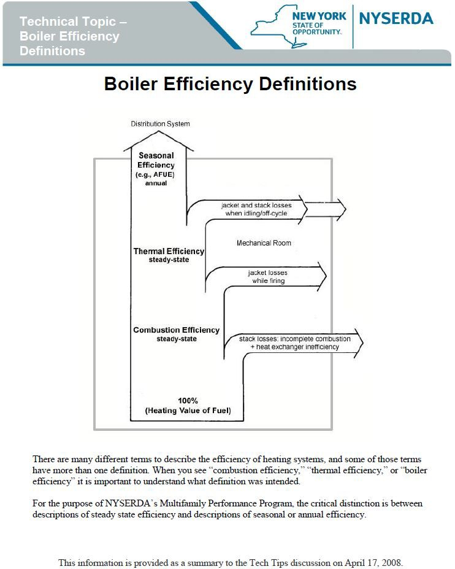
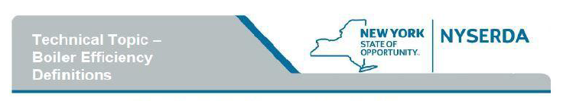

Combustion efficiency and thermal efficiency describe steady state efficiency. Annual Fuel Utilization Efficiency (AFUE) and other measures of seasonal or annual efficiency are non-steady state measures that include a boiler's performance when it is operating at part load and idling between calls for heat.
Working with Efficiency Ratings
ASHRAE Standard 90.1-2004 describes the minimum acceptable ratings for ne
boilers: Boiler Btu/hour input Standard Used for Minimum Rating
<300,000 AFUE
300,000- 2,500,000 Thermal Efficiency (Ei)
>2,500,000 Combustion Efficiency (Ee)

The Hydronics Institute Division of GAMA (HI) provides directories listing these ratings at GAMA Product Directories. Specifically, see the directories for Residential and Commercial boilers.
Combustion Efficiency %= ((Fuel Input – Stack Losses) ÷ Fuel Input) x 100
Combustion efficiency is most commonly defined as shown above and usually describes the results of a combustion efficiency field test on an existing combustion appliance. Combustion efficiency does not account for jacket losses or off cycle losses. The test estimates the heat lost up the stack when the combustion appliance has been firing long enough to reach equilibrium. Stack heat loss is assessed by measuring:
- Net stack temperature, the difference between the temperature in the flue and the temperature in the mechanical mom
- Carbon dioxide concentration or oxygen concentration in the flue gas (%) Carbon monoxide is also often measured, as an indication of unburned flue gases.

Combustion efficiency measurements for an installed combustion appliance account for any inefficiency of the heat exchanger due to soot, scale, or poor maintenance, because heat that fails to transfer through the heat exchanger goes up the stack.
The Hydronic Institute Testing Standard BTS-2000 provides a test procedure foe rating the combustion efficiency of new boilers. The BTS-2000 combustion efficiency test is a more precise version of the combustion efficiency field test. Values for combustion efficiency measured using this standard are given in the Hydronics Institute commercial boiler directory referenced above.
Thermal Efficiency % = (Output/ Input) x 100
The definition of thermal efficiency shown above is also from BTS-2000. When a boiler nameplate provides the input and output BTUs, the ratio of those numbers expresses the thermal efficiency.
Thermal efficiency cannot be tested in the field; it requires metering the fuel input and measuring the

Continued on following page…
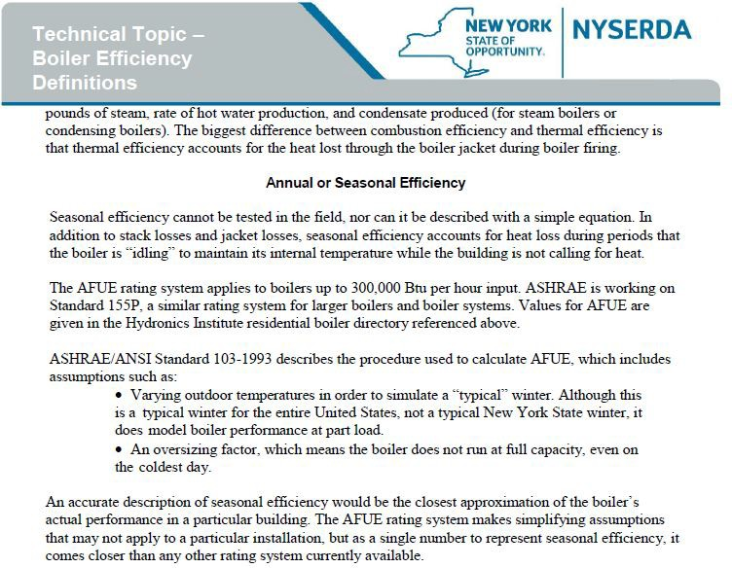

Appendix D: Energy Management Systems

Introduction
In an effort to cost-effectively reduce building-wide overheating, some multifamily building owners choose to install an energy management system (EMS) to control the boiler. The primary function of an EMS in multifamily buildings is to monitor indoor temperatures using a network of temperature sensors and then to use that information to control the heating system. This tech tip focuses on how to use an EMS to better control the run time of the boiler or the temperature of the water circulated through the building.
Background
Many multifamily buildings across New York State are overheated in the winter. In general, the most severe overheating is found in buildings heated by steam and hot water. Frequent causes of overheating are:
• degraded heating distribution systems
• inadequate or improperly calibrated heating system controls
• the complicated reality of heating multifamily buildings
Both New York State Code and New York City Code require a minimum indoor temperature of 68°F during the winter for multifamily buildings. For the purpose of this discussion, we define “overheated” as anything above code minimum, but many building owners aim for a minimum of 70°F to ensure tenant comfort. A range of temperatures is expected, but temperatures more than 72°F are widely considered overheated.

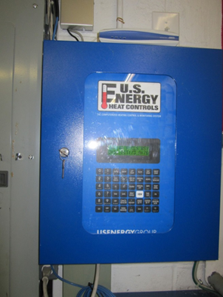
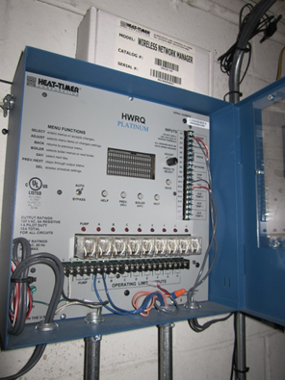
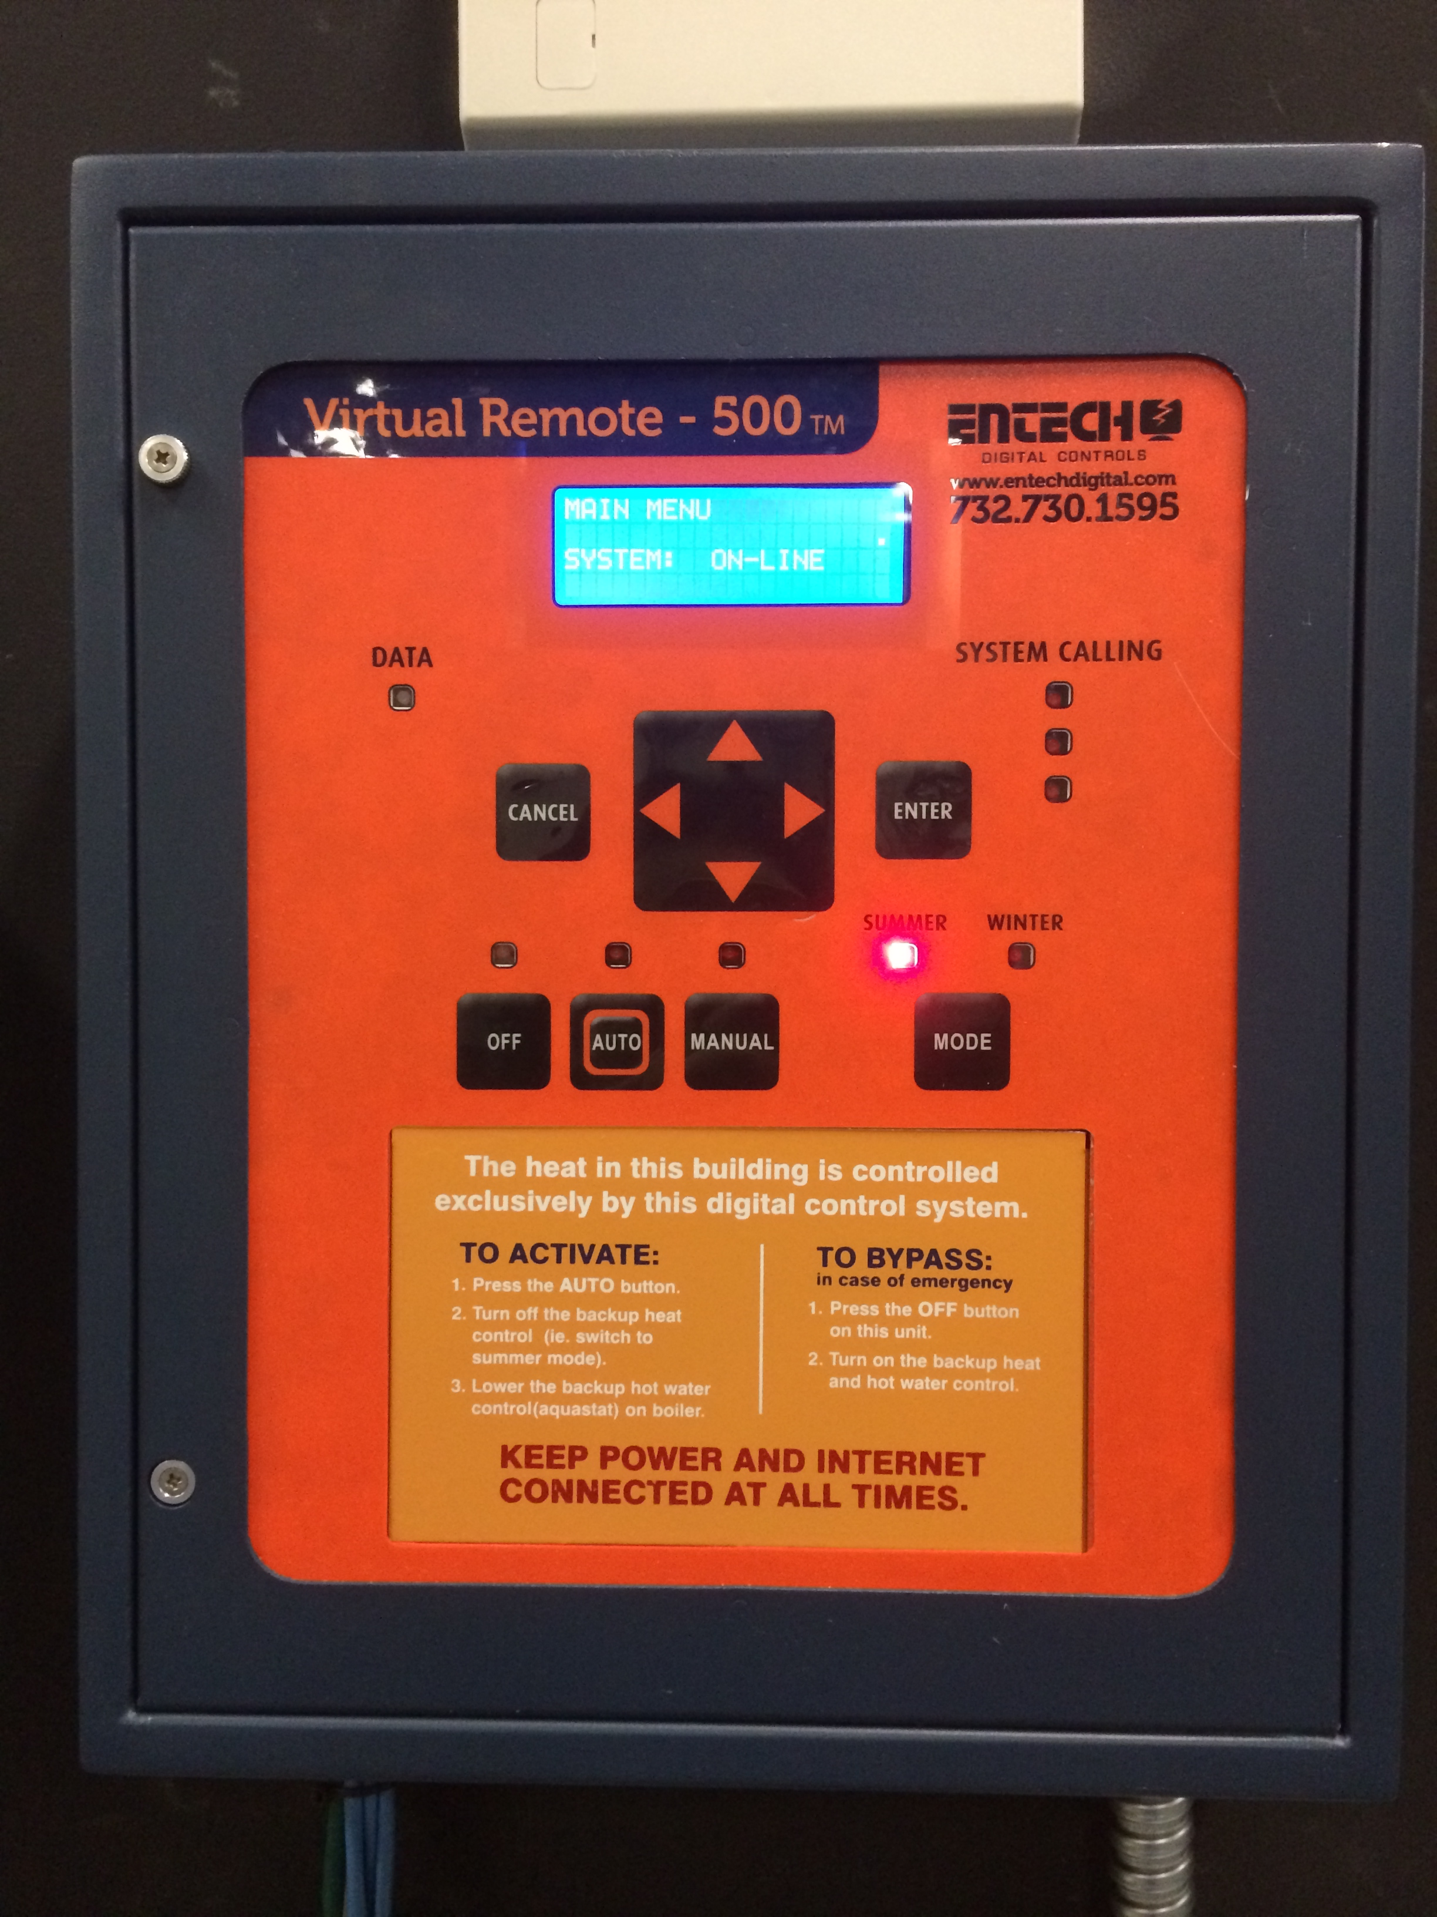
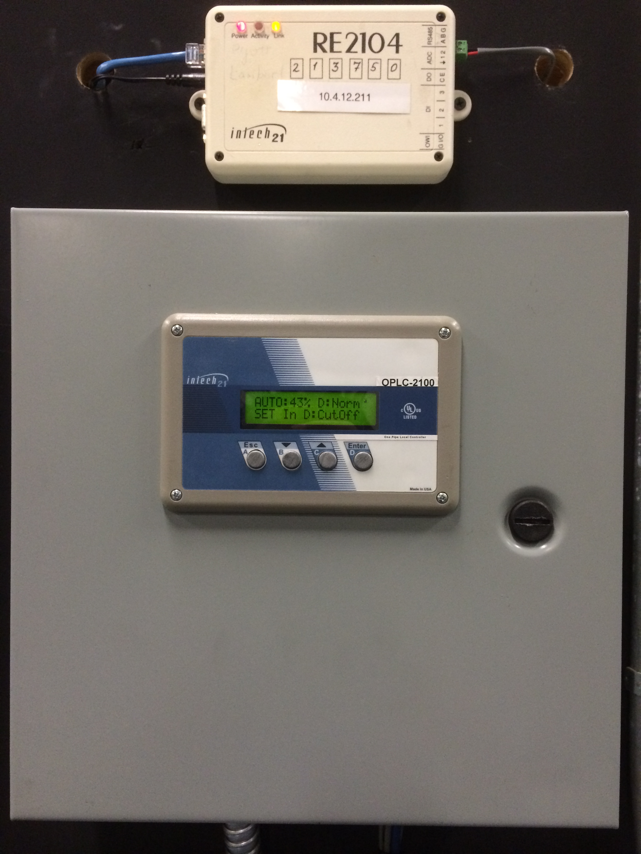
There are many boiler control strategies used to maintain this minimum temperature, and they vary widely in their ability to do so while conserving energy and keeping fuel costs low. Many centralized boiler controls operate without any feedback from indoor temperature sensors, which limits their ability to achieve all three goals. Controls that allow the tenants to adjust the amount of heat coming from a radiator, such as thermostatic radiator valves (TRVs) or thermostats, can reduce both overheating and tenant complaints, but they can be expensive to install. They also typically rely on tenant cooperation to achieve savings. This can make them unappealing for energy conservation retrofits because savings may be unreliable.

NYS and NYC Code
Requirements
New York State – Heat supply. Every owner and operator of any building who rents, leases or lets one or more dwelling unit, rooming unit, dormitory or guestroom on terms, either expressed or implied, to furnish heat to the occupants thereof shall supply heat during the period from September 15th to May 31st to maintain a temperature of not less than 68°F (20°C) in all habitable rooms, bathrooms and toilet rooms. (Section 602.3)
New York City – Heat must be supplied from October 1 through May 31 to tenants in multiple dwellings. If the outdoor temperature falls below 55°F between the hours of six a.m. and ten p.m., each apartment must be heated to a temperature of at least 68°F. If the outdoor temperature falls below 40°F between the hours of ten p.m. and six a.m., each apartment must be heated to a temperature of at least 55°F. (Multiple Dwelling Law § 79; Multiple Residence Law § 173; NYC Admin. Code § 27-2029.)

Figure 1: Central computers of Energy Management Systems installed in the field and manufactured (from left to right) by Heat-Timer, U.S. Energy, EnTech, and Intech 21. Photo credits: Far left and left by Taitem Engineering; right and far right by the Association for Energy Affordability

Description of Energy Management Systems
Energy management systems have two main functions that differentiate them from other types of boiler controls:
First, many EMSs can monitor a wide array of data types and display the data in a computer program or on a website. Depending on the model, data points that can be monitored include domestic hot water temperature, fuel consumption, fuel oil tank level, boiler stack temperature, boiler water usage, and more. Although these monitoring capabilities are often emphasized in marketing materials and can be a useful tool for some boiler operators, they do not produce any energy savings by themselves. Action by the boiler operator is required to turn any of the information listed above into potential energy savings.
Second, EMSs use a network of temperature sensors to better control the run time of the boiler or the temperature of the water circulated through the building. One temperature sensor monitors outdoor air temperature. It determines whether the building should be heated at any given time, where on the outdoor reset curve the boiler should operate, or which curve should be used. Additionally a series of sensors is installed in a sample of apartments to monitor the temperature inside the building.
Multiple temperature sensors are recommended to get an accurate picture of what is going on in the building. Measuring temperatures in several apartments reduces the impact of anomalies caused by open windows, electric heaters, and tenants who shut off their radiators. Best practice: Install sensors in a representative sample of no fewer than 10% of the apartments; this provides adequate redundancy while keeping costs reasonable. Best practice: Install the sensors in apartments on different floors and lines to take into account differences in temperature between upper and lower floors, sunny and shaded sides, and windward and leeward sides of the building. Many EMS manufacturers offer wireless sensors which can reduce installation costs.
The indoor sensors are used to calculate an approximate average building temperature, which the EMS uses to control the boiler. In steam systems, this average temperature is used to prevent unnecessary firing when the building’s target temperature is already met. That is, the apartment sensors “vote.” If enough sensors indicate apartments are warm enough, the EMS keeps the boiler off, and if enough indicate apartments are too cool, the EMS allows the boiler to fire.
In hot water systems, instead of turning the boiler on and off, the EMS uses the apartment temperature data to adjust the outdoor reset curve. For example, if the outdoor reset curve calls for a supply water temperature of 160°F , but the average indoor temperature is close to the setpoint, the outdoor reset curve might be adjusted to provide supply water at 150°F.
Most EMSs can be programmed to lower the indoor temperature at night, which can result in additional savings. We recommend implementing night setback, if permitted by code.
For both steam and hot water systems, the primary result of implementing an EMS is to reduce the average indoor temperature. Keep in mind that the EMS alone cannot supply more heat to specific cold apartments nor reduce the heat supplied to specific hot apartments.

Outdoor Reset Control
In buildings heated with hot water, the use of outdoor reset curves can reduce overheating and save energy by varying the temperature of the water circulating through the building. In general, as the outdoor temperature decreases, warmer water is circulated. Actual water temperatures required are building-specific.
Example: A building might require 140°F circulating water when it is 55°F outside, but 180°F water when it is 20°F outside.
The outdoor reset ratio defines how much the water temperature is increased per degree of outdoor temperature decrease. For example, with a 1:1 ratio, the water temperature is increased 1°F when the outdoor temperature falls 1°F. With a 1:1.25 ratio, the water temperature is increased 1.25°F for every 1°F the outdoor temperature falls.

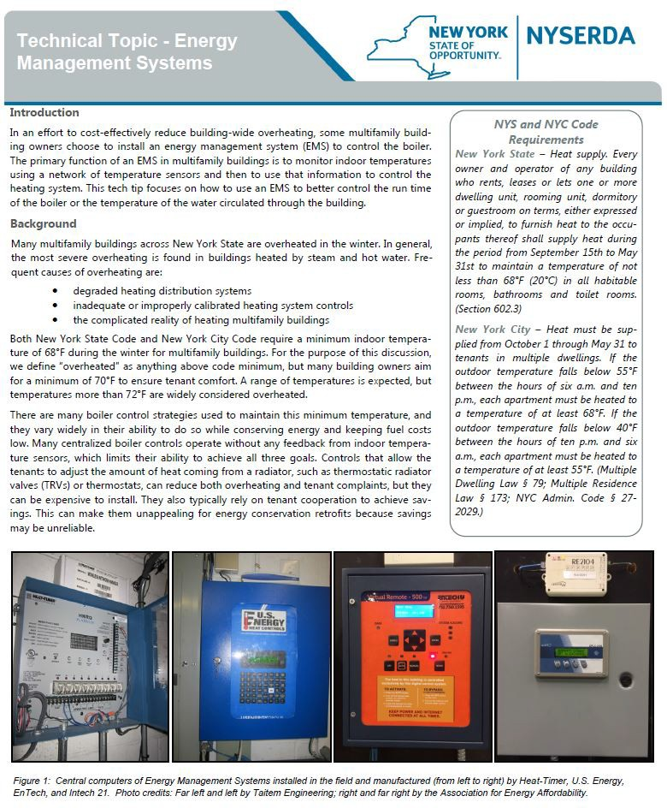
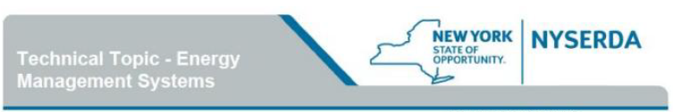

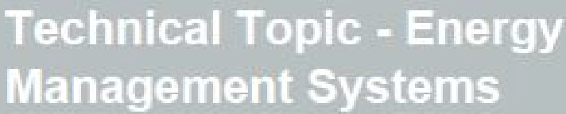
Description of Energy Management Systems
WYORK
TE ORT
NYSERDA
.;....
_
Energy Management systems have two main functions that differentiate them from other types of boiler controls:
Outdoor Reset Control
In buildings heated with hot water, the use of outdoor reset curves can reduce overheating and save energy by varying the temperature of the water circulating through the building. In general, as the outdoor temperature decreases, warmer water is circulated. Actual water temperatures required are building specific.
Example: A building might require 140⁰F circulating water when it is 55⁰F outside, but 180⁰F water when it is 20⁰F outside.
The outdoor reset ratio defines how much the water temperature is increased per degree of outdoor temperature decrease. For example, with a 1:1 ratio, the water temperature is increased 1⁰F when the outdoor temperature falls 1⁰F. With a 1:1.25 ratio, the water temperature is increased 1.25⁰F or every 1⁰F the outdoor temperature falls.
. 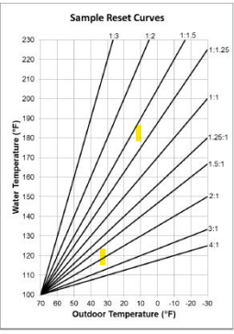

First, many EMSs can monitor a wide array of data types and display the data in a computer program or on a website. Depending on the model, data points that can be monitored include domestic hot water temperature, fuel consumption, fuel oil tank level, boiler stack temperature, boiler water usage, and more.. Although these monitoring capabilities are often emphasized in marketing materials and can be a useful tool for boiler operators. They do not produce any energy savings by themselves. Action by the boiler operator is required to turn of the information listed above into potential energy savings.
Second, EMSs use a network of temperature sensors to better control the
run time of the boiler or the temperature of the water circulated through the building. One temperature sensor monitor outdoor air temperature. It deter­ mines whether the building should be heated at any given time, where on the
outdoor reset curve the boiler should operate, or which curve should be used. Additionally a series of sensors is installed in a sample of apartments to monitor the temperature inside the building.
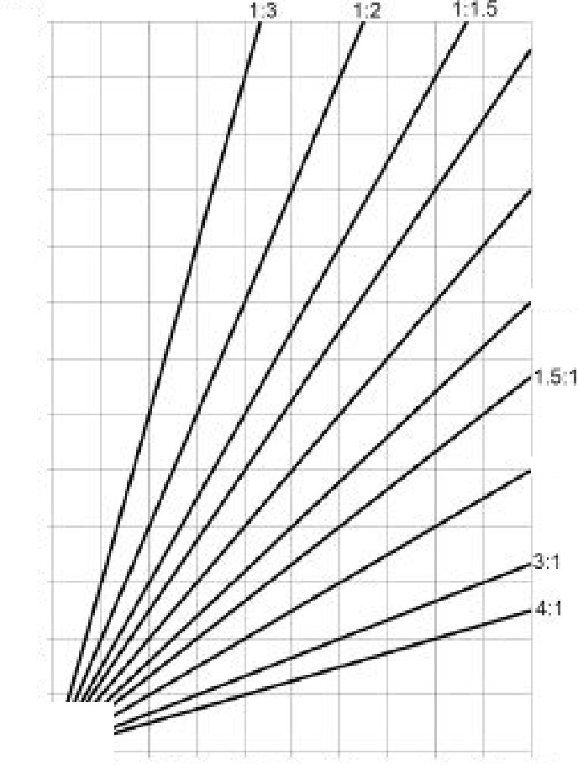
Multiple temperature sensors are recommended to get an accurate picture of what is going on in the building. Measuring temperatures in several apartments reduces the impact of anomalies caused by open windows, electric heaters, and tenants who, shut off their radiators, Best practice: Install sen­ sors in a representative sample of no fewer than 10% of the apartments; this provides adequate redundancy while keeping costs reasonable. Best practice:
Install the sensors in apartments on different floors and lines to take into account differences in temperature between upper and lower floors, sunny and shaded sides, and windward and leeward sides of the building. Many EMS manufacturers offer wireless sensors which can reduce installation costs.
The indoor sensors are used to calculate an approximate average building temperature, which the EMS uses to control the boiler. In steam systems, this average temperature is used to prevent unnecessary firing when the building's target temperature is already met That is, the apartment sensors "vote.” If enough sensors indicate apartments are warm enough, the EMS keeps the boiler off, and if enough indicate apartments are too cool, the EMS allows the boiler to fire.
In hot water systems, instead of turning the boiler on and off, the EMS uses the apartment temperature data to adjust the outdoor reset curve. For example, if the outdoor reset curve call's for a supply water temperature of 160⁰F but the average indoor temperature is close to the setpoint, the outdoor reset curve might be adjusted to provide supply water at 150⁰F,
Most EMSs ·can be programmed to lower the indoor temperature at night; which can result in additional savings. We recommend implementing night
setback, if permitted by code.
For both steam and hot water systems, the primary result of implementing an EMS is to reduce the average indoor temperature. Keep in mind that the EMS alone cannot supply more heat to specific cold apartments nor reduce the heat supplied to specific hot apartments.
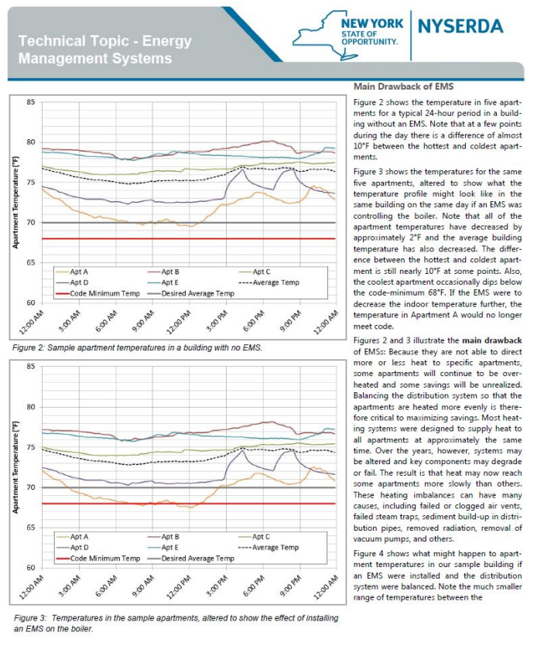

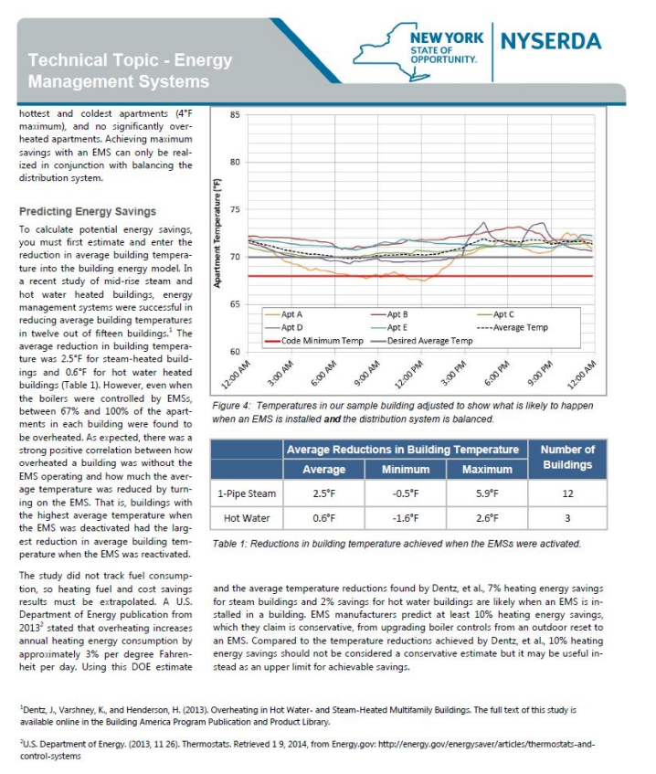
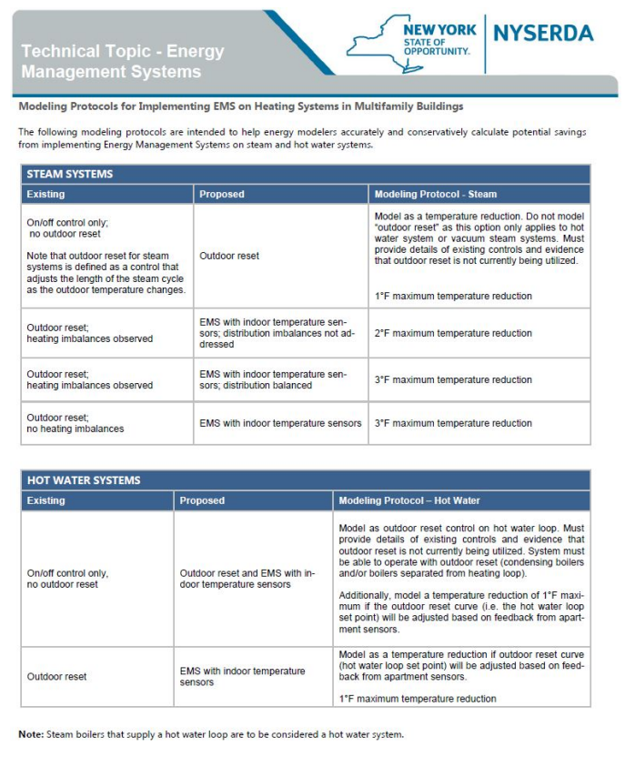
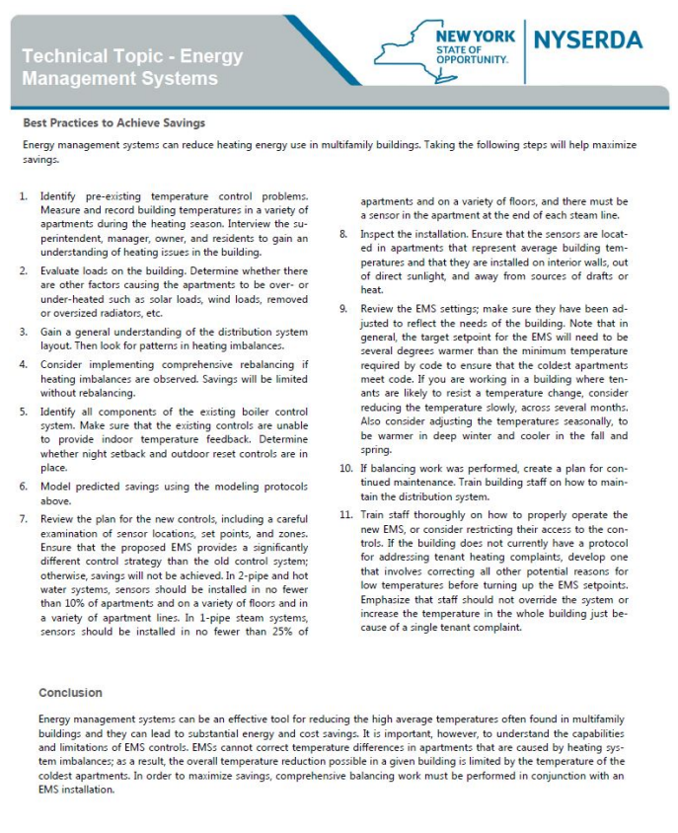

Appendix E: Technical Topic—LED Screw-In Replacements
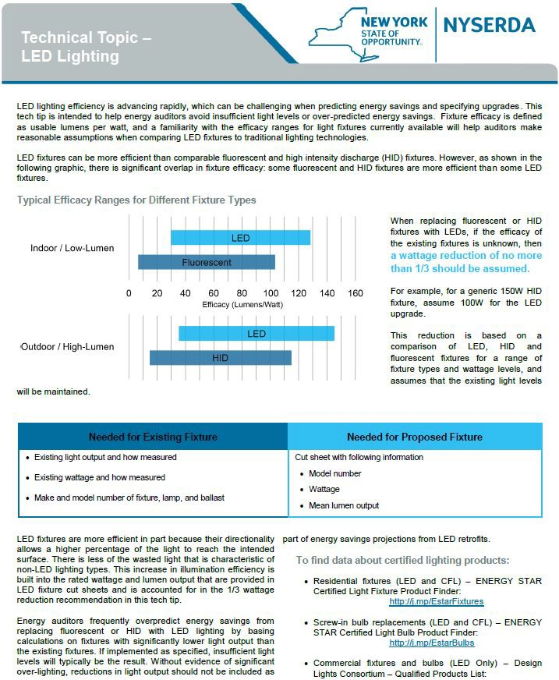

Appendix F: Technical Topic—Elevator Energy Use and Other Essentials
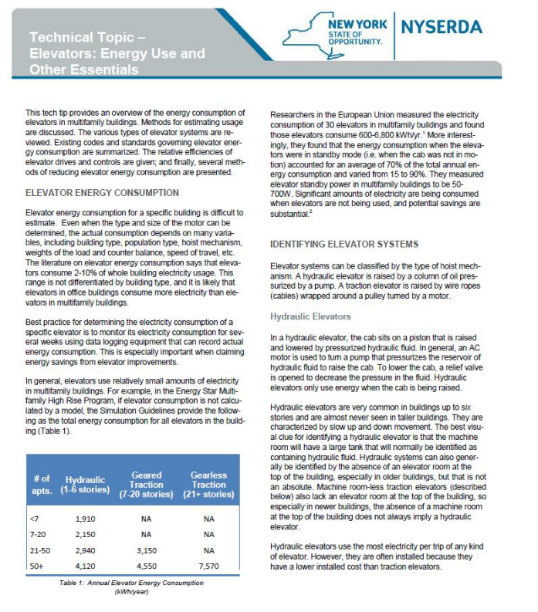

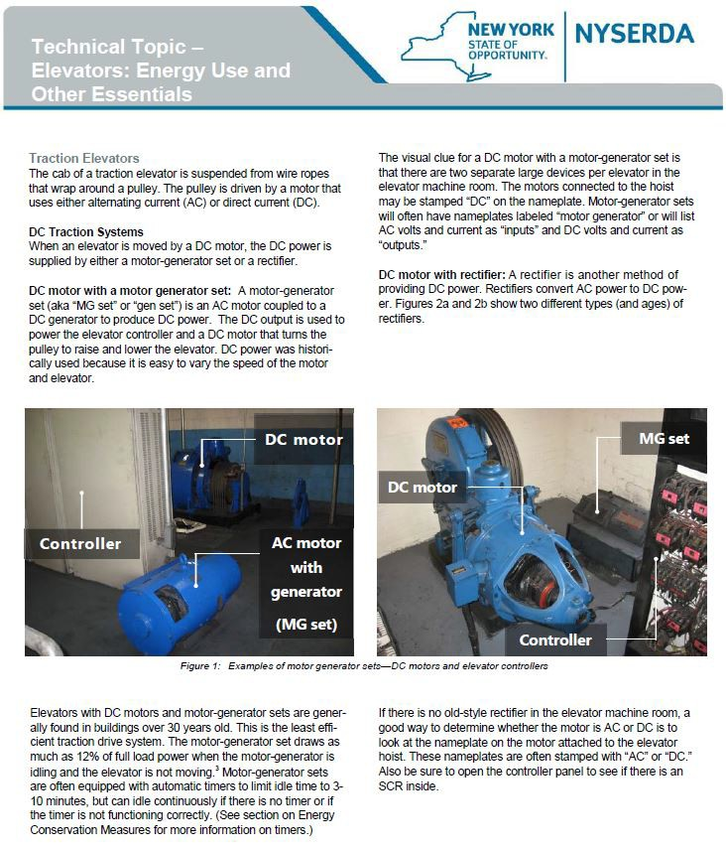

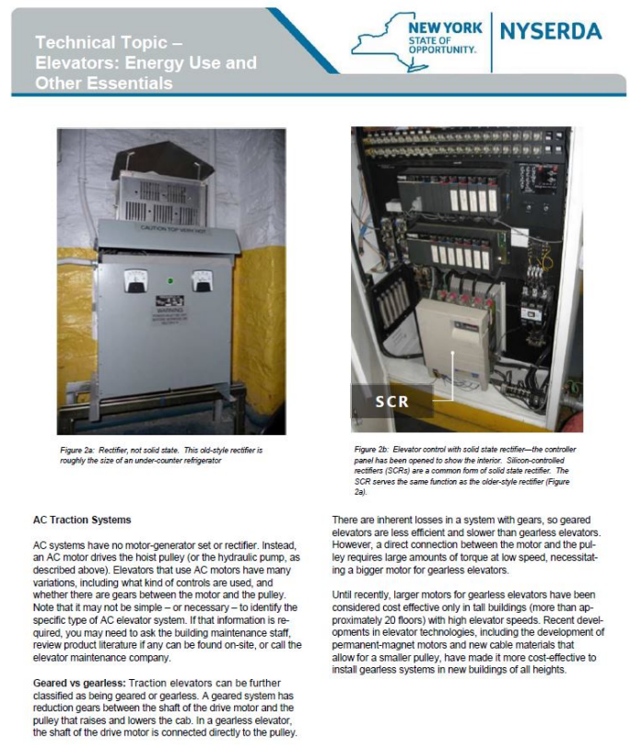

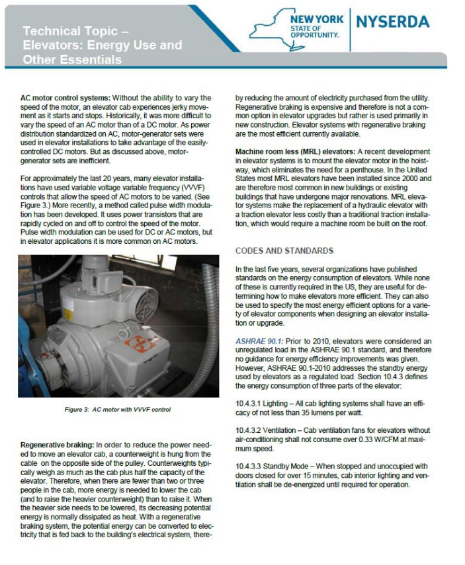
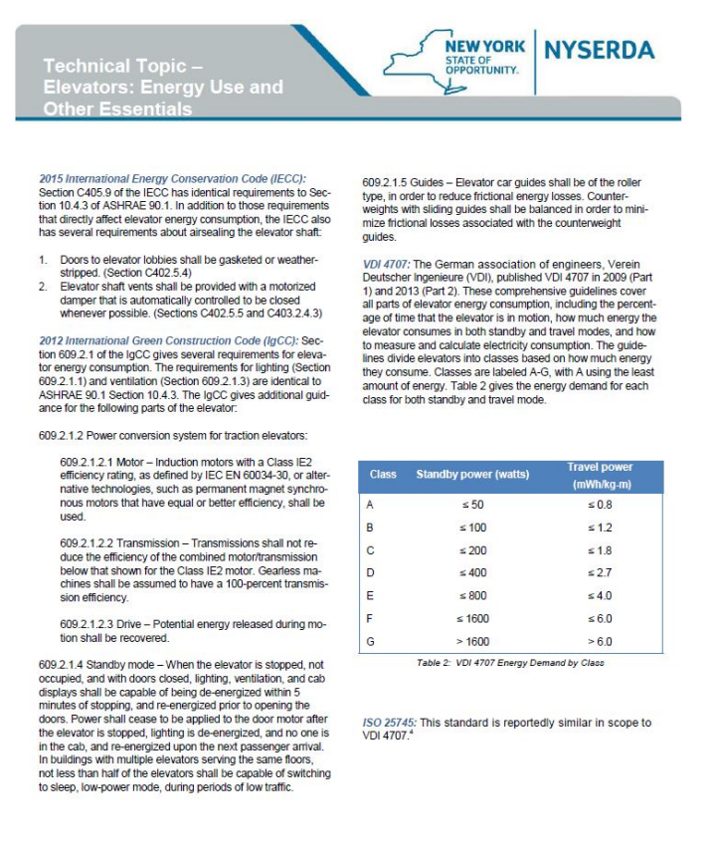
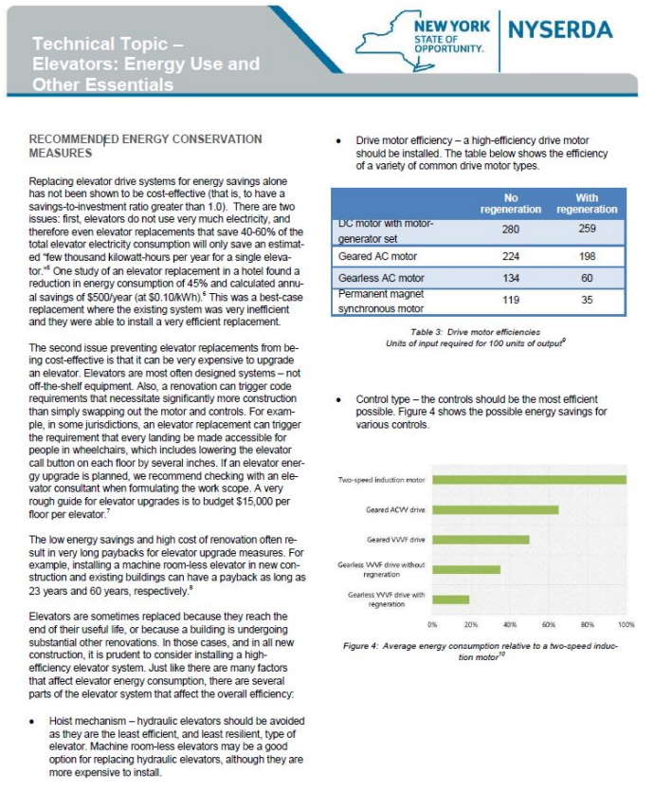

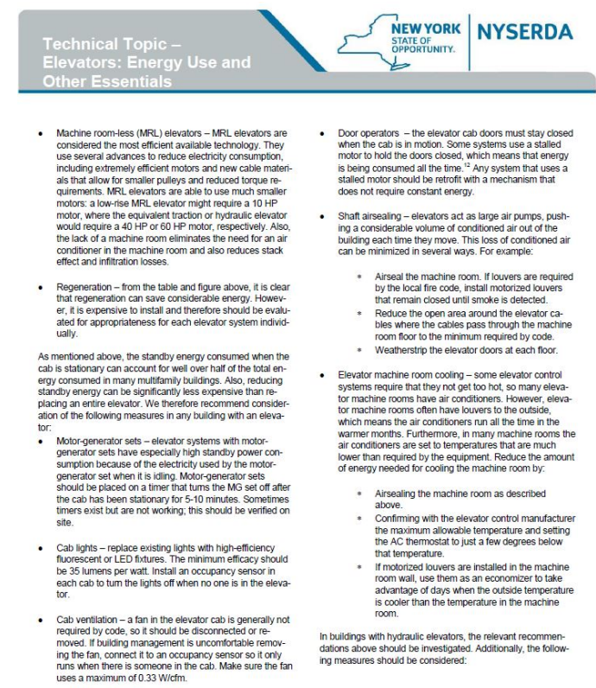

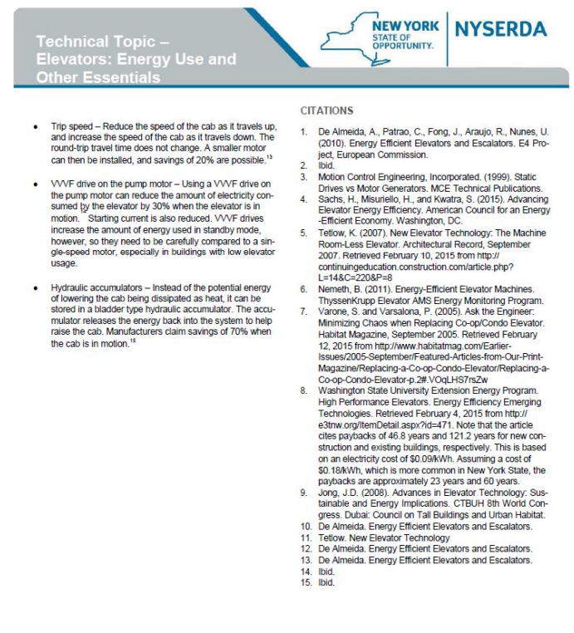

Appendix G: Technical Topic—Indoor Temperature
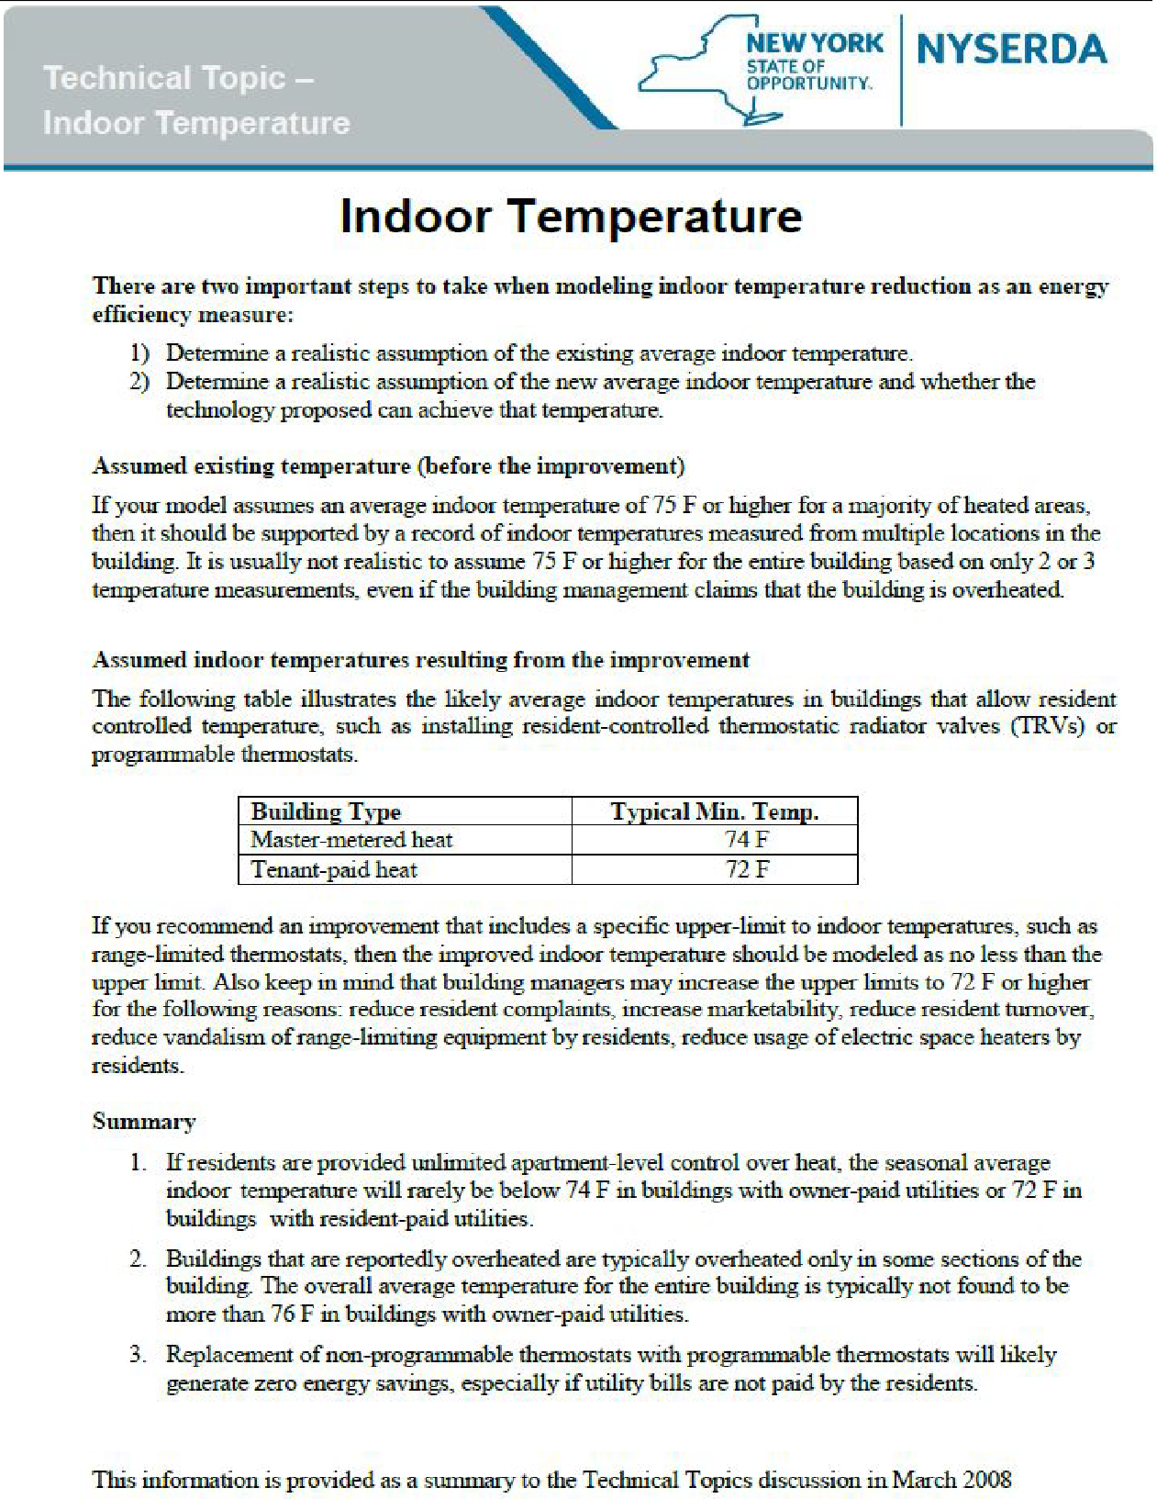

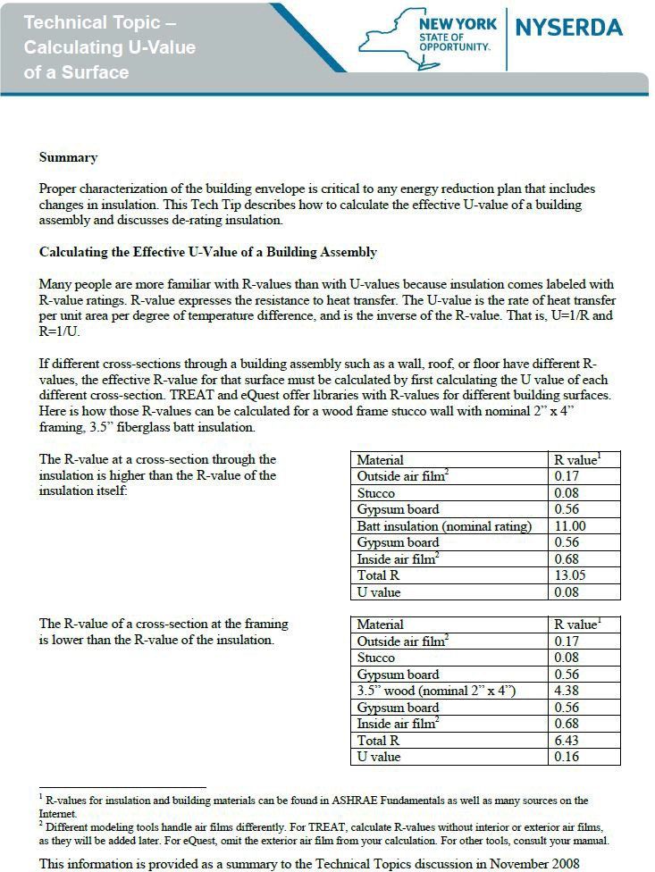
Appendix H: Technical Topic—Calculating the U-Values of a Surface

Assume (per ASHRAE 90.1-2004), that the studs, plates, sills and headers are 25% of the total area of a wood-framed wall, while the cavity insulation is 75% of the total area.

The effective U-value of this wall assembly would be calculated as:
Effective U-value = (0.75 x0.08) + (025 x. 0.16)= 0.1
The effective R-value for the, wall assembly is 1/0.l = 10, lower than the nominal R-value of the
insulation.

ASHRAE Standard 90.1-2004 contains a series of tables that show the effective R-value of different wall, roof and floor assemblies, including both cavity and continuous insulation. If you are considering a building whose construction is not described in the TREAT or eQUESTlibraries or the ASHRAE Standard 90.1-2004 tables, you can calculate its R-value using the procedure described previously.
ASBRAE Fundamentals contains R-values for many building materials; these values are also widely available on the Internet. In addition, Oak Ridge National Laboratory offers free R-value calculation software at http://www.ornl.gov/sci/roof+walls/AWT/InteractiveCalculators/index.htm.

Assumptions: about the fraction of the total surface area that is insulated (compared to the fraction that consists of framing members) have a large effect on the effective U-value of the surface. According to Oak Ridge National Laboratory (ORNL), framing factors such as studs, wall/wall (corners), wall/roof wall/floor, wall/door, and wall/window connections can occupy 10% to 40% of the wall area.
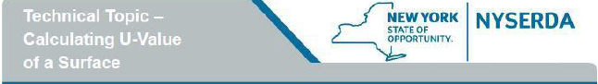
Appendix A of ASHR.AE 90.1-2004 recommends the following assumptions for wood-framed buildings:

Construction type | Material | %of surface  area
Attic roof with, wood joists, Standard framing (insulation  tapers at perimeter) | Full-depth insulation Half-depth insulation  Joists | 85%  5%  10%
Attic roof with wood joists, Advanced framing | Full-depth insulation Joists | 90%  10%
Single-rafter roof (ceiling and roof attached to the same rafter) | Full-depth insulation Joists | 90%  10%
Wood-framed walls,  Standard framing (16” on center) | Insulated cavity  Studs, plates and sills Headers | 75%  21%  4%
Wood-framed walls, Advanced framing  (24” on center) | Insulated cavity Studs, plates: and sills Headers | 78%  18%  4%

This information .is provided as a summary to the Technical Topics discussion in November 2008

Metal Wall Studs
The attached table reproduced from ASHRAE Standard 90.1-2004, Appendix A presents measured R- values for wall insulation installed between steel framing. Metal framing presents a special situation because of the metal’s high thermal conductivity. To calculate the U value for a wall with metal studs, use the R-value of the rest of the wall assembly (e.g. masonry, interior gypsum board, interior and exterior airfilms), using the procedure described previously.

TABLE A9.2B Effective Insulations/Framing Layer R-Values for Wall Insulation Installed Between Steel Framing
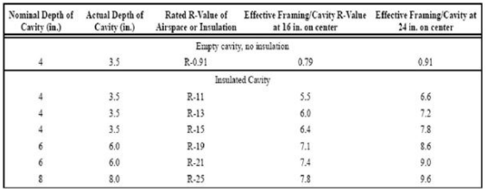

The table below excerpts ASHRAE Standard 90.1-2004, Appendix A, Table A9.2A, which provides measured R-values for metal framed roofs. As with metal-framed walls, you should add the R-values of an films and construction material to this base value.

Effective Insulation/Framing Layer R-Values for Roof and Floor Insulations Installed Between Metal Framing

Rated R-Value of Insulation | Framing/Cavity R-Value
11.00 | 10.01
19.00 | 16.34
38.00 | 28.12
55 | 36.85

If your insulation is an intermediate R-value between those provided in the table, it is legitimate to interpolate between the framing/cavity R-values shown in the table.

Appendix I: Technical Topic—Cut Sheet Requirements

