Temperature and the Tomato

SPN LESSON #38


TEACHER INFORMATION

LEARNING OUTCOME
After learning the genetic and environmental variables that influence plant growth, and after designing and carrying out an experiment on comparative growth of tomato varieties, students are able to predict whether given sets of conditions are conducive to tomato growth. They also are able to relate energy production in tomato plants to energy production in photovoltaic panels.

LESSON OVERVIEW
Students examine several variables that influence plant growth: genetic variation, temperature, and the relative amount of sunlight. It is really the interaction of temperature with genetic variety that governs the results of the experiment student group’s design for this lesson.

The early part of the Student Handout section introduces students to two different reproductive adaptations exhibited by tomato plants. The two distinctly different strategies permit the plants to flower and fruit successfully. Students learn that environmental conditions played a role in the development of the two groups (determinate and indeterminate varieties). Growers selected traits that influenced the time it takes the plants to flower and the length of time the plants produce fruit.

The latter part of the Student Handout section engages students in the process of experimental design. Here, all variables except the variety of tomato are kept constant. The photovoltaic panel is used as a data source. Students find the average temperature and insolation for a two-week period, and then determine if the temperature is suitable for tomato growth. An analogy is drawn between light energy being converted to electrical energy by the PV panel and into chemical bond energy by the tomato plants.

GRADE-LEVEL APPROPRIATENESS
This Level III Living Environment lesson is intended for use with students in grades 9–10.

MATERIALS
Photocopy the Student Handout section, including the “Average Daily Temperature and Amount of Insolation for Two-Week Period” chart. Make sure each student has a copy.
For a class of 24 students, you will also need: approximately 10 seed catalogs for student reference, 2+ gallons of potting soil, 72 planting containers (plastic cups with holes poked in the bottom), plastic trays
in which to set the cups, tomato seeds of several different varieties, marking pens for labeling the containers, 12 plastic spoons for scooping the potting soil into the cups, and 12 thermometers. The amount of soil, number of seeds, and number of planting trays will vary depending on the size of the plastic cups you select for planting containers. Quantities will also vary due to students’ designing different experiments. It would be a good idea to have a supply of newspaper to spread out over the laboratory benches or student desks to contain the mess. Students can use extra plastic cups to water their setups.
Another option would be to provide students with sealable plastic sandwich-size food storage bags and paper towels. Each team of two students will need approximately three sealable bags, six paper towels (two per bag), and seeds. The towels could be wet and the tomato seeds could be placed on top of them. Each bag could be labeled with the tomato variety, the date, and student names. The cups should have the same labels. The benefit of this method is that it is relatively inexpensive, takes up less space than the cups, and students can readily observe what is happening. The benefit of using cups of soil is that the tomatoes can continue to grow, the plants may be transplanted, and the fruit may be harvested. The tomato plants may be taken home by students, grown in the school greenhouse, donated to a community garden, or sold as a fund-raiser for a school organization.
Students will require access to the school or community library and the Internet.

SAFETY
Caution students to observe your laboratory safety rules. Otherwise, there are no special precautions for this lesson.

TEACHING THE LESSON
This lesson can be taught at any time during the school year. Temperature and insolation readings should be taken from the photovoltaic monitor. If the weather is freezing, students may think that it’s silly to record this data for a tomato activity—anyone should know it’s too cold to grow tomatoes! However, students should see that there is light available and that it is the temperature that’s all wrong. The low temperatures will be a perfect lead-in to what students can do to extend the growing season of the tomato plant and other plants grown for food and flowers.
• Introduce the activity by asking students what they have observed about how plants and animals change with the seasons. Make a list of these observations on the board, on overhead transparencies, or on a large sheet of newsprint. Ask students to speculate about why the plants and animals undergo the changes they mention.
• Next, distribute to the students the Student Handout section of Temperature and the Tomato.
• Have students work in teams of two to design their experiments. Check to see that the only variable in the student designs is the variety of tomato seed being planted. Discuss with students that it is important to plant a number of seeds of each variety because not all seeds will germinate. The percentage likely to germinate (referred to as “percent germination”) is generally listed on seed packets.
ACCEPTABLE RESPONSES FOR DEVELOP YOUR UNDERSTANDING SECTION
1. (a) In which growing zone(s) is New York State?
Depending on the part of the State students live in, they could report that they are in Zone II (most of upstate New York), Zone III (Westchester and vicinity), or Zone IV (New York City and Long Island).

(b) What does your zone tell you about the types of plants one can grow in different parts of the State?
Students may respond that most of the plants will require a short growing season. However, some parts of the State (e.g., Long Island) have a longer growing season than other parts (e.g., the Adirondacks). It would also be acceptable for students to indicate that it is possible for different plant varieties to grow in the different regions.

2. (a) Which sections of the United States seem to have the shortest growing season?
Northern states bordering on Canada have the shortest growing season. Also, states having mountains, such as Colorado and Wyoming, have short growing seasons.

(b) What would account for this?
Long, cold winters would account for this.

3. Why do Texas, Louisiana, and Florida have a long growing season?
They are farther south and as a result, the Sun’s rays are more direct there. They have a shorter, warmer winter than the other zones. Also, the ocean helps to moderate their climate so that temperature changes are less extreme.

4. (a) What are the daily temperature and insolation averages for your area right now? Use the information provided by the photovoltaic weather monitor to determine these.
Answers will vary.
- How is this information useful to gardeners?
Gardeners can use this information when they are trying to determine what plants can grow in the area and when it is a good time to plant.

(c) Why is the amount of sunlight available important to plants?
Sunlight is necessary for photosynthesis.

5. Which varieties (A–F) could you grow outdoors in your zone and expect to produce fruit?
Answers will vary depending on which part of the State students live in. Most of the State is in Zone II, where varieties B and C can be grown successfully. Variety E might do OK but planting it involves a greater financial risk.

6. (a) Which variety would produce the greatest yield of fruit in your area?
Answers will vary. In Zone II, variety B will probably produce the highest yield.
(b) Which variety would produce the greatest yield of fruit in Florida? Montana?
In Florida, variety D will yield 6.8 kg of fruit every 10 days. In Montana, variety E will produce 2.6 kg of fruit every 10 days.

7. In 1998, El Nino influenced weather around the world. In many regions of the United States, temperatures were several degrees higher than usual. Describe what effect this could have on plant growth in general.
If the temperature in an area got warmer over a period of time, the types of plants able to grow in that area would change. Plants adapted for a different zone might be able to grow.
- Different plants flower and produce fruit during different months of the growing season. Some plants are called “long-day” plants, while others are referred to as “short-day” plants. Some plants are “day-neutral.” Use the Internet and/or science textbooks to find out what is meant by the terms long-day, short-day, and day-neutral. Use what you have learned to explain how tomato plants are classified and what this would mean in terms of the amount of daylight they must receive.
Tomato plants are day-neutral. The relative length of light and dark periods does not regulate flowering and fruit production. This would mean that tomatoes can be grown any time of the year as long as temperature and other variables are favorable.

9. You are writing a nature column for the local newspaper. Select an animal and explain how temperature affects its life cycle. Be sure to include the influence of temperature on its habitat, food, and ability to reproduce.

Have students select different animals found in the region. Arctic animals are excellent choices, as are animals that migrate or hibernate. Be sure to caution students to focus on what the temperature changes are and how the animal’s adaptations are responsive to them.

ADDITIONAL SUPPORT FOR TEACHERS

SOURCE FOR THIS ADAPTED ACTIVITY
The idea for this activity came from a case study by the same name in Science III: Essential Interactions, published by Centre Pointe Learning, Inc., Cincinnati, Ohio.

BACKGROUND INFORMATION
Experimental Design
Have students rework their designs until they hold all of the variables constant except the variable “variety of tomato.” For instance, the seeds should be planted in the same type and amount of soil, receive the same amount of sunlight and water, and be kept under the same temperature conditions. Each group should develop a data table that records the variety of tomato seed planted in each individual container, the number of seeds that are planted, how many germinate, how long it takes the plants to grow above the soil, and how tall the plants become over the duration of the experiment. Have them include:
a. A statement of the problem/question investigated with a clear definition of dependent and independent variables.
The dependent variable is the rate of germination and growth. The independent variable is the variety of tomato.
b. A description of how their group performed the experiment (a clear description of experimental procedures is necessary).
Answers will vary.
c. A description of what their group found (data—organized in charts or graphs, as necessary—must be provided).
Answers will vary.
d. A description of what their group concluded (on the basis of experimental findings only) and how valid their group thinks these conclusions are.
Students should find that different varieties of tomatoes germinate and grow at different rates when all other variables are kept constant.
e. A description of what they might do to improve their experiment.
Suggestions might include: plant more seeds; plant additional varieties of tomatoes; observe and measure more carefully.

Science and the PV Panel
• There are many varieties of tomatoes. For the purpose of this activity, there is one group in which all of the varieties included grow into short, bushy plants that do not require staking. These are referred to as “determinate” varieties. These plants produce all of their fruit at once. A second group of tomato varieties is referred to as “indeterminate.” These tomato plants require staking. They form long, sprawling vines and once they start producing, they continue to produce until frost destroys them.
• The germination period for a plant is how long it takes for a seed to sprout once it is planted. Temperature is only one factor that influences the germination period of a seed. Others factors include the amount of moisture, oxygen, and light. Some plant species require light for germination, while others require darkness. Seed companies generally list the germination period on the packet. The shorter the time, the more quickly the seed sprouts, and the faster the plant reaches maturity.
• The photovoltaic panel monitor provides both the ambient air and panel surface temperatures. For the purpose of this investigation, have students record the air temperature only. You may want to have teams of students responsible for recording and sharing the photovoltaic panel data, or you may want to have students access the data via the computer network. While recording the temperature data, students should also record the amount of insolation. This number will represent the potential radiant energy available for photosynthesis. Help students to understand that there are many factors that influence plant growth and that energy availability is only one of them. The solar energy so important to plants can be accessed by photovoltaic panels and converted to electrical energy. The processes occurring in both the plants and the panels actively convert radiant energy into another energy form—the chemical energy in organic molecules and electrical energy.
• Until recently, it was thought that the number of hours of sunlight a plant was exposed to determined when it would flower. Now it is known that length of uninterrupted darkness is the critical factor. A short-day plant is actually one that requires a long period of darkness. These plants form flowers when daylight length is less than 12 hours. Many plants that bloom in the spring and fall are short-day species. Exposing them to more than 12 hours of daylight inhibits flower formation. There are other species of plants that require more than 12 hours of light. These are referred to as long-day plants (they could be called “short-night” plants!). Many plants that flower during the summer months are long-day species. Tomatoes are day-neutral plants. They will form flowers regardless of day length.

REFERENCES FOR BACKGROUND INFORMATION
Allen, R. D. and Stroup, D. J. Teaching Critical Thinking Skills in Biology. National Association of Biology Teachers. Reston, VA, 1993.

Carey, S. S. A Beginner’s Guide to Scientific Method. Wadsworth Publishing Company. Belmont, CA, 1994.

Cothron, J. H., Giese, R. N. and Rezba, R. J. Students and Research: Practical Strategies for Science Classrooms and Competitions. Kendall/Hunt. Dubuque, IA, 1993.

Crow, L. W. Enhancing Critical Thinking. Society for College Science Teachers. Washington, DC, 1989.

Deno, N. C. Seed Germination Theory and Practice. Pennsylvania State University. State College, PA, 1993.

Freedman, R. L. H. Open-Ended Questioning: A Handbook for Educators. Addison-Wesley. Menlo Park, CA, 1994.

Grow Lab: A Complete Guide to Gardening in the Classroom. National Gardening Association. Burlington, VT, 1988.

Morholt, Evelyn and Brandwein, Paul F. A Sourcebook for the Biological Sciences. 3rd edition. New York: Harcourt Brace Jovanovich, Publishers, 1986.

Tent, C. Seeds: Seed Experiments for Students. Biotech Publishing. Angleton, TX, 1992.

LINKS TO MST LEARNING STANDARDS AND CORE CURRICULA

Standard 1—Analysis, Inquiry, and Design: Students will use mathematical analysis, scientific inquiry, and engineering design, as appropriate, to pose questions, seek answers, and develop solutions.
Science Key Idea 1: The central purpose of scientific inquiry is to develop explanations of natural phenomena in a continuing and creative process.
S1.1: Elaborate on basic scientific and personal explanations of natural phenomena, and develop extended visual models and mathematical formulations to represent one’s thinking.
S1.1b: Measure and record experimental data.
S1.2: Hone ideas through reasoning, library research, and discussion with others, including experts.
S1.2a: Ask questions and locate, interpret, and process information from a variety of sources.
S1.2b: Make judgments about the reliability of a source and the relevance of information.
S1.3: Work toward reconciling competing explanations; clarify points of agreement and disagreement.
S1.3a: Accept scientific explanations only when they
• are consistent with experimental and observational experience
• can be used to make accurate predictions
Key Idea 2: Beyond the use of reasoning and consensus, scientific inquiry involves the testing of proposed explanations involving the use of conventional techniques and procedures and usually requiring considerable ingenuity.
S2.1: Devise ways of making observations to test explanations.
S2.2a: Develop a research plan which involves researching background information and understanding the major concepts in the area being investigated.
Key Idea 3: The observations made while testing proposed explanations, when analyzed using conventional and invented methods, provide new insights into natural phenomena.
S3.1: Use various methods of representing and organizing observations (e.g., diagrams, tables, charts, graphs, equations, matrices) and insightfully interpret the organized data.

Standard 4—The Living Environment: Students will understand and apply scientific concepts, principles, and theories pertaining to the physical setting and living environment and recognize the historical development of ideas in science.
Key Idea 1: Living things are both similar to and different from each other and from nonliving things.
1.1b: An ecosystem is shaped by the nonliving environment as well as its interacting species. The world contains a wide diversity of physical conditions, which creates a variety of environments.
Key Idea 2: Organisms inherit genetic information in a variety of ways that result in continuity of structure and function between parents and offspring.
2.2: Explain how the technology of genetic engineering allows humans to alter genetic makeup of organisms.
2.2a: For thousands of years new varieties of cultivated plants and domestic animals have resulted from selective breeding (an early form of genetic manipulation) for particular traits.
Key Idea 5: Organisms maintain a dynamic equilibrium that sustains life.
5.1: Explain the basic biochemical processes in living organisms and their importance in maintaining dynamic equilibrium.
5.1a: The energy for life comes primarily from the Sun. Photosynthesis provides a vital connection between the Sun and the energy needs of living systems.
5.3: Relate processes at the system level to the cellular level in order to explain dynamic equilibrium in multicellular organisms.
5.3a: Dynamic equilibrium results from detection of and response to stimuli. Organisms detect and respond to change in a variety of ways at the cellular level and at the organismal level.
Key Idea 6: Plants and animals depend on each other and their physical environment.
6.1: Explain factors that limit the growth of individuals and populations.
6.1e: In any particular environment, the growth and survival of organisms depend on the physical conditions including light intensity, temperature range, mineral availability, soil/rock type, and relative acidity (pH).

Laboratory Skills
i. Follows safety rules in the laboratory.
ii. Selects and uses correct instruments.
v. Makes observations of biological processes.
ix. Designs and carries out a controlled, scientific experiment based on biological processes.
xi. Differentiates between independent and dependent variables.
xiii. Collects, organizes, and analyzes data, using a computer and/or other laboratory equipment.
xiv. Organizes data through the use of data tables and graphs.
xv. Analyzes results from observations/expressed data.
xvi. Formulates an appropriate conclusion or generalization from the results of an experiment.
xvii. Recognizes assumptions and limitations of the experiment.

Extended Activities:
• Record seasonal changes seen in a pet. Describe how these changes might be temperature related.
• Repeat the tomato germination experiment but this time vary the temperature, the amount of sunlight, or the length of the period of light to which the seeds/plants are exposed.

Produced by the Research Foundation of the State University of New York with funding
from the New York State Energy Research and Development Authority (NYSERDA)
www.nyserda.org

Should you have questions about this activity or suggestions for improvement,
please contact Bill Peruzzi at billperuz@aol.com

(STUDENT HANDOUT SECTION FOLLOWS)

Name ___________________________________
Date ____________________________________

Temperature and the Tomato
Have you ever wondered why there are no palm trees growing in your yard? How is it possible that in some parts of the country people can grow tomatoes in their backyard gardens year-round, while in New York State tomatoes can only be grown during the summer? What role does temperature play in determining what plants can grow successfully in an area? What role does the amount of sunlight play?
Most plants begin to grow when the soil temperature is over 5ºC. The length of the growing season in a region is equal to the number of days with an average temperature above 5ºC. Daily temperatures higher than 5ºC are necessary to produce a good crop. The Hardiness Zone Map shows the growing zones, referred to in many seed catalogs as “hardiness zones,” in the United States. Catalogs selling seeds and plants to gardeners generally include a copy of this map. For each plant variety, the catalog also indicates the zones in which it can be grown successfully.
This temperature zone map shows the minimum temperatures expected for North America. Zone maps like this are typically used to determine tree and plant hardiness for a particular geographic area.



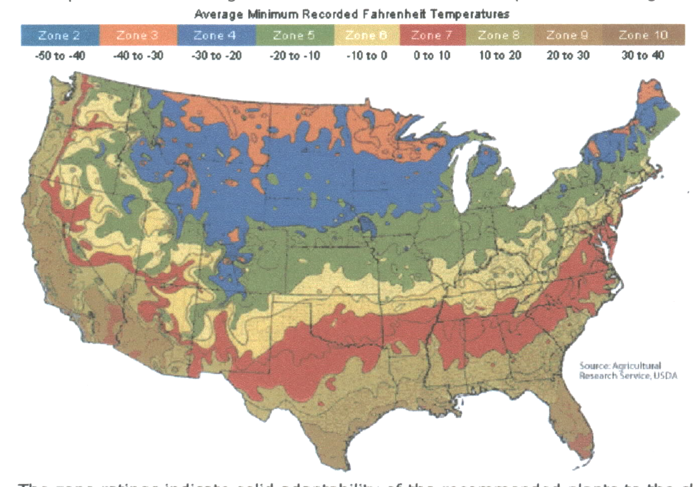

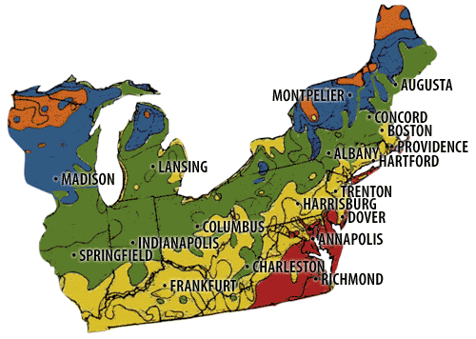

DEVELOP YOUR UNDERSTANDING
Refer to the map and answer questions 1–3.
1. (a) In which growing zone(s) is New York State?

(b) What does this tell you about the types of plants you can grow in different parts of the State?

2. (a)Which sections of the United States seem to have the shortest growing seasons?

(b) What would account for this?

3. Why do Texas, Louisiana, and Florida have long growing seasons?

4. (a) What is the average daily temperature in your area right now? How much sunlight is available for plant growth? Use the data provided by the photovoltaic weather monitor to determine the average daily temperature and amount of sunlight (insolation) for the next two weeks. Record the information in the “Average Daily Temperature and Amount of Insolation for Two-Week Period” chart.

(b) Explain how this information is useful to gardeners.

(c) Why is the amount of sunlight available important to plants?

The Growing Season and the Tomato
Growing tomatoes in New York State can be a problem. If you plant a tomato seed outside, it will not germinate until the soil temperature is at least 10ºC. That might not happen until 20 or more days into the growing season. Then, after germination, the plant will not continue to grow until the temperature overnight is at least 7ºC or higher. On cool days, it will grow more slowly than on warm days.
Tomato breeders have taken care of some of the problems by cross-pollinating plants with short growing seasons and good fruit yield. Over time, they have been able to develop new varieties that will grow quickly in cooler weather and produce fruit in regions with short growing seasons. However, there is a limit to what the breeders can accomplish. If grown entirely outdoors, even these new, fast-growing varieties require 60–80 days before they flower. After the tomato flower is pollinated, more time is needed before the tomato is mature and ready to be picked. The amount of tomatoes that can be picked and eaten or sold is called the yield. The yield is measured by growers in kilograms.
The chart shows a number of tomato varieties, the zones they are suited for, and the yield. Some types of tomato plants produce all of their fruit in a short period of time. These are called “determinate.” Other varieties, once they start, keep producing fruit until frost kills the plant. These are called “indeterminate.”
The Tomato Yield Chart provides zone and expected yield information. The plants have been divided into determinate and indeterminate sections since the yield is expressed differently. For indeterminate plants, the yield is listed as kilograms per plant every 10 days after it starts producing. For determinate plants, the yield is expressed as the total number of kilograms produced during their short time of maturity.

Tomato Yield Chart
Variety | Zone(s) variety can grow in successfully | Yield for determinate varieties (kg/plant) | Yield for indeterminate varieties (kg/plant)
A | III – IV | 10
B | I – III | 15
C | I – III | 10
D | V – VI |  | 6.8
E | I |  | 2.6
F | IV – V |  | 4.2

DEVELOP YOUR UNDERSTANDING
Refer to the Tomato Yield Chart and answer questions 5–6.
5. Which varieties (A–F) could you grow outdoors in your zone and expect to produce fruit?

6. (a) Which variety would produce the greatest yield of fruit in your area?

(b) Which variety would produce the greatest yield of fruit in Florida? Montana?

Activity Analysis
7. In 1998, El Nino influenced weather around the world. In many regions of the United States, temperatures were several degrees higher than usual. Describe what effect such a temperature difference could have on plant growth in general.
8. Different plants flower and produce fruit during different months of the growing season. Some plants are called “long-day” plants while others are referred to as “short-day” plants. Some plants are “day-neutral.” Use the Internet and science textbooks to find out what is meant by the terms long-day, short-day, and day-neutral. Use what you have learned to explain how tomato plants are classified and what this would mean in terms of the amount of daylight they must receive.
9. You are writing a nature column for the local newspaper. Select an animal found in your area and explain how temperature affects its life cycle. Be sure to include the influence of temperature on its habitat, food, and ability to reproduce.

Growing Tomatoes
Access the data display of the school’s photovoltaic panel. Record the average ambient air temperature (temperature of the air surrounding the panel) and the average insolation for the past week in the “Average Daily Temperature and Amount of Insolation for Two-Week Period” chart. Complete the chart by recording the average temperature and insolation for the next week. You will have a record of this data for a two-week period when done.
What could you do if you find that the outside temperature this time of year is not good for growing tomatoes—and you really want fresh, homegrown tomatoes? In other words, what could you do to lengthen the growing season? You’ve got it! You can either start the plants inside and move them out or grow them entirely indoors where you can better control the important variables.
In a warm location, tomato seeds will start to germinate in a few days. When the plant is about a month old, it can be planted outside in the garden (as long as the soil is warmer than 10ºC). Design an experiment that would allow you to determine which tomato varieties would germinate the most quickly at room temperature. Your experimental design must include all of the following:
• problem/question statement (What are you attempting to find out?)
• materials list (What materials will you need to conduct your experiment?)
• outline of procedure (Organize this outline as a series of numbered steps.)
• data chart(s) (How will you organize your data? You will need a data table with appropriate headings. You might also want to graph your results.)

Work with your research team to design your experiment. Provide your teacher with an outline of what you propose to do. Once it has been approved, conduct your experiment.

Summarize your findings in a final written report that includes:
a. A statement of the problem/question investigated with a clear definition of dependent and independent variables.
b. A description of how your group performed your experiment (a clear description of experimental procedures is necessary).
c. A description of what your group found (data—organized in charts or graphs, as necessary—must be provided).
d. A description of what your group concluded (on the basis of experimental findings only) and how valid your group thinks these conclusions are.
e. A description of what you might do to improve your experiment.

Average Daily Temperature and Amount of Insolation for Two-Week Period

Week One |  |  |  |  |  |  |  | Week Two
Date |  | Time |  | Temperature  (Degrees/Celsius) |  | Insolation |  | Date |  | Time |  | Temperature  (Degrees/Celsius) |  | Insolation

Average Temperature for Two-Week Period = ____________________

Average Amount of Insolation for Two-Week Period = ________________

