
Fossil Fuels (Part I), The Geology of Oil:
1. Origins of Petroleum Deposits
2. Deposition of Black Mudstone Sediments
3. Black Mudstones of the Acadian Orogeny

SPN LESSON #35
TEACHER INFORMATION
LEARNING OUTCOME
After completing the sets of activities in this lesson, students are able to:
• identify the components of petroleum;
• cite the factors controlling the accumulation of petroleum deposits;
• describe the close relationship between mudstone sedimentation and petroleum deposits;
• locate the environments of deposition existing in the New York State area during the Acadian Orogeny.

LESSON OVERVIEW
A combination of pencil-and-paper work, laboratory experimentation, and map reading, this lesson explores the parameters of oil formation. Students investigate:
• the size, variety, and habitat of foraminifera fossils, one of the microscopic organism groups that provide the organic material that becomes oil;
• the processes of transportation and deposition of sediments in a water
environment;
• a black shale/oil depositional environment existing in North America (and New York State) during the Acadian Orogeny.

GRADE-LEVEL APPROPRIATENESS
This Level II or III Physical Setting lesson is intended for use with students in grades 8– 12 who are enrolled in Regents Earth Science.
MATERIALS
Student handout sheet
Mud sample
6-inch section of settling tube
2 rubber stoppers
Water push rod (fits inside settling tube)
Sediment cradle
Hand lens
Ruler
Siphon tube
Microwave oven
New York State Earth Science Reference Tables
Political map of North America

SAFETY
Warn students not to burn their hands after microwaving the sediment column.
TEACHING THE LESSON
This is the first of three SPN lessons dealing with the topic of fossil fuels, their formation, and their geology (see also SPN #s 36 and 37). This lesson is divided into three parts that can stand alone as separate activities but are designed as one continuous exploration:
Part 1 can be started in class and finished as a homework assignment.
Part 2 should be done as a class laboratory activity, but students can collect the
mud at home in order to provide a variety of samples and results.
Part 3 can best be done as a small group activity to facilitate the finding and
sharing of information on the maps and charts.
ACCEPTABLE RESPONSES FOR DEVELOP YOUR UNDERSTANDING SECTION:
Part 1:
1. (a) hydrocarbons (b) 2 X #carbon + 2 = #hydrogen
2. nitrogen and sulfur
3. methane; CH4
4. carbon
5. heating
6. pore space between particles
7. in the holes (pores) of permeable rocks
8. sand, sandstone, fissured limestone
9. it implies that they need to be free to move
10. they trap the gas and oil by not allowing the molecules to pass through
11. near former or present tectonic plate boundaries and mantle hot spots
12. life-forms
13. (a) optical activity of some petroleum substances “twists” light
(b) the porphyrins present in petroleum come from plants or animals, and their presence indicates a lack of free oxygen in the environment where they accumulated
(c) land plants were not important suppliers of material; marine animals were
(d) organic material in seafloor muds starts to change to oil in approximately 3,000 to 9,000 years—bacterial action is important
(e) 70 percent of oil is located in Mesozoic and Tertiary marine sediments
14. they can live in oxygen-free environments; they take oxygen from organic matter
15. fats and wax
16. increased heat and pressure
17. (a) deeper in Earth’s crust
(b) sediments get buried and compacted
18. [Name two of the three listed here] Psammosphaera, Reophax, Pilulina
19. [Name two of the eight listed here] Nodosaria, Textularia, Verneuiliana, Endothyra, Lenticulina, Biloculina, Miliolina, Lagena
20. (a) .019 (b) .267 (c) .319
21. silt
22. billions

Part 2:
(e) they settled through the water to the bottom of the tube
(f) answers will vary depending on the mud sample used: in general, the larger particles will be most abundant in the lower layers, and the smaller particles will be most abundant in the upper layers
(j) 1. (variable) most probably sand
2. near the bottom
3. clay
4. larger particles and particles of greater density settle more quickly
5. the graph should show an inverse relationship: higher on the left,
lower on the right
6. (variable) more larger-sized particles are found near the bottom,
more smaller-sized particles are found near the top
7. larger particles with their greater weight are affected more by Earth’s gravity so are pulled downward faster; therefore, like-sized particles settle together to form layers of similar-sized particles
8. faster
9. silt on the bottom, clay on the top
(k) 1. greater
2. yes, yes, yes
3. approximately 50 cm/sec
4. it starts to settle to the bottom of the stream
5. size, density, and shape of the particle; depth of the water
6. (a) yes
(b) the depth of the water; how fast the current moves; how fast the particle settles
(c) (variable) if the current is 40 cm/sec and the particle settles at 20 cm/sec and the particle started moving 20 cm above the bottom, then the particle hits bottom 40 cm downstream
7. (a) cobbles, pebbles, sand, silt, and clay
(b) they would settle to the bottom
(c) yes
8. (a) the small boulders, cobbles, and larger pebbles would settle in that order
(b) about 1 cm in diameter
(c) they settled along the bottom of the stream
9. (a) largest; smallest
(b) (variable) since larger particles of actual size are too big to fit on the diagram, students will most likely draw particles of relatively large size (small boulders) on the streambed to the left, cobbles in the middle, and large pebbles on the right [you may want to discuss the actual sizes of sediment particles with your students and talk about the idea of scale size: assume the stream depth is 1 meter]
10. vertical sorting
11. (a) 5 cm/sec
(b) yes (hopefully)
(c) (variable) yes; 50 cm/sec
12. 27.5 cm/sec
13. 17 cm/sec
14. drawn lines should be 27.5 cm and 17 cm, respectively
15. (variable) acceptable answers include:
(1) swamps
(2) lagoons
(3) oceans
(4) rivers flowing over flat landscape
16. (1) size of sediment
(2) distance from shoreline
17. many of them lived in oceans and their shells are small-sized like silt

Part 3:
1. Devonian: 418 million years ago (mya)
2. the ocean that separated North America from Laurasia
3. Caledonian
4./5. (see map that follows for answers)
6. (a) water currents were slow moving
(b) it is connected by only narrow waterways
(c) 0 degrees; less; stay at the surface; stay separated from
7. see map for 4 and 5 above
8. on land within the redbeds
9. (a) it gradually gets smaller as distance from shore increases
(b) the depositional environments moved westward over time as the sediment piled up on the east
(c) Aneurophyton and the Naples Tree (from the New York State Earth Science Reference Tables)
(d) Bothriolepis
(e) Phacops

ADDITIONAL SUPPORT FOR TEACHERS
SOURCE FOR THIS LESSON This set of activities was developed from several sources that are listed in the References for Background Information section below. The map on page 35.20 is modified from Principles of Stratigraphic Analysis. The petroleum readings (Readings 1 and 2, Student Handout section) are paraphrased from Principles of Physical Geology. The Foraminifera graphic is from Invertebrate Paleontology. The Stream Current vs. Particle Size graphs are modified from the NYSED Earth Science Reference Tables. The map on page 35.22 and the block diagram on page 35.23 are modified from Geology of New York.
BACKGROUND INFORMATION A major source of scientific background information for the teacher can be the students’ reading passages. Some equipment for the sediment deposition activity can be made from the standard plastic settling tubes: a) the settling “jar” can be a section of tubing cut to a length of 6 inches; and b) the sediment cradle can be a 5-inch section of tubing cut in half lengthwise and mounted on a wooden base with caulk. The push rod can be fabricated from a single-hole rubber stopper mounted on a wooden rod.
REFERENCES FOR BACKGROUND INFORMATION
Blatt, Harvey et al. Principles of Stratigraphic Analysis. Blackwell, 1991.
Hamblin, W. Kenneth. The Earth’s Dynamic Systems. Macmillan, 1989.
Holmes, Arthur. Principles of Physical Geology. The Ronald Press, 1965.
Isachsen,Y. W. et al. Geology of New York. New York State Museum, 2000.
Raymo, Chet and Maureen. Written in Stone. Globe Pequot, 1989.

LINKS TO MST LEARNING STANDARDS AND CORE CURRICULA
Standard 1—Analysis, Inquiry, and Design: Students will use mathematical analysis, scientific inquiry, and engineering design, as appropriate, to pose items, seek answers, and develop solutions.
Mathematics Key Idea 1: Abstraction and symbolic representation are used to communicate mathematically.
Mathematics Key Idea 2: Deductive and inductive reasoning are used to reach mathematical conclusions.
Mathematics Key Idea 3: Critical thinking skills are used in the solution of mathematical problems.
Science Key Idea 1: The central purpose of scientific inquiry is to develop explanations of natural phenomena in a continuing, creative process.
Science Key Idea 2: Beyond the use of reasoning and consensus, scientific inquiry involves the testing of proposed explanations involving the use of conventional techniques and procedures and usually requiring considerable ingenuity.
Science Key Idea 3: The observations made while testing proposed explanations, when analyzed using conventional and invented methods, provide new insights into phenomena.
Standard 6—Interconnectedness: Common Themes: Students will understand the relationships and common themes that connect mathematics, science, and technology and apply the themes to these and other areas of learning.
Key Idea 1: Through systems thinking, people can recognize the commonalities that exist among all systems and how parts of a system interrelate and combine to perform specific functions.
Key Idea 2: Models are simplified representations of objects, structures, or systems used in analysis, explanation, interpretation, or design.
Key Idea 3: The grouping of magnitudes of size, time, frequency, and pressures or other units of measurement into a series of relative order provides a useful way to deal with the immense range and the changes in scale that affect the behavior and design of systems.
Key Idea 5: Identifying patterns of change is necessary for making predictions about future behavior and conditions.
Standard 4—The Physical Setting: Students will understand and apply scientific concepts, principles, and theories pertaining to the physical setting and living environment and recognize the historical development of ideas in science.
Key Idea 1: The Earth and celestial phenomena can be described by principles of relative motion and perspective.
1.2i: The pattern of evolution of life-forms on Earth is at least partially preserved in the rock record.
• Fossil evidence indicates that a wide variety of life-forms has existed in the
past and that most of these forms have become extinct.
• Human existence has been very brief compared to the expanse of geologic
time.
1.2j: Geologic history can be reconstructed by observing sequences of rock types and fossils to correlate bedrock at various locations.
• The characteristics of rocks indicate the processes by which they formed and the environments in which these processes took place.
• Fossils preserved in rocks provide information about past environmental conditions.
• Geologists have divided Earth history into time units based upon the fossil record.
• Age relationships among bodies of rocks can be determined using principles of original horizontality, superposition, inclusions, cross-cutting relationships, contact metamorphism, and unconformities. The presence of volcanic ash layers, index fossils, and meteoritic debris can provide additional information.
• The regular rate of nuclear decay (half-life time period) of radioactive isotopes allows geologists to determine the absolute age of materials found in some rocks. Key Idea 2: Many of the phenomena that we observe on Earth involve interactions among components of air, water, and land.
2.1l: The lithosphere consists of separate plates that ride on the more fluid asthenosphere and move slowly in relationship to one another, creating convergent, divergent, and transform plate boundaries. These motions indicate Earth is a dynamic geologic system.
• These plate boundaries are the sites of most earthquakes, volcanoes, and young mountain ranges.
• Compared to continental crust, ocean crust is thinner and denser. New ocean crust continues to form at mid-ocean ridges.
• Earthquakes and volcanoes present geologic hazards to humans. Loss of property, personal injury, and loss of life can be reduced by effective emergency preparedness.
2.1m: Many processes of the rock cycle are consequences of plate dynamics. These include the production of magma (and subsequent igneous rock formation and contact metamorphism) at both subduction and rifting regions, regional metamorphism within subduction zones, and the creation of major depositional basins through down-warping of the crust.
2.1n: Many of Earth’s surface features such as mid-ocean ridges/rifts, trenches/subduction zones/island arcs, mountain ranges (folded, faulted, and volcanic), hot spots, and the magnetic and age patterns in surface bedrock are a consequence of forces associated with plate motion and interaction.
2.1t: Natural agents of erosion, generally driven by gravity, remove, transport, and deposit weathered rock particles. Each agent of erosion produces distinctive changes in the material that it transports and creates characteristic surface features and landscapes. In certain erosional situations, loss of property, personal injury, and loss of life can be reduced by effective emergency preparedness.
2.1u: The natural agents of erosion include:
• Streams (running water): Gradient, discharge, and channel shape influence a stream’s velocity and the erosion and deposition of sediments. Sediments transported by streams tend to become rounded as a result of abrasion. Stream features include V-shaped valleys, deltas, flood plains, and meanders. A watershed is the area drained by a stream and its tributaries. 2.1v: Patterns of deposition result from a loss of energy within the transporting
system and are influenced by the size, shape, and density of the transported particles. Sediment deposits may be sorted or unsorted.
2.1w: Sediments of inorganic and organic origin often accumulate in depositional environments. Sedimentary rocks form when sediments are compacted and/or cemented after burial or as the result of chemical precipitation from seawater.

Produced by the Research Foundation of the State University of New York with funding from the New York State Energy Research and Development Authority (NYSERDA)
www.nyserda.org
Should you have questions about this activity or suggestions for improvement, please contact Bill Peruzzi at billperuz@aol.com
(STUDENT HANDOUT SECTION FOLLOWS)

Name ________________________________
Date _________________________________
Fossil Fuels (Part I), The Geology of Oil:
Part 1. Origins of Petroleum Deposits
Introduction
If solar energy is to make major inroads into energy consciousness in the United States, we will have to overcome our infatuation with oil/gas technologies. Our society has become dependent on the use of petroleum products for our everyday existence, from manufacturing processes to personal transportation. Although the existence of oil and natural gas has been known for centuries, their widespread use has been a fairly recent development. Since these materials are found in the rocks of the Earth, their study falls in the realm of Earth science. Petroleum geology is one of the major subdivisions (and career areas) of the geological sciences. Ironically, efforts to use solar energy rather than rely on fossil fuels represent a battle between new, in-your-face sunlight and old, stored solar energy.
Develop Your Understanding
Part 1: Origins of Petroleum Deposits
This pencil-and-paper activity explores the origins of the petroleum deposits found in the rocks of Earth’s crust. The source of most of the energy used by industrial countries around the world, these deposits are not evenly distributed but are found in specific localities determined by the underlying geologic structures and sedimentary depositional histories of those localities. Let’s find out what the controlling factors are. Start by reading the passage below and responding to the items that follow it.
READING 1
WHAT PETROLEUM IS
Petroleum (from the Greek word Petra for “rock” and the Latin word oleum for “oil”) is a general term for all natural hydrocarbons, found in rocks, whether they are gaseous, liquid, or solid. In everyday use, however, the term is used for liquid oils. The gaseous petroleum is called natural gas, and the highly viscous solid petroleum is called bitumen or asphalt. The term asphalt also is used to describe the bituminous material left over when petroleum is refined, and the natural and artificial paving materials made of sands or gravels and cemented together by bituminous cement.
Petroleum consists of a very complex mixture of hundreds of different hydrocarbons, accompanied by smaller amounts of related compounds that contain nitrogen, sulfur, or oxygen. The hydrocarbons can be classified into several natural series (e.g., the paraffin series). All hydrocarbons can be represented by the general formula CnH2n+2. Hydrocarbons range from
• light gases such as methane, CH4, the chief constituent of natural gas, to
• a series of liquids that are the products of successive distillations, such as
gasoline, paraffin oil, and lubricating oil, to
• solid paraffin wax, C20H42, and relatively more complex solids.

Crude oils that have solid hydrocarbons as the main ingredient are said to have a paraffin base. They tend to be pale in color with a yellowish or faintly greenish hue. The darker brown and greenish oils typically contain a high proportion of the naphthene series, each of which has a composition of the type CnH2n. The darker oils serve as heavy fuel oils and, because they leave behind a dark asphaltic residue when refined, they are said to have an asphaltic base. There are also intermediate varieties that have a mixed base of wax and asphalt. All crude oils also contain smaller proportions of several other series, including acetylene and its higher members, CnH2n-2, and a great variety of aromatic hydrocarbons. The benzene series, CnH2n-6, is an example of an aromatic hydrocarbon.
Neither oil shales nor cannel and boghead coals contain petroleum. If they did, the petroleum could be dissolved out using carbon disulphide. What they do contain is pyro-bituminous substances that can be altered into oil and bitumen by heat. Such deposits therefore can be made to yield a group of petroleum products through the process of destructive distillation. Gasoline and related products can be obtained in commercial quantities from suitably powdered coals of ordinary types by fluidization with hydrogen at high temperatures. Gasoline also can be made from the heavier and less valuable oils by hydrogenation, a similar but less elaborate process. The table that follows summarizes the sources of oil and related products:
Bituminous deposits of  petroleum | Pyro-bituminous deposits  requiring destructive  distillation | Carbonaceous deposits  requiring fluidization with  hydrogen
Natural gas | Special coals: | Ordinary coals
 | Cannels
Crude or mineral oil | Bogheads
Bitumen and mineral wax | Oil shales
Tar sands and asphalt

Because oil and gas are fluids, they behave very much like groundwaters. They occupy the openings (interstices) of permeable rocks such as sand and sandstone and cavernous or fissured limestones. These permeable rocks (since they contain oil and gas they can be called reservoir rocks) typically have their hydrocarbons in places that are enclosed by impervious rocks that tend to keep the oil and gas sealed up. Accumulations on a scale sufficient to repay the costs of drilling wells are known as oil or gas pools. The pool, however, is merely the part of a sedimentary formation that contains oil or gas rather than groundwater.
1.
(a) What are the components of oil called? ______________________

(b) What is the ratio of carbon atoms to hydrogen atoms in the paraffin series
of petroleum substances? ___________ to ___________
2. What chemical impurities that can produce air pollutants causing acid rain are

typically associated with petroleum deposits? ____________________ and

__________________

3. What is the main ingredient in natural gas? ______________ Its formula is:

____________

4. Compared to the ratio of carbon to hydrogen in the paraffin series, the heavier
components of petroleum have a greater proportion of ________________.
5. Oil can be produced from oil shale deposits by ____________________.

6. A definition of interstices is: _________________________________________

7. In general, where do oil and gas collect in rocks of Earth’s crust?

8. What three types of material usually serve as reservoirs for petroleum?

____________________, _____________________, and ___________________

9. What does the fact that these materials have to be “permeable” imply about the

movement of petroleum? _____________________________________________

10. What is the role of “impervious” rocks in the formation of oil and gas pools?

But where does the petroleum come from? It is a source of energy; therefore, you would think that it comes from some source that contains energy (you must have heard that matter and energy cannot be created or destroyed). Read on to find out if it is true that petroleum comes from a source that contains energy. Respond to the items at the end of the following reading passage.

READING 2
THE ORIGIN OF PETROLEUM
Petroleum differs from coal in that coal retains within itself visible evidence of the kind of material from which it was formed, and petroleum does not. Some scientists have speculated that petroleum (oil) may have been formed by volcanic or deep-seated chemical processes similar to the production of acetylene by the action of water on calcium carbide. These hypotheses have now been ruled out because they do not account for the known geological distribution of petroleum, nor for its particular composition and properties. The evidence points convincingly to organic origins for both coal and petroleum:

• Some components of petroleum have the property of altering the direction of vibration of light rays. This optical activity occurs in many substances produced by plants and animals, but not in similar compounds generated by inorganic chemical reactions.

• The minor components of petroleum include porphyrins, which are produced from chlorophyll from plants or from coloring substances of animal origin. Also, porphyrins can be formed by other compounds that can be extracted from plants and animals by using organic solvents. Such compounds, but especially porphyrins, are quickly destroyed in the presence of oxygen. The persistence of porphyrins in petroleum suggests that they have originated in an environment that lacks oxygen.

• The existence of oil fields in pre-carboniferous sediments from as far back as the Ordovician age suggests that land plants were not essential to petroleum formation. This inference is supported by the fact that no extensive lateral connection between coal seams and oil pools has ever been detected. In cases in which the two have been found in close proximity, faulting is likely to have brought them together, or one substance may be above or below the other but in a different strata. Sometimes land vegetation is swept into the sea by great rivers and this may contribute somewhat to oil formation. Such events would produce very little petroleum compared to the contributions furnished by the organic remains of marine algae and diatoms and of similar dead but not consumed organisms. Two important plant components believed important to the formation of coal—cellulose and lignin—appear to be of little importance as a source of petroleum. Most hydrocarbons extracted from marine sediments, whether recent or old, include components that are identical or similar to those made by marine plants and animals. Such components are not found in either cellulose or lignin.

• Samples of organic debris in sediment brought up in borings obtained from the floors of the Gulf of Mexico and the Black Sea show that at least the early stages of oil formation are continuing to take place. Long-term continuous bacterial action on the organic material seems to be essential to petroleum formation. Newly deposited muds occur on the sea bottom’s surface but contain no detectable hydrocarbons. Yet, within a few feet of the sea bottom’s surface, hydrocarbons gradually appear. The age of such organic matter as determined by the radiocarbon method shows that the earliest detectable stages of conversion into oil require from 3,000 to 6,000 years.

• Petroleum is not found in association with volcanoes and volcanic rocks, nor with other igneous rocks, except for a few instances that can be attributed to accidental events. For example, west of Edinburgh, oil shales have been invaded by intrusions and penetrated by volcanic pipes, yielding results comparable to those obtained when oil shales are distilled. Petroleum freed by metamorphic actions would be expected to migrate into overlying sandstones, and sure enough, it has been found to do so in some instances. However, no major oil field that originated in this way has ever been located. About 70 percent of the world’s known oil fields have been found in marine sediments of Mesozoic and Tertiary ages, typically along the flanks and in the less folded portions of the orogenic belts. Almost all of the remaining fields occur in Paleozoic sediments (e.g., in North America and the countries that were formerly part of the U.S.S.R.), or in the uptilted beds around salt domes.

The various lines of evidence all lead to the conclusion that
• petroleum originates from organic matter found in muddy sediments deposited in depressed regions of the seafloor, and
• it develops under conditions of stagnant water and a lack of oxygen.

Under such conditions, anaerobic bacteria obtain their oxygen from the organic material. They thereby transform the organic matter molecule by molecule into fatty and waxy materials. The lighter members of the paraffin and other hydrocarbon series appear to be later derivatives, possibly produced by a kind of natural refining. This refining was brought about by increasing pressures and temperatures present within the deep burial locations, together with continued activity of the bacteria that have been shown to exist in certain oil fields. Finally, time, which is abundant when thought of in geological terms, is a fundamental requirement for petroleum formation.

11. If petroleum were produced by some sort of volcanic activity, as some scientists

have speculated, where should most pools be located? _____________________

12. From what source does the evidence suggest petroleum comes? ___________

13. Summarize the evidence presented in the reading passage in sections (a) through (e) regarding the organic origins of oil:

(a) __________________________________________________________

(b) __________________________________________________________

(c) __________________________________________________________

(d) __________________________________________________________

(e) __________________________________________________________

14. What is the importance of anaerobic bacteria in oil formation?

15. What substances are formed from the organic remains in the ocean sediments?

__________________ and _______________

16. What two processes do scientists say form the paraffins?

17. (a) Where are those conditions found?________________________________

(b) What does this imply happens to the sediments containing organic debris?

But what organisms provide the organic matter that becomes oil? Actually, there are several candidates for this honor; many of these are members of the protozoa (one-celled organisms that have extensive representation in the fossil record). One of the more common organism groups is the foraminifera (foram, for short). These are one-celled, amoeba-like organisms that secrete a shell around themselves made out of materials such as chitin (a complex organic compound), calcareous material (calcite), or in some cases, small sediment particles like sand grains or sponge-skeleton pieces (called spicules) cemented together. The diagram on the following page shows the variety of the members of this group of bottom-dwelling and free-floating organisms.

Foraminifera

18. If you read the captions under the fossil pictures, you will notice that some of them say “agglutinated.” This word, referring to the test (casing around the fossils as shown in the diagram), indicates that the test is made out of particles found in the foram’s environment and that the foram has glued those particles together to make a protective covering for itself. Name two forams that include sponge spicules in their tests.

_____________________________ and ______________________.

19. Some forams secrete a solid shell around themselves made of calcite. Name two forams that have tests made of calcite.

______________________________ and __________________________

20. Using the ruler on the cover of your Earth Science Reference Tables, determine the actual life-size circumference (to the nearest thousandth of a centimeter) of the tests of:
(a) Lagena: ____________________ centimeters

(b) Ammodiscus: ____________________ centimeters

(c) Lenticulena: ____________________ centimeters

- According to information on pages 6 and 7 of the Earth Science Reference Tables, what clastic sediments are equal in size to these foram tests?

_____________________

- Forams are considered to be a primary source of organic material from which petroleum is made. Considering foram size, estimate how many of these organisms, and others of similar size, have died over geologic time in order to produce the petroleum deposits found in the sedimentary rocks of Earth’s crust.

So let’s put all of these things together. We need:
(1) a depositional basin where large quantities of mudrocks (shales and siltstones) accumulate;
(2) abundant organic remains that probably come from the millions of bodies of small marine organisms; and
(3) an anoxic (having no free oxygen available) depositional environment where anaerobic bacteria flourish in a way that preserves the organic material.

Part 2 of this lesson investigates the conditions necessary for the accumulation of mudrock sediments.
Part 2: Deposition of Black Mudstone Sediments
This investigation involves the separation of clastic sediments by deposition from the currents present in water environments. Both vertical sorting and horizontal sorting are explored using laboratory and pencil-and-paper means.
Since the organic material that becomes oil is thought to concentrate within mud-size sediments, an exploration of the conditions that control where these sediments accumulate will be useful for understanding where oil deposits are located on Earth’s surface. What are mud sediments and how are they separated from all the other pieces of rock material of various sizes being moved by the erosional agent water?
Materials:
Mud sample
6-inch settling tube section
2 rubber stoppers
Water
Push rod
Sediment cradle
Hand lens
Ruler
Siphon tube
Microwave oven
(a) To help answer the first part of this question, collect some mud from the bottom of your favorite puddle. Sometimes this material isn’t all technically mud, but give it a try and see what you collect.

(b) Place a rubber stopper in one end of the tube, set the tube upright on the stopper, and place the mud in the tube so that it is half filled.

(c) Add enough water to the tube to nearly fill it, leaving room for another stopper plus a little airspace at the top. Close the top with another rubber stopper.

(d) Shake the tube to create a mud-water mixture, being careful not to dislodge the stoppers, and then set the tube down quickly in an upright position on a level surface and observe. This may take some time: you might have to wait until the next day for the settling of the mud sediments to be completed.

(e) Record your observations in the space below by describing what happened to the

sediments inside the tube.__________________________

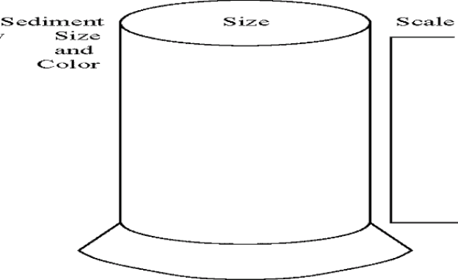 _________________________

_________________________

_________________________

_________________________

_________________________

_________________________

_________________________

(f) After all the sediment particles have settled to the bottom, make a sketch of what you see inside the tube in the tube diagram above at the right.
1. Label the differences in color and size of the particles that you can see.
2. Draw a scale ruler to the side of the diagram to indicate the height above the bottom stopper of any features that you observed.

(g) After the water has cleared, carefully siphon off the water from the tube.

(h) Set the tube with the top removed in a microwave and heat for several minutes to speed the evaporation of the water within the sediments.

(i) When the tube and sediments have cooled, tip the tube on its side, carefully remove the bottom rubber stopper, and gently and slowly push the sediments from the tube onto the sediment cradle, using the push rod.

(j) Look at the Relationship of Transported Particle Size to Water Velocity chart on page 6 of your Earth Science Reference Tables to find the size range of the various types of clastic sediments. Using this chart and a hand lens and working with care, determine the sizes and names of the particles in the “mud” at different locations within your sample.

Record the results of your search on the settling tube diagram above.
1. What is the name of the largest-sized particles in your sample? _____________

2. Where were these particles found in your tube? ___________________

3. What types of particles did you find at the top of your sediment pile?

_______________________________

4. What caused the particles to become arranged in this order?

5. Make a graph in the space below showing the general relationship between the size of a sedimentary particle and the position of a particle of that size in the settling tube.

Top

Location of
Particle Size
Within
Settling Tube

Bottom
Small Large

Particle Size of Sediments
6. Summarize the relationship shown by the graph in words:

7. Explain why the pattern of deposition in the settling tube developed:

8. In summary, bigger particles usually settle to the tube bottom

______________________ than smaller ones.

9. In the race to the bottom of the settling tube, where do the sedimentary particles

that make up mudstones, clays, and silts finish? _________________________

But this is only part of the story: Take a closer look at the chart on page 6 of the Earth
Science Reference Tables to find out more. Look at the enlarged version of the chart on the next page.

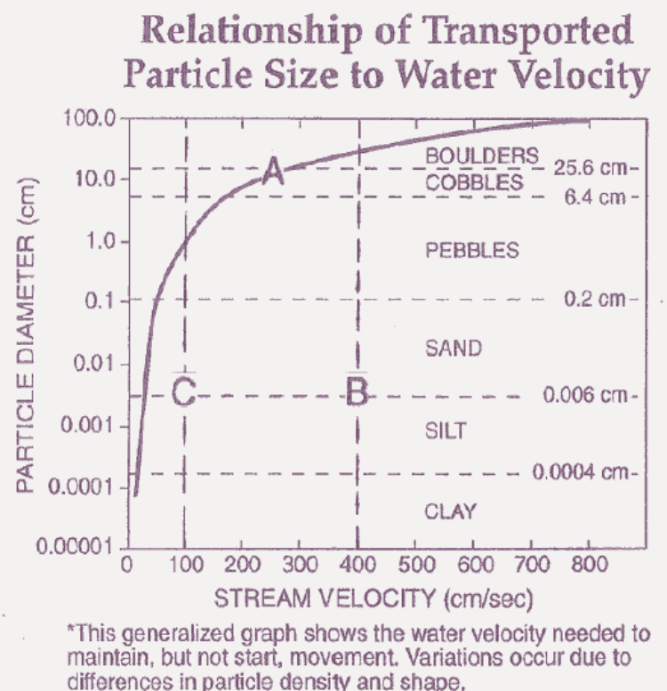

(k) Besides defining the various types of clastic sedimentary particles by size (so that you know the difference between pebbles and silt, for instance), another feature of this chart is the relationship shown by Graph Line A. This line shows the speed of water current necessary to keep a particle of a certain size, say 0.2 cm, in motion when a stream is transporting it. Or maybe the line shows the speed of ocean water rushing back to the ocean after a wave has broken on a beach.

1. The stream velocity needed to transport a boulder is _____________ than the stream velocity needed to transport a pebble.

2. According to Graph Line A, if the stream velocity is fast enough to transport a pebble, can it also transport sand grains?
______ Silt? ______ Clay? _____

3. How fast must the water current be to keep that 0.2 cm particle in motion?

________________ cm/sec

4. What happens to that particle when the current speed slows?

5. What determines how long it takes the particle to reach the bottom of the body of water transporting it?

6. (a) Does the particle continue to move with the water current while it is settling toward the bottom?
____________

(b) What factors determine how far the particle moves with the current before it reaches the bottom?

______________________________________________________

(c) Give an example to support what you claimed in (b) above.

__________________________________________________________

Now look at the chart/graph above from the Earth Science Reference Tables in a different way. Dashed Line B shows a water current velocity of 400 cm/sec. Notice that Dashed Line B intersects Graph Line A in the Boulders section of the chart/graph.

7. (a) What types of clastic particles can a water current moving at 400 cm/sec transport downstream in a river? Smaller boulders and what other size particles?

_______________________________________________

_______________________________________________

(b) What would happen to these particles if the water current suddenly slowed?

(c) Would you expect these particles to be somewhat layered and separated by
size like your mud samples? ______________
8. (a) If this same current were slowed to the velocity shown by Dashed Line C instead of being stopped, what would happen to the particles that were in transport at 400 cm/sec?

_____________________________________________________

  - (b) In cm, what is the largest-diameter particle that would normally continue
              - in transport down the stream? ______________

(c) What happened to the particles bigger than that diameter that were in
transport?
____________________________________________

9. (a) In summary, as a water current slows down, particles being transported by that current begin to settle to the bottom;
________________ particles settle first, and________________ particles settle to the bottom last.
(b) So if a mountain stream flowing at 400 cm/sec entered a section of its streambed where it gradually slowed to 100 cm/sec, what sediments would be deposited along the streambed?
• Show your response to this item by drawing those sediment particles along the streambed diagram below.
• Show the relative size of the particles and label each with their proper name.

STREAMBED CROSS SECTION

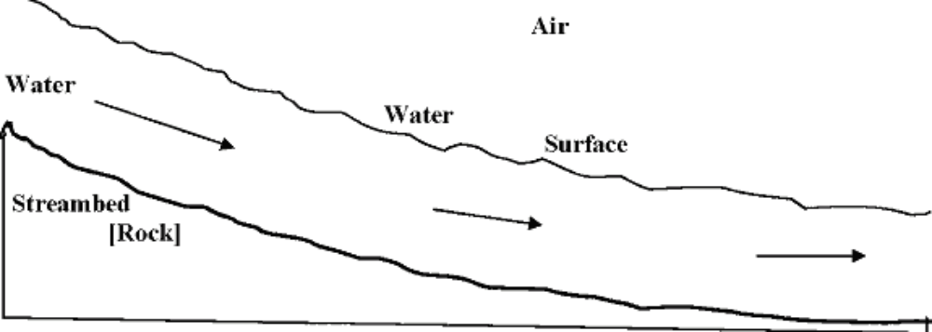

- This separation of sediments according to size by moving water is called horizontal sorting as opposed to the settling of the mud sample in the settling tube. What do you think the settling tube type of settling is called?

_______________________________________________________________

The relationship between stream velocity and the size of particle transported is fairly easy to determine when the velocity is above 100 cm/sec, but becomes much more difficult when the current is slower and the particles are small. You determined the stream velocity needed to transport the largest sand grain (0.2 cm diameter) earlier. You probably had little trouble since that stream velocity is pretty close to halfway between 0 and 100 cm/sec, but reading this graph is more difficult for silts and clays, which have a particle size similar to that of organic-rich mudstones. The process of oil formation typically begins within mudstones. There are things you can do to make reading graph values easier and more accurate. Look at the graph on the next page.

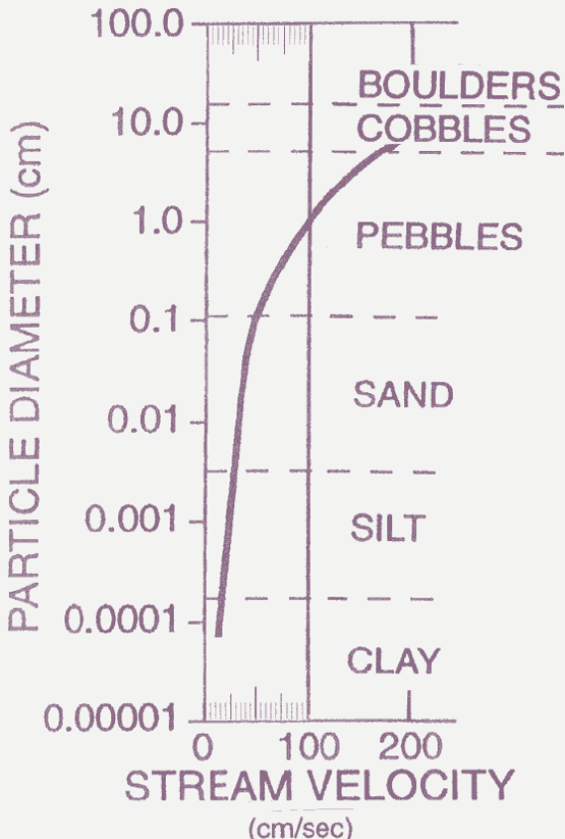

You may find it difficult to enlarge the graph as we have done, but you certainly could add an accurate scale to make your values more accurate and easier to read.

11. (a) On the graph above, label the value of the three new, longer scale lines that have been added between 0 and 100 cm/sec. What is the interval value represented by the space between the shortest lines on the new scale?

_________________ cm/sec

(b) Use a ruler to draw lines to connect these three lines from top to bottom. Do the lines that you have drawn make it easier to read the speed values of Graph Line A?

- Label the value of the three lowermost horizontal dashed lines on this graph. Does the estimate you made earlier of the stream velocity needed to transport a particle of 0.2 cm in diameter agree with the value you read from this graph?

__________

If it does, good; if not, what’s your newly determined value? __________ cm/sec.

[Remember to read the center of the lines where they cross. This is particularly important in situations such as this where a line like Graph Line A is thick. The same is true when you make a graph: it’s the center of the points you make that count. Making a big thick dot for a point on a line graph does not give you a better chance of plotting a point accurately. On graphing items on the Earth Science Regents exam, teachers read the center of your dots to determine accuracy.]

Now that our enlarged graph is set up properly, use it to determine when water currents produce sediment deposits that will become mudstone.
12. At what current velocity does the smallest sand-sized particle drop out of the water
transport system?
____________ cm/sec

[If you answered 25 cm/sec, that’s not too bad, but try to be more precise.]
13. What velocity separates the clays from silt?

____________ cm/sec

14. Draw two lines below to represent the distance traveled in one second for each of the currents in items 12 and 13.

A line to show the distance a water current that can transport the largest piece of silt travels in one second.
A line to show the distance a water current that can transport the largest piece of
clay travels in one second.

15. Describe two places where currents of this velocity exist on Earth.

(1)___________________________________________________

(2)___________________________________________________
Many rivers during normal (not flooding) water flow periods bring sand, silt, and clay particles to their mouths, where the current runs into the relatively still waters of the ocean or a lake. The currents slow down as indicated by the decreasing length of the arrows in the cross-sectional diagram below. Label the relative position of deposition of the sand, silt, and clay particles along the ocean floor that normally occurs as the current velocity decreases.
Atmosphere
River

Ocean Floor

16. What appear to be the two most important factors in determining the location of sediment-size deposition on the ocean floor?

(1) _________________________________________________________

(2) _________________________________________________________

- Why would so many foraminifera be found in clay and silt sediment deposits?

__________________________________________________________________

__________________________________________________________________

Part 3: Black Mudstones of the Acadian Orogeny
The rock record in New York State provides a real-life example of the accumulation of mudrock sediments and oil formation. Many millions of years ago, the developing North American continent collided with two landmasses: a large island called Avalon, which was located off the northern coast of Africa, and the continent of Baltica, which was a combination of Europe and Russia.
1. Using the last two columns on page 9 of your Earth Science Reference Tables, determine when this collision began. It began during the beginning of the

______________Period of geologic time, approximately __________ million

years ago.

2. What was the Iapetus Ocean? _________________________________________

This collision began a time of major uplift in eastern North America as the Acadian Mountains rose to a height of at least four kilometers. Upward swelling of large sections of the ocean floor above active regions of the mid-ocean ridges forced sea levels to rise worldwide. As a result, large sections of continental landmasses flooded, producing epicontinental seas (saltwater seas on top of the continents) on North America and other continents.

The map on the next page shows North America and Europe near the end of the Devonian Period still joined together as the “Old Red Sandstone Continent.” The latitude and many of the features of that supercontinent are shown. The locations of the epicontinental seas are shown by the types of sediment deposition occurring in those seas.

This map is somewhat difficult to read, but if you look at the small parts closely, the big picture will become easier to see. One of the most difficult ideas to understand is that changes occur in the shape and location of continents in much the same way that people move from place to place and over time change in their appearance.

3. The collision of these landmasses produced a long chain of mountains. A mountain-building episode is called an orogeny. Since the Acadian Mountains formed in North America at this time, we call this episode the Acadian Orogeny.
What do you think they call this episode in Greenland (“G.L.” on the map on previous page) and in Northern Europe?
The _______________________ Orogeny 4.
4. Complete each of the following tasks on the map on the previous page:
• Find the line of mountains created by this collision. Notice the dashed line with x’s running down through the middle of these mountains. This line marks the location of the suture where the landmasses were joined together by the plate tectonic collision. Draw a black line along the suture from its northern end near Kolyma Island to its southern end at Quachita Sea.

• Color the land area that is above sea level north and west of the suture line light yellow. [This gets a little tricky because the map legend shows the edge of the continent as a solid line, but remember that parts of the continent were flooded at the time and that the edges of most continents are usually under water (the so-called continental shelf area).]

• Color the land area south and east of the suture that is above sea level light orange.

5. Label the location of the former island Avalon on the map.
• The areas that you have not colored were for the most part ocean and sea areas. The dashed lines that show where the shoreline disappears indicate areas where geologists have insufficient evidence to determine exactly what happened. The redbed areas were at least occasionally above sea level. Of course, the whole region shown on the map was constantly undergoing change. However, the area of interest, the black shale depositional basin, was a long-lasting feature of the continental midsection. This down-warped area of the continent was caused by the tremendous weight of the nearby Acadian Mountains pressing down on the mantle rocks below them. Color this down-warped black shale depositional basin with a light green stripe.
6. (a) What do you already know about the conditions in this depositional basin?

  - (b) What you didn’t know you can see for yourself now. Look at the shape of this basin. How open to the Rheic Ocean to the south is the black shale basin?

  - If you said “not very,” your response was good, because there were only narrow passageways through which this basin could exchange water with the open ocean. The result of this poor circulation was that much of this continental sea had only limited exchange of water with the open ocean. This limitation made it easier for stagnant anoxic conditions to develop.

(c) The latitude of this sea further contributed to the development of the anoxic conditions that preserved the organic materials that would eventually become petroleum. What is the latitude of the middle of this continental sea?
_____________________________________________

Because this region is so warm, the surface waters of this sea tended to become very warm. Because of the water’s high temperature, the surface waters tended to be ___________________ dense and therefore _______________________. Thus, the waters of the top of the sea (which is usually highly oxygenated) tended to mix with / stay separated from [circle one] the oxygen-poor and organic-rich waters of the sea bottom.

7. Locate New York State, using a political map of North America (political outlines are shown as dotted lines, and states and countries are labeled). Draw a circle approximately .5 cm in diameter at the proper place and label it “NYS.” [During this map time the eastern sections of New York State were being covered by redbeds while the western section was receiving deposits of oil shale.]

  - A closer look at the deposition occurring in the eastern United States is shown on the map below. The pattern of deposition of sediments should be about what you would expect. Weathering and erosion of the rocks in the Acadian Mountains produced loose sediment that was carried by streams (indicated by the arrows) toward the epicontinental sea to the west, where sand, silt, and clay were deposited in sequence away from the shoreline.

8. Where were the pebbles, cobbles, and boulders deposited? _________________
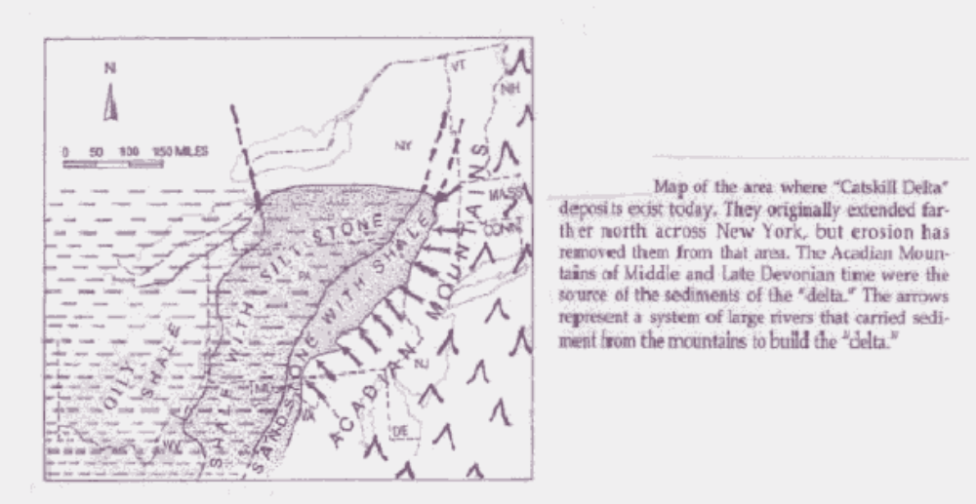

The block diagram below provides a better picture of what this region was like. Each of the depositional environments is identified and more detail is provided.

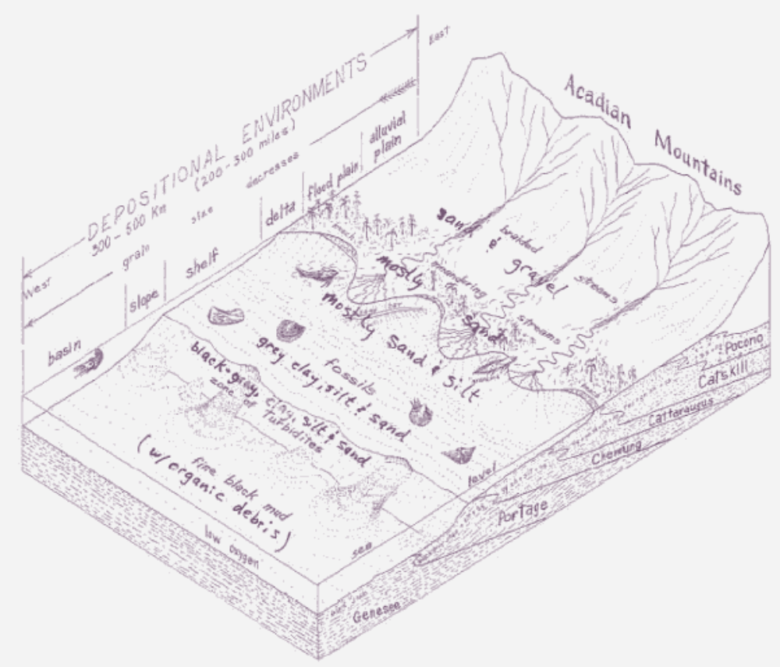

9. (a) What happens to the size of sediment grain as the distance from the shoreline increases?
_________________________________________

- Notice the names along the near edge of the diagram: these are the names of rock formations found in New York State today that were produced by each one of the depositional environments shown in the diagram. What do the diagonal boundaries between these rock units signify about the depositional environments and the location of deposition of these rock units?
________________________________________________

  - (c) This diagram represents middle-to-late Devonian time. Name a fossil that you might expect to find in the Catskill Formation.

  - ________________________________________________________

- Name a fish that might have been swimming in this inland sea.
________________________________________________________

(e) Name a trilobite that you might expect to find fossilized in the black shales of the Genesee Formation and that might have contributed to the organic matter that accumulated there.

____________________________

As might be expected, some of the areas of New York State underlain by the Genesee Formation shales have been sites where oil and natural gas have been discovered and, in some cases, pumped to the surface for commercial use.

