Allocating Energy from a Photovoltaic System

SPN LESSON #27
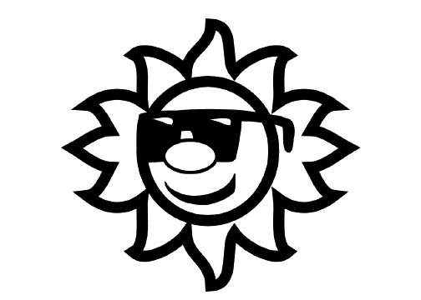

TEACHER INFORMATION

LEARNING OUTCOME
Students look up and analyze power ratings for the appliances they use, and make decisions on allocation of the photovoltaic electric energy, as it is generated, to appliance use on an hourly basis. Students then are able to cite examples of compromises that could be made to conserve energy while experiencing minimum effects on lifestyle.

LESSON OVERVIEW: This lesson helps students distinguish between power and the amounts of electric energy generated or used. The purpose of the lesson is twofold: students are to inventory their use of electric energy for home appliances and compare this with the typical total of 6.5 kilowatt-hours (kWh) produced in New York State by a 2 kilowatt (kW) photovoltaic system. Then students are to allocate the photovoltaic electric energy, as it is generated, to appliance use on an hourly basis.

GRADE-LEVEL APPROPRIATENESS
This Level III Physical Setting lesson is intended for use in high school physical science or physics classrooms.

MATERIALS: Student handout

SAFETY: No special precautions are necessary.

TEACHING THE LESSON: This lesson provides an excellent opportunity to distinguish between power (the rate at which electric energy is generated by the photovoltaic system or used by electric appliances) and the amounts of electric energy generated or used. Students are to look up the power ratings for the appliances they use, and then multiply these ratings (in kilowatts, converted from watts) by the time used (in hours) to find the amount of electric energy used (in kilowatt-hours). As a culmination of the lesson, you might want to contrast the net-metered approach in place for your school’s PV system to systems that attempt to store excess energy that is produced.

ACCEPTABLE RESPONSES FOR DEVELOP YOUR UNDERSTANDING SECTION: These responses will vary considerably. Some students may have difficulty cutting their electric energy usage back to 6.5 kWh per day and will have to draw the remainder of their electric
energy usage from their local utility. Other students might end up with a stored surplus. These students, however, should be helped to realize that building up an indefinite amount of energy
storage into their system is expensive and that since a new supply of solar energy is received every day, there is little point in trying to store more than a day’s usage (in the case of extremely overcast weather).

ADDITIONAL SUPPORT FOR TEACHERS

SOURCE FOR THIS ADAPTED ACTIVITY: Data used is provided by Clayton Handleman, Heliotronics Inc.

BACKGROUND INFORMATION: Power is the rate at which energy is produced or used. Its basic unit is the watt. The amount of energy produced or used is determined by multiplying the power by the time. If the power is given in kilowatts and the time in hours, the energy is given in kilowatt-hours. If the power is given in watts and the time in seconds, the energy is given in joules.

REFERENCES FOR BACKGROUND INFORMATION: any physics text

LINKS TO MST LEARNING STANDARDS AND CORE CURRICULA: 1: M1.1, 3.1, T1.1; 2: 1.1,1.5; 6: 1.1, 6; 7: 1, 2; 4: 4.1b,i, p

Standard 1—Analysis, Inquiry, and Design: Students will use mathematical analysis, scientific inquiry, and engineering design, as appropriate, to pose questions, seek answers, and develop solutions.
Mathematics Key Idea 1: Abstraction and symbolic representation are used to communicate mathematically.
M 1.1: Use algebraic and geometric representations to describe and compare data.
Mathematics Key Idea 3: Critical thinking skills are used in the solution of mathematical problems.
M 3.1: Apply algebraic and geometric concepts and skills to the solution of problems.
Technology Key Idea 1: Engineering design is an iterative process involving modeling and optimization, which is used to develop technological solutions to problems within given constraints.
T1.1: Students engage in the . . . steps of a design process.

Standard 2—Information Systems: Students will access, generate, process, and transfer information, using appropriate technologies.
Key Idea 1: Information technology is used to retrieve, process, and communicate information as a tool to enhance learning.
1.1: Understand and use the more advanced features of word processing, spreadsheets, and database software.
1.5: Model solutions to a range of problems in mathematics, science, and technology, using computer simulation software.

Standard 6—Interconnectedness: Common Themes: Students will understand the relationships and common themes that connect mathematics, science, and technology and apply the themes to these and other areas of learning.
Key Idea 1: Through systems thinking, people can recognize the commonalities that exist among all systems and how parts of a system interrelate and combine to perform specific functions.
1.1: Define boundary conditions when doing systems analysis to determine what influences a system and how it behaves.
Key Idea 6: In order to arrive at the best solution that meets criteria within constraints, it is often necessary to make trade-offs.

Standard 7—Interdisciplinary Problem Solving: Students will apply the knowledge and thinking skills of mathematics, science, and technology to address real-life problems and make informed decisions.
Key Idea 1: The knowledge and skills of mathematics, science, and technology are used together to make informed decisions and solve problems, especially those relating to issues of science/technology/society, consumer decision making, design, and inquiry into phenomena.
Key Idea 2: Solving interdisciplinary problems involves a variety of skills and strategies, including effective work habits; gathering and processing information; generating and analyzing ideas; realizing ideas; making connections among the common themes of mathematics, science, and technology; and presenting results.

Standard 4—The Physical Setting: Students will understand and apply scientific concepts, principles, and theories pertaining to the physical setting and living environment and recognize the historical development of ideas in science.
Key Idea 4: Energy exists in many forms, and when these forms change energy is conserved.
4.1: Students can observe and describe transmission of various forms of energy.
4.1b: Energy may be converted among mechanical, electromagnetic, nuclear, and thermal forms.
4.1i: Power is the time-rate at which work is done or energy is expended.
4.1p: Electrical power and energy can be determined for electric circuits.

Produced by the Research Foundation of the State University of New York with funding from

the New York State Energy Research and Development Authority (NYSERDA)
www.nyserda.org

Should you have questions about this activity or suggestions for improvement,
please contact Bill Peruzzi at billperuz@aol.com

(STUDENT HANDOUT SECTION FOLLOWS)
Name ___________________________________
Date ____________________________________

Allocating Energy from a Photovoltaic System

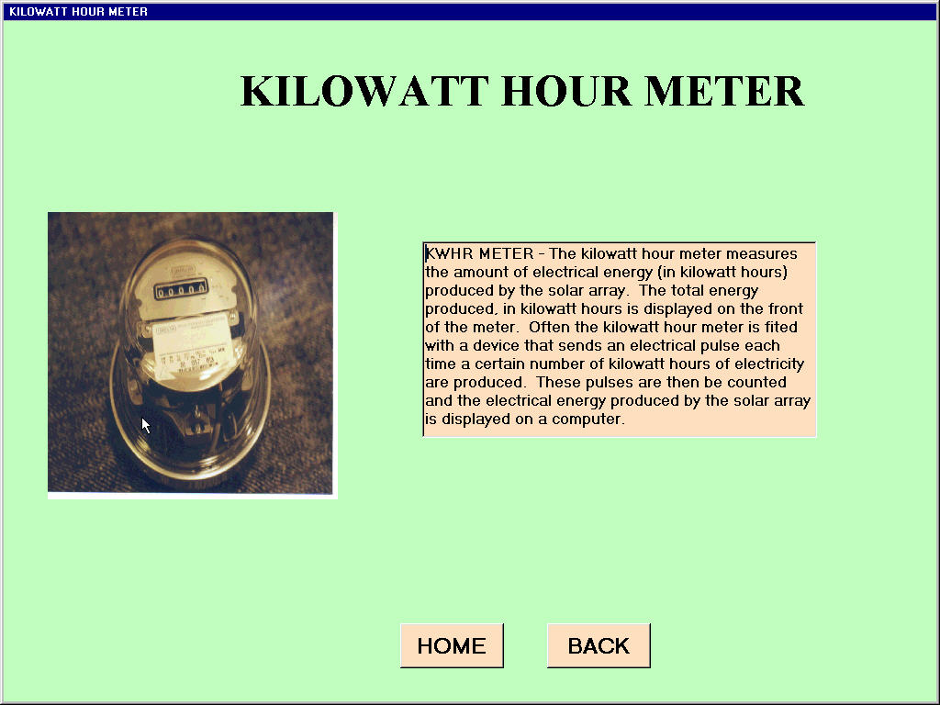
A 2 kW photovoltaic system produces 2 kW only at maximum insolation— when the Sun’s rays are shining most intensely on its panels. The number of watts produced at any given time tells us the power, or rate at which energy is produced. The amount of energy produced in any given time interval is found by multiplying this rate by the interval of time. If the rate of energy production is given in kilowatts and the time interval in hours, the amount of energy is given in units of kilowatt-hours. A 2 kW photovoltaic system in New York State can be expected to produce an average of 6.5–7 kWh of electric energy per day.

DEVELOP YOUR UNDERSTANDING

How many kilowatt-hours of electric energy do you use per day? To find out, list the electric appliances you use, the number of hours per day that you use them, and the rate at which they use electric energy in watts, according to the table “Number of Watts for Some Typical Home Appliances” below. If you list this information in a spreadsheet like the one below, you can facilitate your calculations. To determine the number of kilowatts in the fourth column, divide the number of watts in the third column by 1000. To determine the number of kilowatt-hours per day, multiply the number of kilowatts in the fourth column by the number of hours per day in the fifth column.

Number of Watts for Some Typical Home Appliances
Appliance | Number of appliances | Power (W) | Power (kW) | Number of hours/day | Number of kWh/day
- What is the total number of kilowatt-hours used in a day?

When it comes to the generation and use of electric energy, it is also important that it is generated when it is wanted. Otherwise, it must be stored. Even if you use less than 6.5 kWh per day, it is unlikely that the amount of electric energy produced in every given hour of the day will match the amount you want to use. Therefore, some electric energy will need to be stored for future use. If you use more than 6.5 kWh per day, you will need to get the rest of what you use from your local electric utility. In column two of the table below, list the number of kilowatt-hours generated in each hour of a typical day by a 2 kW system. In column three, list how you will allocate this electric energy (identify what appliances are to be used for what amount of time, and then total up and record the number of kilowatt-hours). In column four, indicate how many kilowatt-hours are to be stored for future use. If you use stored energy, this number is to be reduced. If you draw energy from the utility, indicate this in column five. Add columns four and five to determine your total electric energy storage and total reliance on your local utility.

Hour of day | #kWh generated | Allocation of kWh | Number of kWh stored | Number of kWh drawn from local utility
12 m – 1 a.m. | 0
1 a.m. – 2 a.m. | 0
2 a.m. – 3 a.m. | 0
3 a.m. – 4 a.m. | 0
4 a.m. – 5 a.m. | 0
5 a.m. – 6 a.m. | 0
6 a.m. – 7 a.m. | 0
7 a.m. – 8 a.m. | 0.1
8 a.m. – 9 a.m. | 0.25
9 a.m. – 10 a.m. | 0.5
10 a.m. – 11 a.m. | 0.9
11 a.m. – 12 n | 1.5
12 n – 1 p.m. | 1.5
1 p.m. – 2 p.m. | 0.9
2 p.m. – 3 p.m. | 0.5
3 p.m. – 4 p.m. | 0.25
4 p.m. – 5 p.m. | 0.1
5 p.m. – 6 p.m. | 0
6 p.m. – 7 p.m. | 0
7 p.m. – 8 p.m. | 0
8 p.m. – 9 p.m. | 0
9 p.m. – 10 p.m. | 0
10 p.m. – 11 p.m. | 0
11 p.m. – 12 m | 0

- How many kilowatt-hours did you cumulatively store in your system?

- How many kilowatt-hours did you draw from your local utility?

- What changes could you make to eliminate reliance on your local utility?

Number of Watts for Some Typical Home Appliances

(from Energy: How Does It Impact Our Lives? ©1994 by the Research Foundation of the State University of New York on behalf of the New York Science, Technology and Society Education Project)

Electric Appliance | Power (W) | Electric Appliance | Power (W)
Air cleaner | 50 | Hot plate | 1200
Air conditioner, large window | 1300 | Hot water circulating pump | 200
Blender | 390 | Humidifier | 177
Broiler | 1200 | Iron | 1100
Can opener | 100 | Light bulb | 60
Carving knife | 100 | Light bulb | 75
Clock | 2 | Light bulb | 100
Clothes dryer | 5000 | Lighted mirror, fluorescent | 20
Coffeemaker, drip | 1100 | Lighted mirror, incandescent | 50
Coffeemaker, percolator | 600 | Microwave oven | 1450
Coffeemaker, urn | 1200 | Mixer | 150
Computer | 300 | Oil burner motor | 260
Computer monitor | 600 | Portable electric heater | 1350
Computer printer | 200 | Radio | 70
Corn popper, hot air | 1400 | Range | 12000
Corn popper, oil | 575 | Refrigerator/freezer, frost free, 17.5 cu.ft. | 450
Curling iron | 40 | Sewing machine | 75
Deep fryer, mini | 600 | Shaver | 15
Deep fryer, regular | 1500 | Skill saw | 1000
Dehumidifier | 625 | Slow cooker, Crock-Pot™ | 200
Dishwasher | 1200 | Stereo | 80
Drill, ¼” | 250 | Sunlamp | 300
Electric blanket | 170 | Television, solid state (B & W) | 160
Fan, attic | 375 | Television, solid state (color) | 300
Fan, table | 100 | Toaster | 100
Fan, window | 200 | Toaster oven | 1500
Food grinder | 200 | Toothbrush | 10
Freezer, frost free 16 cu.ft. | 400 | Trash compactor | 400
Freezer, manual defrost 16 cu.ft. | 340 | Typewriter | 30
Frying pan | 1200 | Vacuum cleaner | 650
Garbage disposer | 445 | Waffle iron | 1200
Grill, sandwich | 1200 | Warm air furnace motor | 375
Hair dryer, hand held | 1200 | Washing machine | 375
Hair setter | 350 | Water bed heater | 375
Heat lamp | 250 | Water heater | 4000
Heating pad | 60 | Well or water pump | 335

