An Environmental Puzzle: The Carbon Cycle

SPN #21


TEACHER INFORMATION

LEARNING OUTCOME
After completing readings on our ultimate energy source and on how photosynthesis relates to the energy requirements of both plants and animals, students work out relationships present in a carbon dioxide puzzle. Accordingly, students are able to describe the operation of the oxygen–carbon dioxide cycle and relate the use of alternative forms of energy to maintaining levels of oxygen and carbon dioxide in the atmosphere.

LESSON OVERVIEW

This lesson provides an overview of how respiration and photosynthesis cycle carbon through ecosystems. The background reading describes the role of the Sun as Earth’s ultimate energy source and explains how the energy requirements of plants and animals are met through photosynthesis. The presence of oxygen in the atmosphere is due to the photosynthetic activity of both prehistoric and present-day plants. As a result of burning fossil fuels, humans are not only adding carbon dioxide to the atmosphere but also depleting the supply of oxygen.

GRADE-LEVEL APPROPRIATENESS

This Level II Environmental Considerations lesson is intended for students in grades 6–8.

MATERIALS
1 copy of the reading passage per student
1 copy of the KWL sheet per student
1 envelope containing the 17 puzzle pieces per team of two students

SAFETY

There are not safety concerns associated with this activity.

TEACHING THE LESSON
Before class:
• Photocopy the student pages for An Environmental Puzzle: The Carbon Cycle.
• Photocopy the two sets of puzzle pieces. You will need 12 sets of copies for a class of 24 students. For each set, cut out all of the pieces of a correct puzzle and place them in an envelope. From the incorrect puzzle, cut out only the pieces 1, 3, 12, and 14. Add these to the envelope. Discard the “blank” pieces of the incorrect puzzle. There should be a total of 14 puzzle pieces in each envelope. Suggestion: Use cardstock, or laminate the copies, so that the puzzle pieces can be used with multiple classes.
During class:
(1) Have students identify as many energy sources as they can from memory. As each source is named, list it on an overhead transparency or sheet of newsprint. The newsprint list can be left for students to think about and perhaps add to later in the lesson.
Once the list is fairly extensive, have students identify which of these energy sources is the most important and why.
Next, ask students which of the types of energy listed can be traced back to the Sun and how the energy we get from our food also can be traced to the Sun.
(2) As an additional pre-reading activity, have students complete a modified KWL chart. Ask them to write down three to five things they know about fuels and energy. They should be absolutely certain that their comments are true. These should be listed in the “What I know” column of their KWL chart. Next, ask students to record three to five things they think might be true about fuels and energy in the “What I think I know” column. They can complete this in teams of two.
(3) Give students the reading passage from An Environmental Puzzle: The Carbon Cycle. Direct them to read the passage carefully and complete the “What I learned” column of the KWL chart. At this point, students should be ready to work on the puzzle. The KWL worksheet can be handed in as a “ticket” for access to an envelope of puzzle pieces. Students should work on this part of the activity in teams of two.

ACCEPTABLE RESPONSES FOR DEVELOP YOUR UNDERSTANDING SECTION

Activity Analysis

Puzzle Table

Piece Number | Responses | Statement
1. | Incorrect | Wood is a nonrenewable resource.
2. | Correct | The Sun provides both plants and animals with energy.
3. | Incorrect | Plants do not require oxygen for respiration.
4. | Correct | Oxygen in the atmosphere comes from photosynthesis.
5. | Correct | More cars burning more gasoline add to the amount of carbon dioxide in the atmosphere.
6. | Correct | Both flowing water and wind energy can be traced back to the Sun.
7. | Correct | Reducing the use of fossil fuels will help maintain an appropriate balance of carbon dioxide and oxygen in the atmosphere.
8. | Correct | Carbon from carbon dioxide in the atmosphere is used to make sugar.
9. | Correct | Plants respire 24 hours a day.
10. | Correct | Solar energy is a renewable energy source.
11. | Correct | Photosynthesis and respiration are processes important to the movement of carbon through an ecosystem.
12. | Incorrect | Fossil fuels are renewable resources since swamps with ferns and trees still exist.
13. | Correct | Sugars are used by both plants and animals for energy.
14. | Incorrect | Cutting down trees will reduce the amount of carbon dioxide in the atmosphere.
15. | Correct | Both plants and animals play an important role in the carbon cycle.
16. | Correct | Matter cycles through an ecosystem.
17. | Correct | Energy cannot be recycled.
Students should eliminate incorrect pieces 1, 3, 12, and 14.
1. Including several clover plants and a rabbit, draw a diagram to represent the oxygen–carbon dioxide cycle. Indicate at which stage(s) photosynthesis is occurring and which gases are being taken in and given off. Also show the stage(s) where respiration is occurring and which gases are being taken in and given off.
Student illustrations should show the clover carrying out both photosynthesis and respiration. In addition, illustrations should show oxygen and carbon dioxide both entering and leaving the plants. Students may or may not depict water entering and leaving the plant (this should be shown but is often forgotten). The rabbit should only carry on respiration. Oxygen should enter the rabbit, and carbon dioxide and water vapor should exit.
2. It has been said that green plants can survive without animals but animals cannot survive without plants. In terms of photosynthesis and respiration, explain how this could be true.
Plants provide both food and oxygen that are used by animals. Animals provide plants with carbon dioxide. However, when plants respire, they release carbon dioxide. Students may mention that when plants burn (such as in a forest fire), carbon dioxide is given off.
3. Explain how using solar energy to generate more of the electricity we use (e.g., using photovoltaic panels) would help to maintain the levels of oxygen and carbon dioxide in the atmosphere.
Increased use of solar energy for electricity production would decrease the amount of combustion and therefore the amount of oxygen being removed from the atmosphere, and also decrease the amount of carbon dioxide being added to the atmosphere. This would help to maintain the appropriate balance.

Extended Activities
1. Have students make posters that show how the photovoltaic panel on the school roof is like a green plant carrying out photosynthesis.
2. Assign teams of students to design a series of “oxygen saver” cards. Each card might list a simple action that an individual can take, or a task that he or she can do, to save some of the oxygen in Earth’s atmosphere. In essence, many of these cards will feature energy conservation activities such as “plant a plant,” “save a tree,” “talk to someone about the benefits of solar energy,” or “write a letter to the editor describing the carbon cycle or explaining how solar energy saves oxygen.” Allow students to be creative. It would be ideal to have them draw a card periodically and personally take the action suggested. That way they will feel that together they are making a contribution to maintaining a more ideal oxygen–carbon dioxide balance.

ADDITIONAL SUPPORT FOR TEACHERS

SOURCE FOR THIS ADAPTED ACTIVITY
“The Formation of Fossil Fuels” from Fossil Fuels: Student Activities, Revised edition. New York Energy Education Project. Published by the Research Foundation of the State of New York. 1988.

BACKGROUND INFORMATION
Photosynthesis and respiration/combustion are the two main processes that cycle carbon through ecosystems. Carbon bonds carry and store the energy needed by living things. Solar energy is captured and stored, on a continuing basis, through the process of photosynthesis.
During photosynthesis, light energy absorbed by chlorophyll is used to split water molecules. The oxygen is released out of the cells to the atmosphere. Then carbon and oxygen, from the carbon dioxide that has entered the plant, react with hydrogen from the split water molecules. From these small carbon-hydrogen-oxygen units, larger organic molecules such as glucose are synthesized. As a generalization, glucose is said to be the energy source for living organisms. Therefore, almost all organisms except chemosynthesizers rely on the Sun, either directly or indirectly, as their energy source.
Respiration and combustion are processes that release energy from carbon bonds. Large organic molecules such as starches and cellulose can be broken down by combustion. So can fossil fuels! The combustion process removes oxygen from the atmosphere. Much atmospheric oxygen is present as a result of photosynthesis that occurred millions of years ago. The carbon compounds forming fossil fuels were synthesized from simple molecules produced by photosynthesis. Thus these fuels act as a carbon repository. As long as they remain untouched, the oxygen released during photosynthesis remains available in the atmosphere. Once these fuels are burned, the oxygen is removed and carbon dioxide is released back into the atmosphere. The processes of photosynthesis and respiration complement each other in terms of maintaining an appropriate balance of carbon dioxide and oxygen in the atmosphere The combustion of fossil fuels tends to disrupt that balance.
Students should become aware that both plants and animals respire 24 hours a day. Students should also be helped to learn that both plants and animals require oxygen to release energy from their food, and both give off carbon dioxide as an end product. Many students hold the misconception that plants respire only at night and that they always breathe in carbon dioxide and breathe out oxygen.

REFERENCES FOR BACKGROUND INFORMATION
Miller, Kenneth and Joseph Levine. Biology. Pearson Education, Inc., Upper Saddle River, NJ, 2003.

Smith, Leo. Ecology and Field Biology. 4th edition. HarperCollins Publisher, New York, 1990.

Wright, Richard T. and Bernard J. Nebel. Environmental Science: Toward a Sustainable Future. Pearson Education, Inc., Upper Saddle River, NJ, 2002.
http://www.oaerre.napier.ac.uk/users/p.tett/Env/Ocycle.html provides information about the oxygen cycle.
http://home.nyu.edu/~pet205/biogeochem1.html provides some information about biochemical cycles including both the oxygen and carbon cycles.
http://telstar.ote.cmu.edu/environ/m3/s4/cycleCarbon.shtml supported by Carnegie Mellon as part of their “Environmental Decision Making, Science, and Technology” Web site. This URL links to pages that provide extensive background information on the carbon cycle. There are links to information about the oxygen cycle and energy use.
http://www.barc.usda.gov/psi/vl/bpdkids/page2.html#oxygen provides information appropriate for use with younger students. A cute illustration of the oxygen cycle and the role of plants is included.

LINKS TO MST LEARNING STANDARDS AND CORE CURRICULA

Standard 4 – Science
Living Environment
Key Idea 6: Plants and animals depend on each other and their physical environment.

6.1: Describe the flow of energy and matter through food chains and food webs.
6.1c: Matter is transferred from one organism to another and between organisms and their physical environment. Water, nitrogen, carbon dioxide, and oxygen are examples of substances cycled between the living and nonliving environment.

6.2: Provide evidence that green plants make food and explain the significance of this process to other organisms.
6.2a: Photosynthesis is carried on by green plants and other organisms containing chlorophyll. In this process, the Sun’s energy is converted into and stored as chemical energy in the form of a sugar. The quantity of sugar molecules increases in green plants during photosynthesis in the presence of sunlight.
6.2b: The major source of atmospheric oxygen is photosynthesis. Carbon dioxide is removed from the atmosphere and oxygen is released during photosynthesis.
6.2c: Green plants are the producers of food which is used directly or indirectly by consumers.

Key Idea 7: Human decisions and activities have had a profound impact on the physical and living environment.
7.1: Describe how living things, including humans, depend upon the living and nonliving environment for their survival.
7.1c: In all environments, organisms interact with one another in many ways. Relationships among organisms may be competitive, harmful, or beneficial. Some species have adapted to be dependent upon each other with the result that neither could survive without the other.

7.2: Describe the effects of environmental changes on humans and other populations.
7.2a: In ecosystems, balance is the result of interactions between community members and their environment.

Physical Setting
Key Idea 2: Many of the phenomena that we observe on Earth involve interactions among components of air, water, and land.

2.1: Explain how the atmosphere (air), hydrosphere (water), and lithosphere (land) interact, evolve, and change.
2.1a: Nearly all the atmosphere is confined to a thin shell surrounding Earth. The atmosphere is a mixture of gases, including nitrogen and oxygen with small amounts of water vapor, carbon dioxide, and other trace gases. The atmosphere is stratified into layers, each having distinct properties. Nearly all weather occurs in the lowest layer of the atmosphere.

2.2: Describe volcano and earthquake patterns, the rock cycle, and weather and climate changes.
2.2r: Substances enter the atmosphere naturally and from human activity. Some of these substances include dust from volcanic eruptions and greenhouse gases such as carbon dioxide, methane, and water vapor. These substances can affect weather, climate, and living things.
Key Idea 4: Energy exists in many forms, and when these forms change energy is conserved.
4.1: Describe the sources and identify the transformations of energy observed in everyday life.
4.1a: The Sun is a major source of energy for Earth. Other sources of energy include nuclear and geothermal energy.
4.1b: Fossil fuels contain stored solar energy and are considered nonrenewable resources. They are a major source of energy in the United States. Solar energy, wind, moving water, and biomass are some examples of renewable energy resources.

Standard 6: Students will understand the relationships and common themes that connect mathematics, science, and technology and apply the themes to these and other areas of learning.
Key Idea 1: Through systems thinking, people can recognize the commonalities that exist among all systems and how parts of a system interrelate and combine to perform specific functions.

1.4: Describe how the output from one part of a system (which can include material, energy, or information) can become the input to other parts.

Process Skills Based on Standard 4 (Laboratory Skills)

General Skills
1. Follow safety procedures in the classroom and laboratory.
8. Identify cause-and-effect relationships.

THE NEXT TWO PAGES CONTAIN THE “CORRECT” AND “INCORRECT” PUZZLES FOR USE BY YOUR STUDENTS.
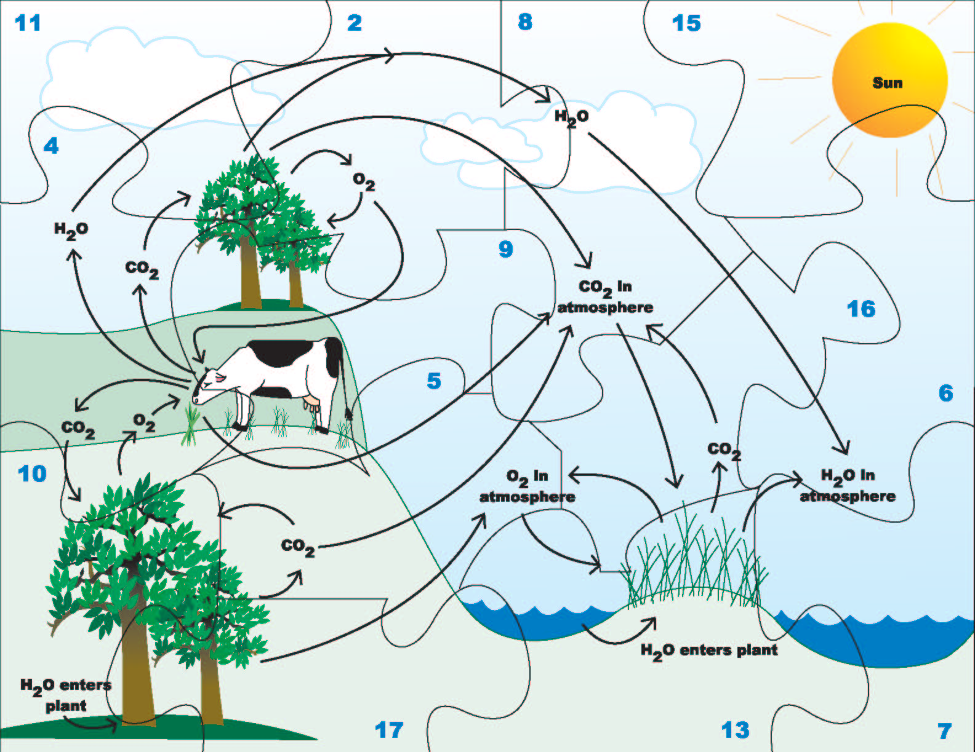
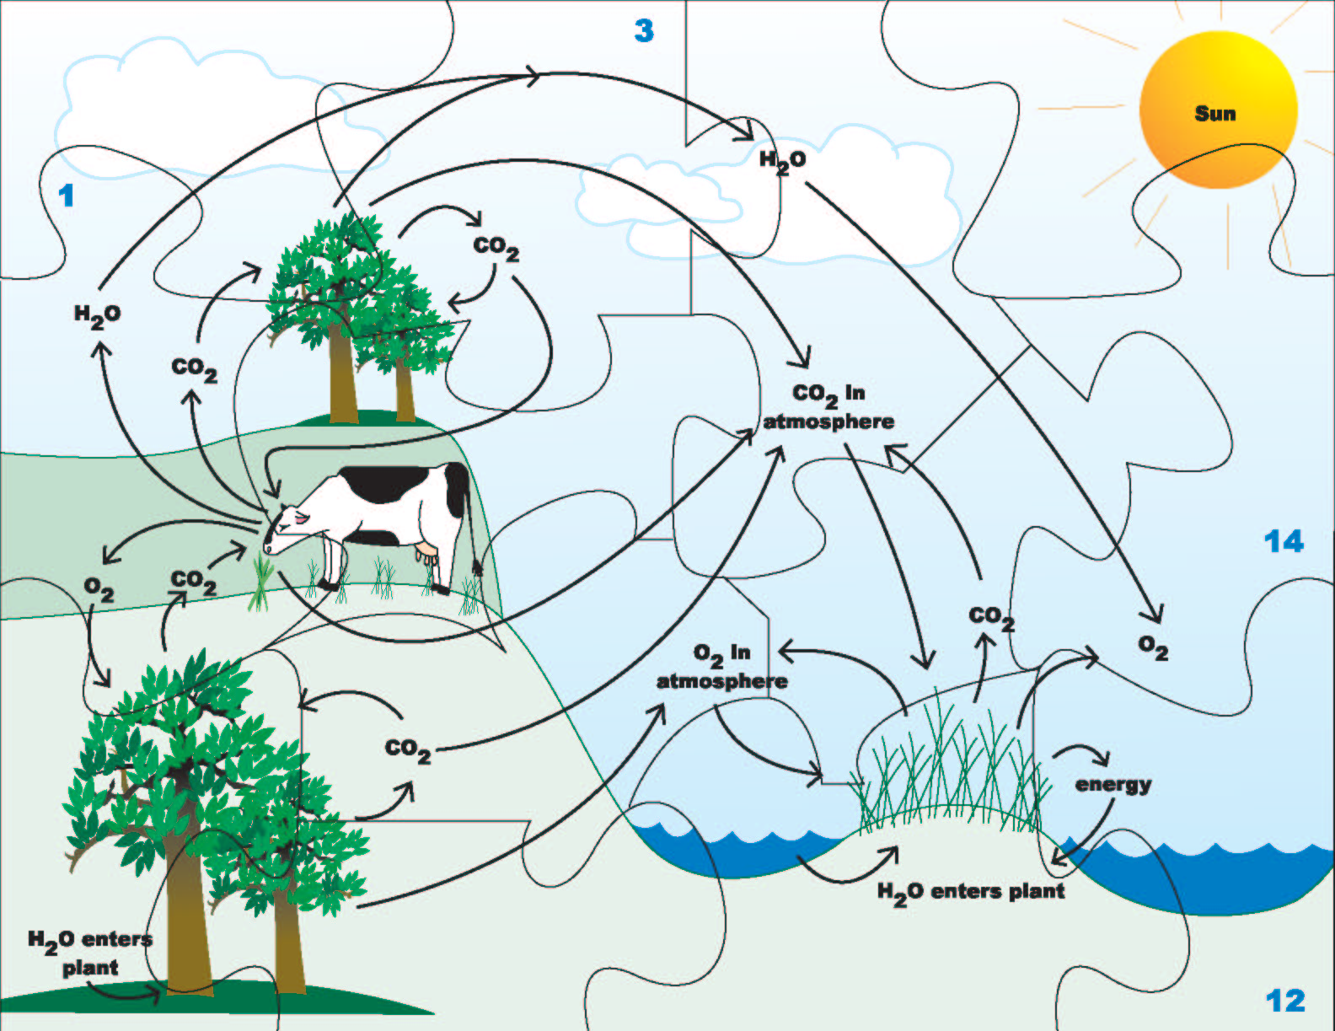

Produced by the Research Foundation of the State University of New York

with funding from the New York State Energy Research and Development Authority (NYSERDA)
www.nyserda.org

Should you have questions about this activity or suggestions for improvement,
please contact Bill Peruzzi at billperuz@aol.com

(STUDENT HANDOUT SECTION FOLLOWS)
Name ___________________________________
Date ____________________________________

An Environmental Puzzle: The Carbon Cycle

K  What I know | W  What I think I know | L  What I learned
1.

2.

3.

4.

5.

Strategy modified from “Content Reading Instruction in the Primary Grades: Perceptions and Strategies,” by M. W. Olson and T. C. Gee, 1991, in The Reading Teacher, 45 (4), and “Teaching Reading in the Content Areas: If Not Me Then Who?” by R. Billmeyer and M. L. Barton, 2nd edition, McREL, 1998.

Name ___________________________________

Date ____________________________________

An Environmental Puzzle: The Carbon Cycle

Background Reading
There are many sources of energy in our world. Most energy comes to us either directly or indirectly from the Sun. Solar energy is the original source of most of the energy on Earth. Energy from the Sun heats Earth’s surface and the air above it. Sometimes this causes winds. Water evaporated by the Sun forms clouds and rain to give us flowing rivers and streams. Both wind and flowing water are sources of energy.
Through photosynthesis, organisms containing chlorophyll (plants and algae, along with some bacteria and protozoans) convert light energy into chemical energy. This is not a single-step process. During the first part of the reaction, light energy absorbed by chlorophyll is used to split water into hydrogen and oxygen. Most of the oxygen is released into Earth’s atmosphere.

water + light energy —> hydrogen + oxygen
During the second phase of the reaction, carbon dioxide from the atmosphere is combined with the hydrogen from the split water molecules. The carbon, oxygen, and hydrogen are combined in the correct proportions to form a simple sugar—glucose.
hydrogen + carbon dioxide —> glucose
The Sun’s energy can be stored. Organisms that carry out photosynthesis store energy from the Sun. They do so as long as they produce more food than they need to grow and carry on life processes. Fruits, vegetables, and wood from trees, for example, all contain stored solar energy. This is called biomass energy, from bio for “life” or “living.” Biomass energy is referred to as renewable because it is produced quickly and is constantly being replaced. However, it takes longer to grow a tree than it does to make use of energy from the Sun directly, as wind and flowing water do.
You need energy to move and to think. You also need energy to synthesize new molecules. Some of these molecules are used for growth and repair, while others are used to fight off disease. Every moment of every day, your body needs energy. This energy comes from food molecules such as glucose. Your food can actually be thought of as fuel for your body. In the cells of your body, oxygen from the atmosphere is used to break down food molecules and release the energy stored in them. This process is known as respiration. As the food, such as sugar, is broken down, carbon dioxide and water are released.
oxygen + sugar —> carbon dioxide + water + energy
Plants also respire. At night (during darkness), just like animals, plants use oxygen and release carbon dioxide as they break down sugar for their energy needs. During the day (in sunlight), photosynthesis is going at a faster rate than is respiration. So, during the day, plants release much more oxygen than carbon dioxide. Yet they are still respiring and releasing energy from sugar. Photosynthesis, however, is producing more oxygen than plants require for respiration.
When energy is stored in a material, we refer to that substance as a fuel. Food and wood are biomass fuels. When biomass fuels are old—really old—and have become concentrated through natural events, they are called “fossil fuels.” Fossil fuels (coal, oil, and natural gas) are found deposited in rock formations that are millions of years old. Coal was formed from the remains of ferns, trees, and grasses that grew in vast swamps 345 million years ago. When the plants died, they sank below the water and became concentrated at the swamp bottom in layers under conditions that prevented them from reacting with oxygen.
The exact processes that resulted in the formation of coal, oil, and natural gas are not completely understood. It is known that fossil fuels cannot be replaced quickly. In fact, in terms of our lifetimes, they cannot be replaced at all. For that reason, fossil fuels are referred to as nonrenewable resources. It is also known that the energy stored in fossil fuels came originally from the Sun and was captured by plants through photosynthesis. Thus, these fuel molecules contain carbon and oxygen from carbon dioxide and hydrogen from water taken in by plants millions of years ago. When we burn coal, oil, and natural gas, we are putting back into the ecosystems carbon dioxide and water that were removed from circulation millions of years ago. We are also removing from the atmosphere oxygen that was put there when plants in the ancient swamps split apart water molecules during photosynthesis.
It is important to life on Earth that an appropriate balance of oxygen and carbon dioxide be maintained. The plants provide oxygen and sugars (fuel) for the ecosystems. Both plants and animals provide carbon dioxide and water for the ecosystems. The processes of photosynthesis and respiration support one another. The movement of carbon through photosynthesis and respiration is called the carbon cycle. The burning of fossil fuels and wood is a very important part of the carbon cycle.

DEVELOP YOUR UNDERSTANDING

Materials: Envelope of puzzle pieces
Putting Together the Puzzle:
- Obtain an envelope containing the 17 carbon cycle puzzle pieces.
- Each puzzle piece has a number. Read the statement on the Puzzle Table that corresponds to that number. If the statement is correct, keep the piece for use in constructing the puzzle.
If the information is incorrect, return the piece to the envelope.
Using the information provided in the reading, and drawing on your knowledge of science, indicate which statements are correct and which are incorrect.

Puzzle Table

Piece Number | Statement
1. | Wood is a nonrenewable resource.
2. | The Sun provides animals with food energy.
3. | Plants do not require oxygen for respiration.
4. | Oxygen in the atmosphere comes from photosynthesis.
5. | More cars burning more gasoline add to the amount of carbon dioxide in the atmosphere.
6. | Both flowing water and wind energy can be traced back to the Sun.
7. | Reducing the use of fossil fuels will help maintain the appropriate balance of carbon dioxide and oxygen in the atmosphere.
8. | Carbon from carbon dioxide in the atmosphere is used to make sugar.
9. | Plants respire 24 hours a day.
10. | Solar energy is a renewable energy source.
11. | Photosynthesis and respiration are processes important to the movement of carbon through ecosystems.
12. | Fossil fuels are renewable resources since swamps with ferns and trees still exist.
13. | Sugars are used by both plants and animals for energy.
14. | Cutting down trees will reduce the amount of carbon dioxide in the atmosphere.
15. | Both plants and animals play an important role in the carbon cycle.
16. | Matter cycles through an ecosystem.
17. | Energy cannot be recycled.
- Construct the puzzle, using only the pieces featuring a statement you think is correct. If you find that you have more than one piece for a particular spot in the puzzle, check back to see if you still agree with all of your choices. Do the same if you are missing a piece!
- Once your puzzle is finished, it will provide you with an accurate illustration of the carbon cycle. Check with your teacher to see if you have the correct solution.
Analysis
1. Including several clover plants and a rabbit, draw a diagram that the oxygen–carbon dioxide cycle. Indicate at which stage(s) photosynthesis is occurring and which gases are being taken in and given off. Also show at which stage(s) respiration is occurring and which gases are being taken in and given off.
2. It has been said that plants can survive without animals but animals cannot survive without plants. In terms of photosynthesis and respiration, explain how this could be true.
3. Explain how using solar energy to generate more of the electricity we use (e.g., using photovoltaic panels) would help to maintain the levels of oxygen and carbon dioxide in the atmosphere.

