Energy for Earth: The Sun
SPN LESSON #14



TEACHER INFORMATION

LEARNING OUTCOME: Students describe the production of energy within the Sun, citing the process of nuclear fusion; describe the transfer of that energy by convection and radiation to the surface of the Sun; and explain how that energy is finally released to space by the process of radiation.

LESSON OVERVIEW: The production of energy within the Sun and the transfer of that energy from the Sun through space to Earth is explored through modeling and laboratory work. In addition to learning what energy is and how it is transformed, students focus on the production of, and the nature of, radiation.

GRADE-LEVEL APPROPRIATENESS: This Level II Physical Setting lesson is designed for students in grades 5–8.

MATERIALS
Hot plate
Telescope (optional)
Per group:
A solid steel ball (1/2-inch diameter)
Sheet of foil-faced insulation (4” x 12”)
3 metric rulers
Calculator
Felt-tip marker
Balance scale
Graduated cylinder (plastic)
Hand lens
2 sheets of stiff white paper
Pin
Colored pencil

SAFETY

Warn the students not to look directly at the Sun at any time due to the danger of eye injury.
Also warn them not to focus the hand lenses on anything that might burn.

TEACHING THE LESSON

This lesson is divided into four parts. Part 1 serves as an introduction to the topic of the Sun as an energy (light) source. Pick a sunny day, and have the students make their pinhole sheets and take them outside to safely “view” the Sun. You may want to bring a telescope outside when the students try their pinhole cameras. Aim the telescope at the Sun and project its image from the eyepiece into a white-paper-lined box to show them a larger view of the Sun. The questions for part 1 and part 2 could be done for homework.
After reviewing parts 1 and 2, part 3, steps 1 through 12, will take another class period, especially for those students who are weaker in mathematics and would benefit from in-class guidance. Steps 1 through 12 could be finished for homework and clarified in the next class period. It might take another class period to gather the data for steps 13 and 14. The graphs and questions at the end could be started in class and finished for homework.
Part 4 should take another period and homework session to finish after part 3 is discussed. A class period should be reserved to finish discussion and reinforce learning objectives.

ACCEPTABLE RESPONSES FOR QUESTIONS

Part 1:
- Answers will vary depending on the Sun’s 11-year sunspot cycle.
- When the hole becomes too large, the image disappears.
- You get two images.
- You would get a brighter image.
- An image of the sky, Sun, and clouds.

DEVELOP YOUR UNDERSTANDING SECTION
- The light is being diffracted by the edge of the pinhole (just like a convex lens).
- Yes, it too is upside down and backwards because of diffraction of light.
- Light is composed of electromagnetic waves that change velocity when they enter a medium (glass) of different density or when unevenly slowed by nearby collisions with a solid (the paper).
POST-LAB:
- No
- As the hot plate gets hotter, it starts to glow dull red, gradually changing to orange-red.
- When it got hot
- Yes.
- The radiation felt has a longer wavelength than the radiation seen.
- Increased temperature produces radiation of shorter wavelength.

Part 2:
2.
4 Protons 2 Neutrons
2 Protons
+ + +

3. Radiation: Heat Energy
Electromagnetic wave

Convection:
Rises away from
Gravitational Center

Warmed Material

Heat Energy

DEVELOP YOUR UNDERSTANDING SECTION
- Sunspots are cooler than the rest of the Sun’s photosphere (3,500–5,000 vs 6,000 Kelvin). They are relatively darker.
- Heated plasma expands, becomes less dense, and rises.
- It is transformed into (1) heat; (2) light; and (3) mechanical.
- The helium nucleus has less mass than the original 4 hydrogen protons.
- The repulsive electrostatic charges are trying to keep the protons apart.
- It gets absorbed by the plasma within the Sun.
- A change in the density of the fluid material
- They must be diffuse enough to let the radiation through.
- Sun: V = 4/3 π r³ = 4/3 (3.14) (432,000 miles)³ = 3.377 x 10¹⁷ miles³
Earth: V = 4/3 (π) (3,960 miles)³ = 2.601 x 10¹¹ miles³
Sun Volume / Earth Volume = 3.377 x 10¹⁷/ 2.601 x 10¹¹ = 1.3 x 10⁶ times larger

Part 3:

Procedure:
- Answers will vary, mostly from ½ to ¾ inches.
- Answers will vary.
- Answers will vary.
- Answers will vary.
- a. Yes. b. Answers will vary.
- There can be many improvised devices here; most will involve projecting a small probe below the level of the foil surface into the depression, then measuring the depth from the probe.
- The ball had velocity, and therefore force, when it hit the foil.

a. Answers should be consistent with #3 above.
  - t² = 2 d / g = [(2) (.05 meters)] / 10 meters/second² = .1 / 10 meters/meter/second²
t² = .01 seconds²
t = .1 second
  - v = g t = (10 m/s²) (.1 sec) = 1 meter/second
  - KE = ½ m v² = (.5) (mass) (1 meter/sec)² = .5 the mass kilogram meters/second².
11. PE = (m) (10 meters/sec²) (.05 meters) = .5 the mass kilogram meters/second².
- They are equal to each other.
- It should have more energy and make a bigger dent.
- Answers will vary but should show a trend toward wider and deeper.
- Answers will vary but should show a trend toward wider and deeper.
- The higher the ball, the greater the energy.

Part 4:

- Level 6
- Level 6
- A fast-moving electron
- It increases also.
- Purple (right-hand one)
- The same one
- The shorter the wavelength, the greater the energy.

Relative Energy
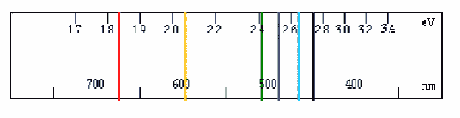
1
2
3
4
5
6
Radiation Wavelength

DEVELOP YOUR UNDERSTANDING SECTION
- By electromagnetic radiation
- Nuclear fusion of hydrogen into helium
- By radiation and convection (and conduction)
- Excited electrons in the atoms there absorb energy, become excited, and lose the energy as radiation as they return to a lower energy state.

ADDITIONAL SUPPORT FOR TEACHERS

SOURCE FOR THIS ADAPTED ACTIVITY
Part 1 was adapted from Activities courtesy of the Stanford SOLAR Center
http://solar-center.stanford.edu/observe/observe.html
Parts 2, 3, and 4 were not adapted from a source.

BACKGROUND INFORMATION

Part 1:
If you want to learn more about how light works, you can join artist Bob Miller’s Web-based “Light Walk” at the Exploratorium. It’s an eye-opening experience for students and teachers alike. His unique discoveries will change the way you look at light, shadow, and images! Bob Miller’s Light Walk http://www.exploratorium.edu/light_walk/lw_main.html

These Web sites give instructions for building more exotic pinhole cameras for observing the Sun:

Cyberspace Middle School http://www.scri.fsu.edu/~dennisl/CMS/sf/pinhole.html
Jack Troeger’s Sun Site http://www.cnde.iastate.edu/staff/jtroeger/sun.html
Related Resources
Activity courtesy of the Stanford SOLAR Center
http://solar-center.stanford.edu/observe/observe.html

Part 2:
The process of stellar nuclear fusion is a complicated series of nuclear reactions that change with changes in temperature. The Sun is essential a plasma ball in which some electrons have escaped from the atoms with which they are normally associated. At about 4 million degrees Celsius, the elements lithium, beryllium, and boron are involved in the production of helium from hydrogen. At higher temperatures around 15 million degrees Celsius, carbon, nitrogen, and oxygen play critical roles. If 1 gram of matter is converted to energy, E = mc² gives us a value of energy equal to 1 gram x (3 x 10¹⁰ cm/sec)² which equals 9 x 10²⁰ ergs. At this rate, one millionth of the Sun’s mass will be converted to energy in the next 15 million years.
Students may have a difficult time finding the lost mass in the nuclear fusion reaction. Essentially we know the mass is missing because we can measure the decreased mass using the mass spectrometer. We know the energy is released because we can observe and measure the released energy. In essence, we recognize that bound nucleons (protons and neutrons) of the nucleus have less mass than when free of nuclear confinement. For example: 6 protons @ 1.00728 atomic mass units (amu), 6 neutrons @ 1.00866 amu, plus 6 electrons @ 0.00055 amu add up to 12.0000 amu when combined in a carbon atom.
Part 4:
Energy is lost by rapidly moving electrons surrounding the nucleus of atoms as they “fall” from excited states to lower levels. The model in parts 3 and 4 has been simplified to make it more readily understandable to students. The basic idea that the greater the fall, the greater the amount of energy released by the electron is valid. Further reading may be warranted if a deeper understanding is desired. Some of the more complicating factors involved include:
- Electrons do not always fall all the way back to “base” level in the way that the ball did.
- Each particular change in energy level does produce a set amount of energy release—a quantum—which is unique and consistent for energy level change.
- Some of the radiation wavelengths produced fall outside the visible spectrum.

REFERENCES FOR BACKGROUND INFORMATION

Hewitt, Paul: Conceptual Physics, Addison-Wesley, 1997.
McLaughlin, Dean: Introduction to Astronomy, Houghton Mifflin, 1961.
Strahler, Arthur: The Earth Sciences, Harper & Row, 1971.
Bob Miller’s Light Walk http://www.exploratorium.edu/light_walk/lw_main.html
Cyberspace Middle School http://www.scri.fsu.edu/~dennisl/CMS/sf/pinhole.html
Jack Troeger’s Sun Site http://www.cnde.iastate.edu/staff/jtroeger/sun.htmlelated Resces
Stanford Solar Center http://solar-center.stanford.edu/observe/observe.html

LINKS TO MST LEARNING STANDARDS AND CORE CURRICULA

Standard 1—Analysis, Inquiry, and Design: Students will use mathematical analysis, scientific inquiry, and engineering design, as appropriate, to pose questions, seek answers, and develop solutions.
Mathematical Analysis Key Idea 1: Abstraction and symbolic representation are used to communicate mathematically.
1.1: Extend mathematical notation and symbolism to include variables and algebraic expressions in order to describe and compare quantities and express mathematical relationships.
1.1a: Identify independent and dependent variables.
1.1b: Identify relationships among variables including: direct, indirect, cyclic, constant; identify non-related material.
1.1c: Apply mathematical equations to describe relationships among variables in the natural world.
Key Idea 2: Deductive and inductive reasoning are used to reach mathematical conclusions.
2.1: Use inductive reasoning to construct, evaluate, and validate conjectures and arguments, recognizing that patterns and relationships can assist in explaining and extending mathematical phenomena.
2.1a: Interpolate and extrapolate from data.
2.1b: Quantify patterns and trends.
Key Idea 3: Critical thinking skills are used in the solution of mathematical problems.
3.1: Apply mathematical knowledge to solve real-world problems and problems that arise from the investigation of mathematical ideas, using representations such as pictures, charts, and tables.
3.1a: Use appropriate scientific tools to solve problems about the natural world.
Scientific Inquiry Key Idea 1: The central purpose of scientific inquiry is to develop explanations of natural phenomena in a continuing, creative process.
1.1: Formulate questions independently with the aid of references appropriate for guiding the search for explanations of everyday observations.
1.1a: Formulate questions about natural phenomena.
1.2: Construct explanations independently for natural phenomena, especially by proposing preliminary visual models of phenomena.
1.2a: Independently formulate a hypothesis.
1.2b: Propose a model of a natural phenomenon.
1.2c: Differentiate among observations, inferences, predictions, and explanations.
1.3: Represent, present, and defend their proposed explanations of everyday observations so that they can be understood and assessed by others.
1.4: Seek to clarify, to assess critically, and to reconcile with their own thinking the ideas presented by others, including peers, teachers, authors, and scientists.
Key Idea 2: Beyond the use of reasoning and consensus, scientific inquiry involves the testing of proposed explanations involving the use of conventional techniques and procedures and usually requiring considerable ingenuity.
2.1: Use conventional techniques and those of their own design to make further observations and refine their explanations, guided by a need for more information.
2.1a: Demonstrate appropriate safety techniques.
2.1b: Conduct an experiment designed by others.
2.1c: Design and conduct an experiment to test a hypothesis.
2.1d: Use appropriate tools and conventional techniques to solve problems about the natural world, including:
- measuring
- observing
- describing
- sequencing
Key Idea 3: The observations made while testing proposed explanations, when analyzed using conventional and invented methods, provide new insights into phenomena.
3.1: Design charts, tables, graphs, and other representations of observations in conventional and creative ways to help them address their research question or hypothesis.
3.1a: Organize results, using appropriate graphs, diagrams, data tables, and other models to show relationships.
3.1b: Generate and use scales, create legends, and appropriately label axes.
3.2: Interpret the organized data to answer the research question or hypothesis and to gain insight into the problem.
3.2a: Accurately describe the procedures used and the data gathered.
3.2b: Identify sources of error and the limitations of data collected.
3.2c: Evaluate the original hypothesis in light of the data.
3.2d: Formulate and defend explanations and conclusions as they relate to scientific phenomena.
3.2e: Form and defend a logical argument about cause-and-effect relationships in an investigation.
3.2f: Make predictions based on experimental data.
3.2g: Suggest improvements and recommendations for further studying.
3.2h: Use and interpret graphs and data tables.
3.3: Modify their personal understanding of phenomena based on evaluation of their hypothesis.

Standard 6—Interconnectedness: Common Themes: Students will understand the relationships and common themes that connect mathematics, science, and technology and apply the themes to these and other areas of learning.

Key Idea 2: Models are simplified representations of objects, structures, or systems used in analysis, explanation, interpretation, or design.
2.2: Use models to study processes that cannot be studied directly (e.g., when the real process is too slow, too fast, or too dangerous for direct observation).
Key Idea 3: The grouping of magnitudes of size, time, frequency, and pressures or other units of measurement into a series of relative order provides a useful way to deal with the immense range and the changes in scale that affect the behavior and design of systems.
3.2: Use powers of ten notations to represent very small and very large numbers.

Standard 4: The Physical Setting: Students will understand and apply scientific concepts, principles, and theories pertaining to the physical setting and living environment and recognize the historical development of ideas in science.
Key Idea 1: The Earth and celestial phenomena can be described by principles of relative motion and perspective.
1.1: Explain daily, monthly, and seasonal changes on Earth.
1.1a: Earth’s Sun is an average-sized star. The Sun is more than a million times greater in volume than Earth.
Key Idea 3: Matter is made up of particles whose properties determine the observable characteristics of matter and its reactivity.
3.1: Observe and describe properties of materials, such as density, conductivity, and solubility.
3.1h: Density can be described as the amount of matter that is in a given amount of space. If two objects have equal volume, but one has more mass, the one with more mass is denser.
3.2: Distinguish between chemical and physical changes.
3.2e: The Law of Conservation of Mass states that during an ordinary chemical reaction matter cannot be created or destroyed. In chemical reactions, the total mass of the reactants equals the total mass of the products.
3.3: Develop mental models to explain common chemical reactions and changes in states of matter.
3.3a: All matter is made up of atoms. Atoms are far too small to see with a light microscope.
3.3b: Atoms and molecules are perpetually in motion. The greater the temperature, the greater the motion.
3.3e: The atoms of any one element are different from the atoms of other elements.
Key Idea 4: Energy exists in many forms, and when these forms change energy is conserved.
4.1: Describe the sources and identify the transformations of energy observed in everyday life.
4.1a: The Sun is a major source of energy for Earth. Other sources of energy include nuclear and geothermal energy.
4.1b: Fossil fuels contain stored solar energy and are considered nonrenewable resources. They are a major source of energy in the United States. Solar energy, wind, moving water, and biomass are some examples of renewable energy resources.
4.1c: Most activities in everyday life involve one form of energy being transformed into another. For example, the chemical energy in gasoline is transformed into mechanical energy in an automobile engine. Energy, in the form of heat, is almost always one of the products of energy transformations.
4.1d: Different forms of energy include heat, light, electrical, mechanical, sound, nuclear, and chemical. Energy is transformed in many ways.
4.1e: Energy can be considered to be either kinetic energy, which is the energy of motion, or potential energy, which depends on relative position.
4.2: Observe and describe heating and cooling events.
4.2a: Heat moves in predictable ways, flowing from warmer objects to cooler ones, until both reach the same temperature.
4.2b: Heat can be transferred through matter by the collisions of atoms and/or molecules (conduction) or through space (radiation). In a liquid or gas, currents will facilitate the transfer of heat (convection).
4.3: Observe and describe energy changes as related to chemical reactions.
4.3a: In chemical reactions, energy is transferred into or out of a system. Light, electricity, or mechanical motion may be involved in such transfers in addition to heat.
4.4: Observe and describe the properties of sound, light, magnetism, and electricity.
4.4a: Different forms of electromagnetic energy have different wavelengths. Some examples of electromagnetic energy are microwaves, infrared light, visible light, ultraviolet light, X-rays, and gamma rays.
4.4b: Light passes through some materials, sometimes refracting in the process.
Materials absorb and reflect light, and may transmit light. To see an object, light from that object, emitted by or reflected from it, must enter the eye.
4.4g: Without direct contact, a magnet attracts certain materials and either attracts or repels other magnets. The attractive force of a magnet is greatest at its poles.
4.5: Describe situations that support the principle of conservation of energy.
4.5a: Energy cannot be created or destroyed, but only changed from one form into another.
4.5b: Energy can change from one form to another, although in the process some energy is always converted to heat. Some systems transform energy with less loss of heat than others.
5.2: Observe, describe, and compare effects of forces (gravity, electric current, and magnetism) on the motion of objects.
5.2a: Every object exerts gravitational force on every other object. Gravitational force depends on how much mass the objects have and on how far apart they are. Gravity is one of the forces acting on orbiting objects and projectiles.
5.2b: Electric currents and magnets can exert a force on each other.

PROCESS SKILLS BASED ON STANDARD 4
General Skills
1. Follow safety procedures in the classroom and laboratory.
2. Safely and accurately use the following measurement tools:
- metric ruler
- balance
- graduated cylinder
3. Use appropriate units for measured or calculated values.
4. Recognize and analyze patterns and trends.
7. Sequence events.
8. Identify cause-and-effect relationships.

Physical Setting Skills
10. Determine the density of liquids, and regular- and irregular-shaped solids.
11. Determine the volume of a regular- and an irregular-shaped solid, using water displacement.
12. Using the periodic table, identify an element as a metal, nonmetal, or noble gas.
16. Determine the speed and acceleration of a moving object.

Produced by the Research Foundation of the State University of New York with funding from the New York State Energy Research and Development Authority (NYSERDA)
www.nyserda.org

Should you have questions about this activity or suggestions for improvement,
please contact Bill Peruzzi at billperuz@aol.com

(STUDENT HANDOUT SECTION FOLLOWS)

Name ____________________________________

Date _____________________________________

Energy for Earth: The Sun

SPN LESSON #14

Introduction
The Sun is the major source of energy for Earth. In our everyday activities we are well aware of this: we sit on the sunny side of the house in the morning for breakfast; we get out of the sunlight when it’s too hot; and we sit on that sunny spot on the floor when we are cold in winter. Your school’s solar collector panels are aimed at the Sun. But how do we get this energy from the Sun? How does the Sun produce energy and how does it travel to us? This series of lab activities will help you answer these two questions.

Part 1: Observing the Sun

All of us have “seen” the Sun. We see it rise in the eastern sky, not usually directly east, but most do not people do not notice this. We know it rises higher in the sky during the day and some of us incorrectly think it gets directly overhead here in New York State. Then it sets on the western horizon, but many of us do not know what the horizon is and once again the direction of sunset is not typically directly west. Naturally, most of us have not looked very closely at the Sun. It’s too bright, and it hurts our eyes to look at the Sun. Actually looking at the Sun DOES harm our eyes; you shouldn’t look at the Sun. So here’s a safe way for you to see the source of all of this energy, to see the object we want to study. Remember: don’t EVER look directly at the Sun, with or without a telescope (unless you have the proper filters).

Projecting the Sun

You can easily and safely observe the Sun by projecting it through a tiny hole onto a white sheet of paper. This simple device is called a “pinhole camera.”

Materials (for 2 students)

2 sheets of stiff white paper
1 pin
Hand lens

Procedure
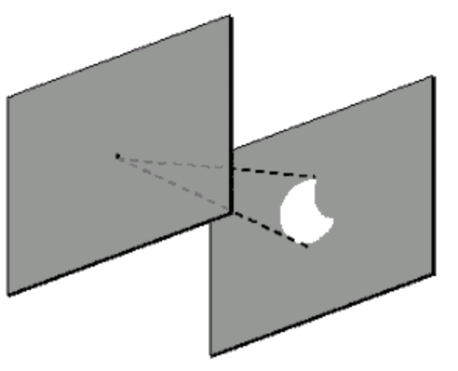

1. With the pin, punch a hole in the center of one
of your pieces of paper.
2. Go outside on a partially sunny day, and hold the piece of paper so that the pinhole is between the Sun and the plain sheet of paper. (Don’t look directly at the Sun either through the hole or in any other way!)
3. Move the higher piece of paper up and down until you see the image of the Sun on the lower sheet.
4. Make sure the image rests on the paper and is in focus (has a nice, crisp edge) and is not just a dot of light.
Does the image of the Sun look like the circular graphic to the right?
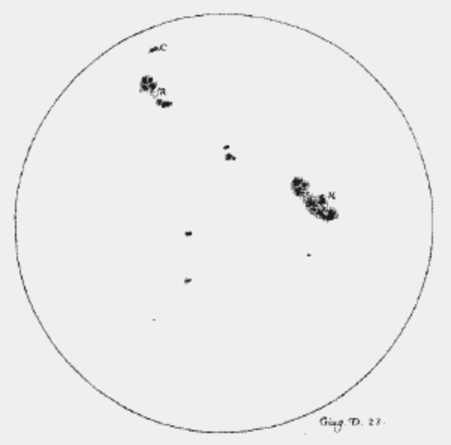
______________________________

5. Experiment by making the hole larger or smaller. What happens to the image?

________________________________________

6. What happens after you punch two holes in the piece of paper?

________________________________________

7. Try bending your paper so the images from the two holes lie on top of each other. What do you think would happen if you punched a thousand holes in your paper and were able to bend your paper so all the images lined up on top of each other?
________________________________________________________________________

In fact, optical telescopes can be thought of as a collection of millions of “pinhole” images all focused together in one place! You can make your pinhole camera fancier by adding devices to hold up your piece of paper, or a screen, on which to project your Sun image. Or you can make your pinhole camera a “real” camera by adding film.

8. While the Sun is behind some thin clouds, hold your hand lens at various distances above the paper. What do you see?

_____________________________________________________________________________

DEVELOP YOUR UNDERSTANDING

- Why does the sunlight coming through the pinhole produce an image of the Sun? What must be happening to the light?
_____________________________________________

________________________________________________________________________

- Does the hand lens produce the same kind of picture of the Sun as the pinhole? Explain.

__________________________________________________________________________

__________________________________________________________________________

- What is it about the nature of sunlight, and light in general, that allows these images to be produced and us to see them?
_______________________________________________

___________________________________________________________________________

Post-lab Demonstration:

Materials

1 hot plate

Procedure:

- Gather close enough to your teacher so that you can see the hot plate clearly. Turn off the lights to darken the room. Turn on the hot plate. Observe the hot plate.
- When the hot plate is first turned on, is it warm or does it glow? ____________________

- Describe the changes in temperature and color that you observe during this demonstration.
___________________________________________________________

- When did the hot plate produce visible light?___________________________________

- Could you feel radiation before you saw any radiation? __________________________

- What is the difference between the radiation you felt and the radiation you saw?

__________________________________________________________________________

- What does this demonstration tell you about the relationship between temperature and the production of radiation?
_____________________________________________________

___________________________________________________________________________

Name ____________________________________

Date _____________________________________

Energy for Earth: The Sun
SPN LESSON #14

Part 2: The Sun’s Structure and Source of Energy

Now that you have actually seen the Sun and have some idea about the nature of radiation and where it comes from, what were you looking at when you observed the Sun? How is the Sun different from the hot plate? What you see when looking at the Sun is the photosphere, the light-producing surface of the Sun.

1. Find this layer in the diagram of the cross section of the Sun below that shows the internal structure of the Sun. With a colored pencil, carefully and lightly shade in the internal part of the Sun between the Sun’s core and the photosphere. You divided the Sun into three parts. Let’s look at these parts one at a time.

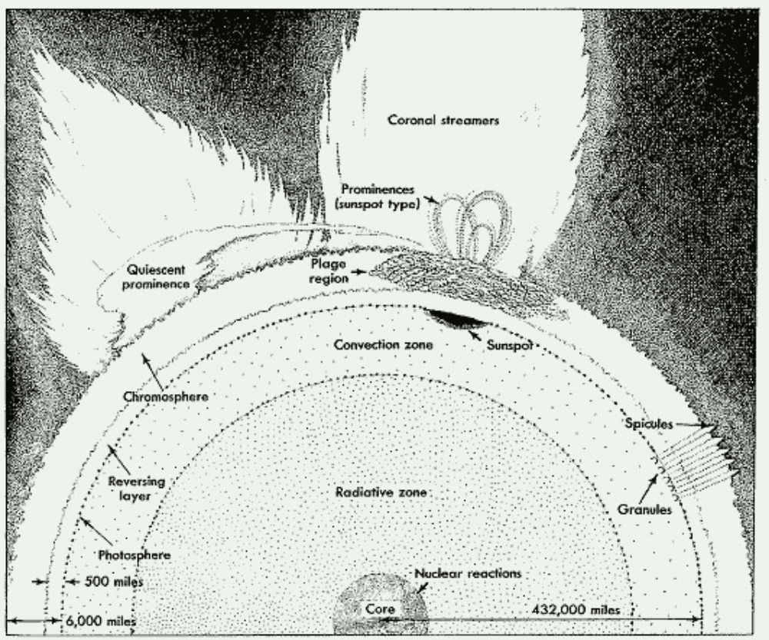
(from McLaughlin, Introduction to Astronomy, 1961, p. 236)

- The Core: Scientific evidence indicates that the nuclear fusion of hydrogen to helium occurs within the core of the Sun. Since the end product, helium, has approximately .7% less mass than the ingredients that it was created from, energy is released. While this is a relatively small amount of mass lost, it is converted into a tremendous amount of energy in the form of heat and radiation. [Einstein correctly predicted that the energy released (E) is equal to the mass lost times the speed of light squared, or E = mc². Since c is such a large number, a little value for m is BIG.] Draw this nuclear reaction using symbols in the space below. Four hydrogen nuclei combine to form one helium nucleus. Use different symbols for the protons and the neutrons.

- The Region You Colored: This region consists of the radiative zone and the convection zone. Each zone is named for the dominant energy transfer process occurring there. Show how each of these processes transfers energy by drawing a labeled diagram of each process in the space provided below.

Radiation: Convection:

4. The Outer Region: The photosphere is the surface we see as the source of sunlight, the Sun’s radiative surface. Sometimes the sunspots, which you may have been able to see while observing the Sun, are present on this surface, creating solar prominences in the Sun’s atmosphere above them.
Circle the sunspot and its prominence on the diagram above.

DEVELOP YOUR UNDERSTANDING

- Why do sunspots look darker than the rest of the Sun’s surface?

________________________________________________________________________

________________________________________________________________________

- Describe how the Sun’s energy is transferred within the convective layer.

__________________________________________________________________________

__________________________________________________________________________

- Identify three other forms of energy into which the Sun’s nuclear energy is transformed.

- ____________________________________________________________________

(2) ____________________________________________________________________

- ____________________________________________________________________

- Where is the mass lost in the hydrogen fusion reaction?

___________________________________________________________________________

- What forces have to be overcome in order for the protons of the hydrogen nuclei to join together to form a helium nucleus?

___________________________________________________________________________

- What stops the radiation found in the Sun’s radiation layer from being Earth’s direct source of solar radiation?
_______________________________________________

- What physical change allows heat energy to be transported by the process of convection?

____________________________________________________________________________

- What must be true about the layers above the Sun’s photosphere to make the photosphere the direct source of solar radiation?

____________________________________________________________________________

- If Earth’s radius is 3,960 miles, how much greater than Earth’s volume is the Sun’s?
[Use the formula V = 4/3π r³ and show your work in the boxes below.]
Sun’s Volume =

Earth’s Volume =
Sun’s Volume =
Earth’s Volume

Name ____________________________________

Date _____________________________________

Energy for Earth: The Sun
SPN LESSON #14

Part 3: Potential and Kinetic Energy

Through lab work we learn how the nuclear reaction energy from the Sun’s interior is changed to light energy received by Earth,

Materials

Per group:

A solid steel ball (1/2-inch diameter)
Sheet of foil-faced insulation (4” x 12”)
3 metric rulers
Calculator
Felt-tip marker
Balance scale
Graduated cylinder (plastic)

Procedure

- Collect the necessary lab equipment for your group of three or four and bring it to your workstation.
- Measure the thickness of your piece of foil-faced insulation.

Thickness = _______________ centimeters
- Measure the mass of the steel ball.
Mass = ______________________ grams
- Measure the volume of the steel ball, using the graduated cylinder and the water displacement technique.
Volume = ___________________ cm³
- What is the density of the steel ball?
Density = M/V = ______________________
- Place the foil-faced insulation on your lab station surface and position the rulers as shown in the diagram below. Set the horizontal ruler so the lower edge is exactly 5 centimeters above the surface of the foil insulation.
- While two students hold the rulers as shown in the diagram, a third student should drop the steel ball from the bottom edge of the horizontal ruler so that it lands on the foil insulation.
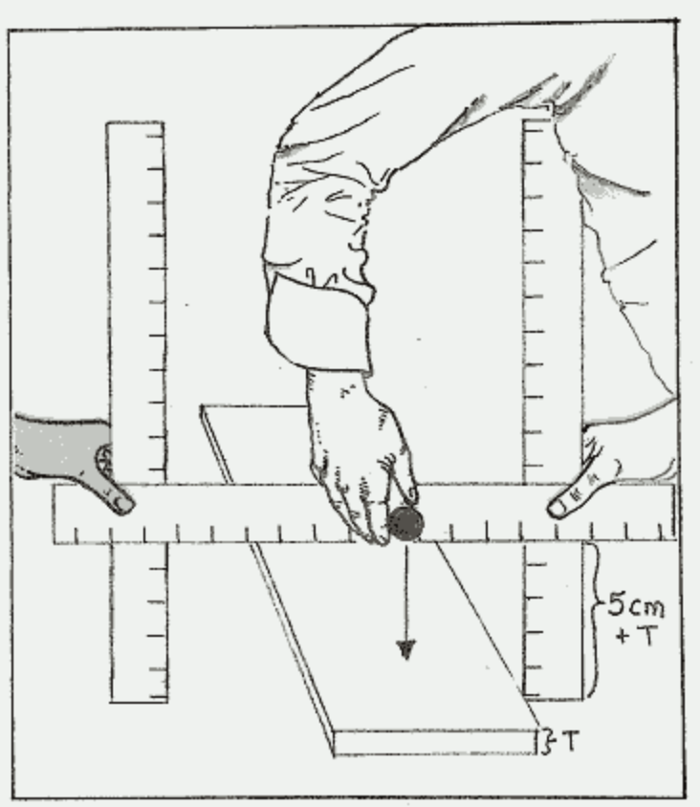

a. Did the ball leave a dent in the surface of the foil? ___________

b. How big is the dent? 1) Distance across = ________________________ cm

2) Depth = ________________________ cm

- You may not have a specific tool to measure this depth. See if your lab group can figure out a method to answer this question. Describe your group’s method.

________________________________________________________________________

________________________________________________________________________

________________________________________________________________________

________________________________________________________________________

- How did the ball make this dent? _______________________________________

- That’s right. The ball is moving or falling because of the force of Earth’s gravity pulling down on it and when it strikes the foil, it exerts a mechanical force on the foil. Another way to say this is to say that the ball, since it has mass and is moving, has kinetic energy. Fortunately for us, mathematicians have developed a formula to help determine exactly how much energy this is: KE = ½ m v². So all we have to find out is the mass of the ball and how fast it was moving (v for velocity) when it hit the foil! So…
- What is the mass of the steel ball in kilograms?
Mass = _____________________ grams
- Did you happen to measure the velocity of the ball as it hit the foil? Was your radar gun broken? That’s too bad. Mathematics comes to the rescue again! The ball is being accelerated by the force of gravity, an acceleration (g) of approximately 10 meters/ second ². Therefore, the velocity of the ball = the acceleration due to gravity (g) x the length of time the ball was falling (t). As long as the ball falls, it increases in speed by 10 meters/second for each second it falls. This formula gives you the ball’s instantaneous velocity: velocity_{instantaneous} = gt.
- But wait, I bet you didn’t time how long the ball was falling, either! That’s OK. As long as we know how far the ball fell, we can calculate how long that fall took. That’s right, mathematics again! The formula is: d = ½ gt². So, let’s find the time so we can determine the velocity. If you algebraically rearrange this formula, you get: t² = 2d/g. In the box below, plug the numbers and units into this formula and solve first for t², then t. [Show how the units cancel to give the correct units for your answer. Also, remember that the distance has to be measured in meters. How many meters did the steel ball fall?

__________________ [meters]

t² = 2 d / g

t = ________________________ [Show the correct units.]

d. Now that you know t, you can calculate the velocity of the ball when it hit the foil by substituting in equation (b) above. Show your work again.

v = g t

v = _______________________[Show correct units]

e. Find the kinetic energy of the ball as it hit the foil using the equation in step 5 above.

KE = ½ m v²

KE = _____________________________ [Show correct units]

- But where did the ball get this energy? Do steel balls always have energy inside just waiting to get out? In this case only if someone put it there. If you are all looking at lab partner #3, good. You have found the guilty party! By lifting the ball 5 cm above the foil, partner #3 stored energy in the ball equal to the mass of the ball times the acceleration due to gravity times the height lifted: this is called potential energy. In a formula form: PE = mgh. Applying this formula, does the amount of stored energy (PE) equal the amount of kinetic energy measured at the end of the fall? [Remember to write height in meters and the mass in kilograms.]
PE = m g h

PE = ___________________________ [Show correct units]

- You might have noticed that the units for potential and kinetic energy became complicated and a lot of baggage to carry around. Scientists realized this too, so to simplify their (and our) lives, they gave these energy units for work or the name joules. [1 joule = 1 gram-meter²/second²] State the relationship in joules between the amount of potential energy used to lift the ball and the amount of kinetic energy present in the ball as it returns to its original height.

___________________________________________________________________

___________________________________________________________________
- Now that you have some understanding of the energy relationships involved, let’s collect some more data. What do you predict will happen to the PE and KE amounts if you lift the ball to a higher level and drop it on the foil?

__________________________________________________________________
Let’s see if you have it right.

14. Using the felt-tip marker, label the dent that you’ve already made in the foil at 5 cm. Raise the horizontal ruler to a height of 10 cm + T. Drop the steel ball onto the foil from this height. Label the dent in the foil by the height from which the ball was dropped. Measure the dent width and depth. Record these values in the chart to the right. Repeat this procedure every 5 cm to a drop height of 30 cm + T.
Ball Height  Above Foil  (cm) | Dent  Width  (cm) | Dent  Depth  (cm)
5
10
15
20
25
30

- Plot this data on the graphs below. Be sure to enter an appropriate scale so as to fit your data on the vertical axis of each graph

Ball Height versus Dent Width Ball Height versus Dent Depth

Dent Width (cm)
Dent Depth (cm)

5 10 15 20 25 30
5 10 15 20 25 30

- Summarize the relationship between the height of the ball drop and the energy indicated by the dent made by the ball in the foil insulation.

____________________________________________________________________

____________________________________________________________________

____________________________________________________________________

Name ____________________________________

Date _____________________________________

Energy for Earth: The Sun
SPN LESSON #14

Part 4: Potential Energy, Kinetic Energy, and Radiation from the Sun

What does the “ball drop activity” have to do with the Earth’s receiving radiation energy from the Sun? If you understand the energy changes from potential to kinetic energy that occurred, you can use it as a model for the production of radiation within a star such as our Sun. The steel ball represents an electron rapidly orbiting the nucleus of an atom. When the huge amounts of energy are released during the nuclear fusion of hydrogen atoms into helium atoms within the Sun’s core, the heat and motion of matter within the Sun cause collisions among the atoms. This energy, when absorbed by the electrons of these atoms, lifts the electron [stored potential energy] from its normal orbit in the circular pathway closest to the nucleus into one of the higher excited states farther from the atomic nucleus [shown by curving arrows 1, 2, 3, 4, 5, and 6 below]. These are like the higher levels to which you lifted the steel ball.

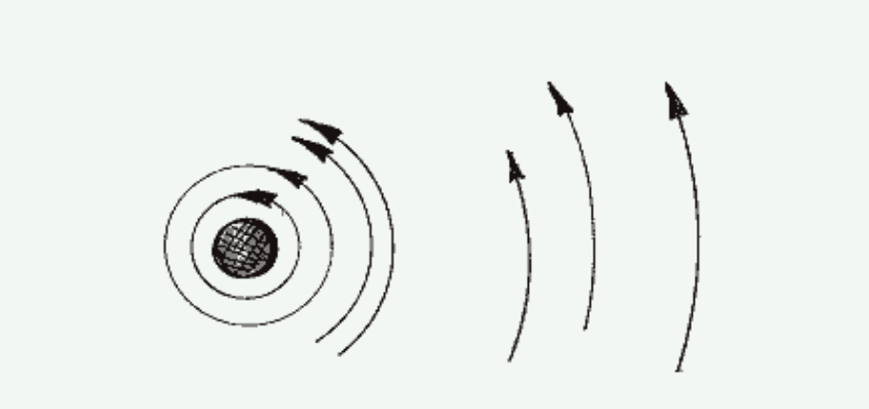

Nucleus

1
2
3
4
5
6
Normal
Electron Orbit

The electron remains at the higher energy level only momentarily, and then falls back toward its original normal level just like the steel ball falling to the foil.

- Which excited electron level in the diagram above represents the greatest input of stored or potential energy? _____________

- The most energy will be released when the electron falls from which excited electron level? ______________

Each drop distance of the electron represents a unique amount of energy. The energy is released in the form of electromagnetic radiation shown in the diagram below. Notice that there are two waves traveling together, an electric wave and a magnetic wave—thus the name.

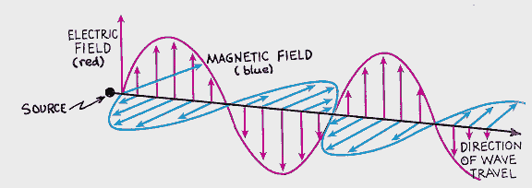
[after Hewitt: Conceptual Physics, p. 590]

You probably know that a moving electric current always produces a magnetic field: an effect that creates the electromagnet. You may also know that the reverse is true. A moving magnetic field can produce an electric current, which is the basis for pieces of technology such as the electric generator. The physicist James Maxwell discovered in the mid-1800s that the radiation from the Sun behaves as a changing electric field that generates a changing magnetic field, which in turn regenerates the changing electric field and so on…. This occurs only if the electromagnetic radiation is moving at a speed of 300,000 meters per second, the speed of light—a value that Maxwell was able to calculate (not measure) from his mathematical equations!

- That radiation has the properties of a fast-moving electric current makes sense given the “source” of the radiation in the diagram above. What is the source?

__________________________________________________________________________

- As the amplitude (the height) of the electric wave increases, what happens to the height of the magnetic wave?
______________________________________________________

When the electromagnetic radiation from the electrons of the atoms of one chemical element in the gaseous phase is refracted through a prism, a distinctive fingerprint of bright lines is seen as shown in the example below. Each line has a particular wavelength (the bottom scale in 10⁻⁷ centimeters) and relative energy (the top scale).

Relative Energy
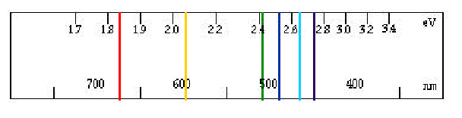
Radiation Wavelength

- Which line has the shortest wavelength? __________________________________

- Which line has the greatest amount of energy? _____________________________

- State the general relationship between wavelength and energy content of these six electromagnetic waves.

____________________________________________________________________________

____________________________________________________________________________

- If these six spectral lines were produced by the fall of our model electron (the steel ball) from the “model electron levels” shown in the first diagram above, which excited orbital state produced which spectral line? To answer this question, place the number of the orbital state next to the line produced on the bright line spectrum above.

DEVELOP YOUR UNDERSTANDING

1. How is energy transferred from the Sun to Earth?

2. Describe the original source of that energy within the Sun’s core.

3. Describe how that energy is transferred from the middle of the Sun to the photosphere.

4. Describe what happens within the photosphere that releases the Sun’s energy to space (and Earth).

