NOTICE OF MEETING AND AGENDA
April 16, 2020

TO THE GUESTS OF THE NEW YORK STATE ENERGY RESEARCH AND DEVELOPMENT AUTHORITY:

PLEASE TAKE NOTICE that a regular (the 246th) meeting of the New York State Energy Research and Development Authority (“Authority”) will be held via video conference, on Tuesday, April 27, 2021, commencing at 1:30 p.m., for the following purposes:

- Discussion Agenda:

  - To receive a report from the President and CEO.

  - To consider a resolution to enter into a private session for the purpose of discussing attorney-client privileged matters.

  - To receive a report from the Governance Committee.

  - To receive a report from the Audit and Finance Committee.

  - To receive a report from the Program Planning Committee.

  - To receive a report from NY Green Bank.

  - To receive a report from one of the Authority’s Programs.

- Consent Agenda

  - To consider and act upon resolutions approving:

        - amendments to the Authority’s Conflict of Interest Policy;

        - general salary increases for Officers consistent with New York State Budget approvals for Management Confidential employees;

        - amendments to the Authority’s Internal Control Manual;

        - the financing of the Green Jobs – Green New York Program;

        - a debt facility on behalf of NY Green Bank; and

        - the periodic contracts report.

- To transact such other business as may properly come before the meeting.

Members of the public may attend the meeting via the video conference which can be accessed at https://www.nyserda.ny.gov/About/Board-Governance/Board-and-Committee-Meetings.

The Authority will be posting a video and a transcript of the meeting to the web as soon as practicable after the meeting. The video and transcript will be posted at http://www.nyserda.ny.gov/About/Board-Governance/Board-and-Committee-Meetings.

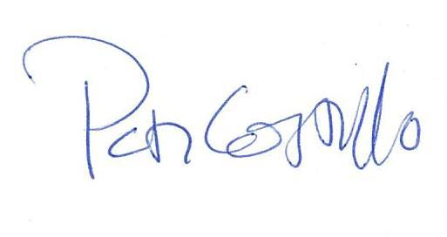

Peter J. Costello
Secretary

