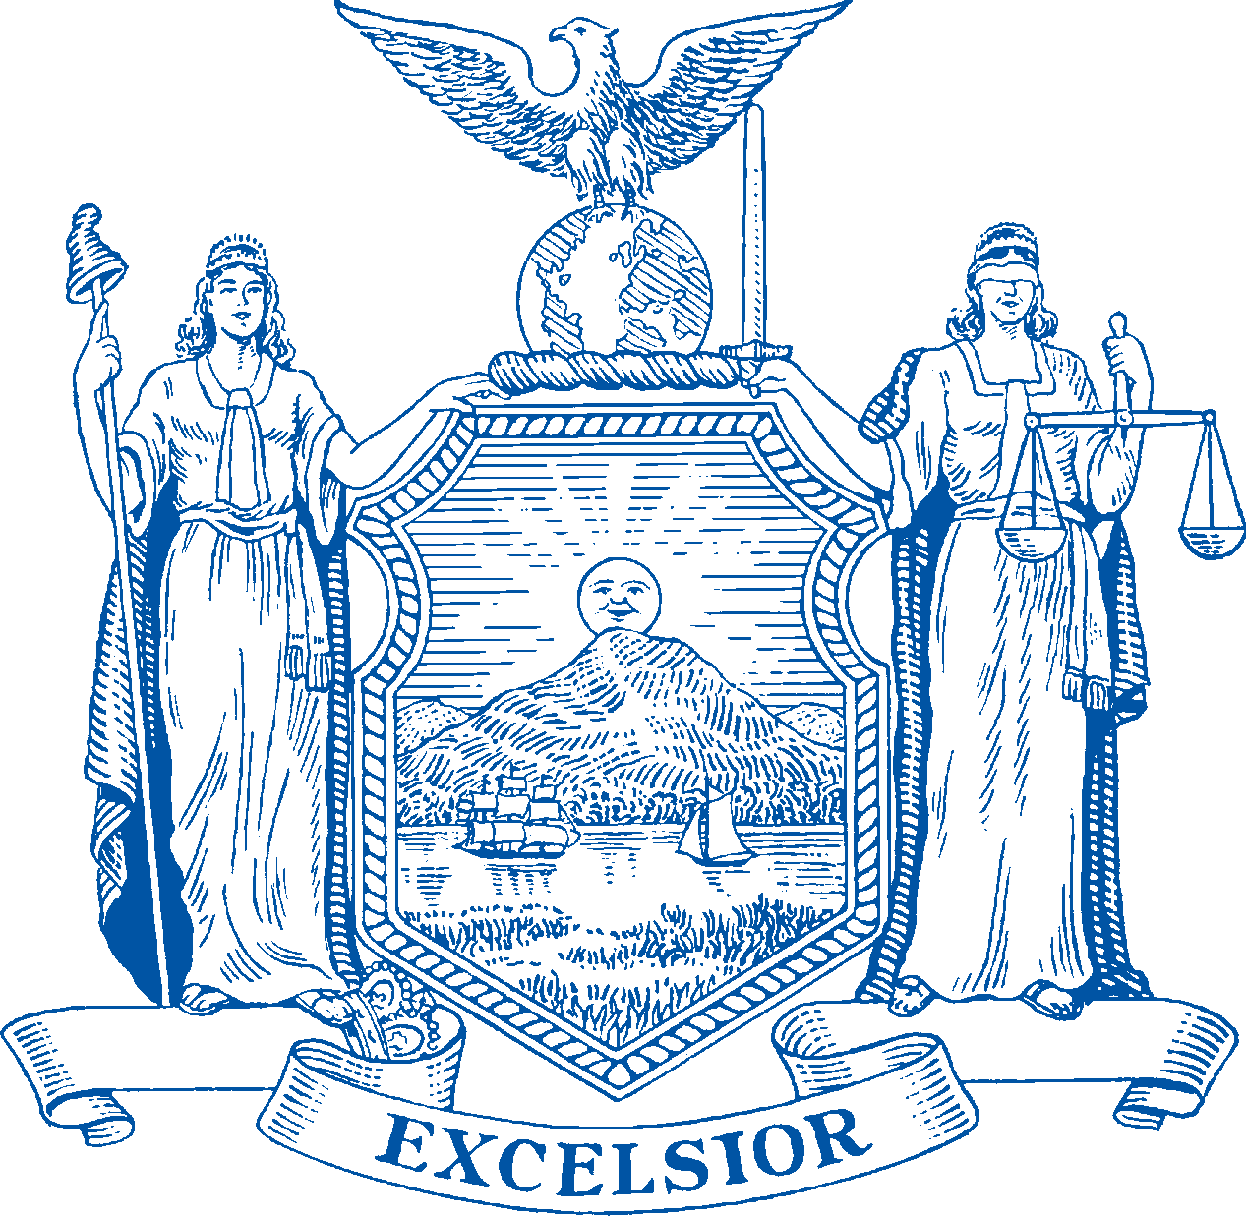

CARRIE WOERNER
Assemblywoman 113th District Saratoga County
Washington County

THE ASSEMBLY STATE OF NEW YORK ALBANY

CHAIR
Legislative Commission on
Skills Development and Career Education

COMMITTEES
Agriculture Local Governments Racing and Wagering
Small Business Tourism, Parks, Arts and
Sports Development

VIA EMAIL

June 29, 2022

Draft Scoping Plan Comments
Doreen M. Harris
President and CEO
NYSERDA
17 Columbia Circle
Albany, NY 12203-6399

Dear President Harris and Council Members:

Thank you for your work on the Draft Scoping Plan and your ongoing efforts to propel New York State toward net zero emissions. I am writing today to urge the Climate Action Council to include a clean/low carbon fuel standard for vehicles and residential and commercial heating applications in the Final Scoping Plan, to highlight the urgent and comprehensive actions NYS must take to achieve its greenhouse gas (GHG) emission reduction targets for 2030 and beyond. As set forth in further detail below, enactment of a clean/low-carbon fuel standard for the transportation and heating sectors is necessary to immediately curb GHG emissions and accelerate the switch to all-electric, even as NYS struggles to address the many hurdles associated with converting its transportation and heating sectors to a renewable energy economy.

Transportation

The Draft Scoping Plan identifies three potential mitigation scenarios (scenarios 2, 3 and 4), each of which incorporates a clean fuel standard. As an integral tool for meeting NYS’s short-term and long-term emission reduction targets, I urge the Council to recommend that NYS immediately enact legislation authorizing the Department of Environmental Conservation (DEC) to promulgate a clean fuel standard. Moreover, if the Council chooses to pursue one mitigation scenario in lieu of all others, I urge the Council to choose mitigation scenario 2 (Strategic Use of Low-Carbon Fuels), because auto makers have not yet sufficiently demonstrated the motivation and/or ability to scale the EV market quickly enough to satisfy emission reduction targets in any mitigation scenario that does not incorporate significant assistance from a clean fuel standard.

Specifically, the Council has identified a goal of selling approximately 3M zero-emission vehicles (ZEVs) in NYS in the next 7 ½ years, by 2030. To achieve that goal, NYS consumers must purchase 200,000 ZEVs by the end of this year and 400,000 every year thereafter for the next 7 years. While a laudable and essential goal, the timetable appears particularly unrealistic for scenarios 3 (Accelerated Transition Away from Combustion) and 4 (Beyond 85% Reduction), because each of those scenarios relies less on a multi-pronged approach and more on the dominant sales of EVs, a solution that hinges on many unknowable and/or uncontrollable private sector variables.

EV Accessibility

Currently, there are approximately 103,000 battery electric vehicles (BEVs) and plug-in hybrid electric vehicles (PHEVs) registered in NYS. Car makers sold approximately 462,000 BEVs in the United States last year, with over 40% (183,933) of those sales occurring in California and approximately 5% (23,076) in NYS., The vast majority of the U.S.’s EV inventory presently comes from Tesla. Tesla alone accounted for close to 80% of U.S. EV sales in 2021 and again in the first quarter of 2022.,, Even with the growth of the EV market, NYS has a long path to replacing its fossil fuel-emitting (FFE) vehicles. Currently, there are over 4M FFE automobiles on NYS roads. Last year’s EV registrations - including PHEVs – accounted for only 38,839 vehicles, less than 1% of overall NYS automotive registrations in 2021.

Thankfully, there is significant potential for growth in EV sales - both in volume and manufacturer offerings – however, as noted by a recent trade magazine, “Automotive companies including Volkswagen Group, Ford, Mercedes and even Tesla are struggling to meet customer demand given ongoing supply chain issues, battery availability, chip shortages and increased interest in EVs exacerbated by rising gasoline prices.” Clearly, these are significant issues that need to be resolved, but they are not the only issues. To increase EV purchases and substantially transition NYS consumers away from FFE vehicles by 2030, the Council must build on NYSERDA’s 2021 report, An Electric-Vehicle Consumer Segmentation Roadmap, to determine how NYS can best improve EV affordability to a wide range of customers, improve consumer education, and ultimately, work with predictable consumer behavior patterns to achieve the state’s fast-approaching emission reduction target deadlines.

Impacts on Consumer Behavior

Across my district and across the country, people want to contribute to reducing GHG emission rates, but their willingness to directly participate depends on foreseeable factors, including product affordability, consumer education, and perceived need. NYS must do more to educate consumers and to respond to their fiscal and functional concerns about EVs. At the same time, NYS must help residents cut emissions now, even while they continue to operate their existing FFE vehicles.

- EV Affordability and Consumer Education/Research

To drive both consumers and manufacturers increasingly toward EV purchases/sales, NYS must take a multi-pronged approach. In addition to promoting progressively lower carbon fuels for existing vehicles, NYS must continue to enhance – and advertise - the incentives it offers for EV ownership. Currently, EVs cost more than FFE vehicles. That fact hinders both consumer motivation to purchase EVs and the motivation of many manufacturers to produce more EVs. California currently leads the nation in EV sales, plus it sells more EVs per capita than NYS. The following example demonstrates the differing incentives available to buyers in San Marcos, CA and Albany, NY. Despite the fact that San Marcos’s median household income is substantially higher than Albany’s, California’s broader incentive program enables a San Marcos buyer to purchase a new Nissan Leaf for less than an Albany buyer.

Vehicle incentives for a Nissan Leaf purchased in San Marcos, CA vs. Albany, NY
San Marcos (92024) | Albany (12208)
Median Household Income = $86,408 | Median Household Income = $48,512
TOTAL INCENTIVES: $10,250 | TOTAL INCENTIVES: $8,500
$7500 Federal Tax Credit | $7500 Federal Tax Credit
$750 CA Clean Fuel Reward | $1000 NY Drive Clean Rebate
$2000 CA Clean Vehicle Rebate Project
CA Vehicle Retirement Consumer Assist Program (CAP)
HOV Lane Exemption | Clean Pass – Long Island Expressway HOV lane exemption
Beneficial State Bank financing assistance
 | EZ Pass Green Discount Plan
Charging station incentive | Charging station incentive
Time of use (TOU) rate plan | Time of use (TOU) rate plan (for Upstate customers)
$17,150 – after incentives applied | $18, 900 – after incentives applied
State tax rate = 7.25%  Add’l County/City tax = ½% | State tax rate = 4%  Add’l county tax = 4%
Registration + fees = $1598.00 | Registration + fees = 1644.50
$18,748  - after incentives, taxes and fees | $20,545  - after incentives, taxes and fees

In addition to the above incentives, some California buyers may also receive a rebate from their locality. California buyers can easily find the incentives that apply to them, as state and local incentives can be found in one, central online location. For example, Alameda residents may determine if they qualify to receive up to $1,500 towards the purchase of a pre-owned EV. Low-income Bay Area residents (which includes Alameda!) may determine whether they qualify to receive an incentive of up to $9,500 to retire a qualifying 1996 or older registered vehicle to be replaced with a ZEV or a “Clipper Card” for public transit. NYS needs to provide vehicle consumers with the same type of easily found and digestible information, plus broader incentives to flip the ratio of EVs purchased in comparison to FFE vehicles.

- Consumer Behavior

Factors other than cost can also sway a consumer’s decision about when – or whether - to purchase an EV. Consumers may consider things like battery range, public charging station locations, home charging capabilities, insurance costs, longevity, cost of a comparable FFE car, and the age and condition of a current car. Despite the fact that each of the three mitigation scenarios calls for 100% of all new “light-duty” vehicle sales to be strictly ZEV by 2035, the age and condition of a person’s current car will continue to be a dominating factor in their decision to purchase an EV in the next 12+ years. According to a survey done by iSeeCars.com in 2018, the average length for owning a new vehicle is almost 7 years, but many original owners will likely keep a variety of particularly beloved models for more than 15 years! With 12 ½ years to 2035 and FFE sales annually outpacing EV sales in NYS by approximately 1000 to 7, we must anticipate the continued presence of a significant number of FFE vehicles in 2035.

In summary, given the intractable challenges associated with exponentially increasing consumer purchases of EVs over the next decade, it becomes even more necessary to enact a clean/low carbon fuel standard as soon as possible. Doing so in conjunction with other manufacturing and consumer incentives will immediately reduce GHG emissions and accelerate the conversion to EVs by contemporaneously motivating fuel producers, automakers, and consumers. NYS agencies can also play a particularly important role in accelerating momentum by immediately committing to purchase EVs for all new fleet purchases and by buying low carbon fuel for its existing fleet operations.

Energy Efficiency and Housing

As of 2030, each of the three mitigation scenarios (2, 3 and 4) calls for the use of renewable natural gas (RNG) blends of varying percentages in pipelines, plus for all new sales of single-family homes [and low-rise residential] to include heat pump systems. Scenarios 3 and 4 also call for the “early retirement of old heating systems.” For the reasons stated below, I urge the Council to recommend that NYS immediately enact legislation authorizing the Department of Environmental Conservation (DEC) to promulgate a clean/low carbon heating fuel standard. Moreover, if the Council chooses to pursue one mitigation scenario in lieu of all others, I urge the Council to choose mitigation scenario 2 (Strategic Use of Low-Carbon Fuels), which represents the most practical approach to the difficult and costly overhaul to heat pumps.

Although the plan to rapidly convert to electric in the transportation sector faces challenges, the conversion from boilers and furnaces to electric heat pumps will face even greater resistance from home builders and consumers. Cost and practicality are both major hurdles, particularly since many consumers may only buy one or two houses during their lifetimes. Builders and remodelers have already approached me with concerns that requiring heat pumps in all new homes will necessitate increased home prices. As a result, these builders warned that the requirement for heat pumps will also hinder their ability to respond to the demand for more affordable housing.

Homeowners have also contacted me. They are concerned that they will be forced to convert to a heat pump within 7+ years, even though their existing furnace or boiler likely has a remaining useful life of 10-25 years and cannot be sold on a secondary market! A mandate to heat pumps, though seemingly necessary, poses various difficult hurdles, including cost, practicality, and consumer demand. As noted above, heat pumps will add a substantial upfront cost to consumers, whether installed in a new home or in an existing one. In terms of practicality, heat pumps require duct work. Many homes in my district are very old, dating back to the mid-eighteen hundreds. They do not have ducts, not are ducts easy to add. In addition to duct work, heat pumps also require a home to be sufficiently “weather-proofed.” This fact is reflected in the mitigation scenarios, all of which call for 25% of homes to have efficient shell upgrades by 2030. Unfortunately, a shell upgrade is also a tricky process for an older home. Many old homes have rubble foundations and dirt floor basements. For these types of homes, creating an efficient shell first necessitates creating a vapor barrier (particularly in the basement) to keep the moisture out while keeping the heat in.

The enactment of a clean/low carbon heating fuel standard can help ease some of these transition issues by immediately curbing GHG emissions and enabling homeowners and suppliers to use existing infrastructure until a homeowner’s current system fails. Implementing a clean/low carbon fuel standard also gives NYS a little more time to determine better ways to incentivize consumers to make the transition.

Thank you for your consideration. There is much to do to achieve our goals, and I look forward to working together to do just that!

Sincerely yours,
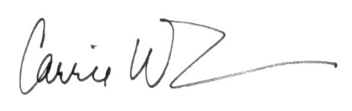
Carrie Woerner
Member, New York State Assembly
113th Assembly District
Saratoga & Washington Counties

New York State Climate Action Council. (2022, December 30). New York State. Retrieved June 24, 2022, from https://climate.ny.gov/Our-Climate-Act/Climate-Action-Council. See p. 74. Scenario 2 calls for 2.7M ZEV sales (90% new sales) by 2030, whereas scenarios 3 and 4 each call for 3.4M (98% new sales).
EValuateNY. (2022, March). Atlas Public Policy. Retrieved June 24, 2022, from https://atlaspolicy.com/evaluateNY/. See “Vehicle Deep Dive.”
Shahan, Z. (2022a, April 11). Top Non-Tesla Electric Cars In USA Had Under 30,000 Sales In 2021. CleanTechnica. Retrieved June 24, 2022, from https://cleantechnica.com/2022/04/11/top-non-tesla-electric-cars-in-usa-had-only-token-sales-in-2021/. ** In contrast, 6.5 million EVs were sold worldwide last year.
California Energy Commission. (n.d.). ZEV And Infrastructure Stats Data. CA.Gov. Retrieved June 24, 2022, from https://www.energy.ca.gov/files/zev-and-infrastructure-stats-data.
Charge NY. (n.d.). Charging Station Programs. NYSERDA.Ny.Gov. Retrieved June 28, 2022, from https://www.nyserda.ny.gov/All-Programs/chargeny/charge-electric/charging-station-programs.
Shahan, Z. (2022, April 12). Tesla Model 3 & Model Y Score ~100,000 US Sales in 1st Quarter of 2022. CleanTechnica. Retrieved June 24, 2022, from https://cleantechnica.com/2022/04/12/tesla-model-3-model-y-score-100000-us-sales-in-1st-quarter-of-2022/. **Encouragingly, 2022 first quarter national BEV sales were over 147,000. However, approximately 46% (67,118) of those sales occurred in California, and just 6% (9,090) in NYS.
Ibid.
ScrapeHero. (2022, June 24). Number of Tesla locations in United States. Retrieved June 27, 2022, from https://www.scrapehero.com/location-reports/Tesla-USA/. **Notably, there are 53 Tesla locations in California.
NYS law currently caps the number of direct car sales locations permitted in the state to five (5). Because Tesla is presently the only car manufacturer in NYS to sell vehicles directly to consumers rather than through a dealer franchise, Tesla has holds all 5 of the direct sale licenses.
Department of Motor Vehicles. (2022, June 1). State of New York. Data.Ny.Gov. Retrieved June 28, 2022, from https://data.ny.gov/d/w4pv-hbkt/visualization.
Charge NY. (n.d.). Electric Vehicle Registration Map. NYSERDA. Retrieved June 24, 2022, from https://www.nyserda.ny.gov/All-Programs/chargeny/support-electric/map-of-ev-registrations.
Badalian, V. (2022, May 24). The truth behind EV sales in 2022. GreenBiz. Retrieved June 24, 2022, from https://www.greenbiz.com/article/truth-behind-ev-sales-2022.
Center for Sustainable Energy et al, An Electric-Vehicle Consumer Segmentation Roadmap: Strategically Amplifying Participation in the New York Drive Clean Rebate Program, October 2021. Retrieved June 27, 2022, from https://www.nyserda.ny.gov/About/Publications/Research-and-Development-Technical-Reports/Transportation-Reports.
Willis, B. (2022, March 28). New National Poll Shows That A Large, Bipartisan Majority of Voters Favor Policies To Accelerate Electric Vehicle Adoption - ZETA. ZETA. Retrieved June 27, 2022, from https://www.zeta2030.org/news/new-national-poll-shows-that-a-large-bipartisan-majority-of-voters-favor-policies-to-accelerate-electric-vehicle-adoption.
Office of The Governor. (2022, February 25). California Leads the Nation’s ZEV Market, Surpassing 1 Million Electric Vehicles Sold. California Governor. Retrieved June 27, 2022, from https://www.gov.ca.gov/2022/02/25/california-leads-the-nations-zev-market-surpassing-1-million-electric-vehicles-sold/.
California’s per capita EV sales are 1.7, whereas New York’s are 0.53.
Median Household Income by State 2022. (n.d.). World Population Review. Retrieved June 27, 2022, from https://worldpopulationreview.com/state-rankings/median-household-income-by-state.
VELOZ. (n.d.). Find 80+ Electric Vehicles and Incentives. Electric For All. Retrieved June 27, 2022, from https://www.electricforall.org/which-car-is-right/.
US Census. (n.d.). U.S. Census Bureau QuickFacts. Census Bureau QuickFacts. Retrieved June 28, 2022, from https://www.census.gov/quickfacts/fact/table/albanycitynewyork,sanmarcoscitycalifornia/PST045221.
Internal Revenue Service. (2022, March 2). Plug In Electric Vehicle Credit IRC 30 and IRC 30D. IRS. Retrieved June 27, 2022, from https://www.irs.gov/businesses/plug-in-electric-vehicle-credit-irc-30-and-irc-30d.
NYSERDA. (n.d.). It’s a Great Time to Get an Electric Car in New York State. New York State. Retrieved June 27, 2022, from https://www.nyserda.ny.gov/drive-clean-rebate.
Department of Consumer Affairs. (n.d.). Consumer Assistance Program Vehicle Retirement. Bureau of Automotive Repair. Retrieved June 27, 2022, from https://bar.ca.gov/consumer/consumer-assistance-program/cap-vehicle-retirement-program.
New York State Department of Transportation. (2022, February 1). Clean Pass Program. New York State. Retrieved June 27, 2022, from https://www.dot.ny.gov/portal/page/portal/programs/clean-pass?nd=nysdot.
Beneficial State Foundation. (2021, September 28). Budget Before You Buy. Clean Vehicle Assistance Program. Retrieved June 27, 2022, from https://cleanvehiclegrants.org/financing/.
New York State Thruway. (2022, February 1). Green Discount Plan. New York State. Retrieved June 27, 2022, from https://www.thruway.ny.gov/ezpass/greentag.html.
Charge NY. (n.d.). Charging Station Programs. NYSERDA.Ny.Gov. Retrieved June 28, 2022, from https://www.nyserda.ny.gov/All-Programs/chargeny/charge-electric/charging-station-programs.
California Air Resource Board. (n.d.). Incentive Search | DriveClean. Drive Clean. Retrieved June 27, 2022, from https://driveclean.ca.gov/search-incentives.
Ibid & BAAMD. (n.d.). Clean Cars for All. Bay Area Air Quality Management District. Retrieved June 27, 2022, from https://www.baaqmd.gov/funding-and-incentives/residents/clean-cars-for-all.
MYEV.com. (2022, June 27). 10 Questions To Ask Yourself Before Buying An Electric Vehicle. Retrieved June 27, 2022, from https://www.myev.com/research/ev-101/10-questions-to-ask-yourself-before-buying-an-electric-vehicle.
Gorzelany, J. (2021, July 19). The Long Haul: 15 Vehicles Owners Keep For At Least 15 Years. Forbes. Retrieved June 27, 2022, from https://www.forbes.com/sites/jimgorzelany/2018/01/12/the-long-haul-15-vehicles-owners-keep-for-at-least-15-years/?sh=6b0a2d362374.
Ibid. **See list of vehicles at Appendix A.
ServiceOne. (2019, December 4). How Long Does a Home Boiler Last. Retrieved June 27, 2022, from https://www.serviceone.com/blog/article/how-long-does-a-home-boiler-last#:~:text=Estimated%20lifespan,most%20parts%20of%20the%20nation. **An oil or gas boiler can often last between 11 and 27 years!

