November 17, 2021

To the White House Environmental Justice Advisory Council:

My name is Dr. Hal Strelnick. I am a Professor of Family and Social Medicine and of Epidemiology and Population Health at the Albert Einstein College of Medicine. For a decade I was Principal Investigator for a grant from the National Institute of Environmental Health Sciences that studied the relationship of adult and childhood asthma with both stationary and mobile sources of air pollution.

I write about the health effects of gas-powered leaf blowers. As many of us are working from home since the beginning of the pandemic, we can hear that these machines are deafening but they are also invisibly toxic.

Gas-powered leaf blowers pose a strong threat to community health because of their emissions. Leaf blowers generate copious amounts of fine and ultrafine particulate matter both through their exhaust and dust blown into the air, which can linger in the air for days.

Because their two-stroke engines run on a combination of gasoline and oil, leaf blowers produce an especially toxic exhaust, including large amounts of unburned fuel, carbon monoxide, cancer-causing hydrocarbons, such as benzene, asthma-inducing ozone and nitrous oxides, and asthma-aggravating fine particulate matter.

Independent laboratories have measured the air pollution generated by two-stroke engines and found their hydrocarbons, nitrous oxides, and carbon monoxide dramatically exceeded regulated cars and pick-up trucks. California air quality officials estimated that in 2020 leaf blowers and other small two-stroke engines produced more hydrocarbon-based ozone pollution than all of the passenger cars in the state. The California scientists estimated that an hour of using a gas leaf blower makes as much pollution as driving a 2016 Toyota Camry 1100 miles. California has passed a law requiring their regulation in 2022 and banning their sale in 2024.

The smaller the particulate size, the farther into the lungs they penetrate, generating inflammation and exacerbating asthma and emphysema and potentially causing cancers. Fine particulate matter increases mortality rates from pulmonary and cardiovascular disease, cancer, and even COVID-19.

Unlike emissions from smoke stack industries or along major highways, this source of air pollution is close to the humans who operate the leaf blowers. Because these aerosols linger near the ground for up to a week, they also expose children and residents long after the lawn care workers have packed up their machines.

I once wrote a paper for Mayor David Dinkins in New York City called “What’s a Mayor to Do About Health” that talked about the limited municipal authority in regulating health. (By treating tobacco smoke as an indoor air pollutant, Mayor Michael Bloomberg showed that municipalities could ban smoking and second-hand smoke in work places.) Municipalities cannot regulate vehicle or smokestack emissions, but the federal government and Environmental Protection Agency can. Phase out gas-powered leaf blowers and other two-stroke engines and replace them with electric equipment or better still, “leave the leaves” and follow the ecological principles of native gardening that support biodiversity and the micro-habitats created by fallen leaves for the non-migrating insects and pollinators that over winter in our gardens and lawns.

One thing municipalities, states, and the federal government CAN do to powerfully improve human health is to limit leaf blowers as much as possible. Allowing the virtually unfettered use of gas-powered leaf blowers in our neighborhoods, parks, and around our schools puts everyone’s health at greater risk.

Thank you.

If you have any questions, please feel free to contact me at hstrelni@montefiore.org or (914) 980-1463.

Sincerely,
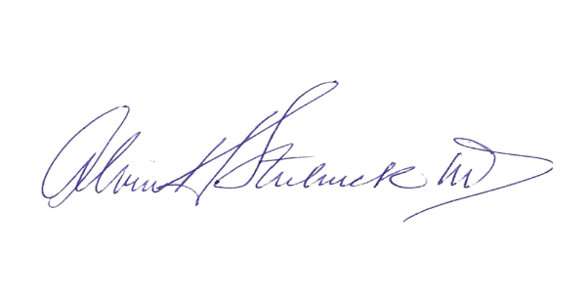

Alvin H. Strelnick, MD
Associate Dean for Community Engagement
Professor, Family & Social Medicine
Project Director, Bronx Healthy Start Partnership, Bronx Health Opportunities Partnership @ Einstein (Bronx HOPE), and Hispanic Center of Excellence

