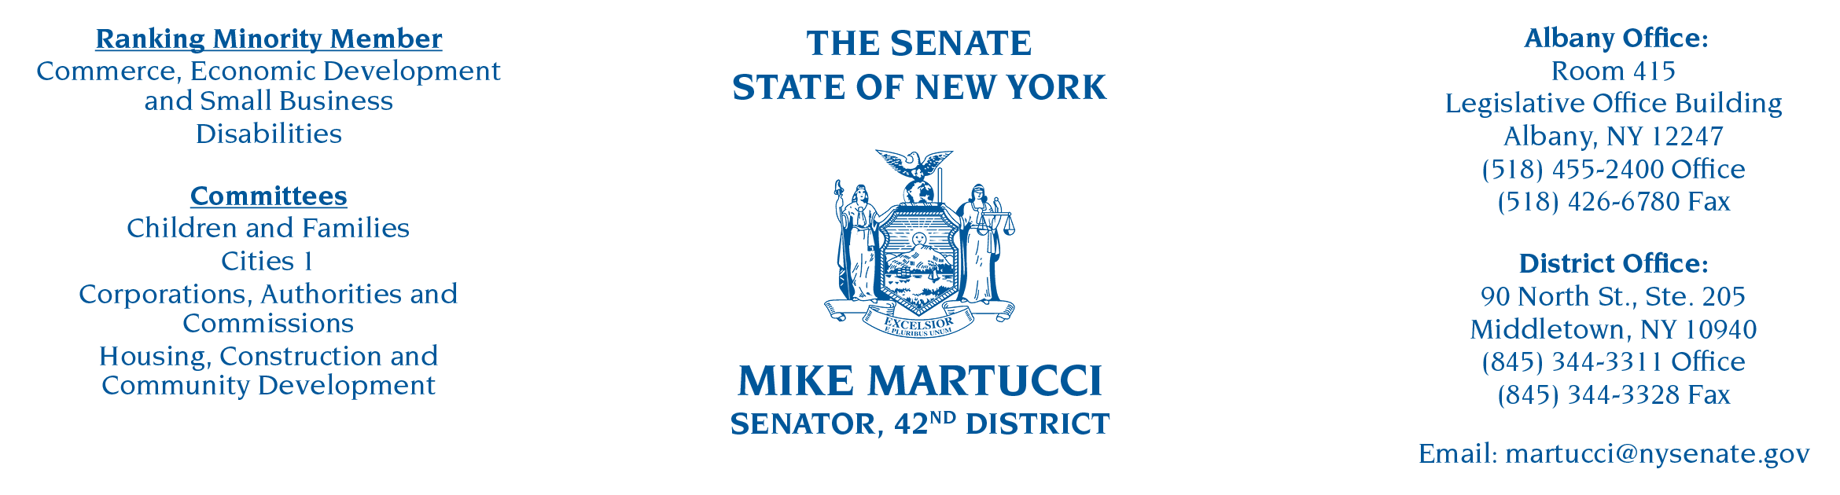

June 29, 2022

NYS Climate Action Council
NYSERDA
17 Columbia Circle
Albany, NY 12203-6399

Dear Members of the Climate Action Council:

I write in opposition to the Draft Scoping Plan, and the impact these regulations will have on small business owners, employees, and residents across the state. Prior to my time serving the 42nd District in the New York State Senate, I was a small business owner. When my wife and I started Quality Bus Service, we ran a serious risk. We used our life savings, and we took on a fair amount of debt. We grew Quality Bus Service to 550 employees, operating over 350 school busses that serviced tens of thousands of New York families.

With the uncertain regulatory environment represented in the Climate Action Council’s Draft Scoping Plan, I do not believe a company like Quality Bus Service would survive. Firstly, the cost of new buses would increase significantly due to the electric bus mandate, which would force a company to retire still-operational gas-powered buses. Moreover, it’s unclear precisely how reliable the new electric bus technology would be.
For example, are there even parts suppliers for these new technologies? What will the availability be with recent supply chain issues we have seen?

Additionally, many of my constituents, some of whom are small business owners themselves, are worried about the costs associated with the mandated switchover to zero-emissions-only vehicles. Delivery companies, transport companies, construction companies, even rideshare entrepreneurs, must now cope with how these new regulations will greatly hurt their businesses.

The sweeping and potentially unintended consequences of the Draft Scoping Plan require further examination and consideration. I urge you to reject the Draft Scoping Plan as it is now, and to grant New Yorkers more time to understand the vast impact these regulations will have on their daily lives.

Sincerely,

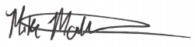
Mike Martucci
Senator, 42nd District

