Hydro Electric Potential on the Genesee River New York

From South to North:

1. The Caneadea Dam built 1928 to produce power but generators never installed.
(Projected annual output 2000 MW October to April)
2. Wiscoy Creek Power Plant. Currently inactive, once operated by RG&E.
3. Mount Morris High Dam US Corp Engineers (Conduits installed for generators but capped)
4. Mount Morris Power Plant. Currently inactive, once operated by RG&E.

PICTURES:

Caneadea Dam. Pictures shows water level Lowered 40 ft
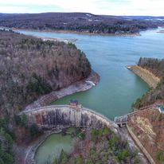

Wiscoy Creek
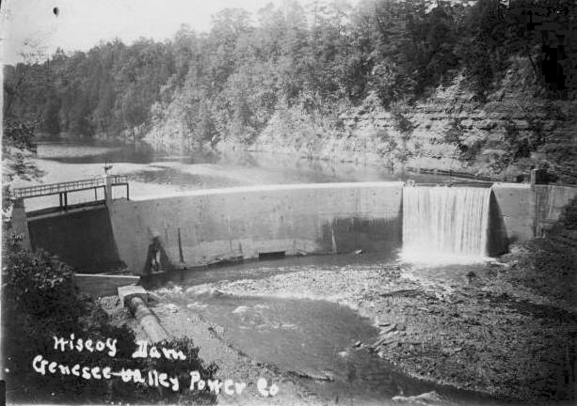

Mount Morris High Dam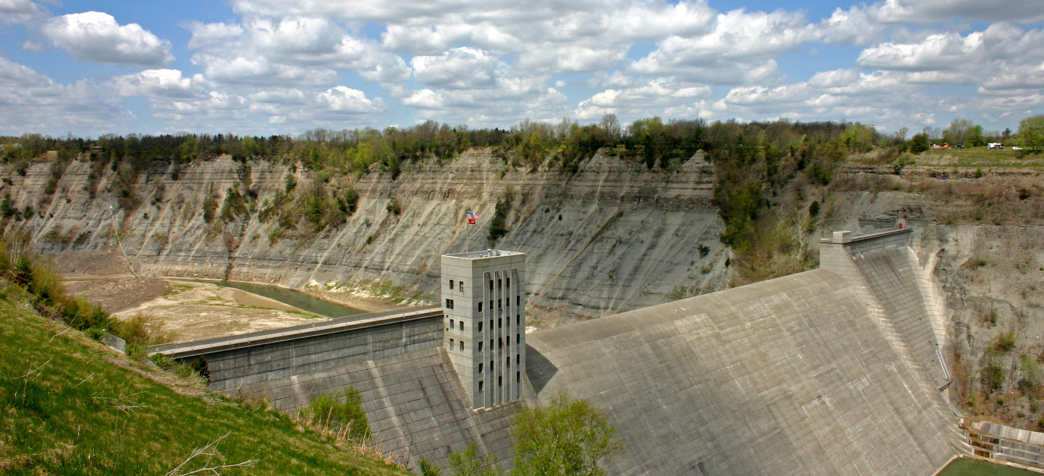

Mount Morris Power Plant near Greenway Trail Bridge