For our own better understanding of the Chapter, our staff created the following chart as a summary of the three funding models:
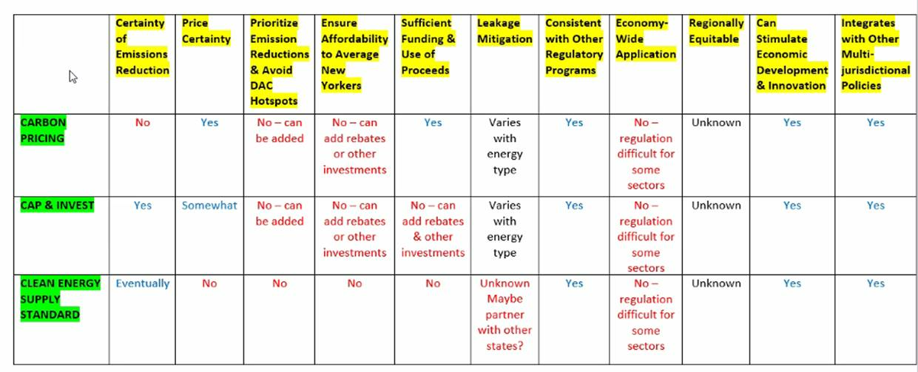
- Page 261, paragraph 1. The most alarming/interesting point is that the authors seem to suggest that an economy-wide application isn’t going to work contrary to what the chapter title indicates. There are some sectors where it can't be applied (e.g., methane from farms, landfills, refrigerants). Although it is stated in this section that there is difficulty in monitoring the methane emissions from these sectors, it would be important to get an idea of how much of the total carbon impact is in this area of the economy. It would be useful to see a full list of exceptions rather than just a few examples and a more robust discussion of how to combine proposals to make something that addresses concerns and is workable.

