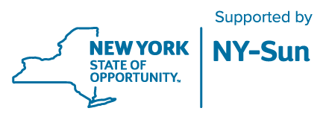 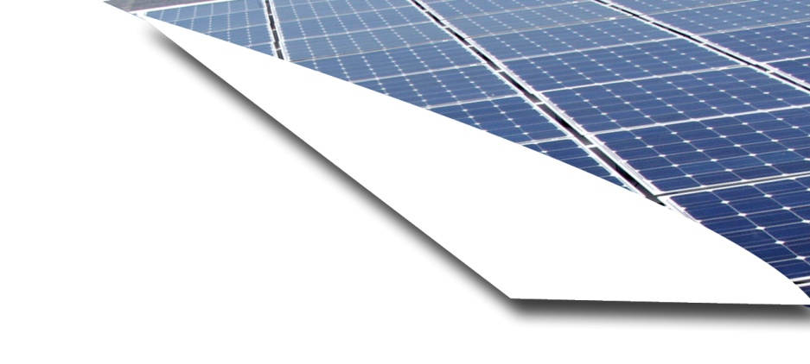

Frequently Asked Questions

Q: What is Solarize?

A: Solarize is a short term (approximately 6-9 months, including planning and outreach), local effort that brings together groups of potential solar customers through widespread outreach and education. This model helps customers choose a solar installation company that is offering competitive, transparent pricing.

Q: How do I know if my home or business is suitable for solar?

A: A south-facing roof is the most ideal location for a solar electric system. Shading can cause a decrease in your system’s ability to function at its maximum capacity. To avoid this, ensure trees and other obstructions, current and future, do not compromise your system.

Q: Will the system produce electricity on cloudy days?

A: Yes, just not as much. Under an overcast sky, panels will generate less electricity than they produce on a clear, sunny day.

Q: Will my system produce power if there is a blackout?

A: Without a battery backup, grid-tied solar electric systems won’t operate when the power goes out. You can add a battery backup to your solar panels to keep the lights on during a blackout, typically battery backups costs range from $5,000- $15,000.

Q: How much will I save by installing a solar electric system?

A: Your solar savings depend on the size of the system you choose, your annual electrical usage, electricity rates and any financing option that you choose. To start, ask your eligible solar contractor how much electricity your new system is expected to produce on an annual basis and then compare that to how much electricity your household uses to get an idea of how much you could save.

**Solar. Simple. Together.**

**Solarize**

**[insert municipality]**

Frequently Asked Questions

Q: Will I still receive a monthly electric bill after installing a solar electric system?

A: Yes. You will receive a monthly bill from your utility company as you always have, but the amount owed will differ depending on your monthly electrical usage. Depending on how your system is sized, you may accrue credits in the more productive summer months, which can be carried over and used in the less productive winter months.

Q: How much maintenance does a solar electric system need?

A: Solar panels require very little maintenance. However, you should consult with your solar installer for tips on how to maintain your panels.

Q: What is the lifespan of a solar electric system?

A: Solar electric systems are usually operational for approximately 20-25 years.

Q: Are state incentives available for my system?

A: The New York State Energy Research and Development Authority (NYSERDA) provide incentives to help New York go solar. The amount of incentive provided is based on the size of your system, orientation, shading and other factors, but for an average solar installation, the incentive will be up to 25% of your system’s total installed cost.

Q: Are federal incentives available for my system?

A: The federal government provides an investment tax credit equal to 30% of your system’s total installed cost, net of state incentives. This can be claimed on your 2015 tax return. This tax credit is set to expire in 2016. The ITC is a 30 percent tax credit for solar systems on residential (under Section 25D) and commercial (under Section 48) properties.

Q: What is a community solar project?

A: A Community Solar project is a group of solar panels installed in a sunny location. Anyone in the area can access the clean energy produced by the panels and get credits on their electric bills.

Q: How do I know if I can take part of a community solar project?

A: To take part in community solar, you just need to have an account with an electric utility and be within the same load zone and utility service as a project.

